RP no: Century Gothic 15pt
(所有圈號用15pt)
What are they? Write.

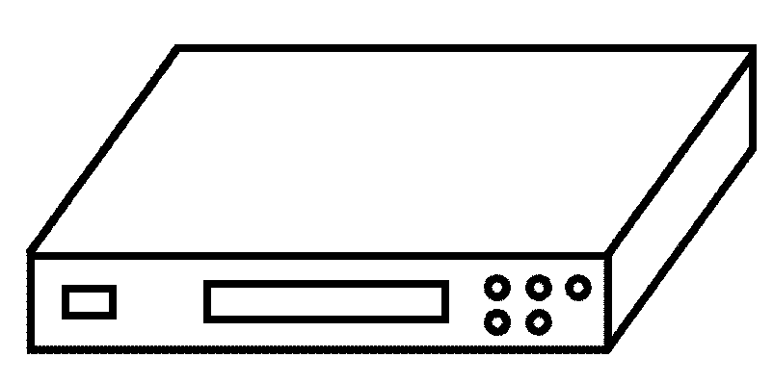  1  2  4  3  5  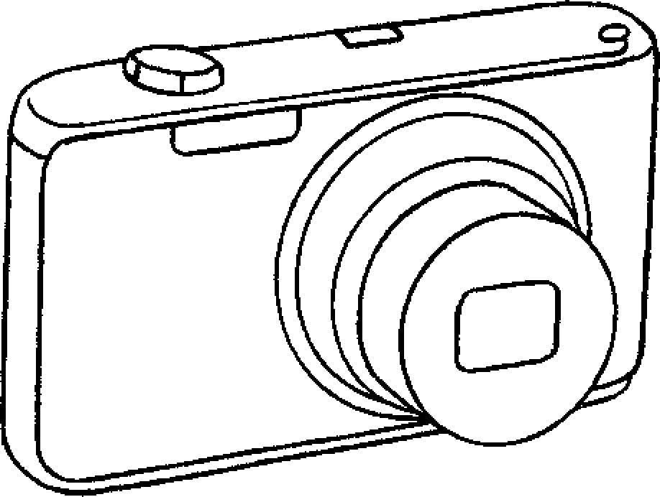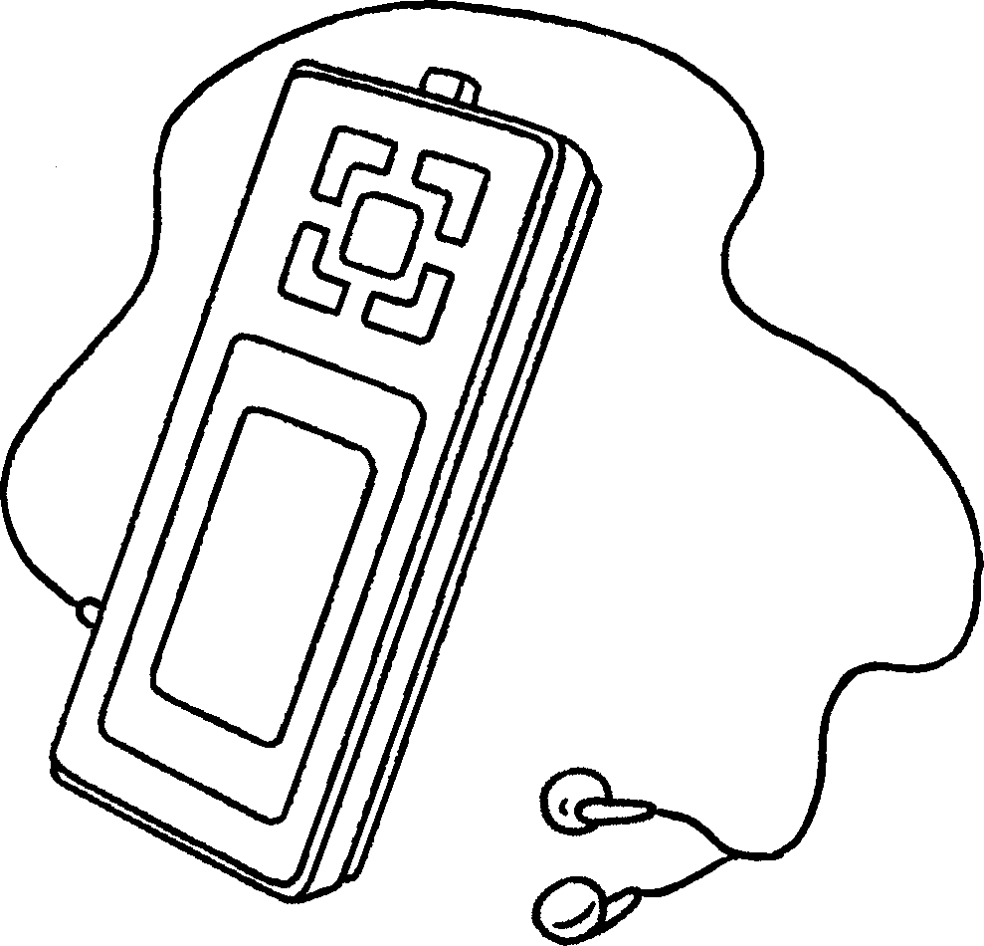  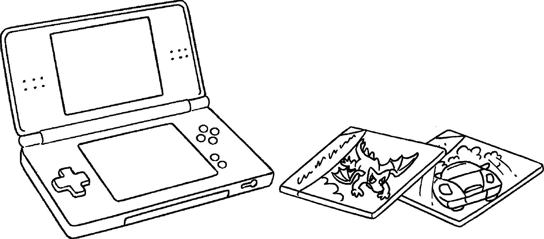 |  | 1 | a m p
 |  | 2 | a DVD p
 |  | 3 | a digital c
 |  | 4 | an M p
 |  | 5 | e g
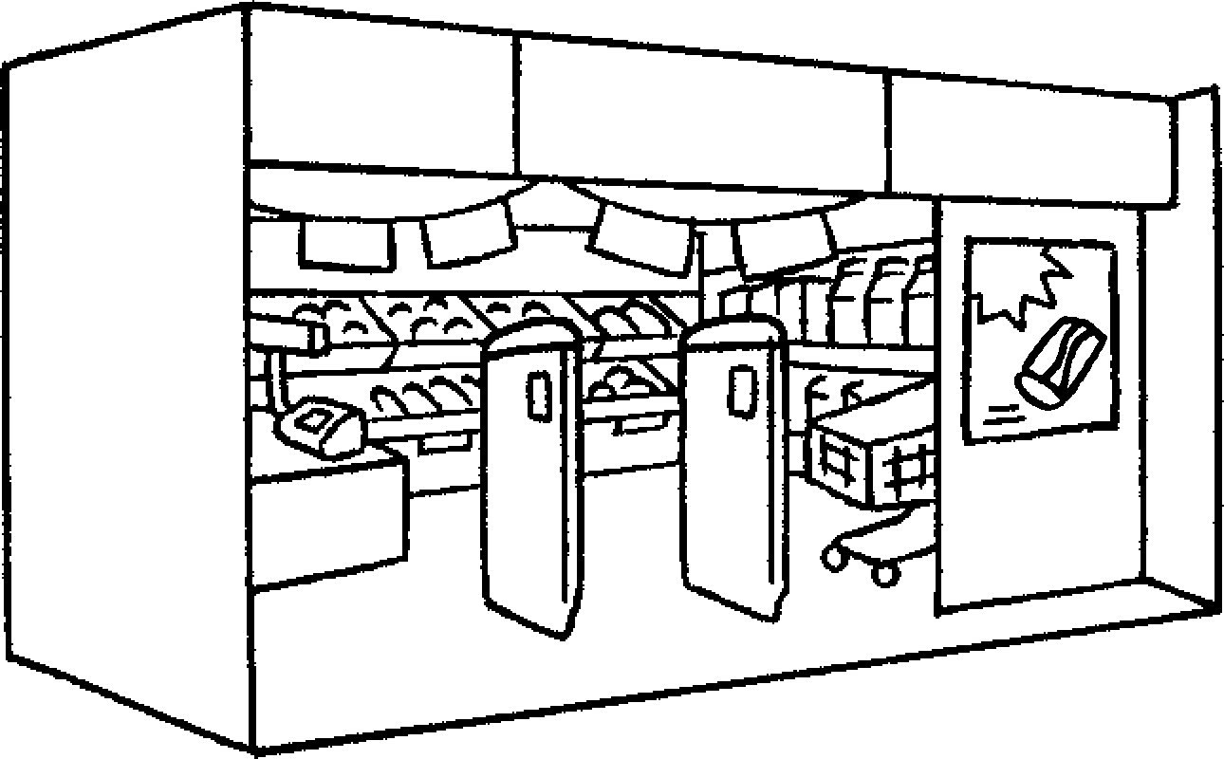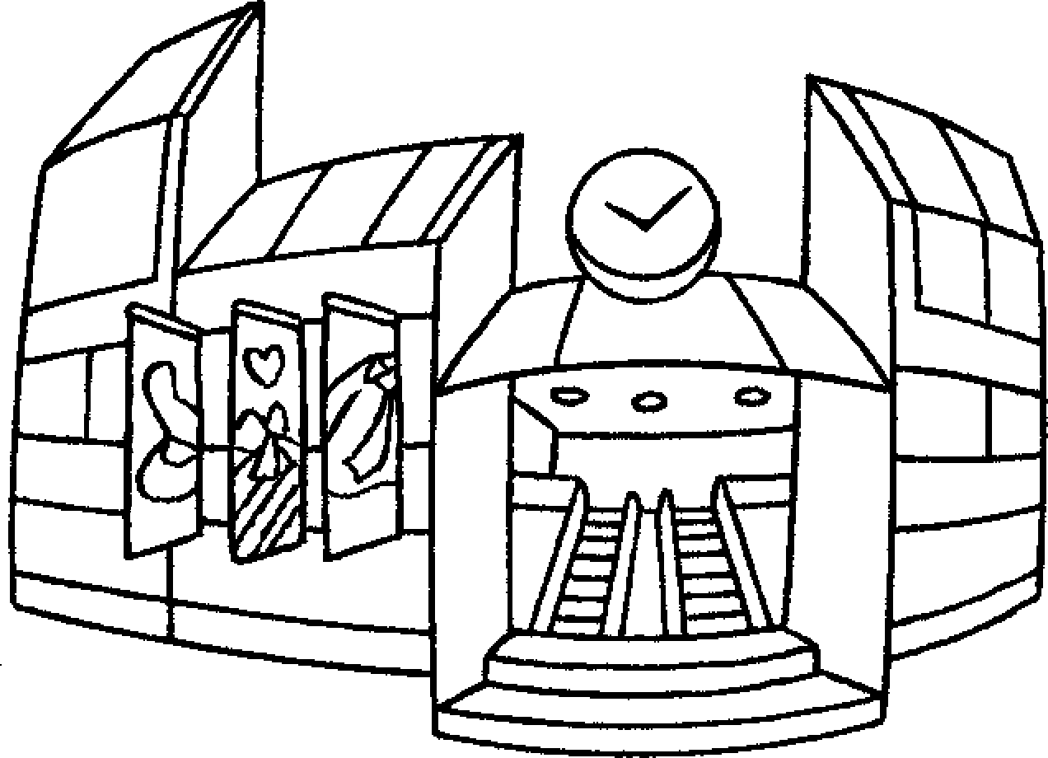  6  7  9  8  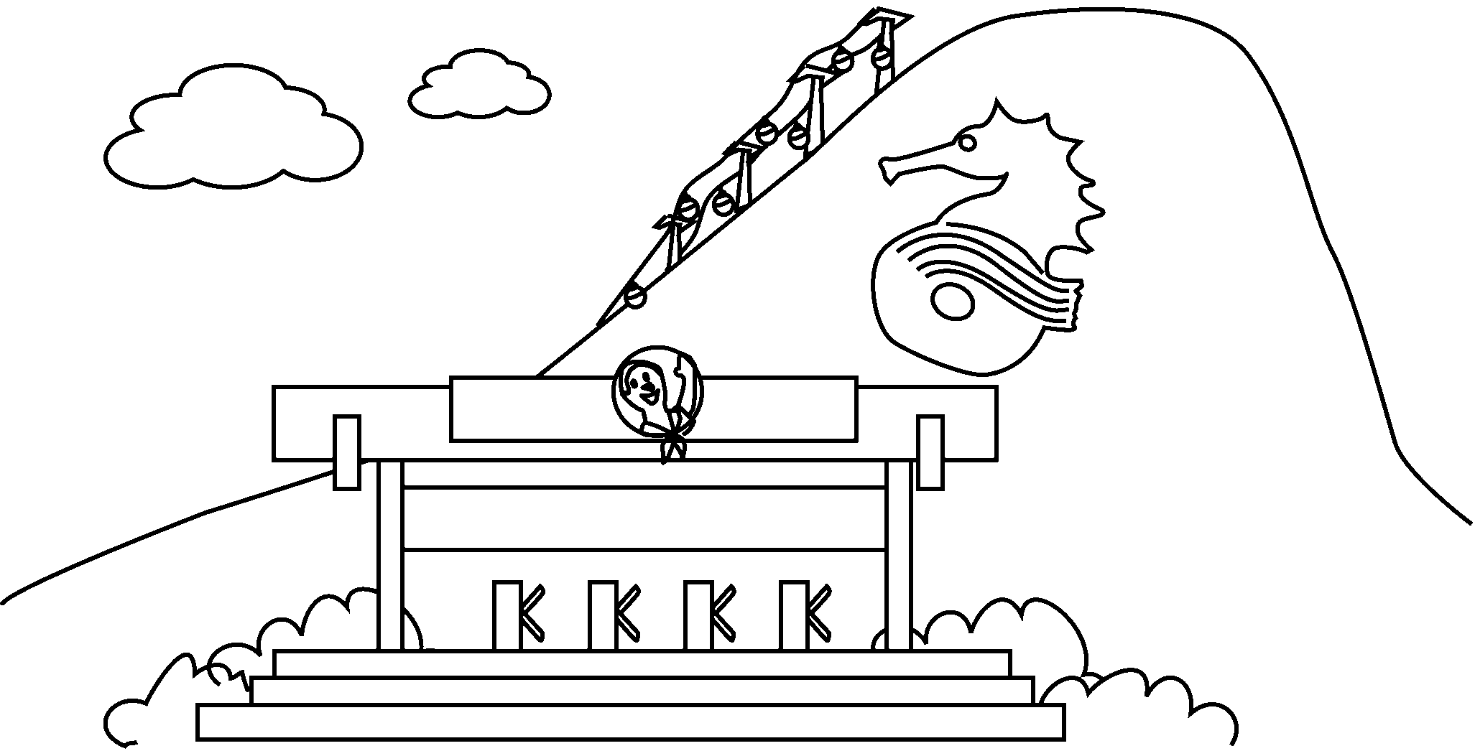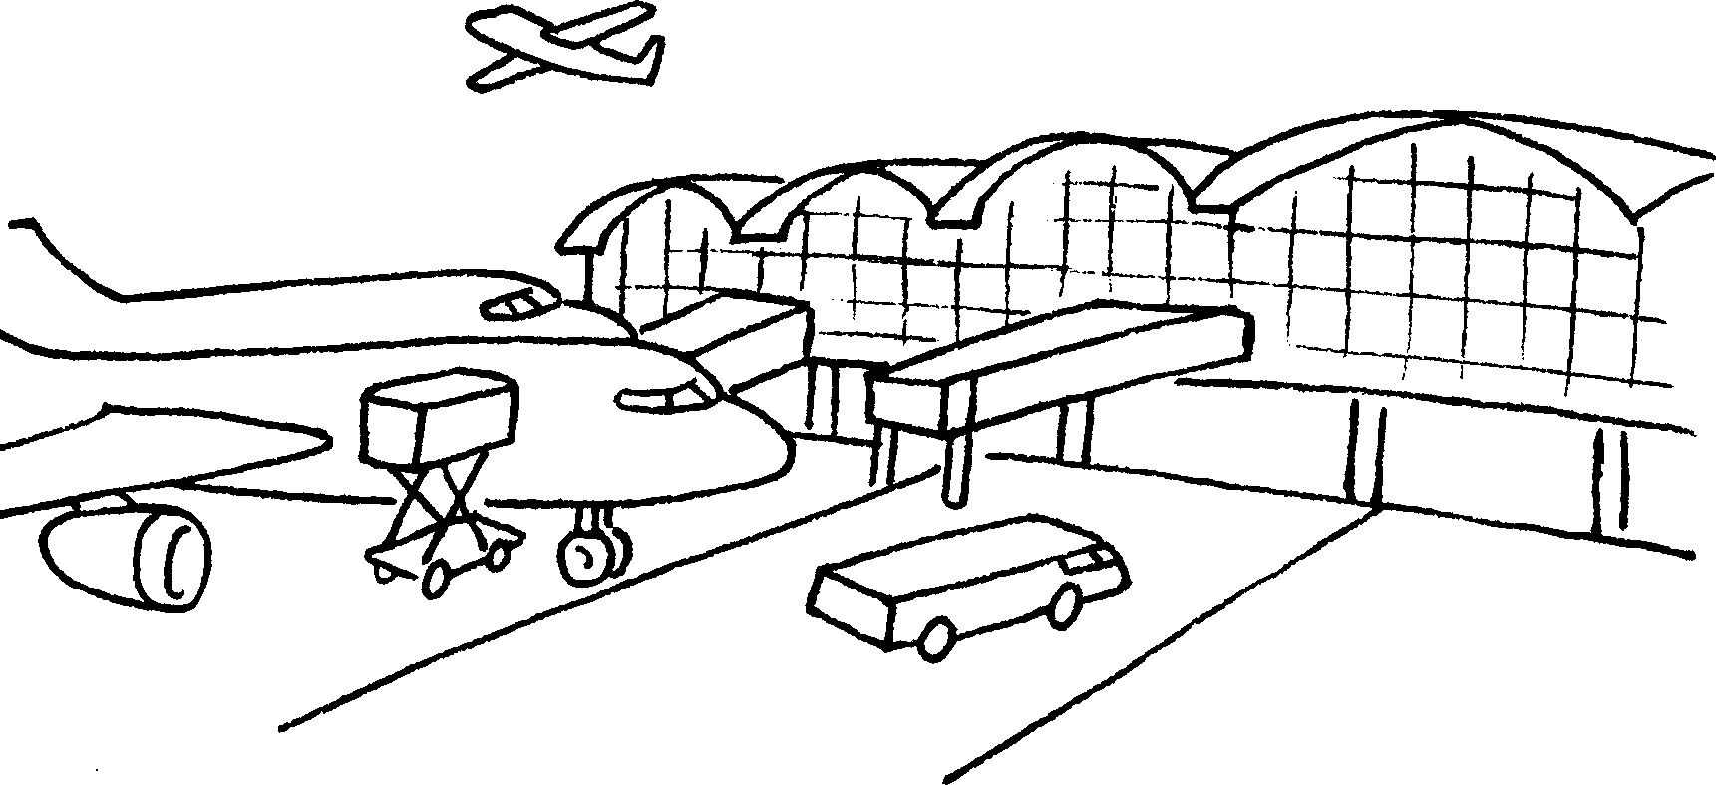 |  | 6 | a s
 |  | 7 | a s c
 |  | 8 | a t p
 |  | 9 | an a


RP no: Century Gothic 15pt
(所有圈號用15pt)

Book 4A Chapter 5 Graded Worksheets
Worksheet 1⬇⬇
- mobile phone
- player
- camera
- MP3 player
- electronic games
- supermarket
- shopping centre
- theme park
- airport
RP no: Century Gothic 15pt
(所有圈號用15pt)

