RP no: Century Gothic 15pt
(所有圈號用15pt)
What are they? Write.

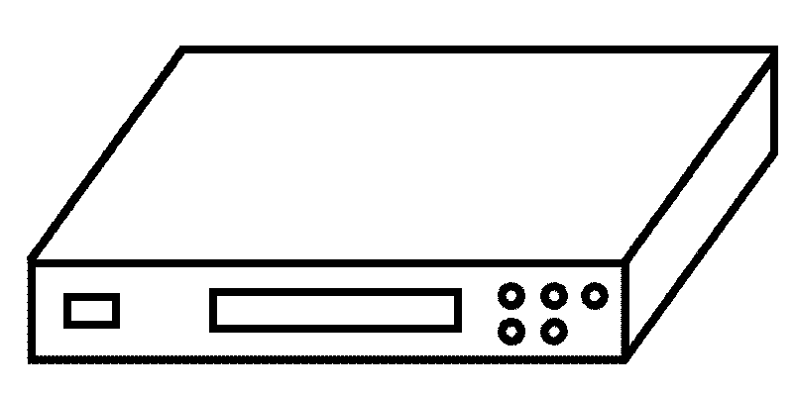  1  2  4  3  5  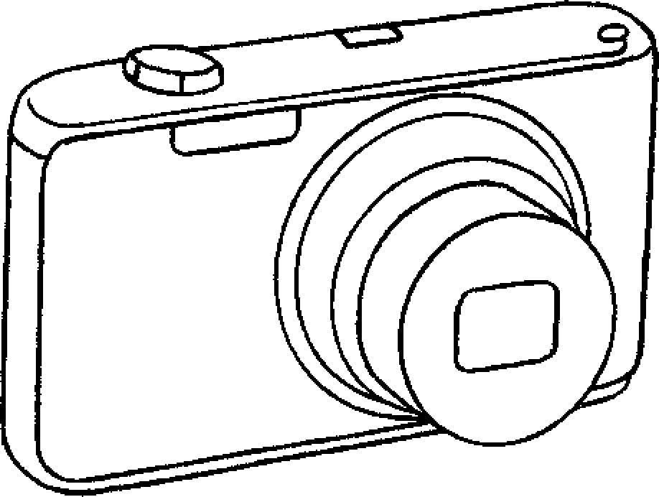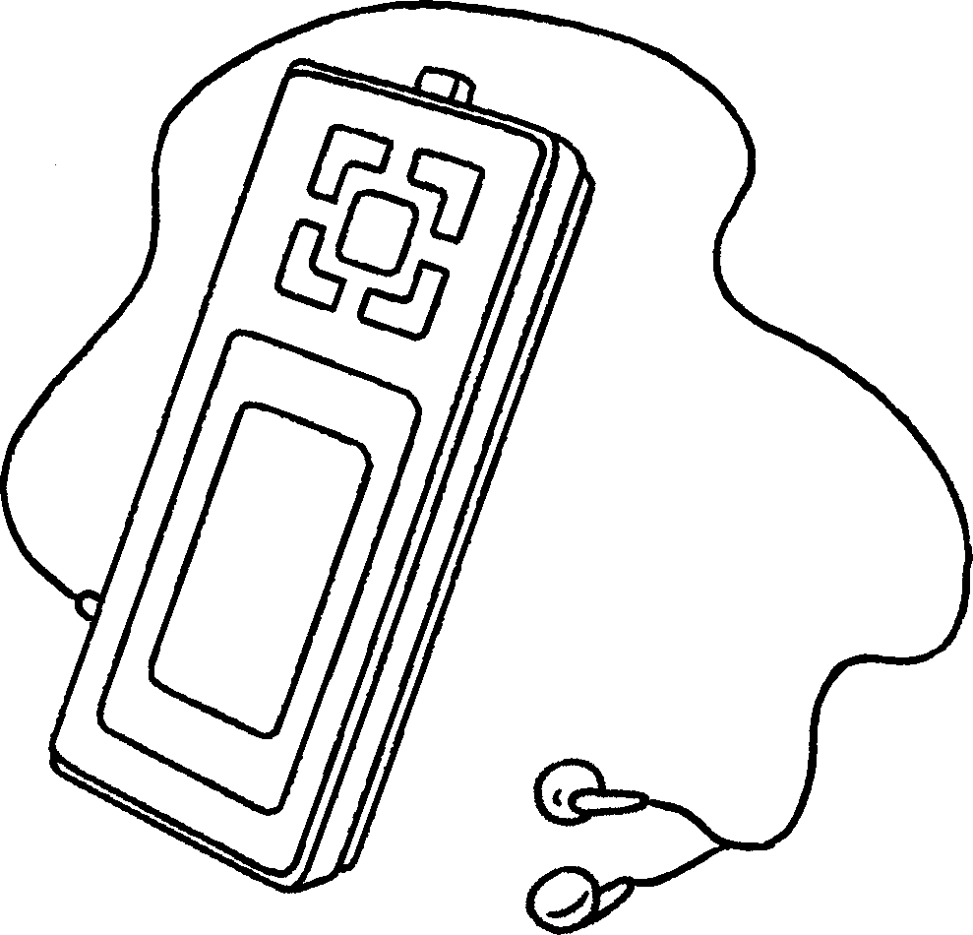  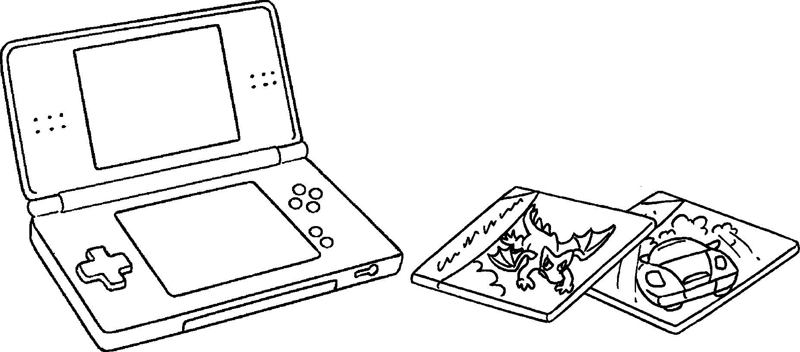 |  | 1 | a
 |  | 2 | a DVD
 |  | 3 | a digital
 |  | 4 | an
 |  | 5
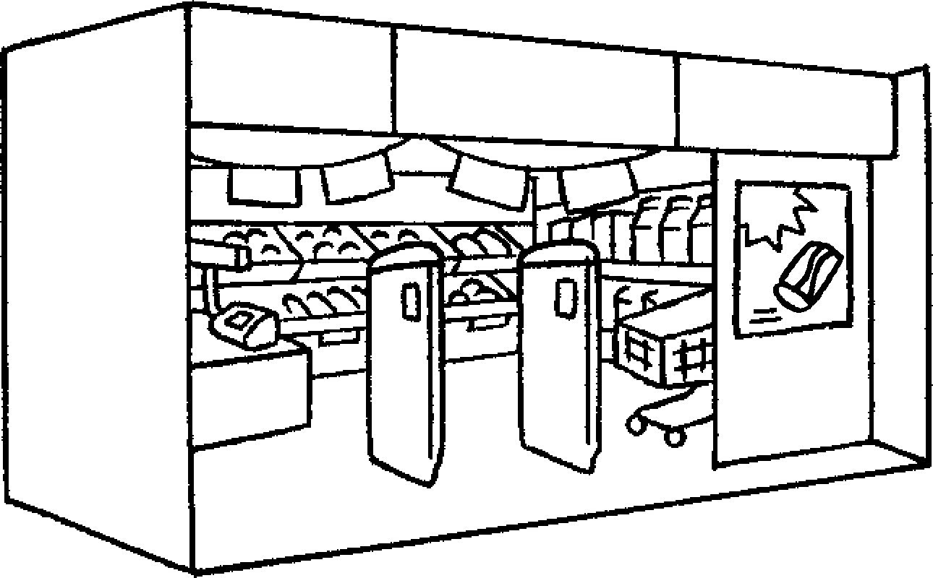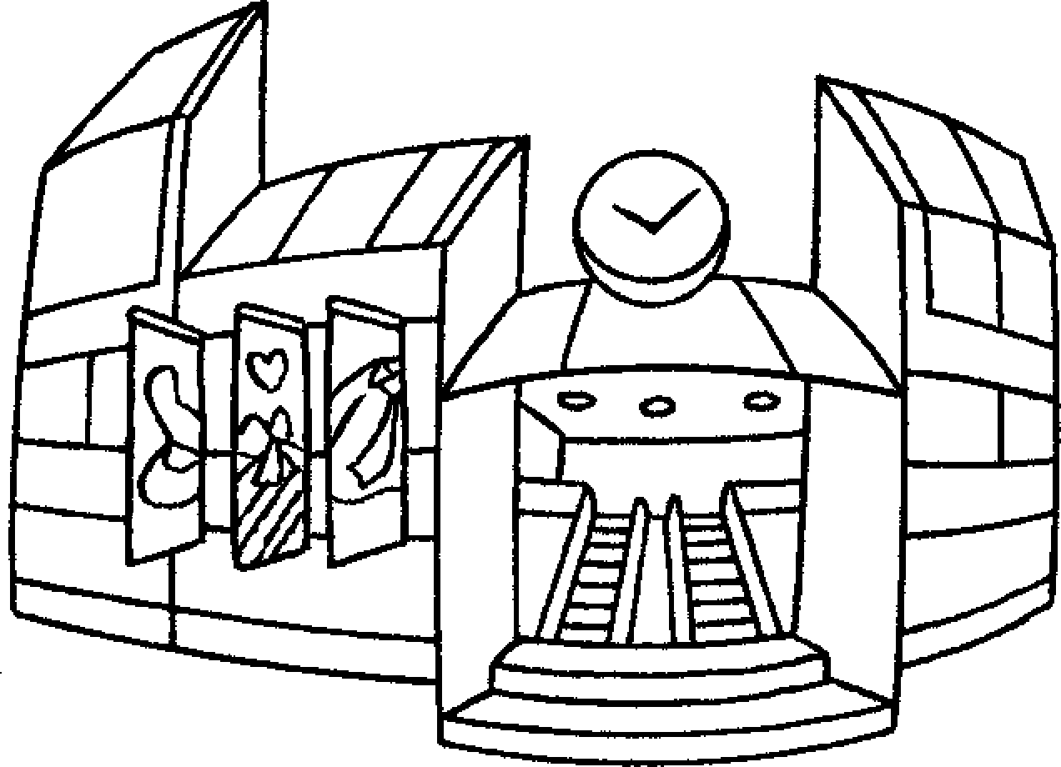  6  7  9  8  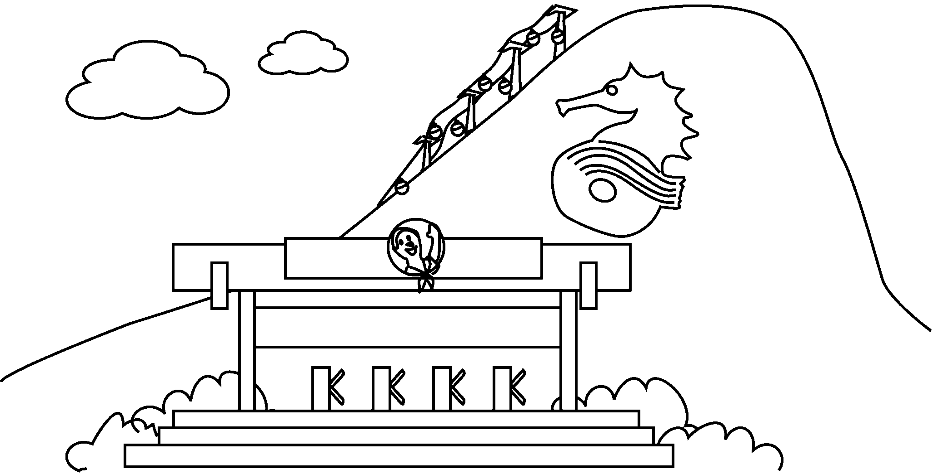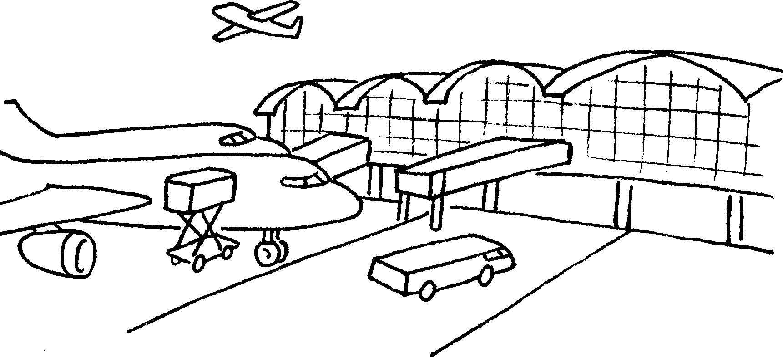 |  | 6
 |  | 7
 |  | 8
 |  | 9


Book 4A Chapter 5 Graded Worksheets
Worksheet 1⬇⬇⬇
- mobile phone
- player
- camera
- MP3 player
- electronic games
- a supermarket
- a shopping centre
- a theme park
- an airport

RP no: Century Gothic 15pt
(所有圈號用15pt)

