Choose and write.

was | were | a
wasn’t | weren’t | an
 |  | any
A
B
1  ✓  ✓  ✗  ✗ | 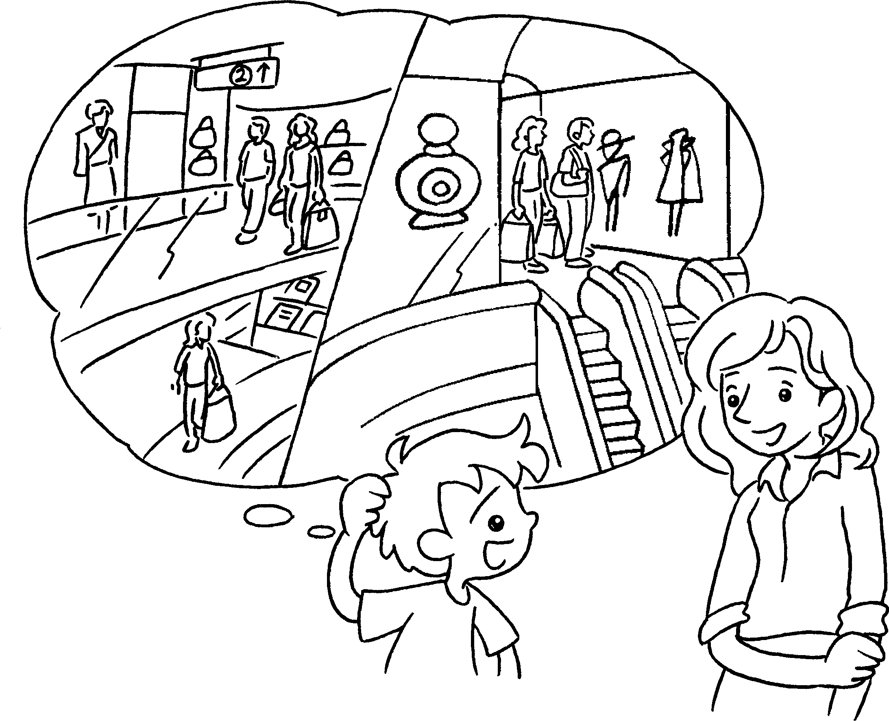 |  | A : there any  shopping centres twenty years ago?  B : Yes, there .
2  A  B |  |  | A : there  airport twenty years ago?  B : Yes, there .
3  A  B | 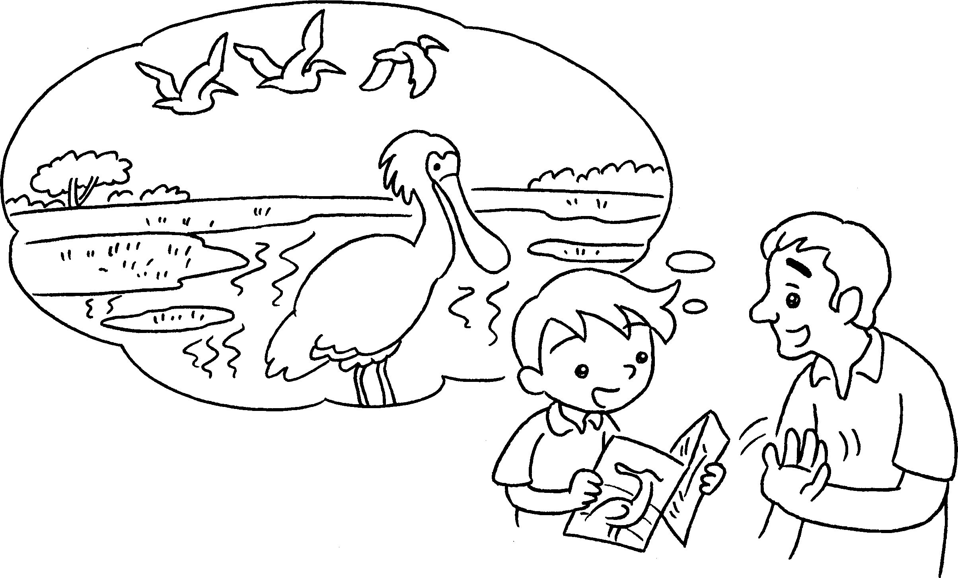 |  | A : there  wetland park twenty years ago?  B : No, there .
4  A  B |  |  | A : there  supermarkets sixty years ago?  B : No, there .


Book 4A Chapter 5 Graded Worksheets
Worksheet 2⬇
- Were
were
2 Was an
was
3 Was a
wasn’t
4 Were any
weren’t

