Finish the questions and answers.

a an any

1  A  B | 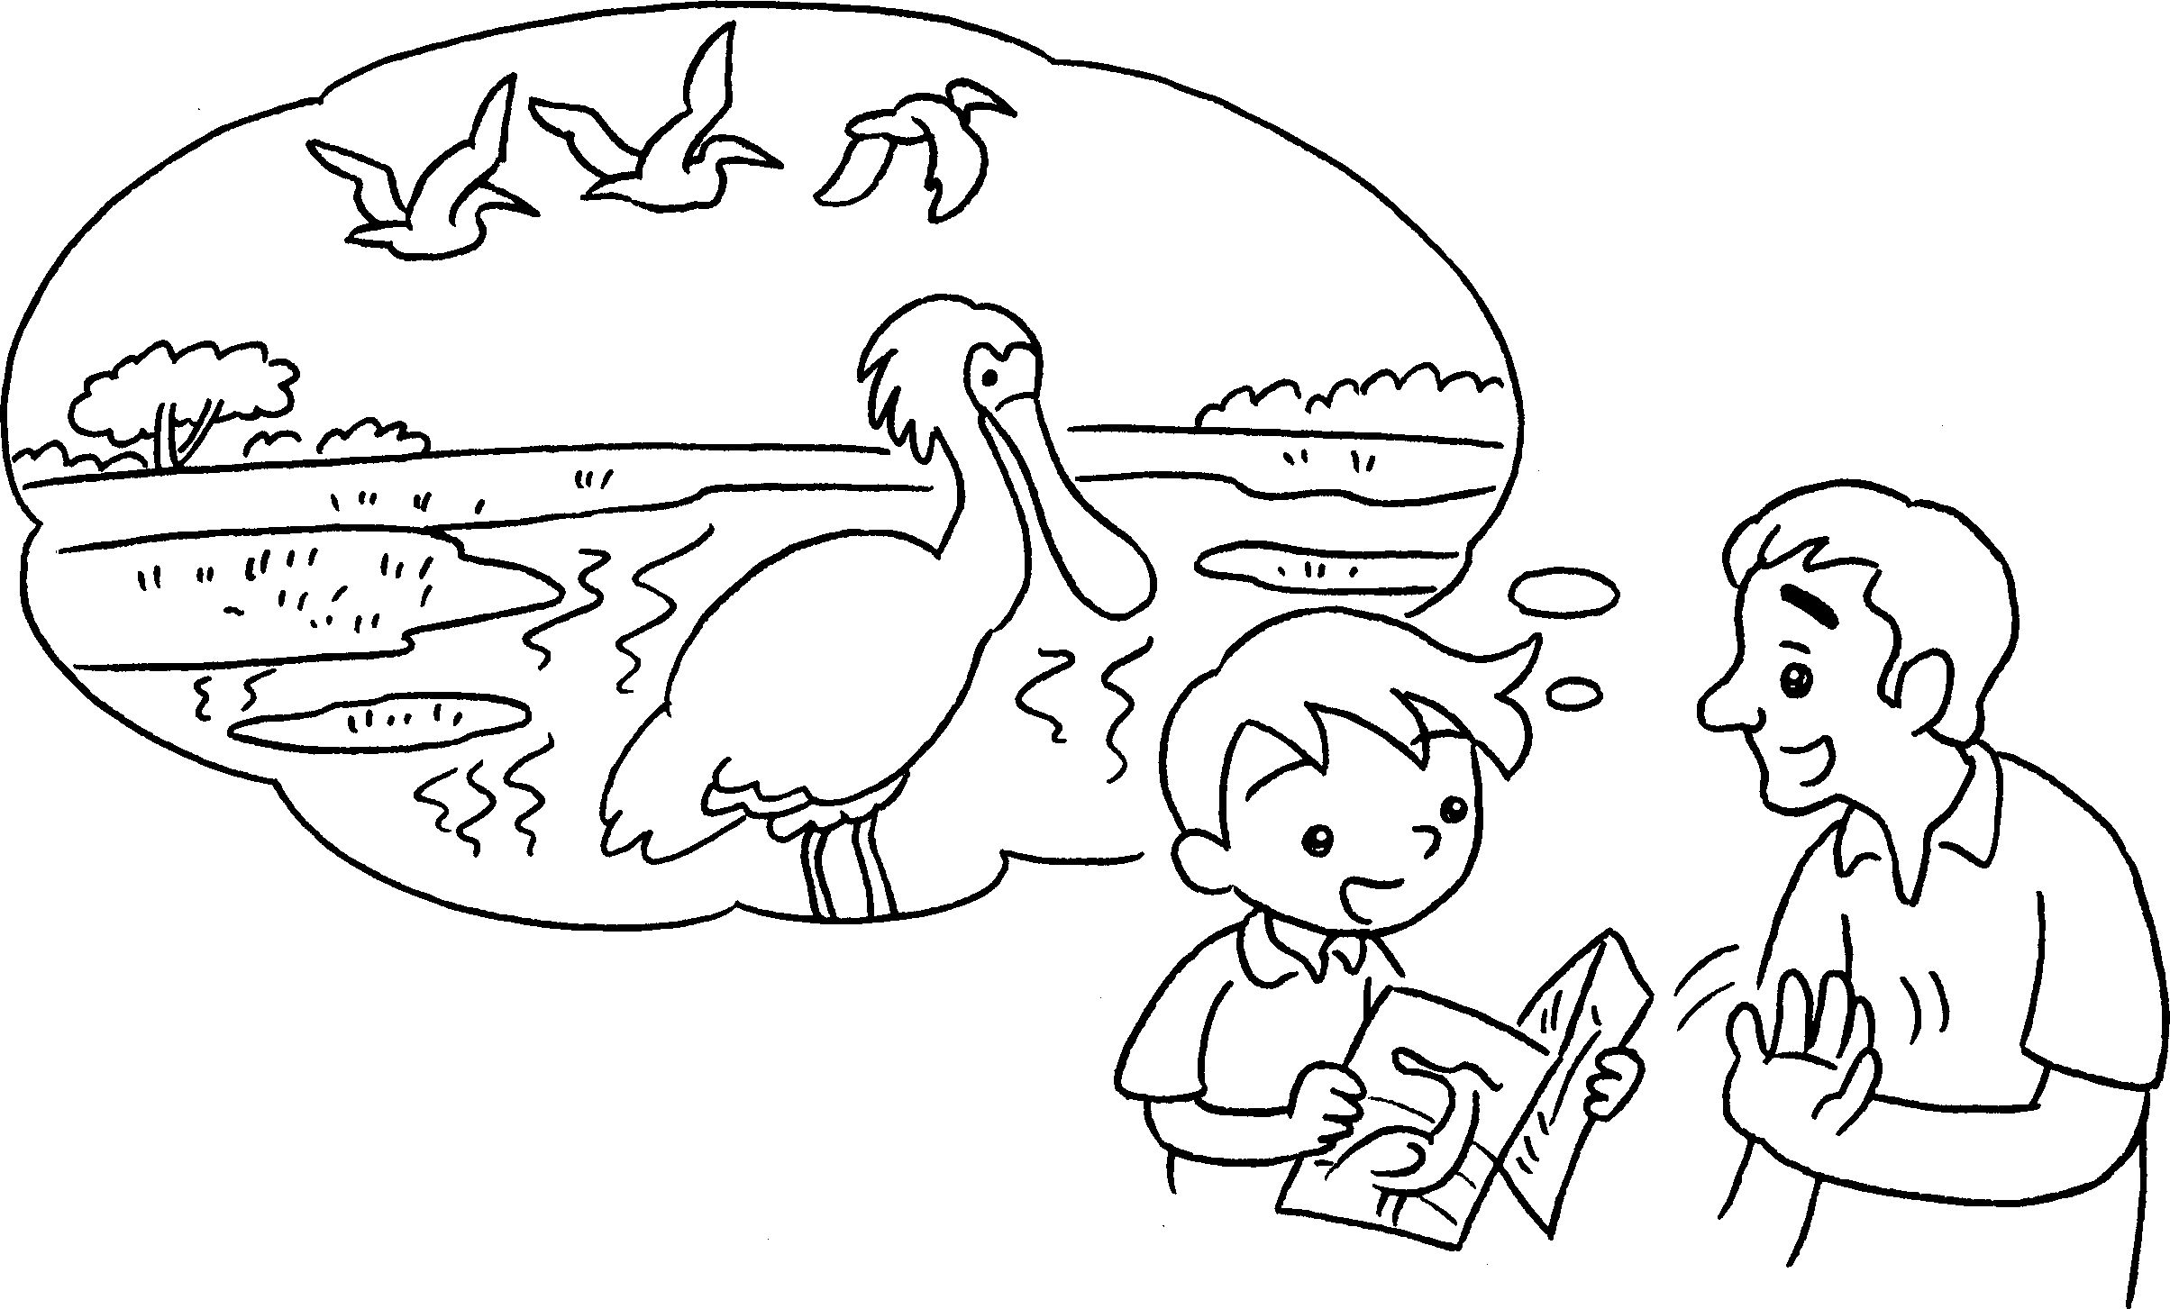  ✗ |  | Was  A : there  wetland park twenty years ago?  B : No, there .
2  ✓  ✓  ✗ | 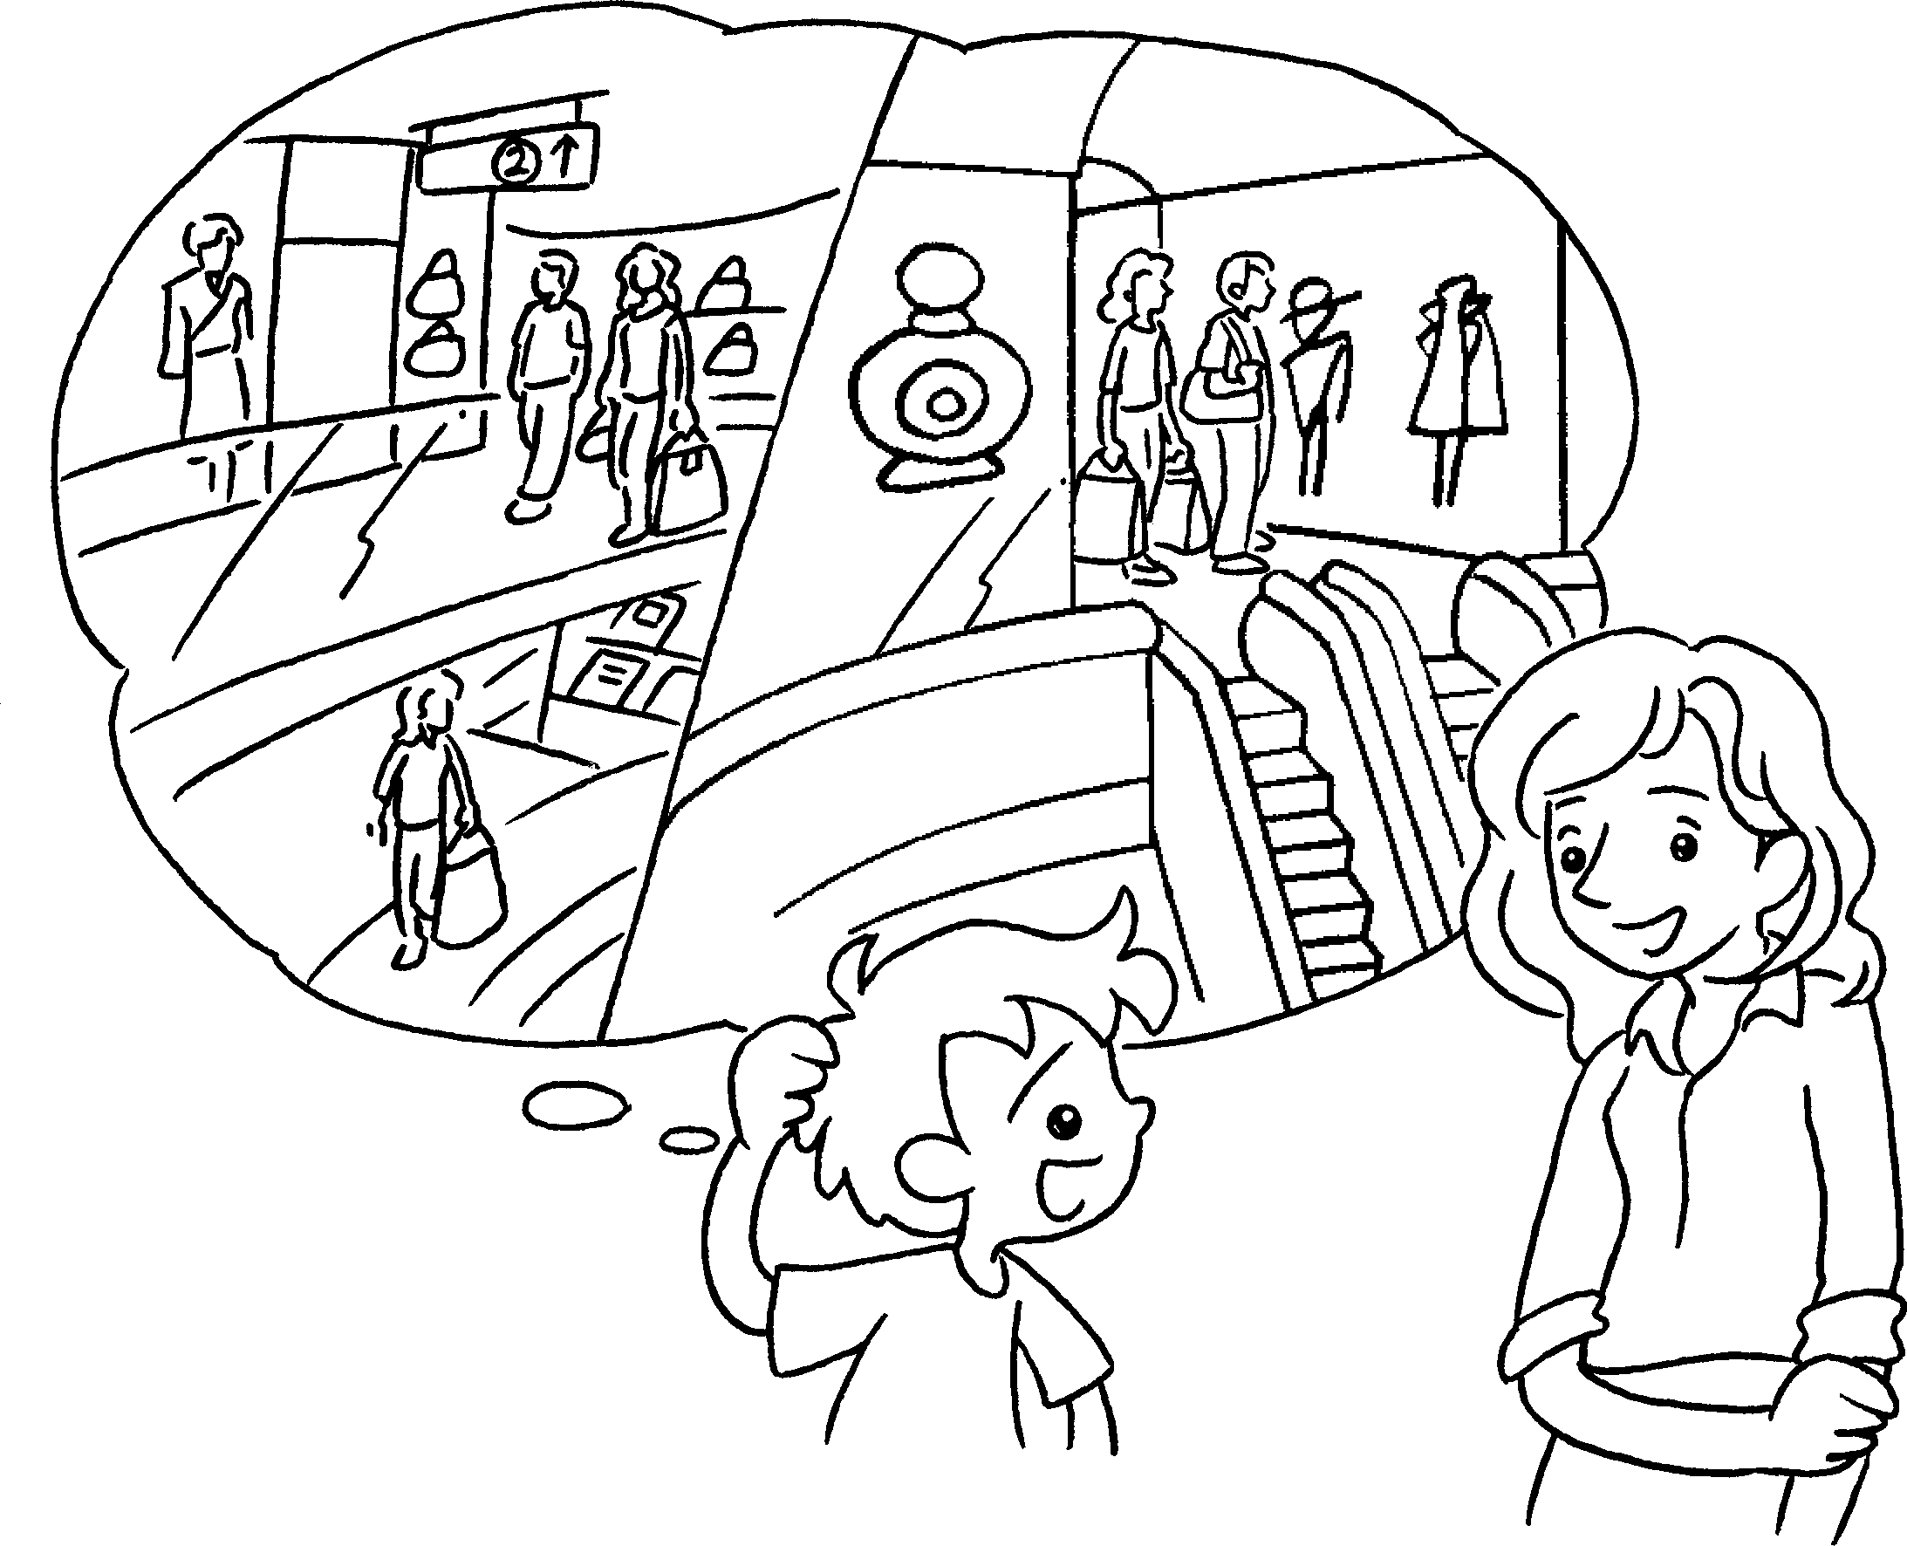  A  B |  | A : there  twenty years ago?  were  B : Yes, there .
3  A  B | 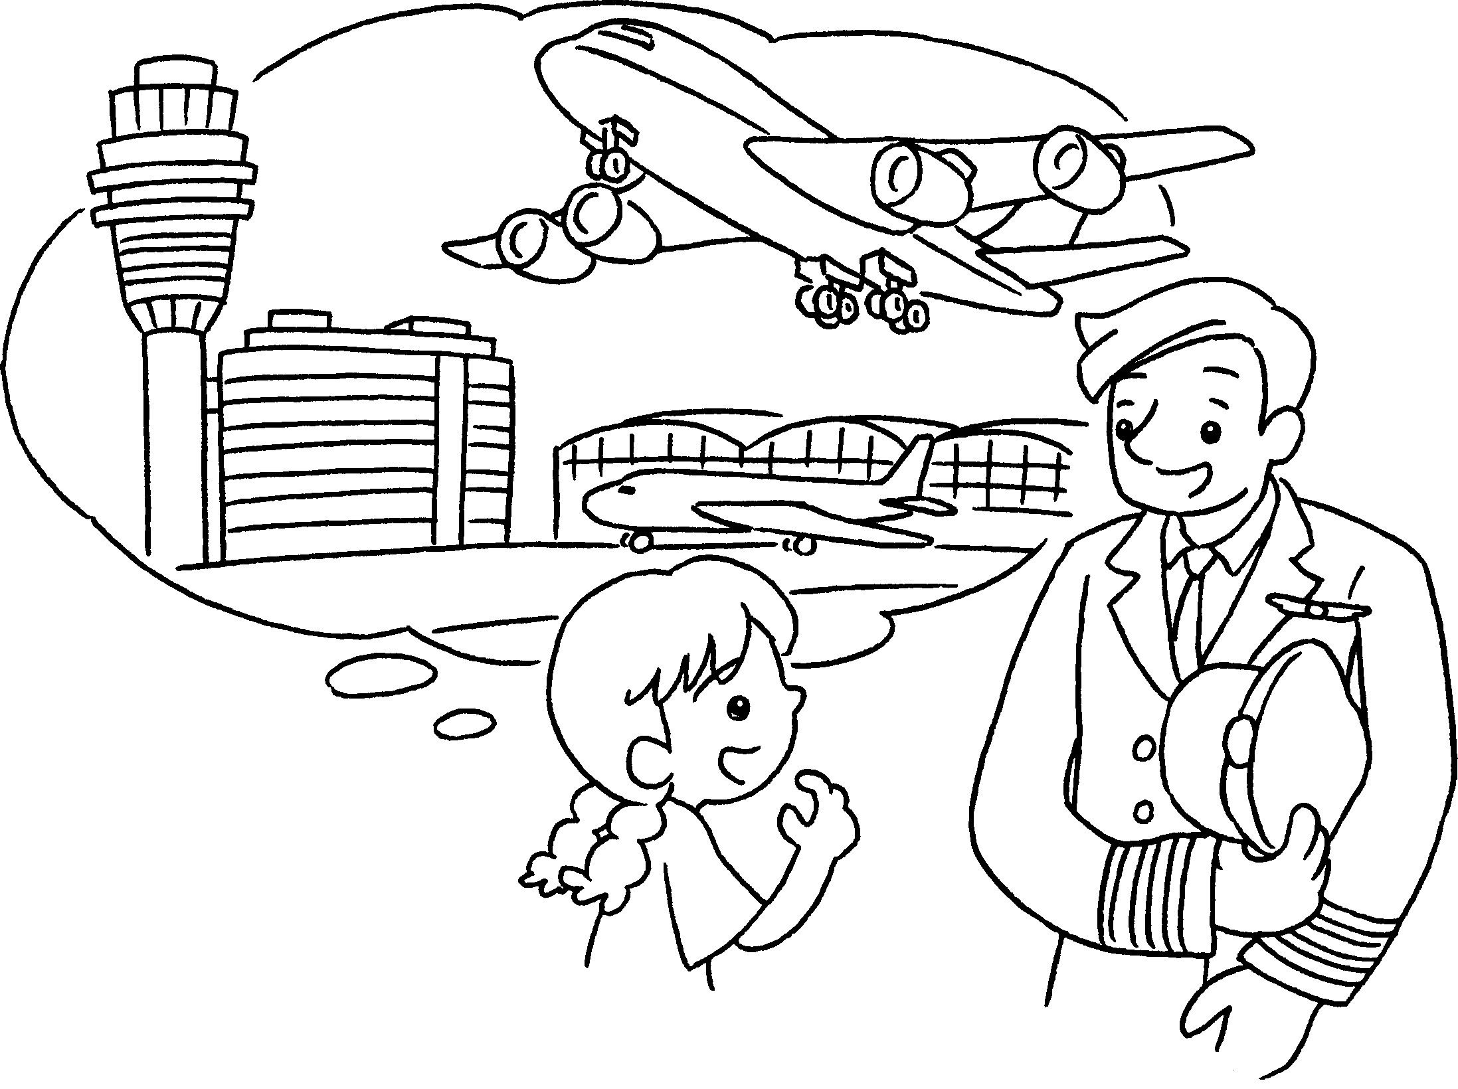 |  | A : there  twenty years ago?  B :
4  A  B |  |  | A :  sixty years ago?  B :


Book 4A Chapter 5 Graded Worksheets
Worksheet 2⬇⬇⬇
- a
wasn’t
2 Were any shopping centres
3 Was an airport
Yes, there was.
- Were there any supermarkets
No, there weren’t.

