RP no: Century Gothic 15pt
(所有圈號用15pt)
Finish the sentences.

Everybody |  | Nobody

When Grandma was young did anybody in her class …?
1 | 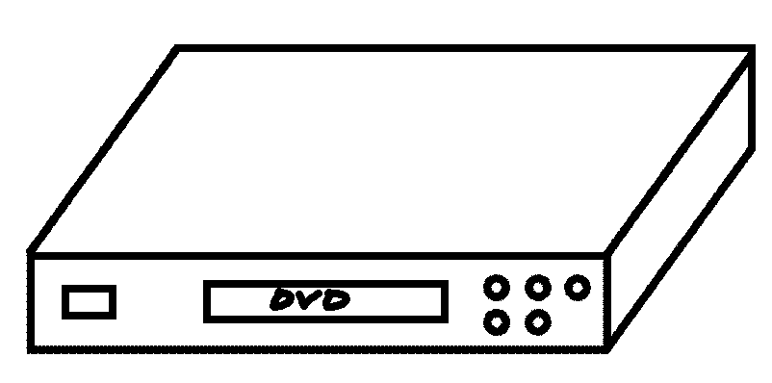 | ✗ | 2 | 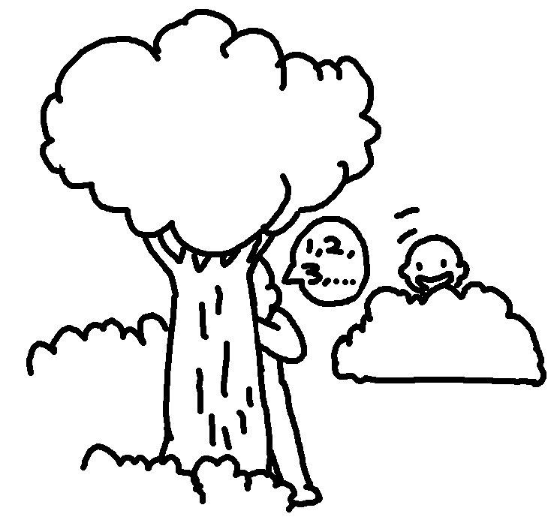
1 | have a DVD player |  | 2 | play hide-and-seek
3 |   ✗ |  | 4 | 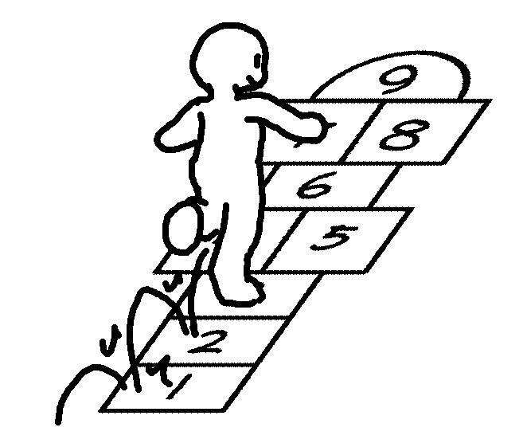 | ✓  ✓
3 | have a mobile phone |  | 4 | play hopscotch | ✓  ✓
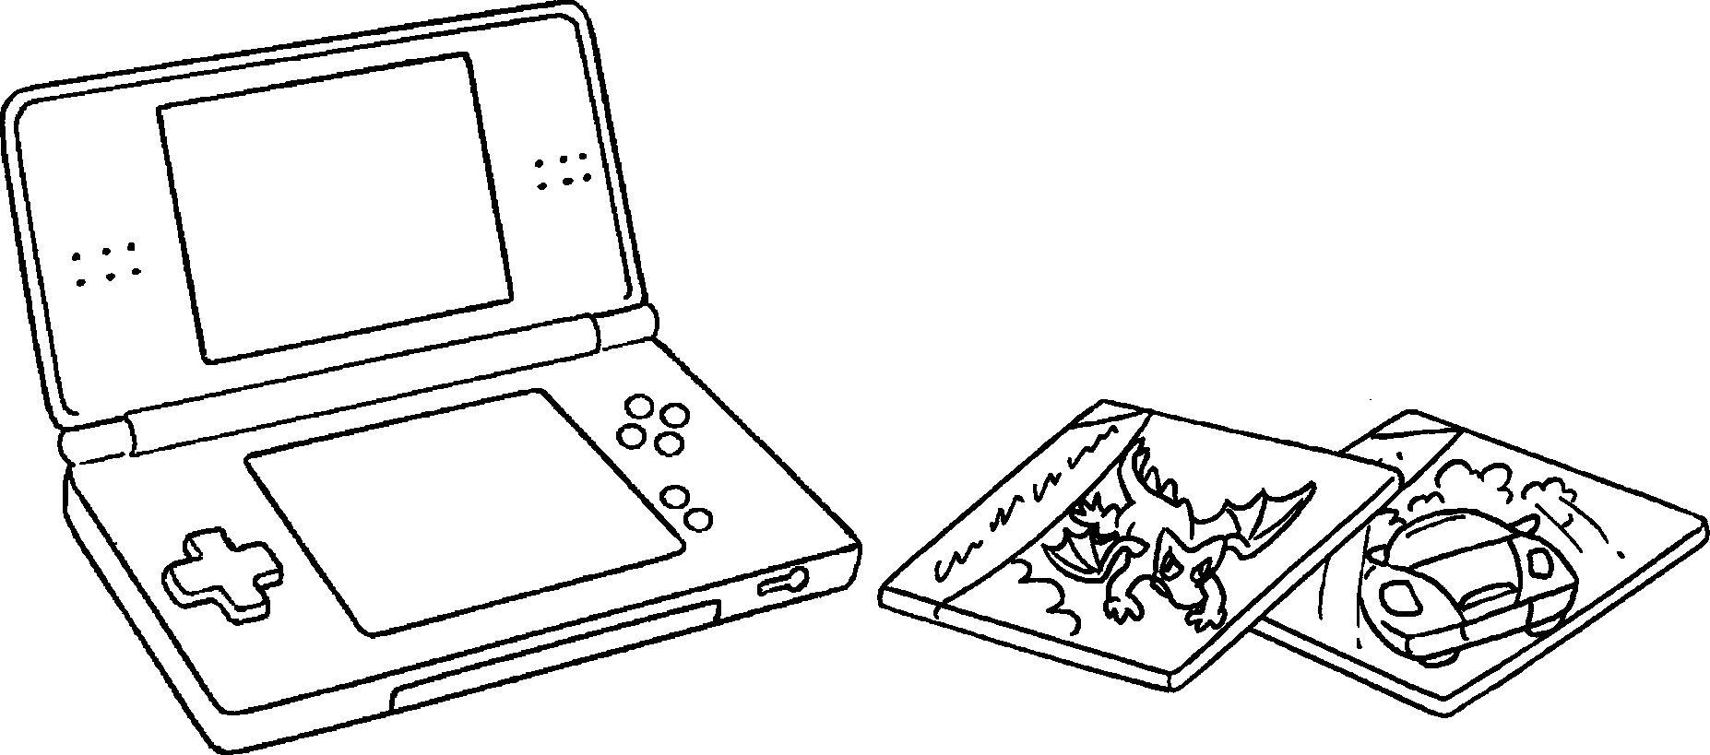
5
✗
play electronic games

1 in Grandma’s class had a DVD player when she
was young.
2 played hide-and-seek.
3 a mobile phone.
4 hopscotch.
5 electronic games.


Book 4A Chapter 5 Graded Worksheets
Worksheet 3⬇
- Nobody
- Everybody
- Nobody had
- Everybody played
- Nobody played

