RP no: Century Gothic 15pt
(所有圈號用15pt)
Finish the sentences.

Everybody |  | Nobody

electronic games mobile phone hopscotch

When Grandma was young did anybody in her class …?
1 | 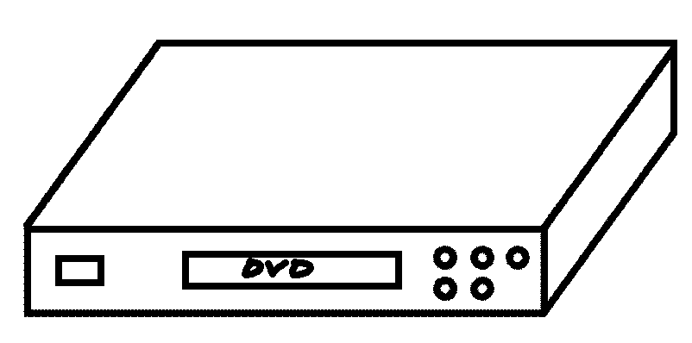 | ✗ | 2 | 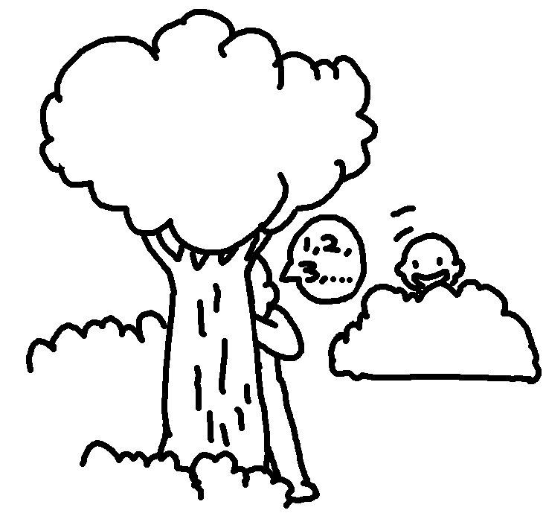
3 | 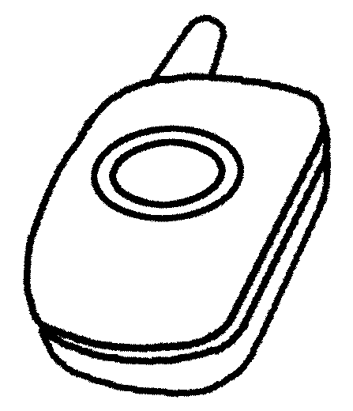  ✗ |  | 4 | 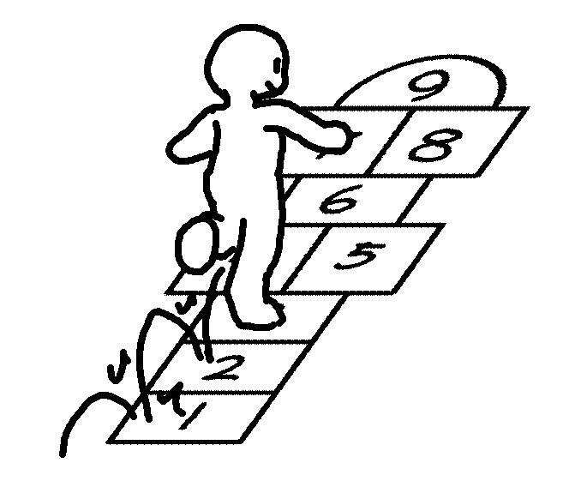 | ✓  ✓
5
✗
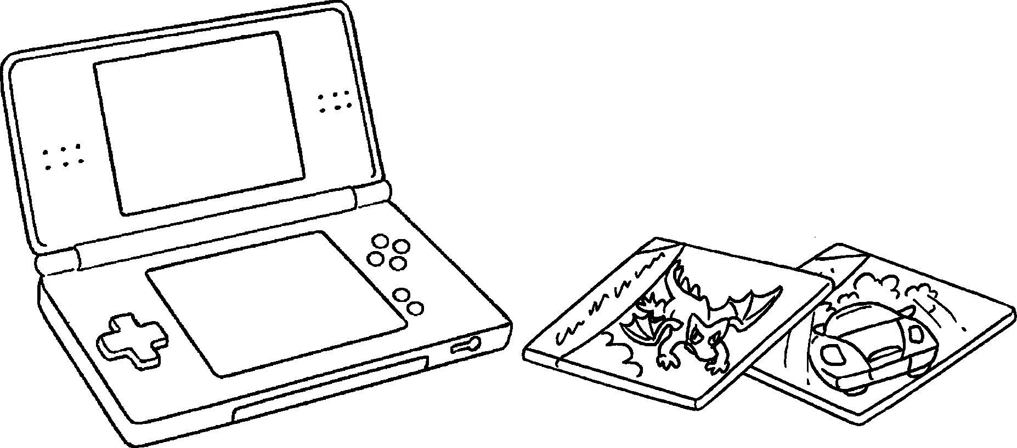

1 in Grandma’s class had a DVD player when she
was young.
2 played hide-and-seek.
3
4
5

RP no: Century Gothic 15pt
(所有圈號用15pt)

Book 4A Chapter 5 Graded Worksheets
Worksheet 3⬇⬇
- Nobody
- Everybody
- Nobody had a mobile phone.
- Everybody played hopscotch.
- Nobody played electronic games.

