Choose and write.

carry my school bag |  | climb the stairs |  | comb my hair
do up my buttons | tie my shoelaces |  | get dressed
pack my school bag

1 | 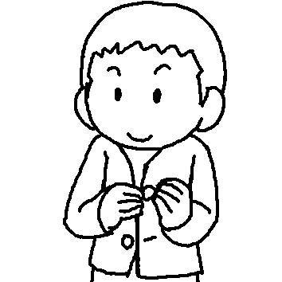
2 | 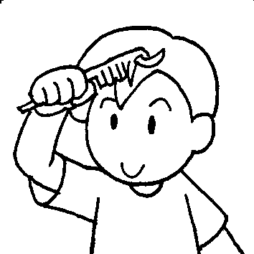
3 | 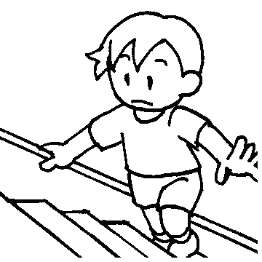
4 | 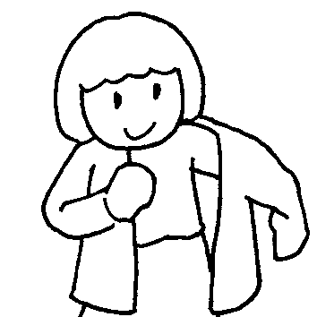
5 | 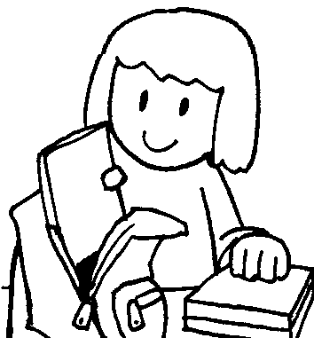
6 | 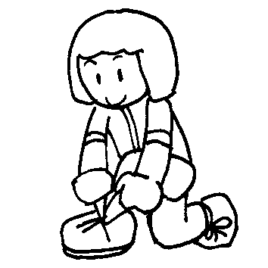
7 | 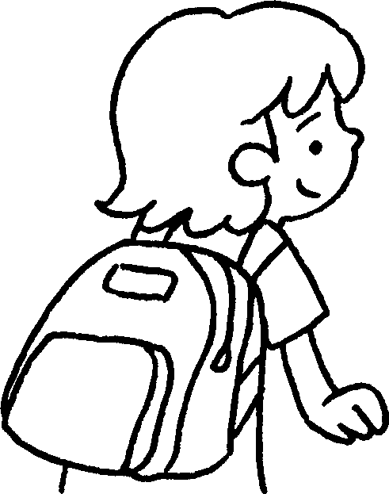


Book 4A Chapter 6 Graded Worksheets
Worksheet 1⬇
- do up my buttons
- comb my hair
- climb the stairs
- get dressed
- pack my school bag
- tie my shoelaces
- carry my school bag

