What can the children do? Write.

1 | 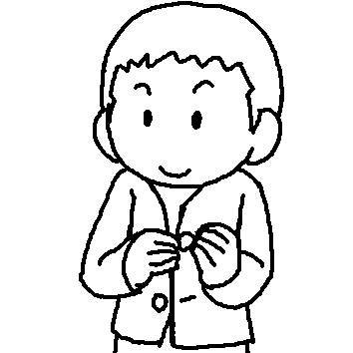 | Paul can d u his buttons.
2 | 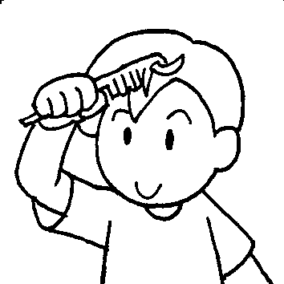 | He can c his h .
3 | 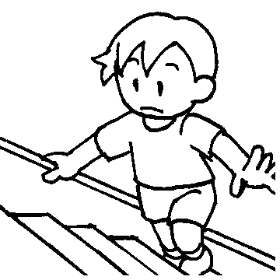 | He can c the s .
4 | 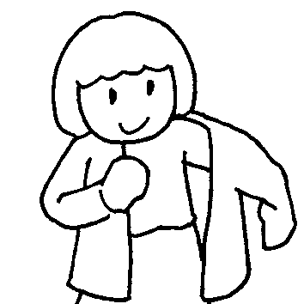 | Amy can g d by herself.
5 | 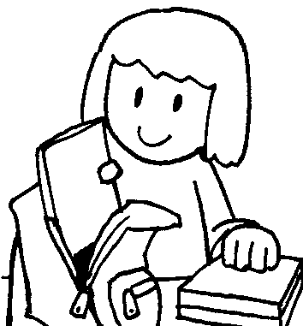 | She can p her s b .
6 | 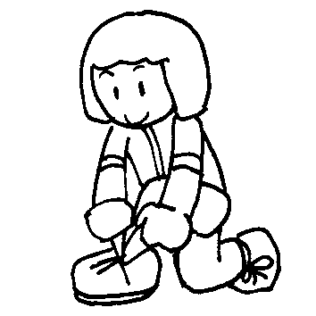 | She can t her s .
7 | 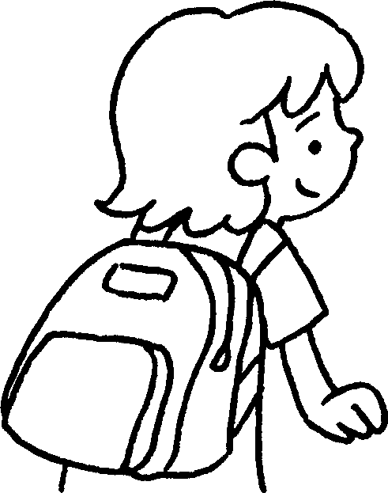 | Cindy can c her s b .


Book 4A Chapter 6 Graded Worksheets
Worksheet 1⬇⬇
- do up
- comb hair
- climb stairs
- get dressed
- pack school bag
- tie shoelaces
- carry school bag

