What can the children do? Write.

1 | 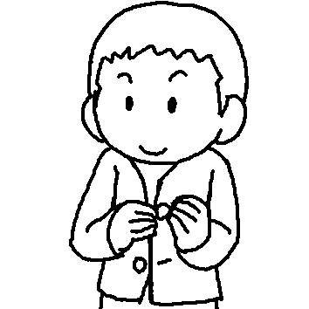 | Paul can his buttons.
2 | 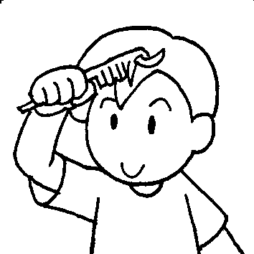 | He can .
3 | 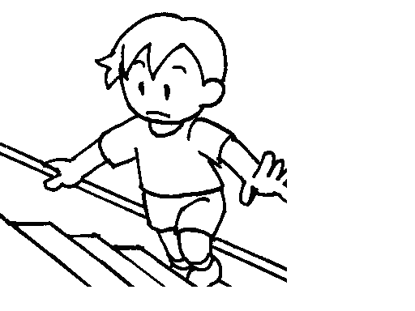 | He can the .
4 | 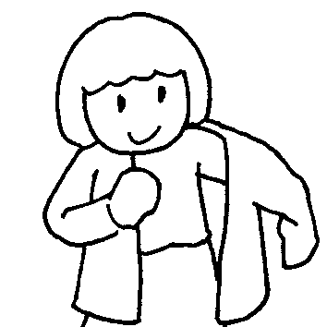 | Amy can get by herself.
5 | 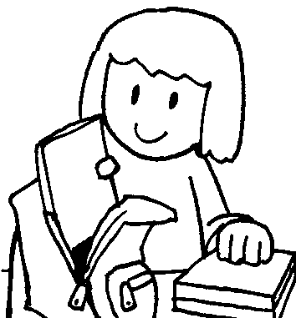 | She can her .
6 | 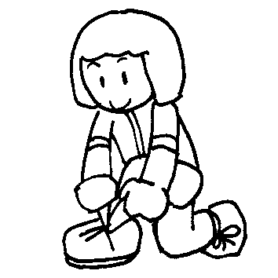 | She can .
7 | 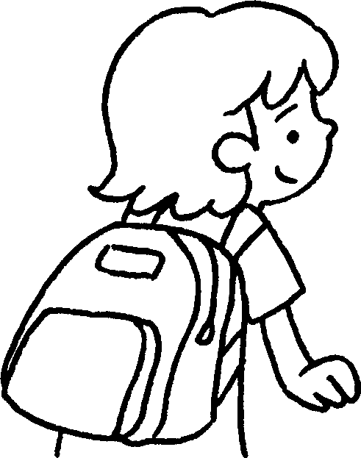 | Cindy can .


Book 4A Chapter 6 Graded Worksheets
Worksheet 1⬇⬇⬇
- do up
- comb his hair
- climb stairs
- dressed
- pack school bag
- tie her shoelaces
- carry her school bag

