Choose and write.

could |  | couldn’t |  | when

1 | 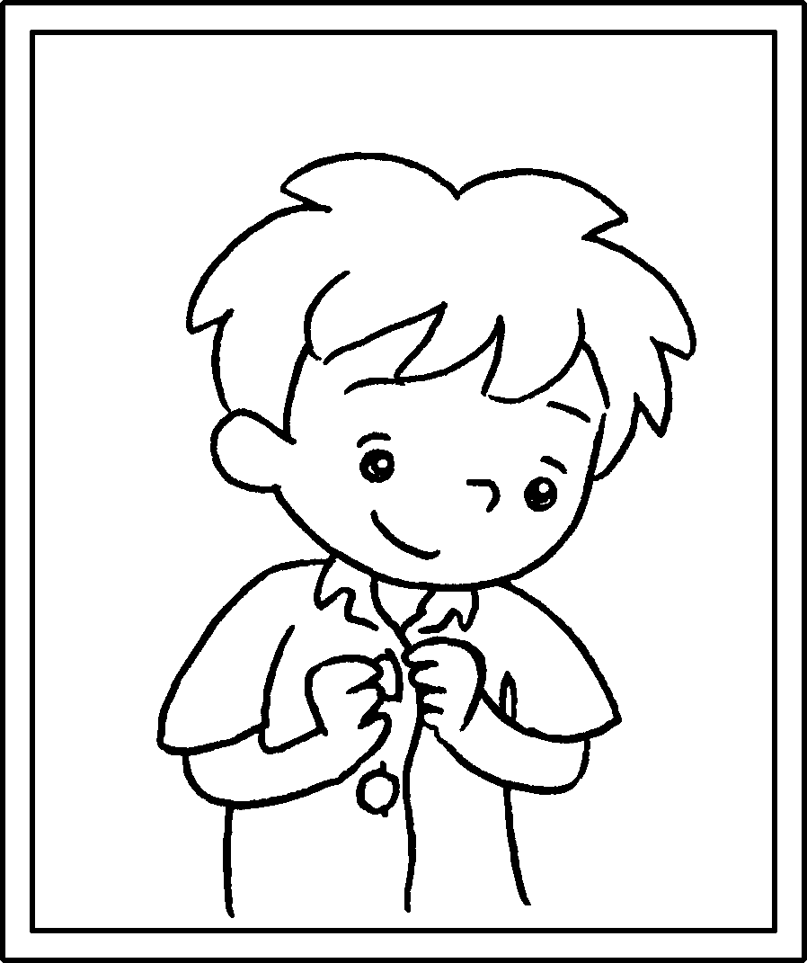 |  | I do up my buttons when I was six.
2 | 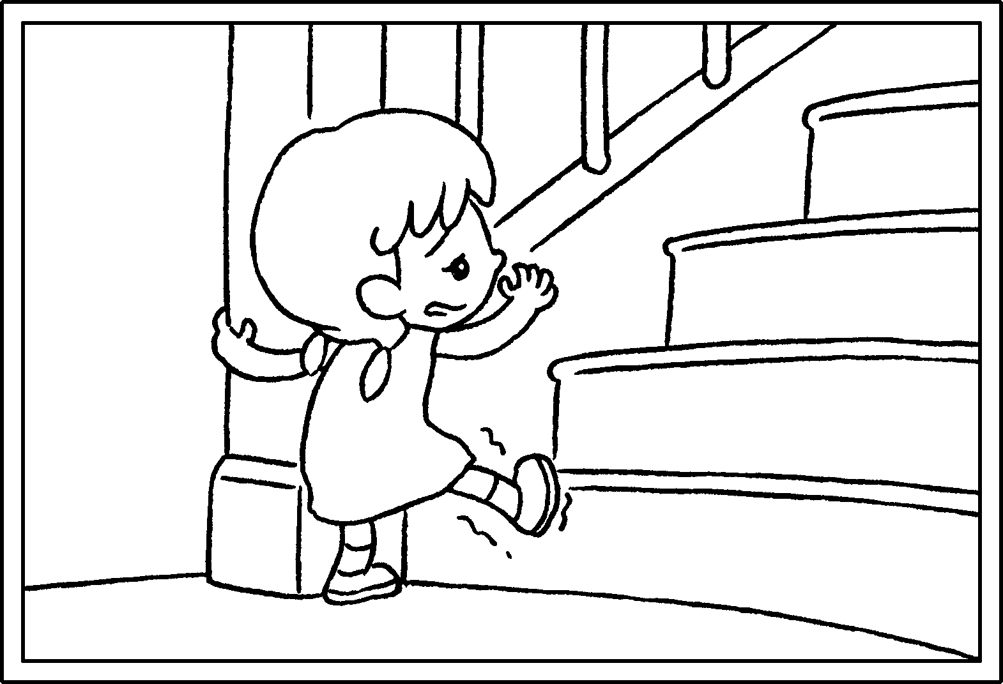 |  | I climb the stairs when  I was two.
3 | 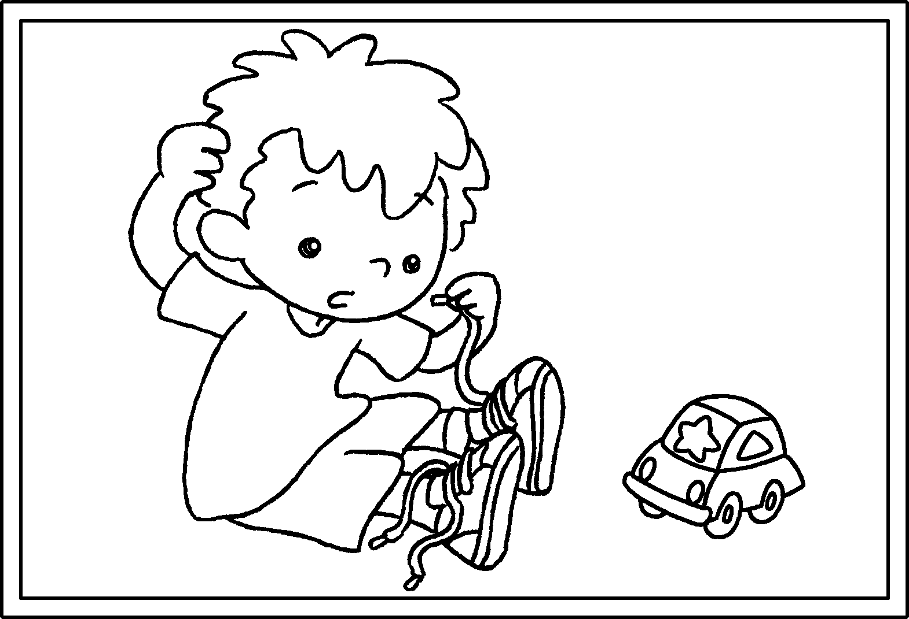 |  | I tie my shoelaces  I was three.
4 | 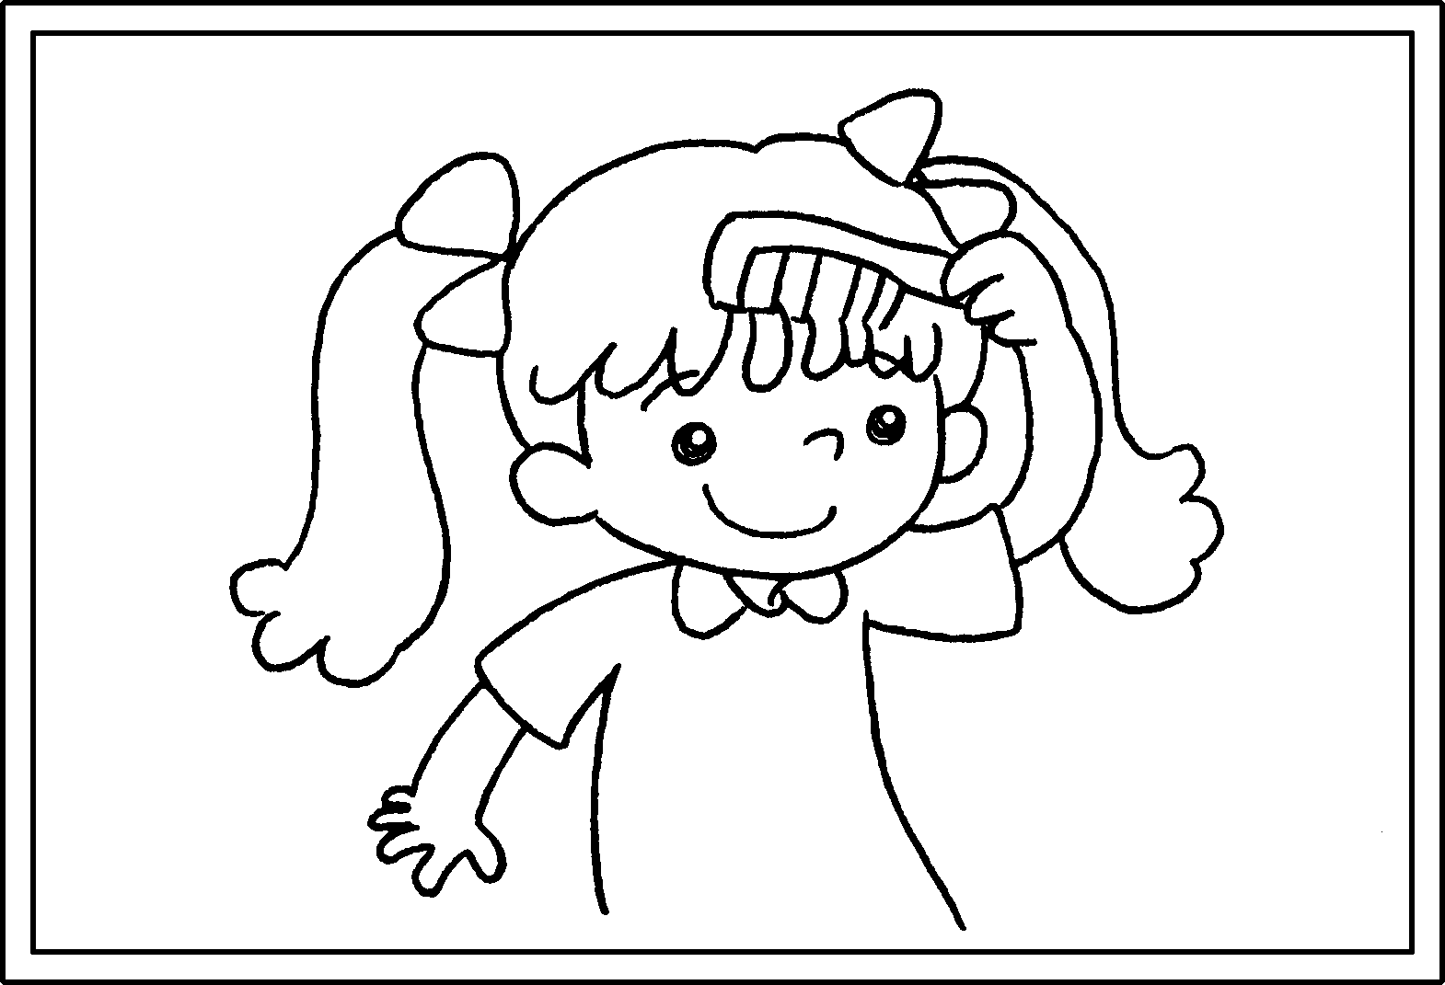 |  | I comb my hair  I was five.
5 | 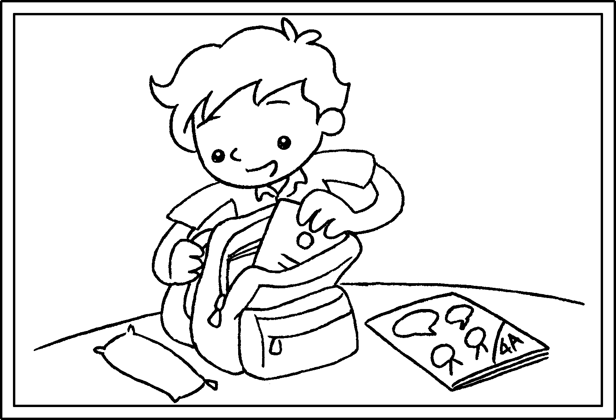 |  | I pack my school bag  I was six.


Book 4A Chapter 6 Graded Worksheets
Worksheet 2⬇
- could
- couldn’t
- couldn’t when
- could when
- could when

