What could / couldn’t they do when they were young? Write.

1 | 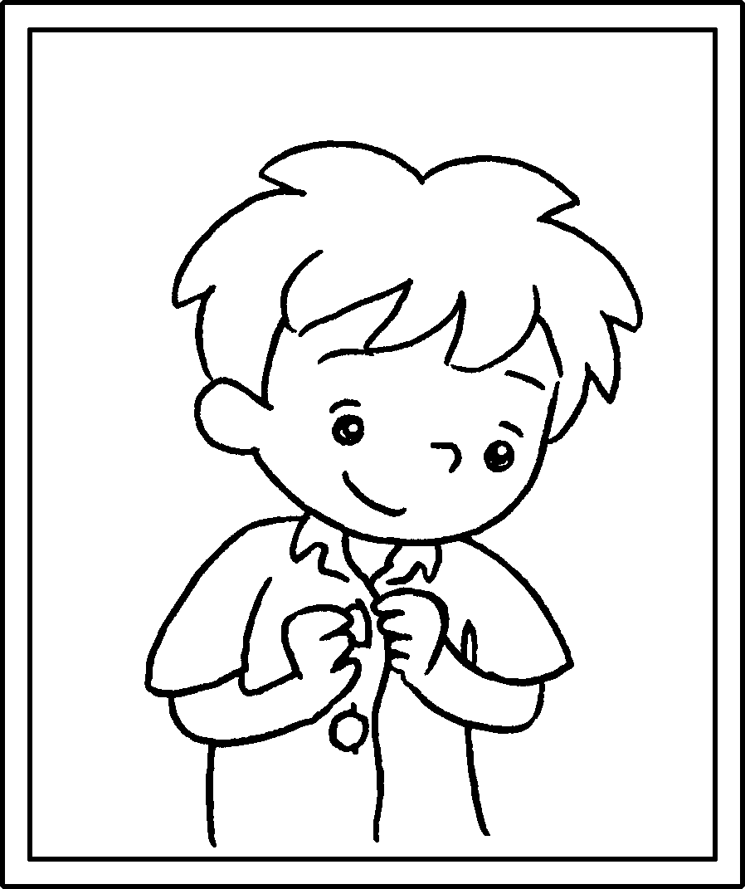 |  | I  could  my buttons when I was six.
2 | 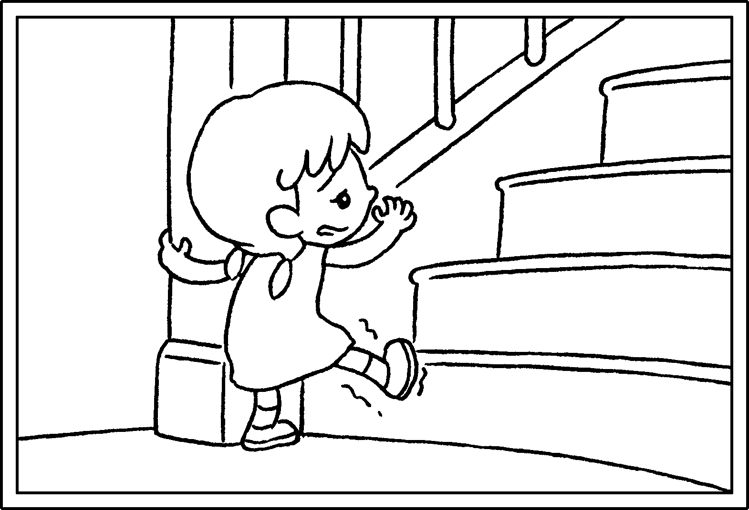 |  | I  the stairs when I was two.
3 | 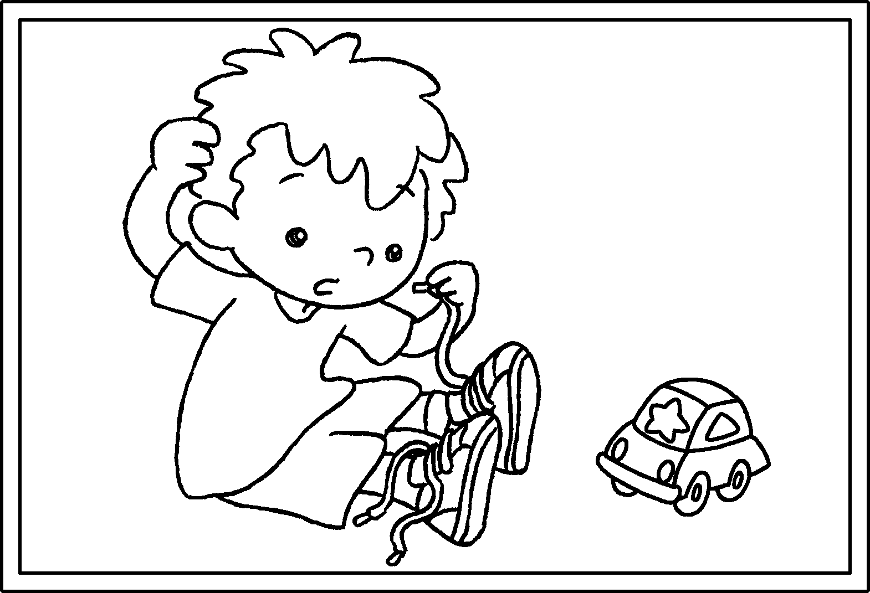 |  | I my shoelaces I was three.
4 | 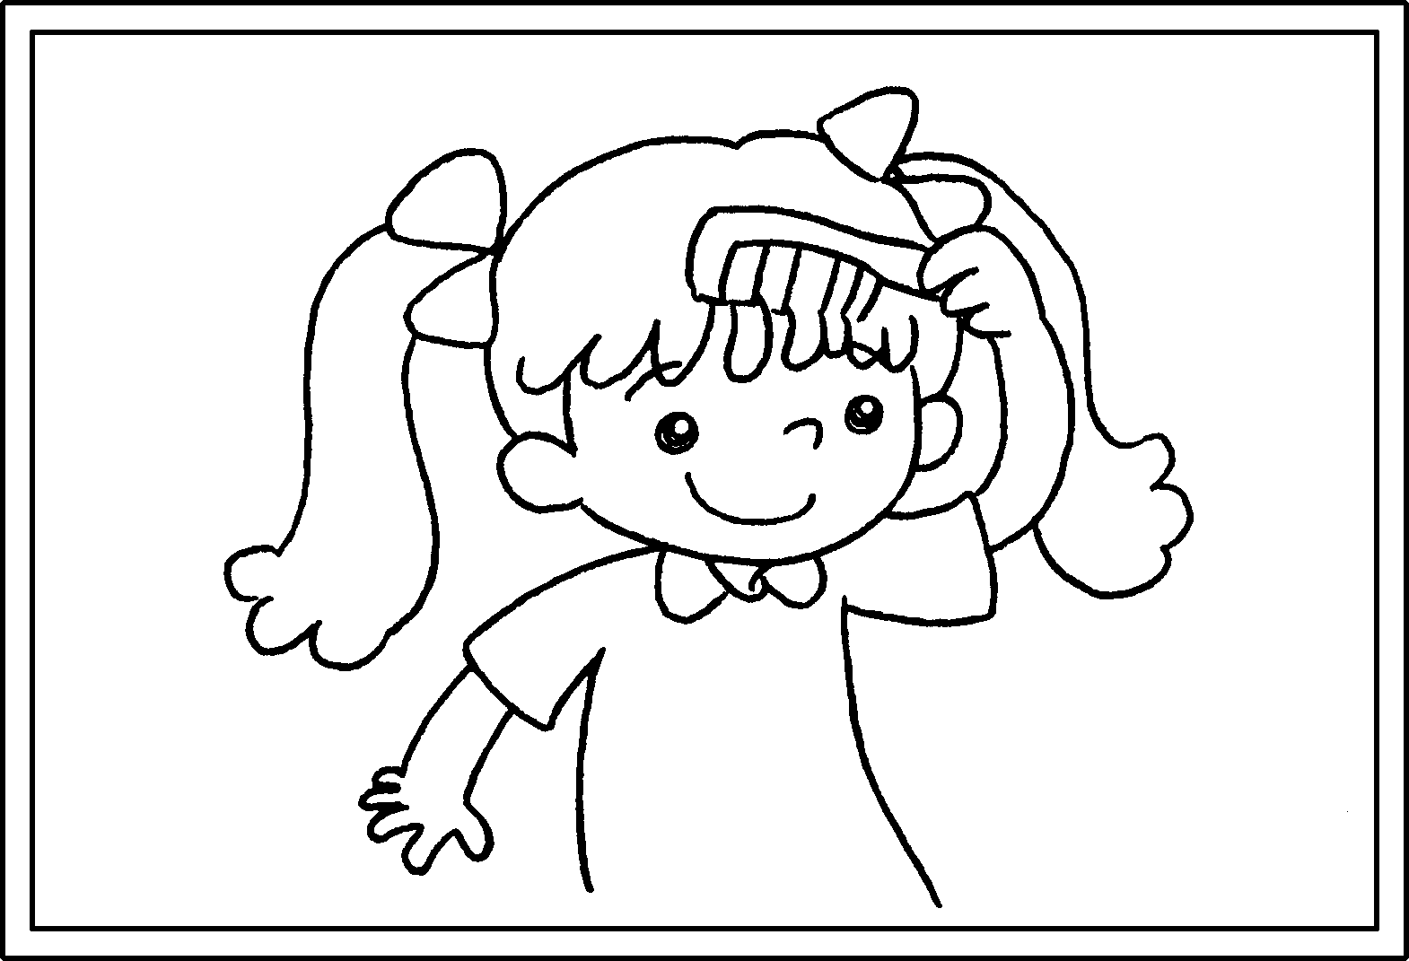 |  | I  I was five.
5 | 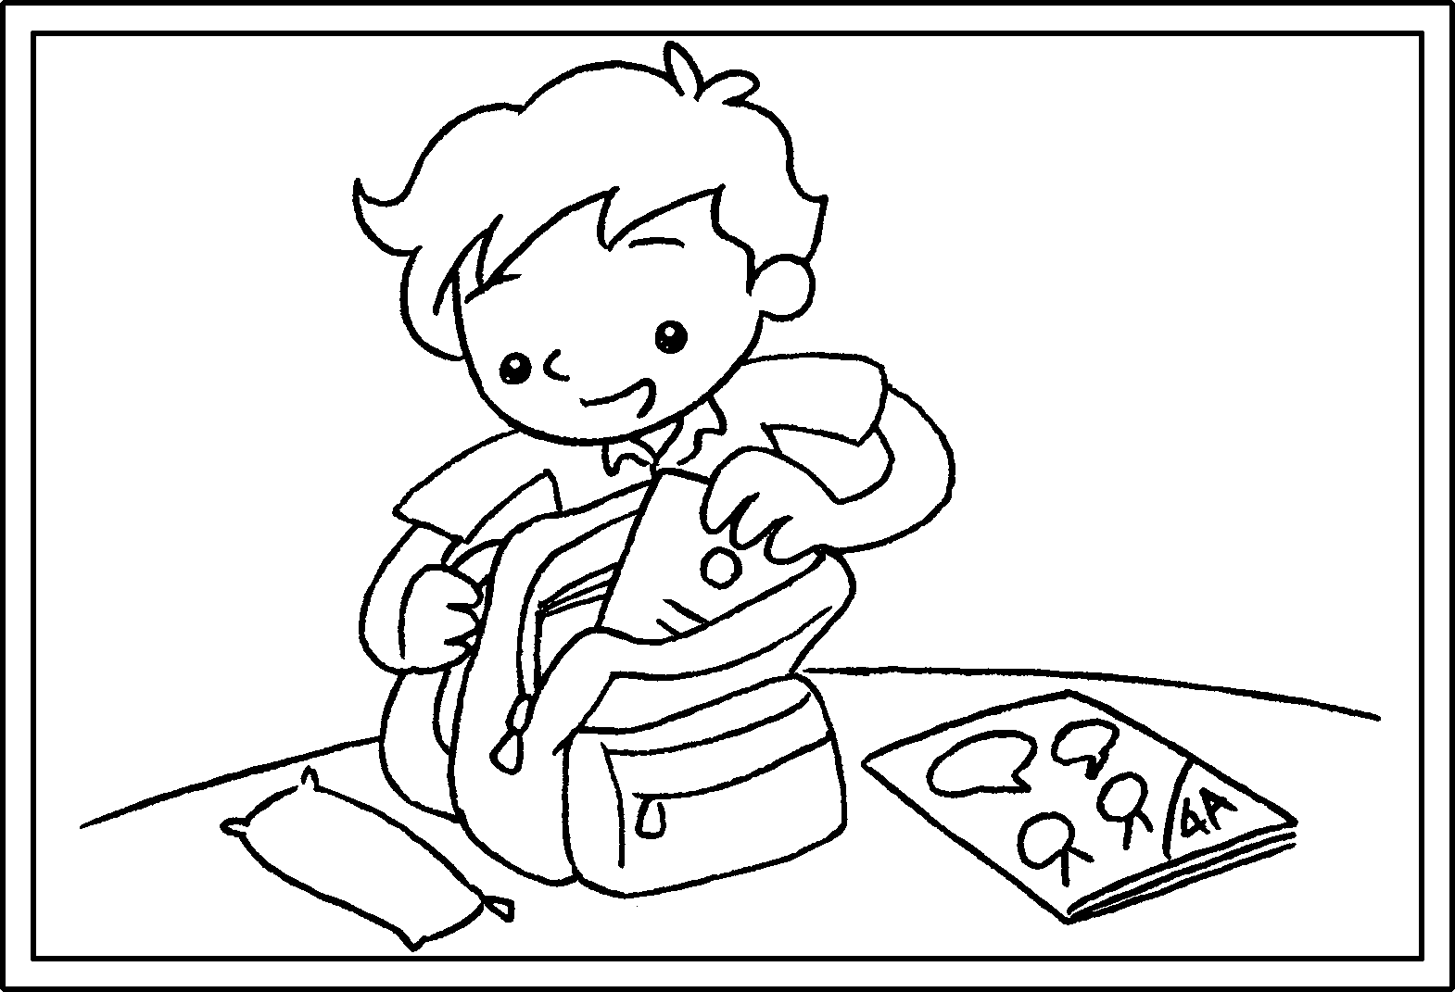 |  | I  I was six.


Book 4A Chapter 6 Graded Worksheets
Worksheet 2⬇⬇⬇
- do up
- couldn’t climb
- couldn’t tie when
- could comb my hair when
- could pack my school bag when

