Choose and write.

myself | himself |  | herself |  | yourself
yourselves |  | ourselves |  | themselves
by
1 | 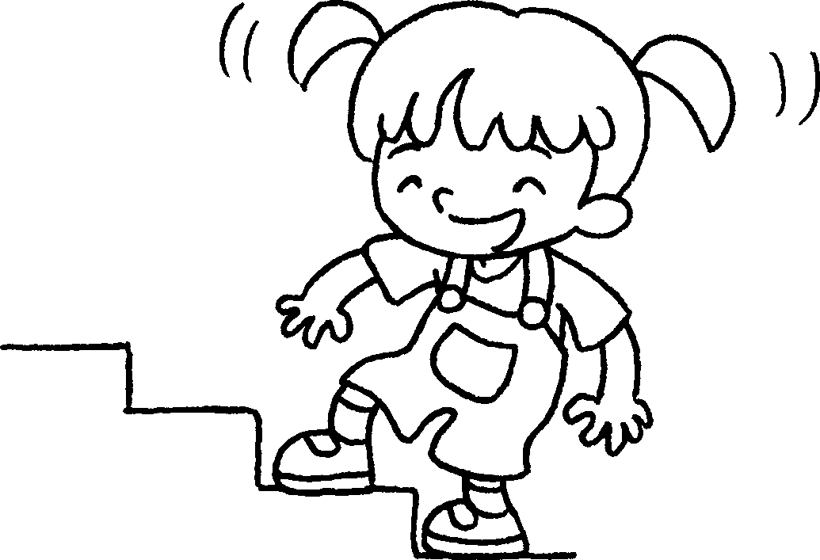 |  | Kitty can climb the stairs by .
2 | 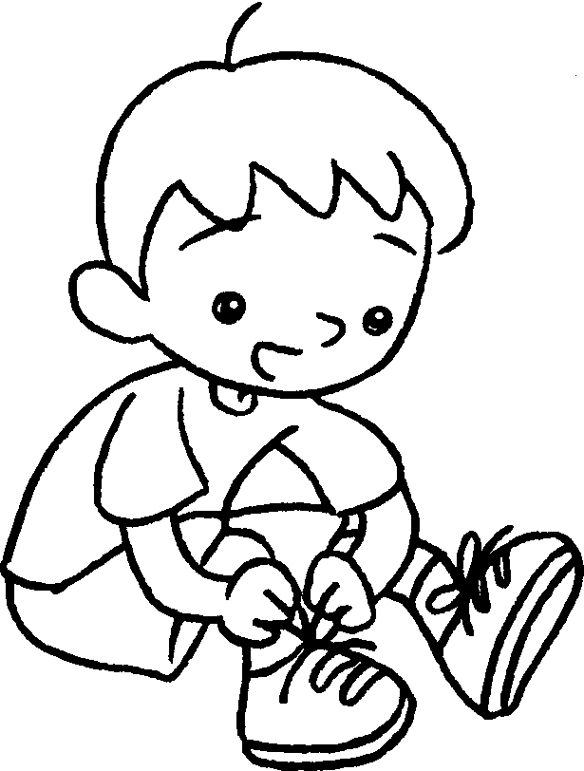 |  | I can tie my shoelaces by .
3 | 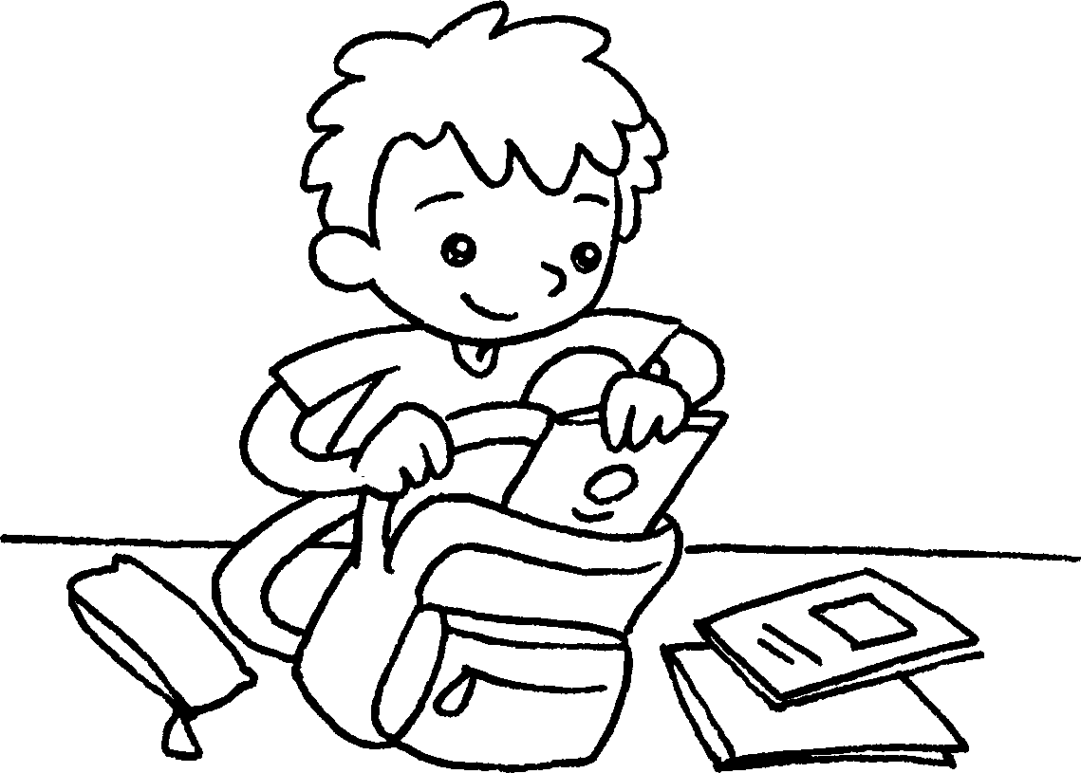 |  | John can pack his school bag by .
4 | 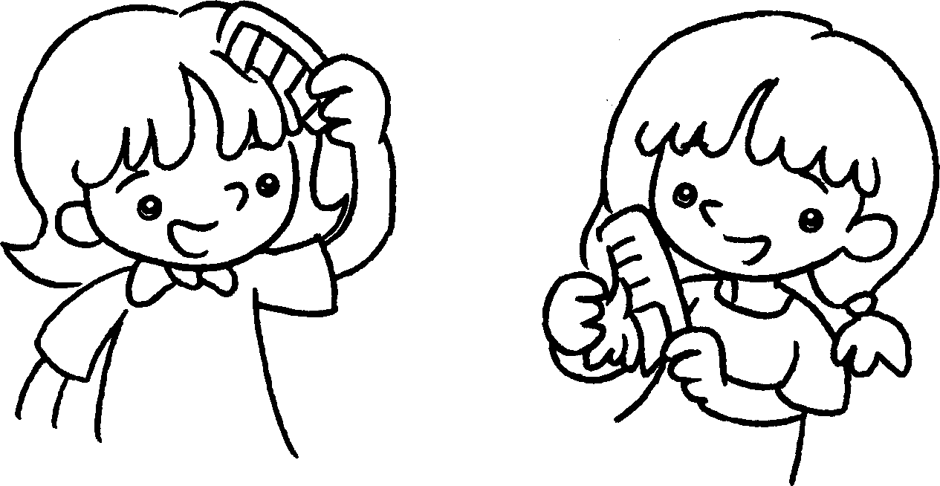 |  | We can comb our hair  .
5 | 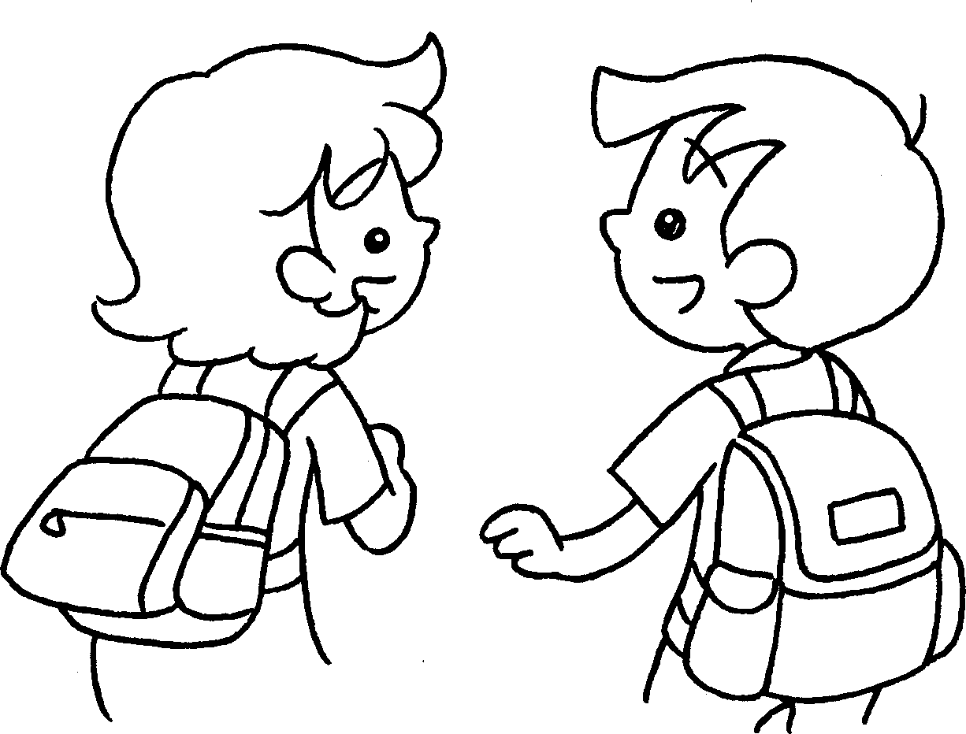 |  | Tina and Sam can carry their school bags .
6 | 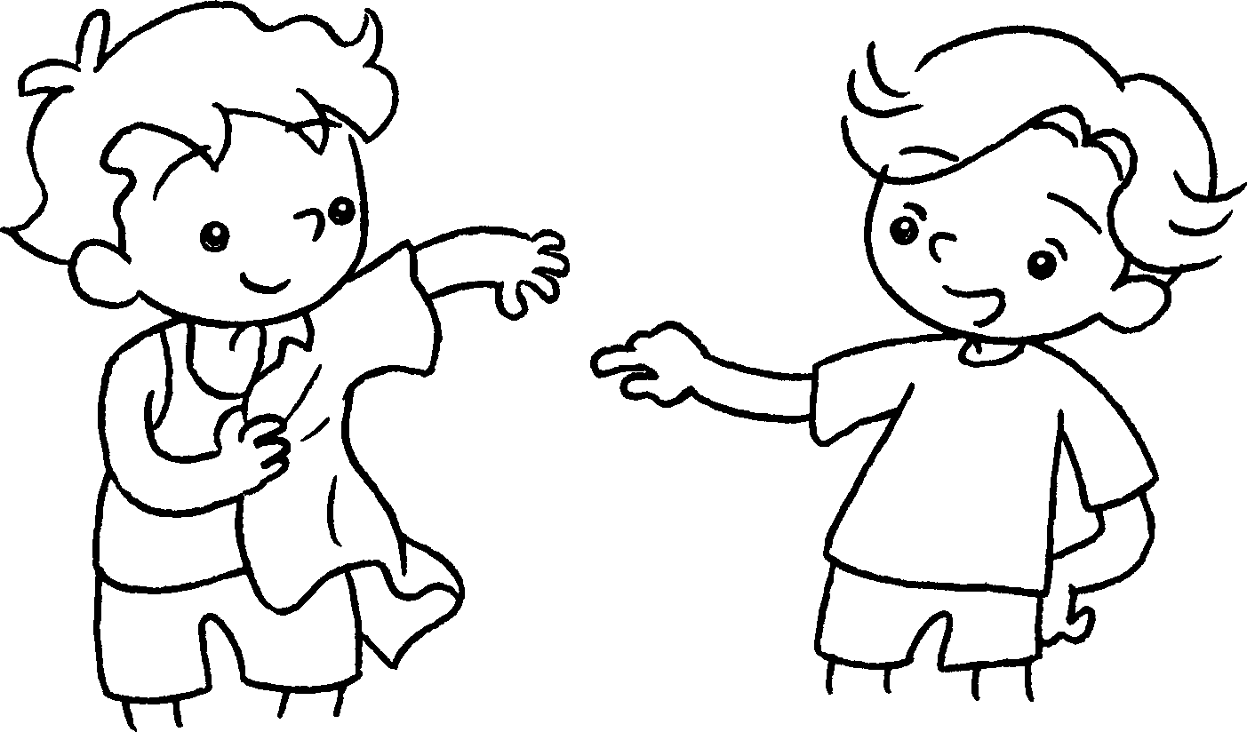 |  | You can get dressed  .
7 | 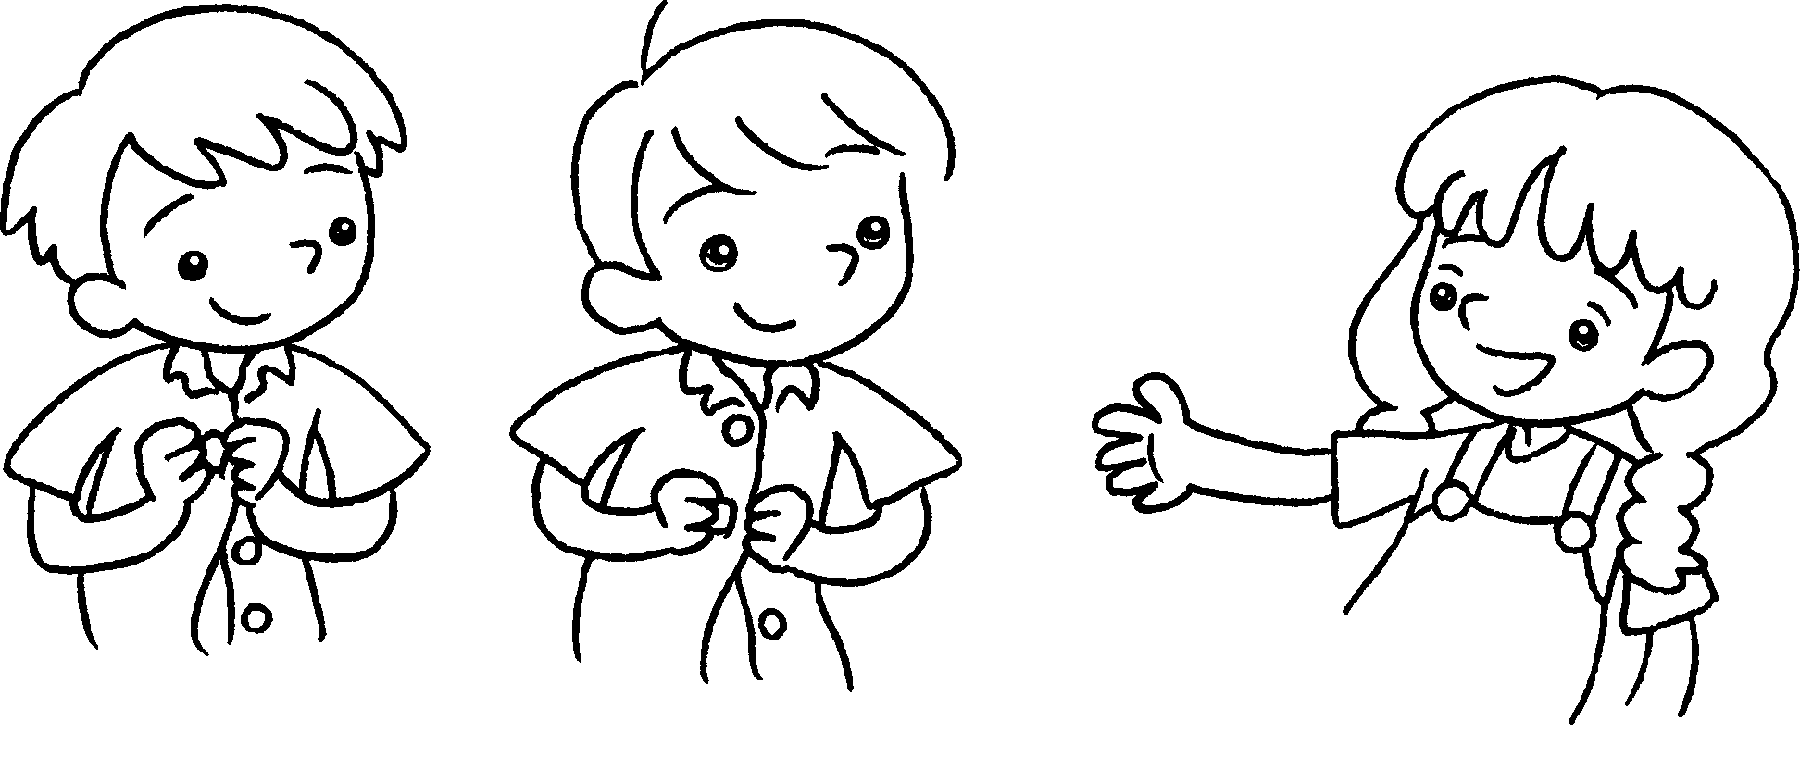 |  | You can do up your buttons  .
…
…
…
…
…


Book 4A Chapter 6 Graded Worksheets
Worksheet 3⬇
- herself
- myself
- himself
- by ourselves
- by themselves
- by yourself
- by yourselves

