What can the children do by themselves? Write.

myself | himself |  | herself |  | yourself
yourselves |  | ourselves |  | themselves
1 | 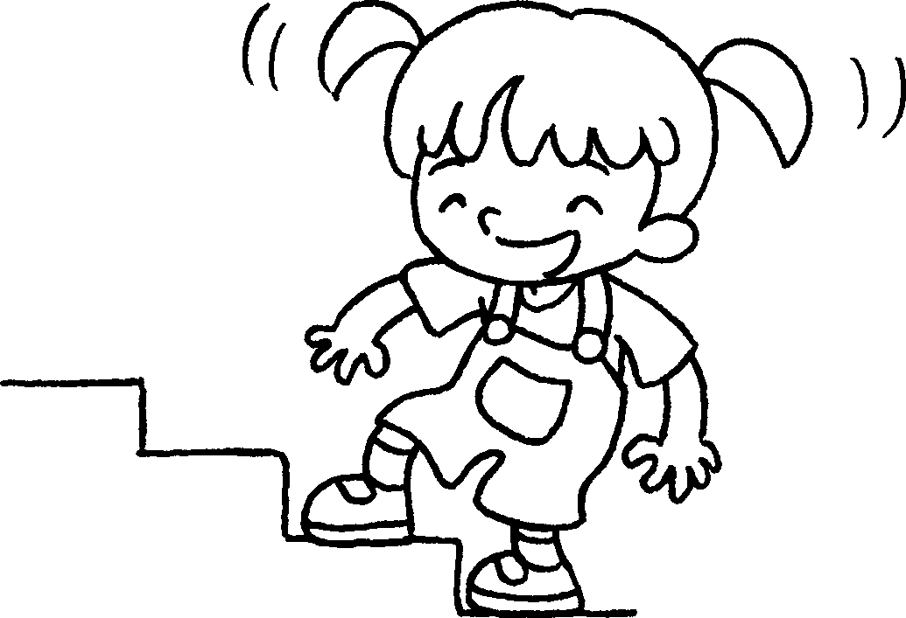 |  | Kitty can climb the stairs by .
2 | 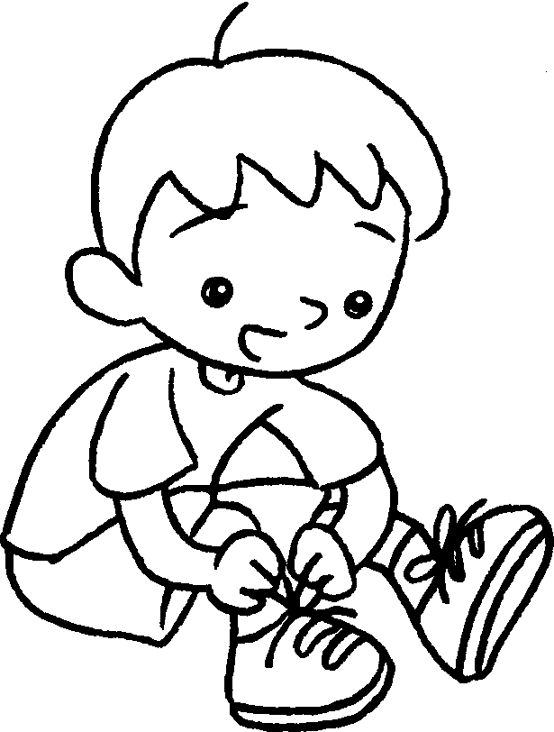  … |  | I can tie my shoelaces by .
3 | 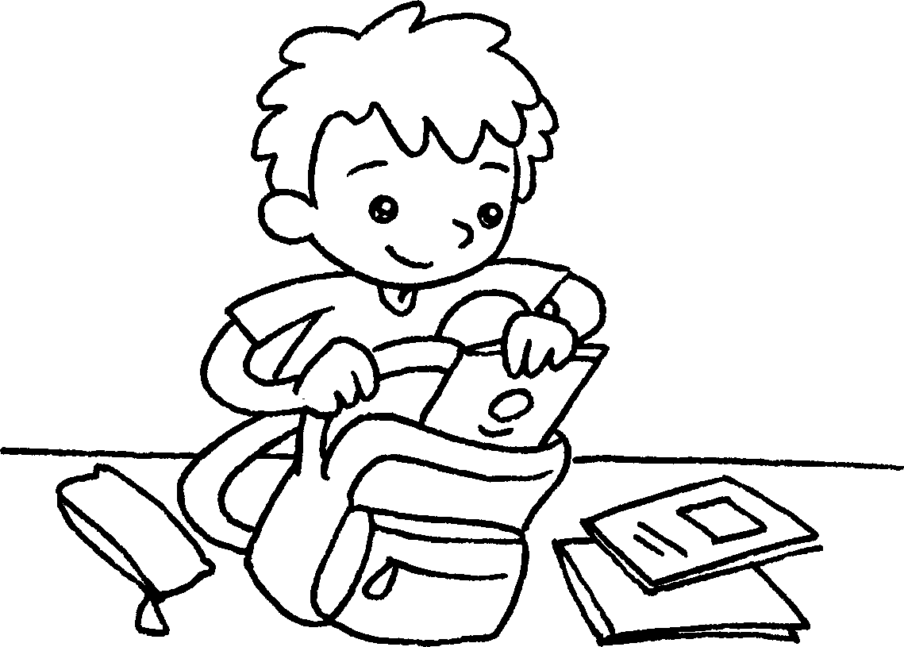 |  | John can his school  bag by .
4 | 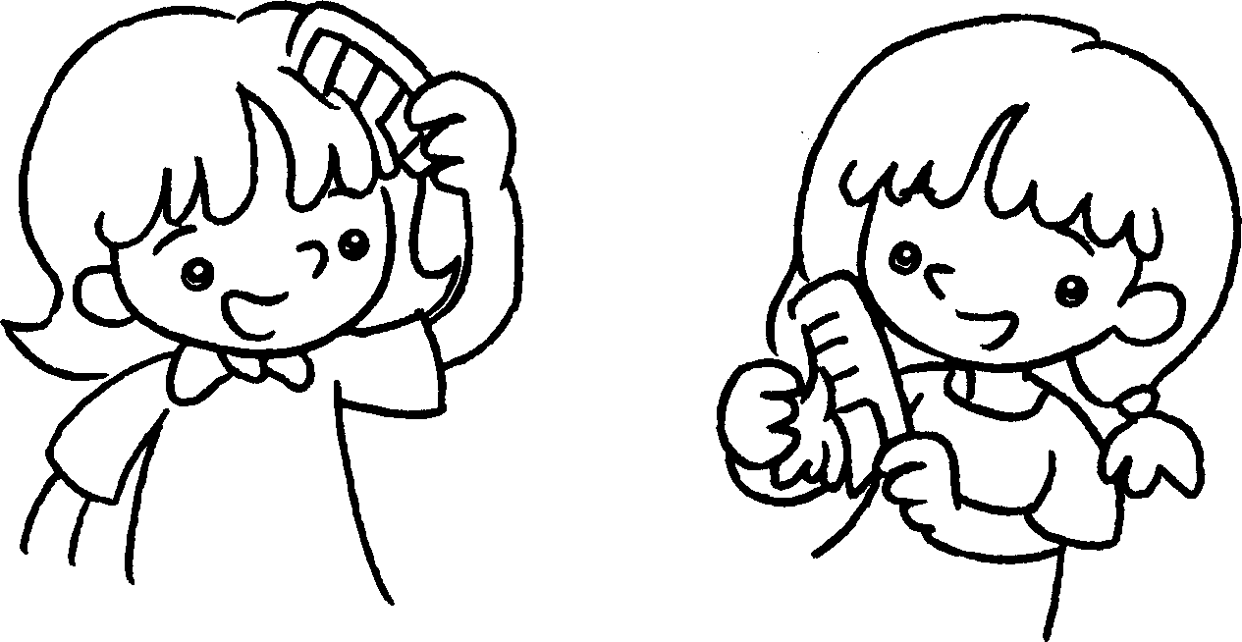  …  … |  | We can our hair  .
5 | 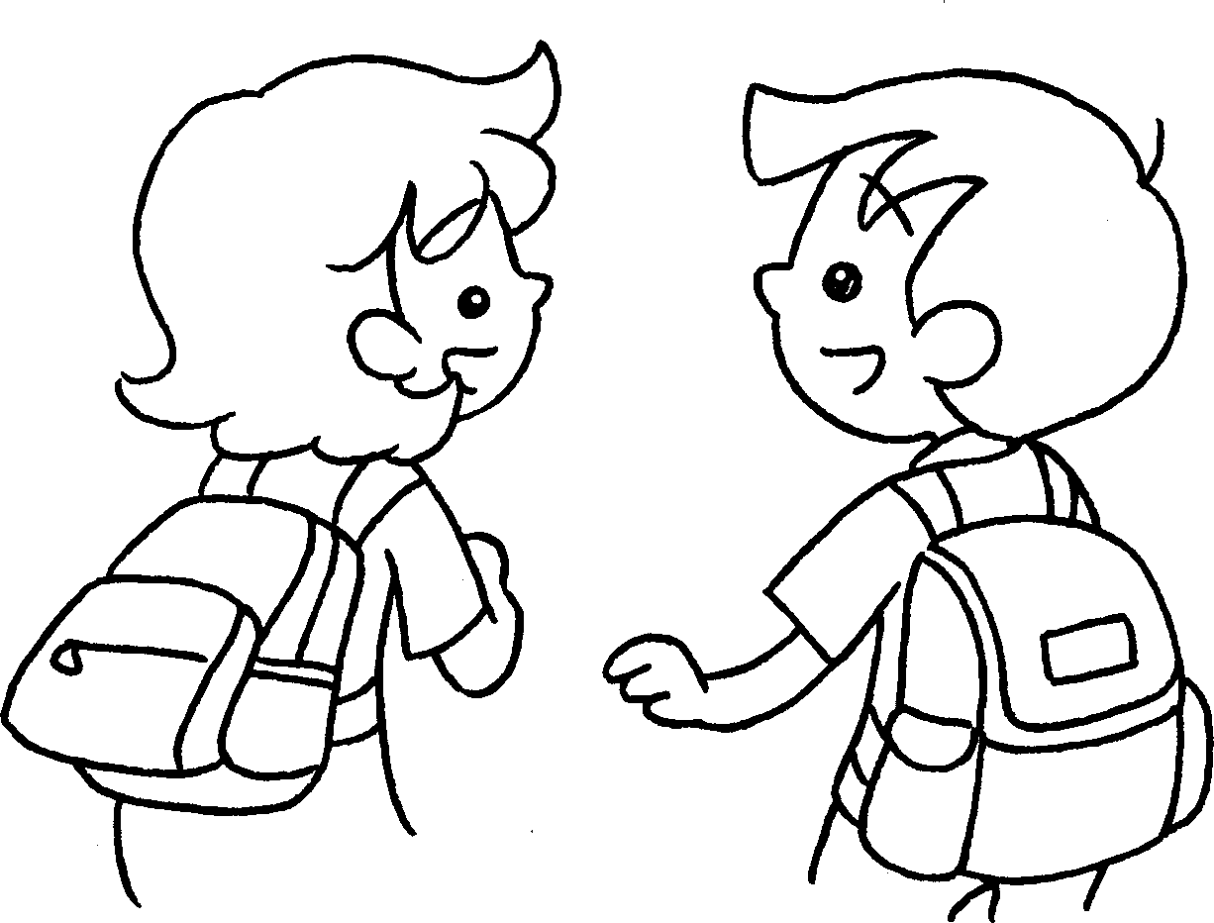 |  | Tina and Sam can their  school bags .
6 | 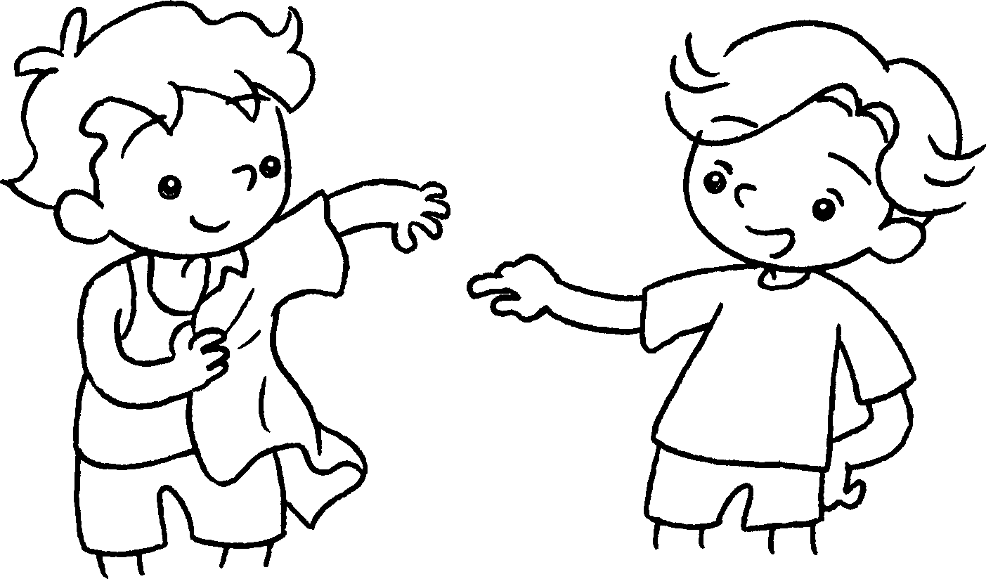  … |  | You can  .
7 | 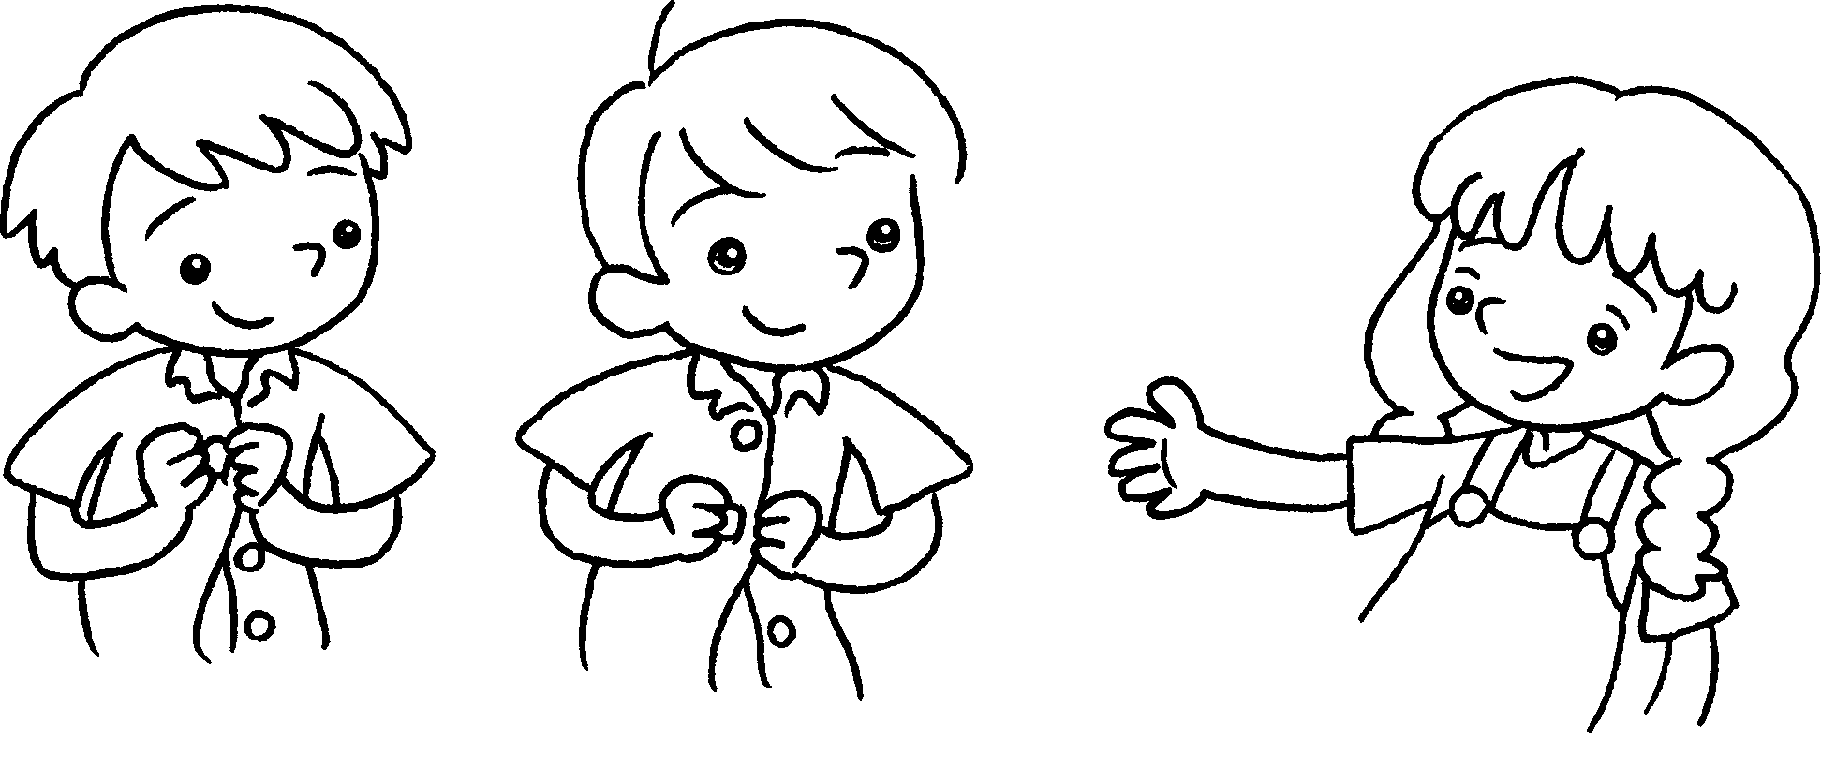  … |  | You can  .


Book 4A Chapter 6 Graded Worksheets
Worksheet 3⬇⬇
- herself
- myself
- pack himself
- comb by ourselves
- carry by themselves
- get dressed by yourself
- do up your buttons by yourselves

