RP no: Century Gothic 15pt
(所有圈號用15pt)
Choose and write.

cartoon |  | cookery programme |  | drama
documentary | game show |  | sports programme
pop music show |  | news and weather report

1  2  3 | 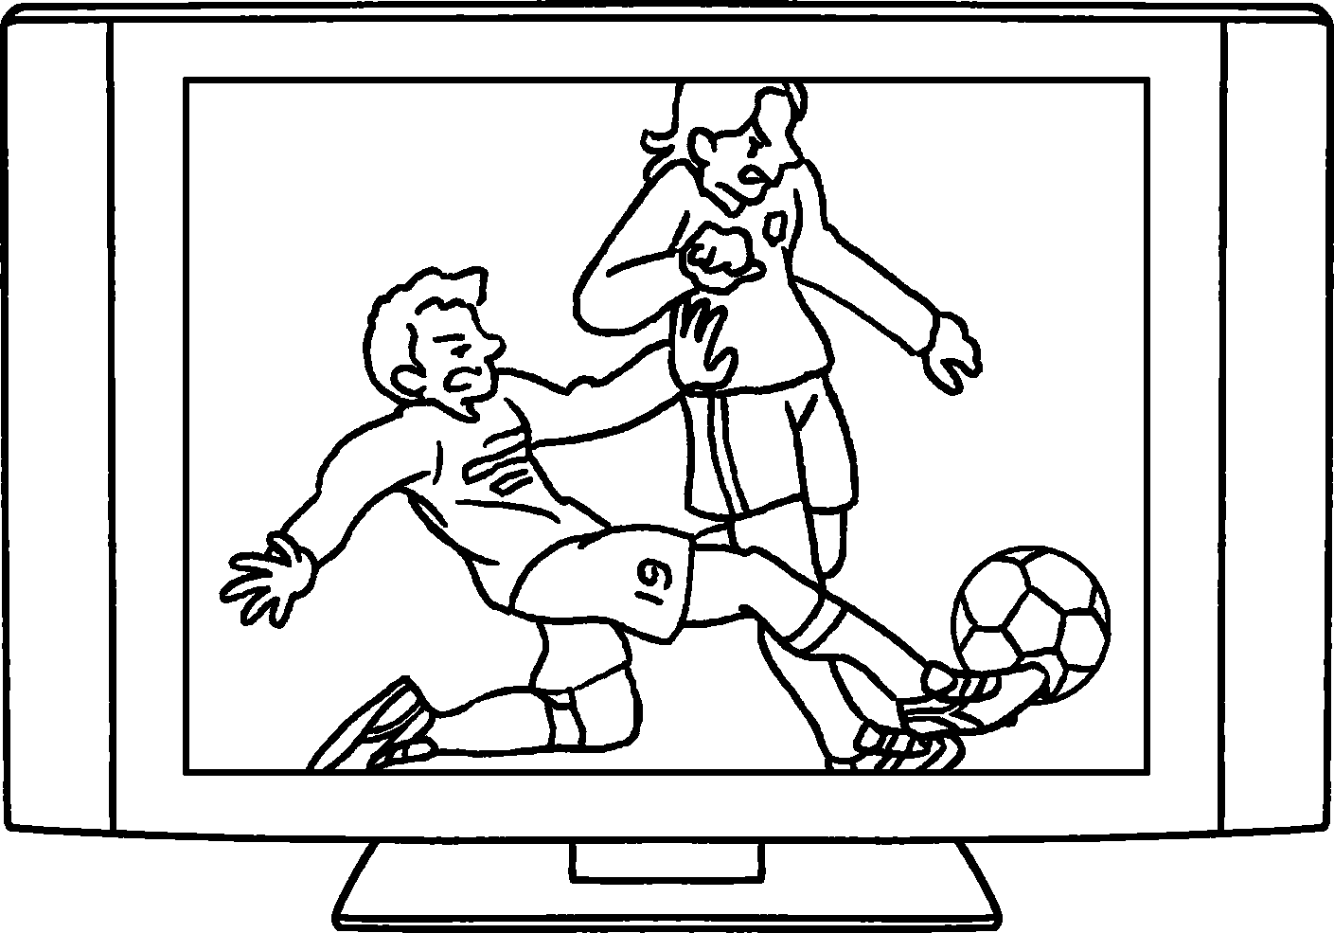 |  | 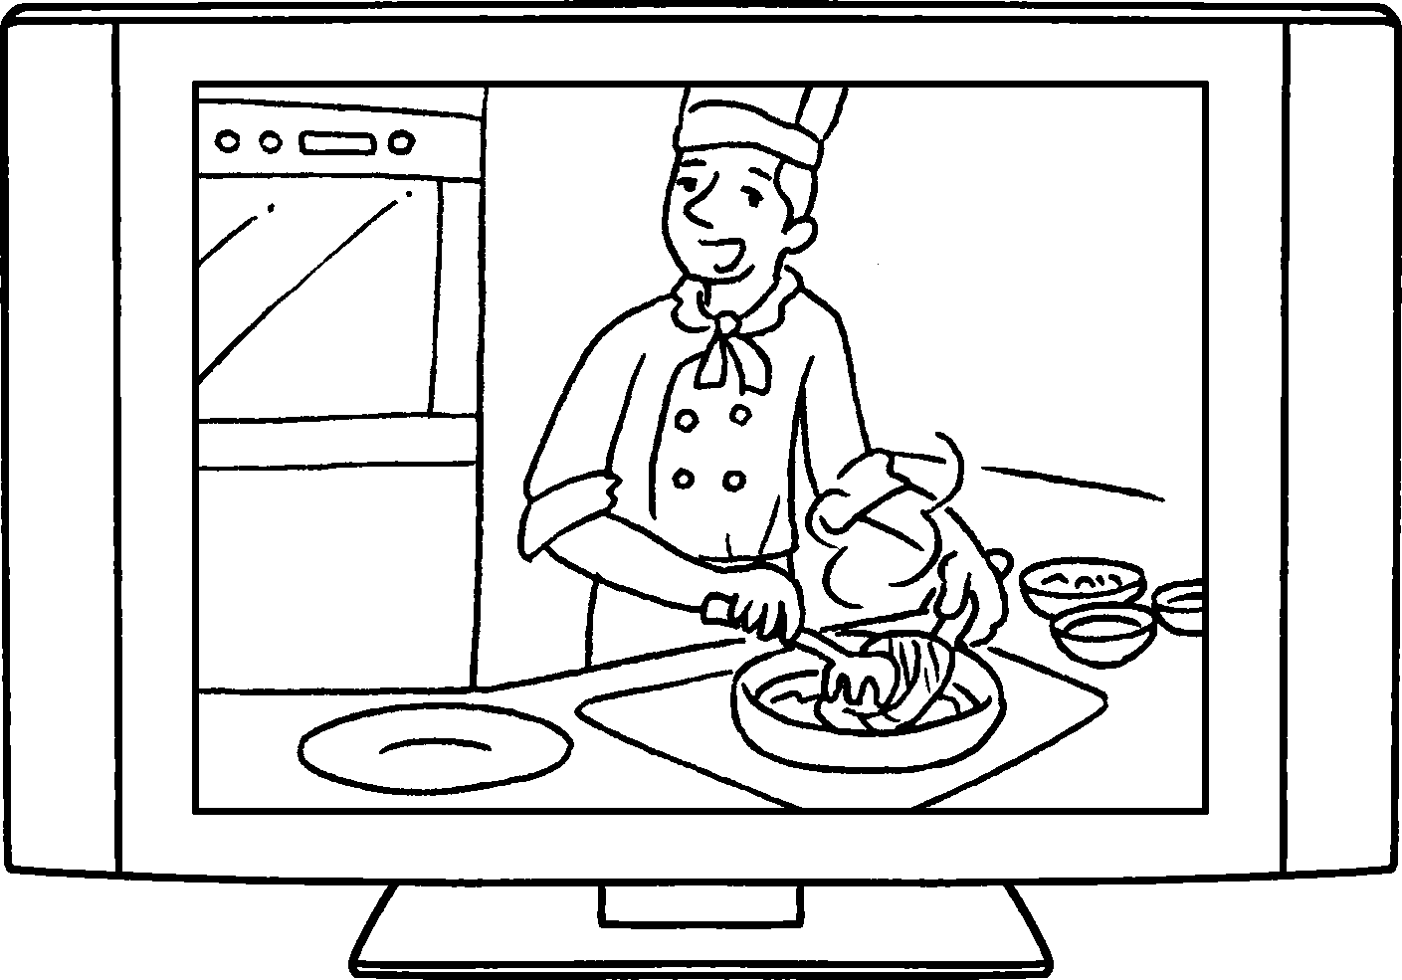 |  |  | 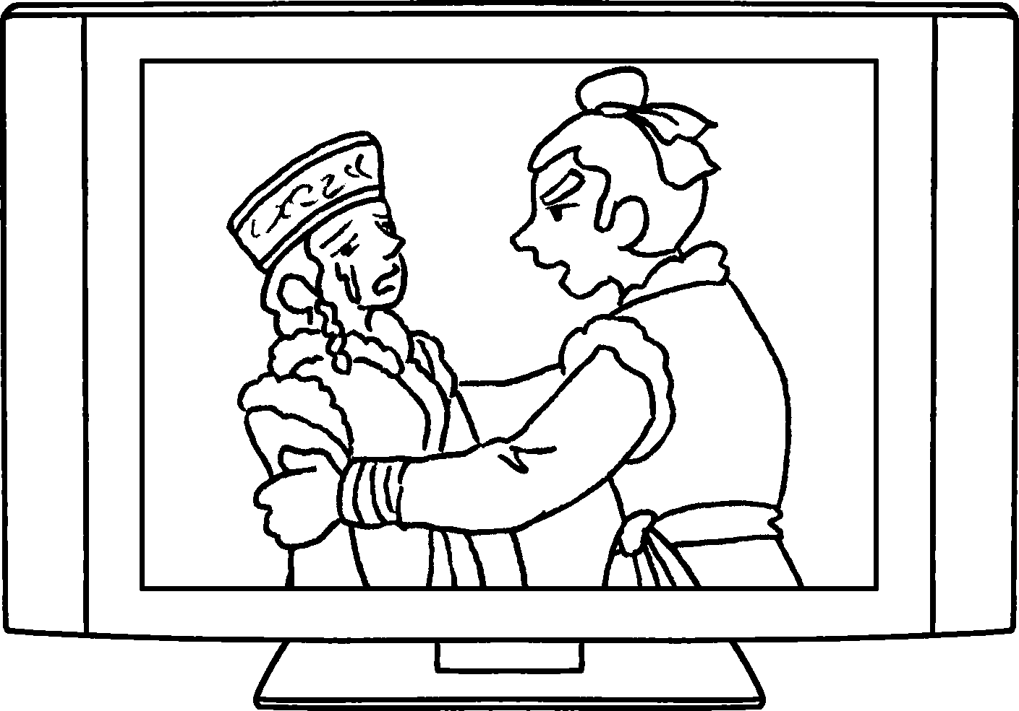
4  5 | 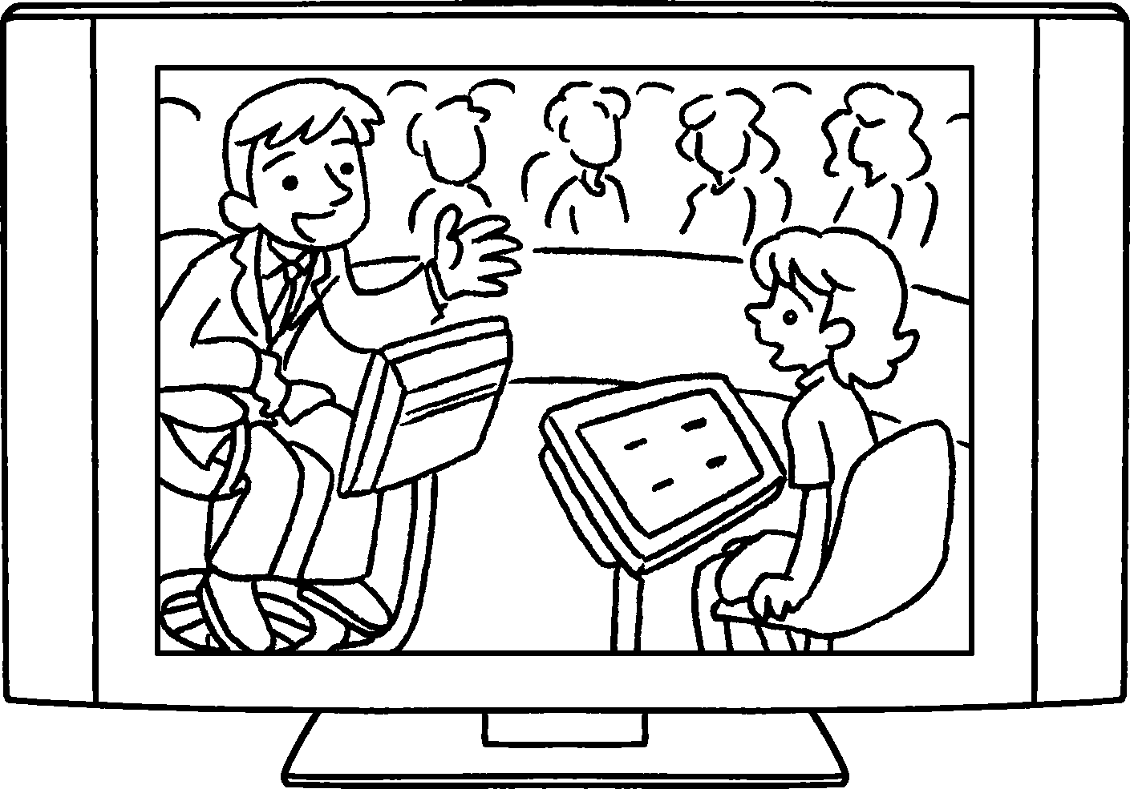 |  |  | 
8  6  7 | 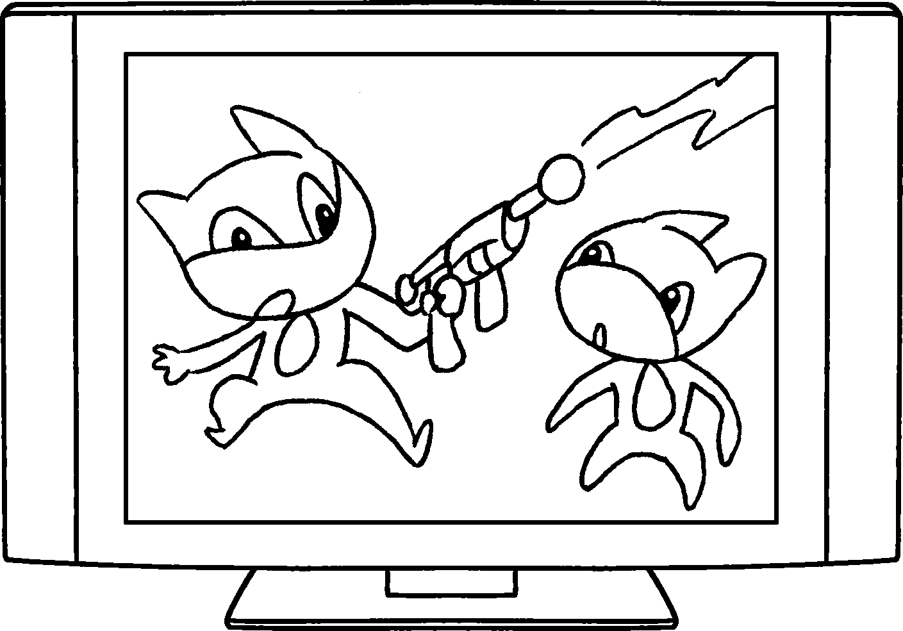 |  | 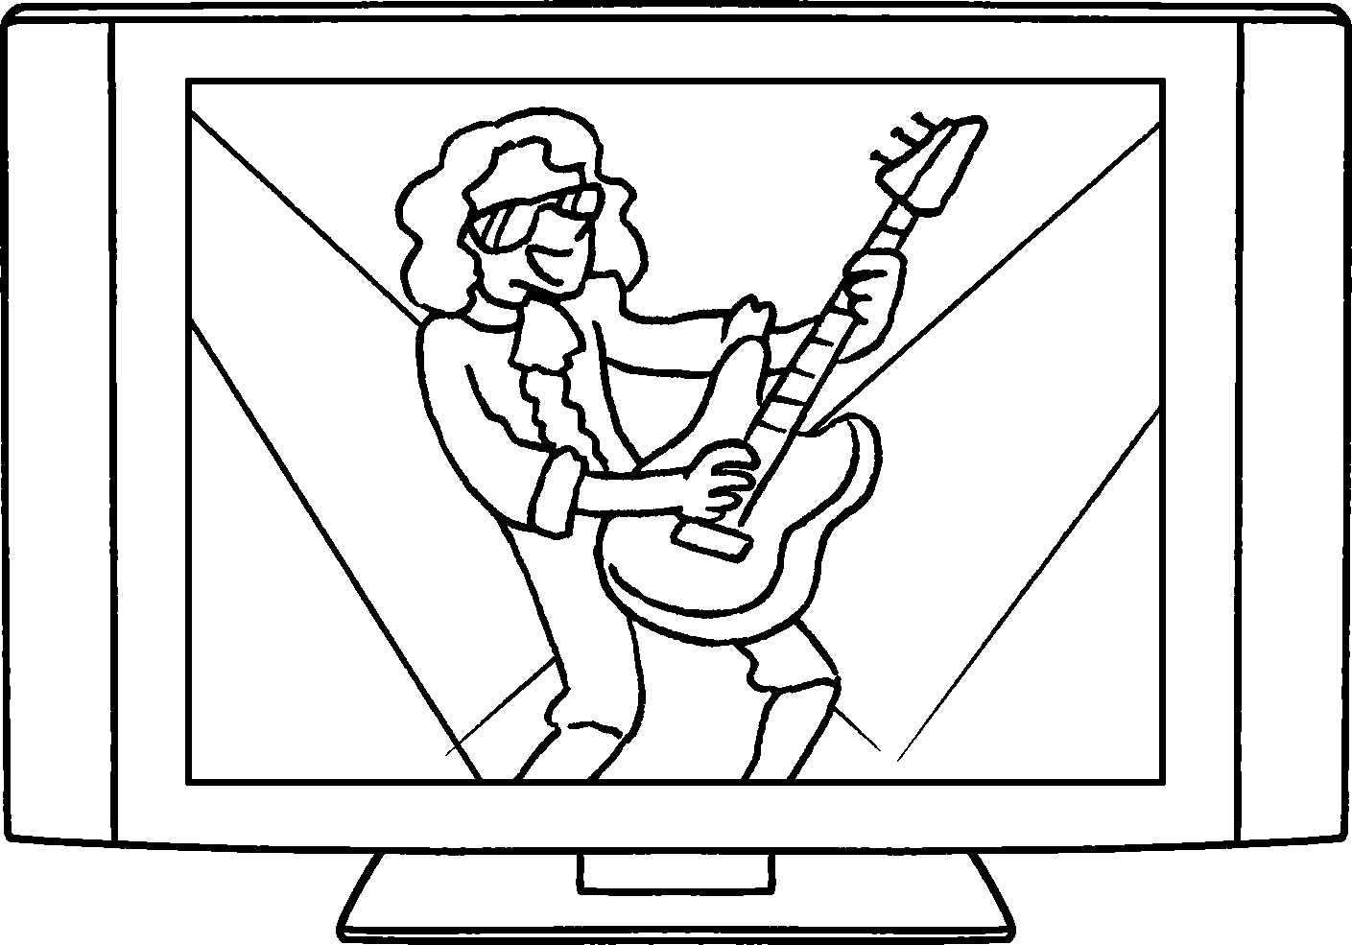 |  |  | 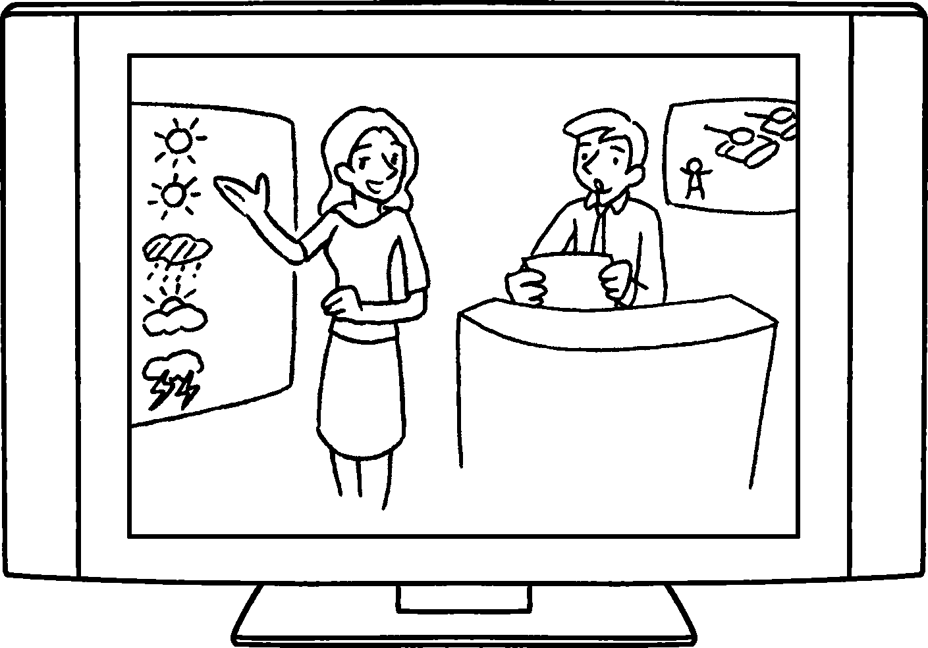

1 | a
2 | a
3 | a
4 | a
5 | a
6 | a
7 | a
8 | the

RP no: Century Gothic 15pt
(所有圈號用15pt)


Book 4A Chapter 7 Graded Worksheets
Worksheet 1⬇
- sports programme
- cookery programme
- drama
- game show
- documentary
- cartoon
- pop music show
- news and weather report

