RP no: Century Gothic 15pt
(所有圈號用15pt)
What kinds of programmes are they? Write.

1  2  3 | 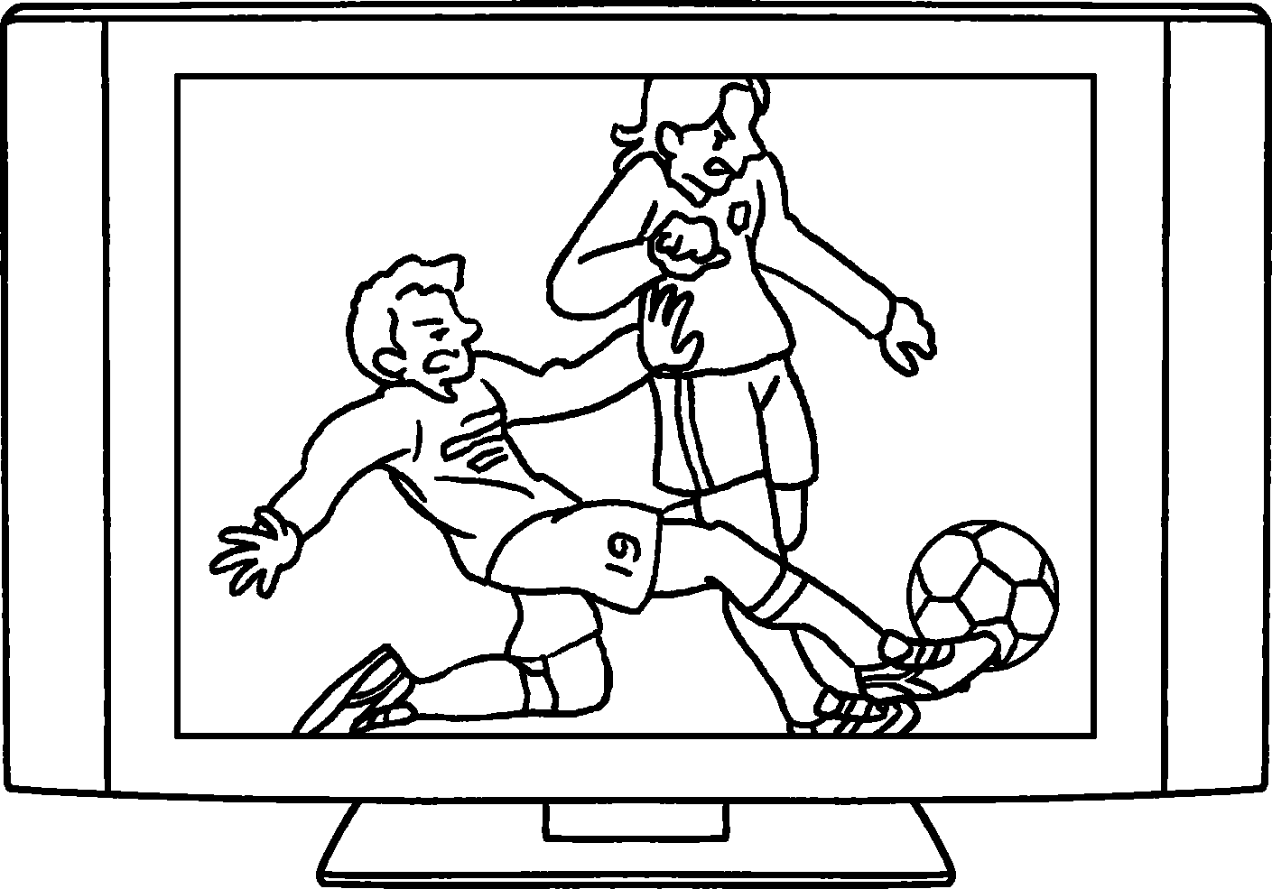 |  | 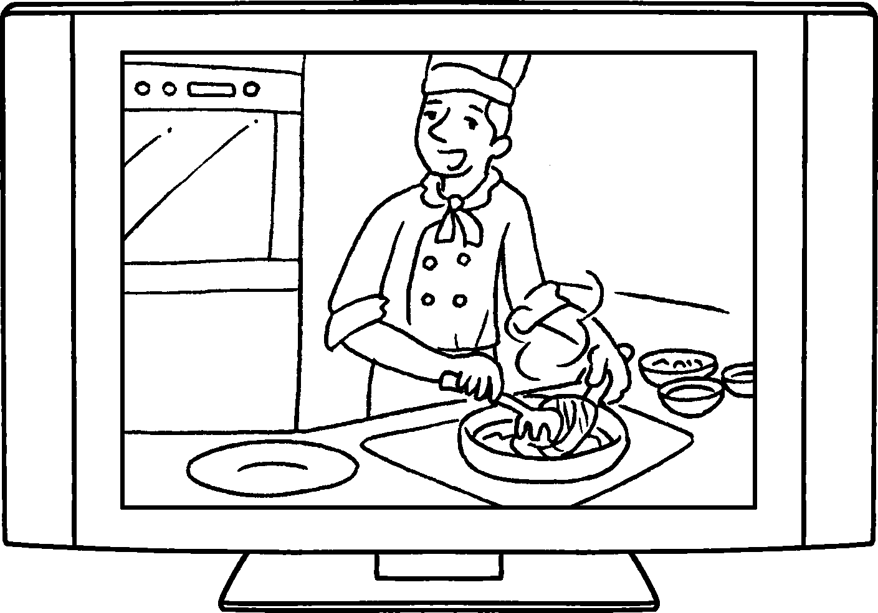 |  |  | 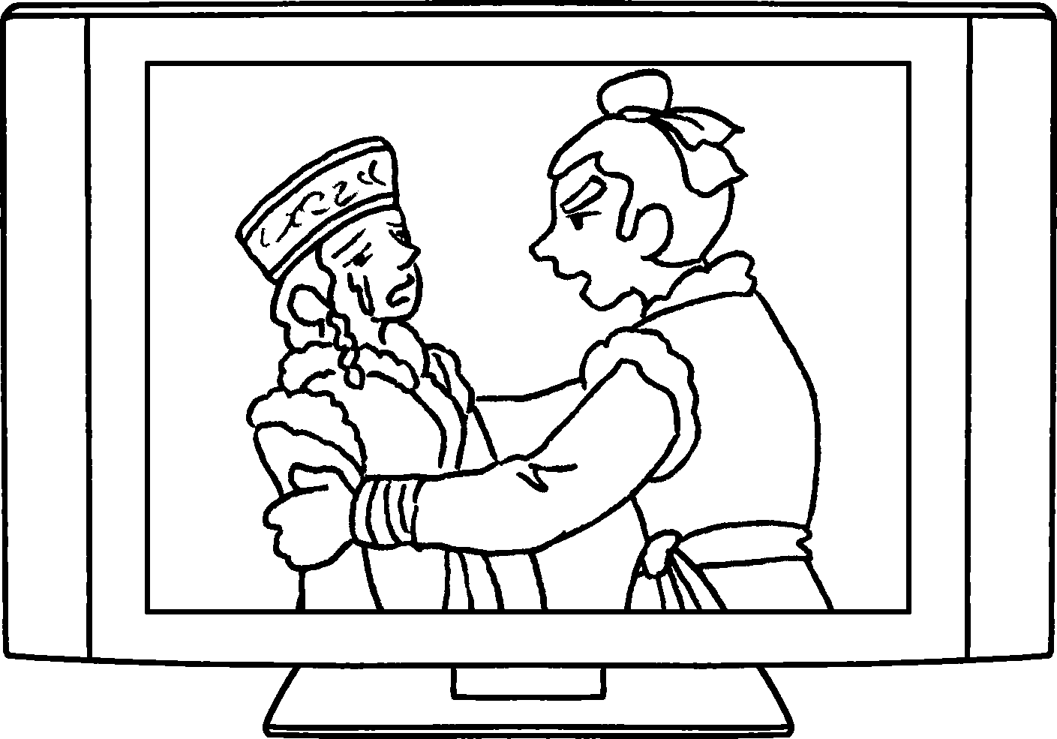
4  5 | 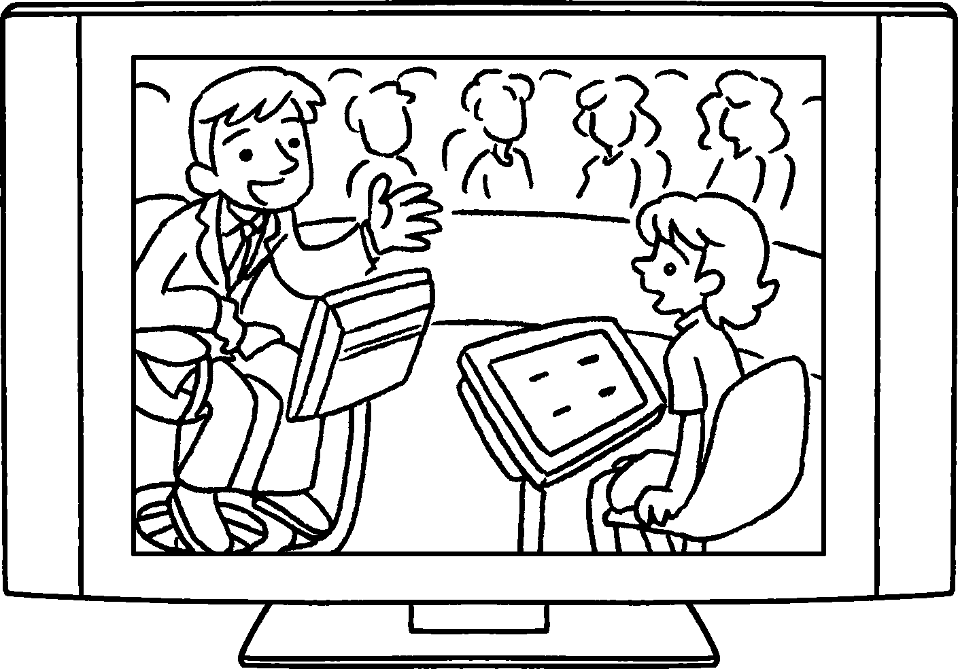 |  |  | 
8  6  7 | 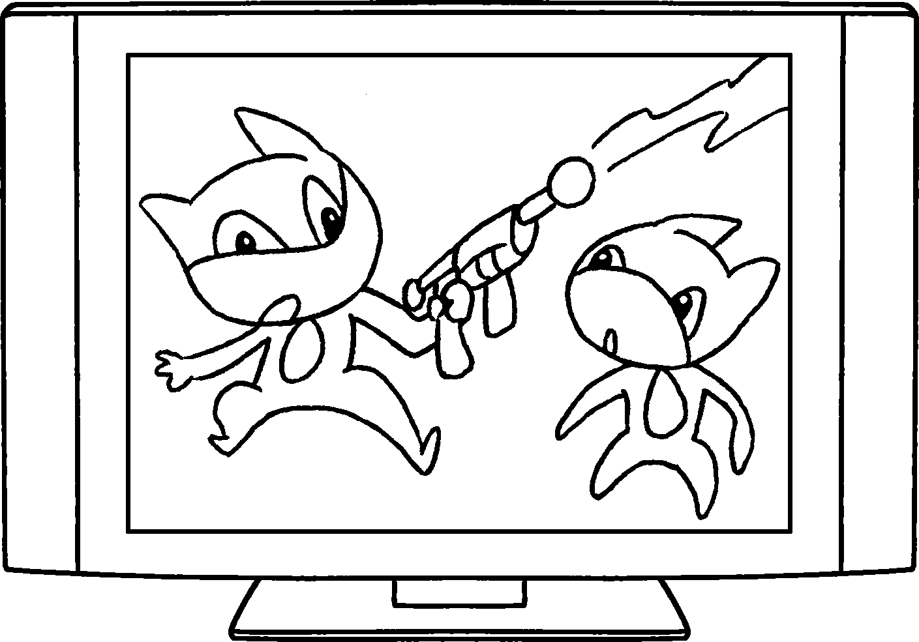 |  | 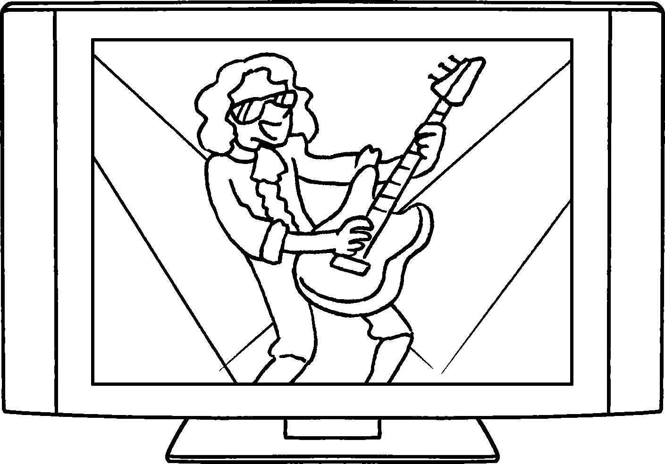 |  |  | 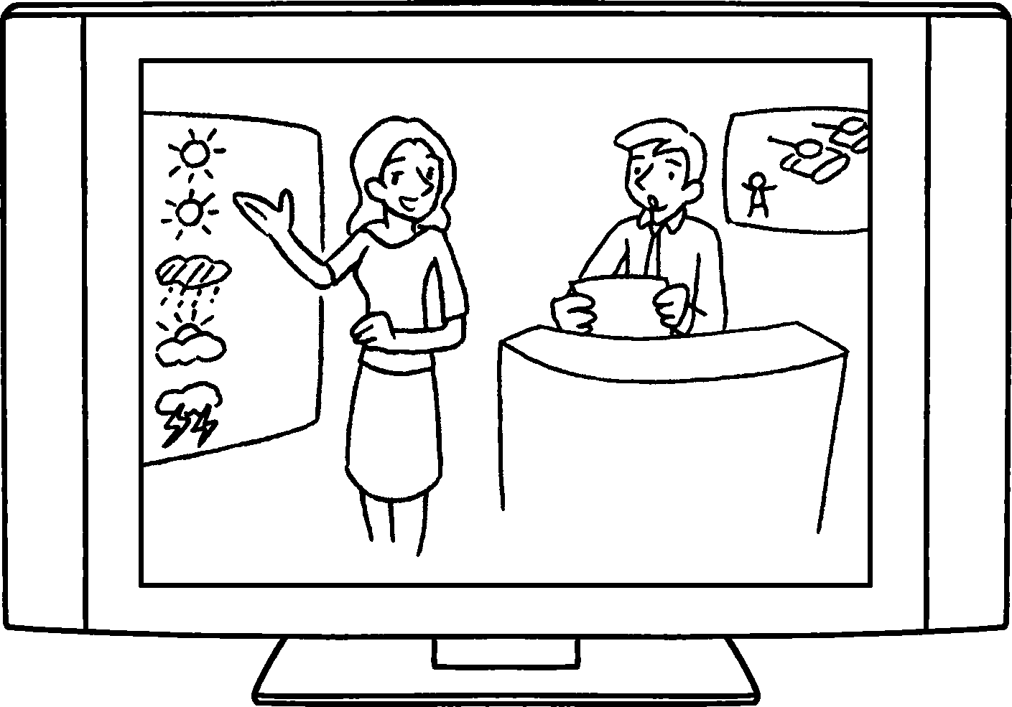

1 | a s p
2 | a c p
3 | a d
4 | a g s
5 | a d
6 | a c
7 | a p m s
8 | the n and w r


Book 4A Chapter 7 Graded Worksheets
Worksheet 1⬇⬇
- sports programme
- cookery programme
- drama
- game show
- documentary
- cartoon
- pop music show
- news weather report

