What kinds of programmes are they? Write.

1  2  3 | 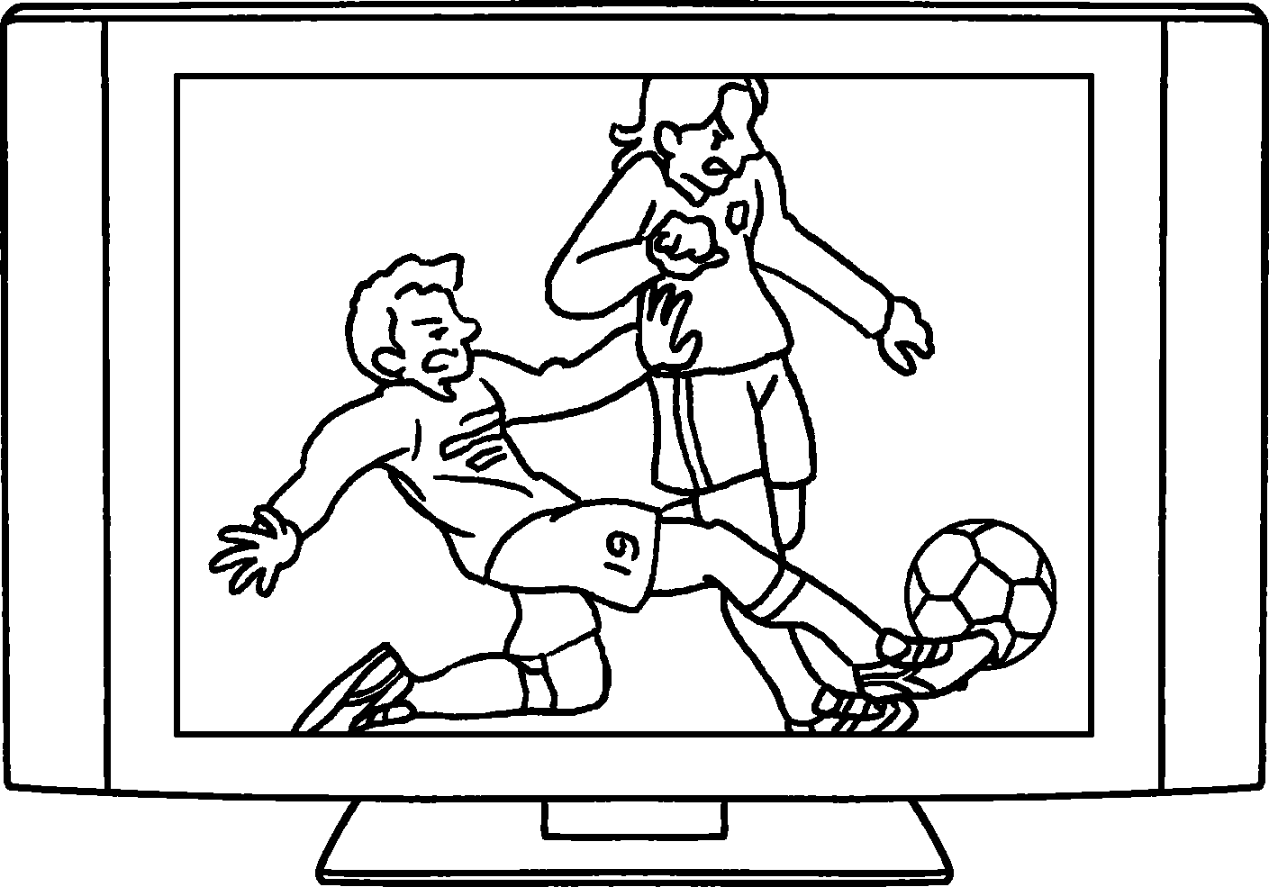 |  | 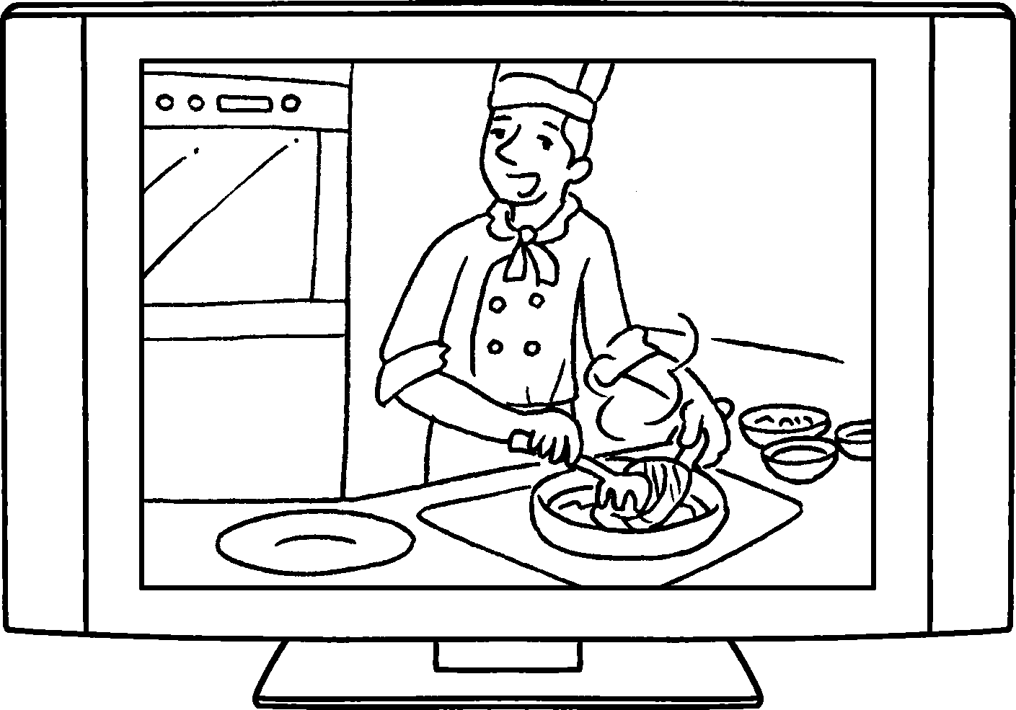 |  |  | 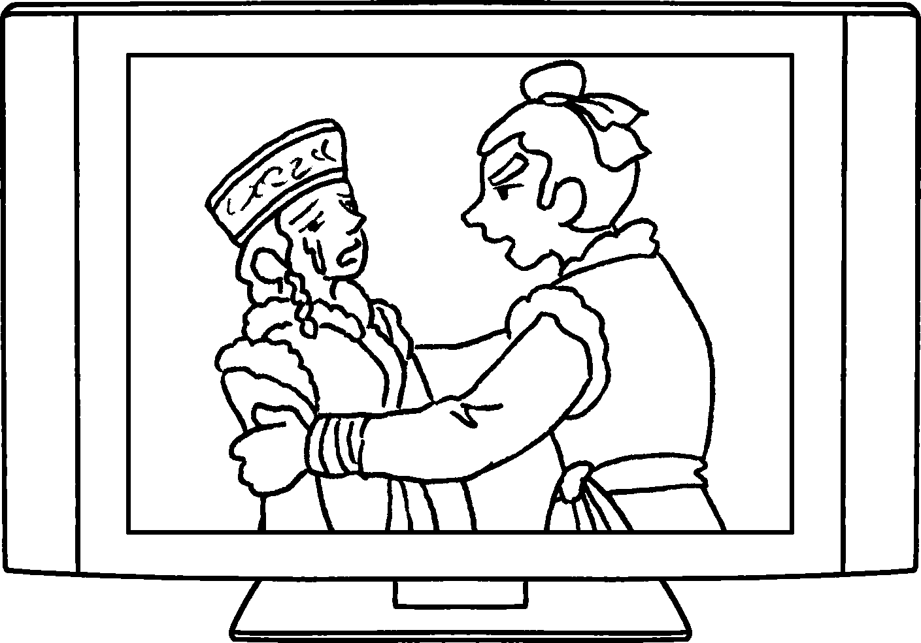
4  5 | 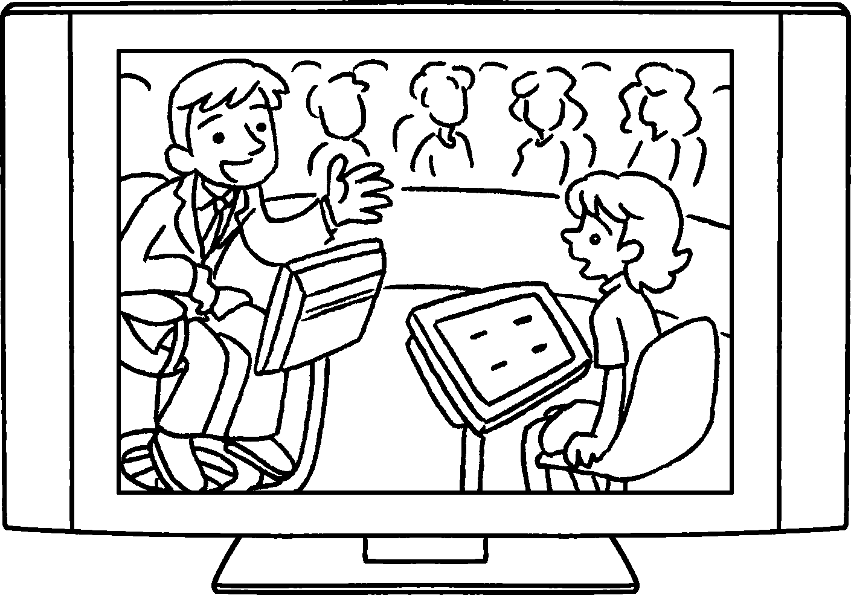 |  |  | 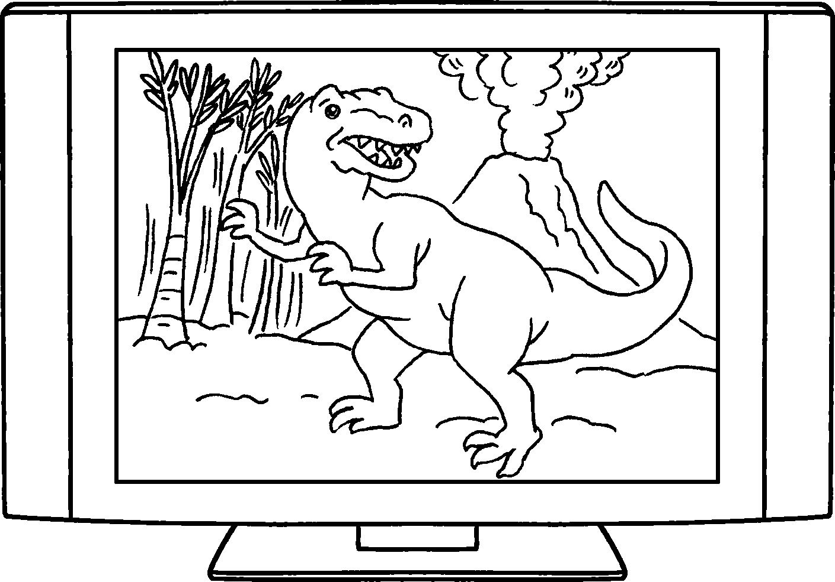
8  6  7 | 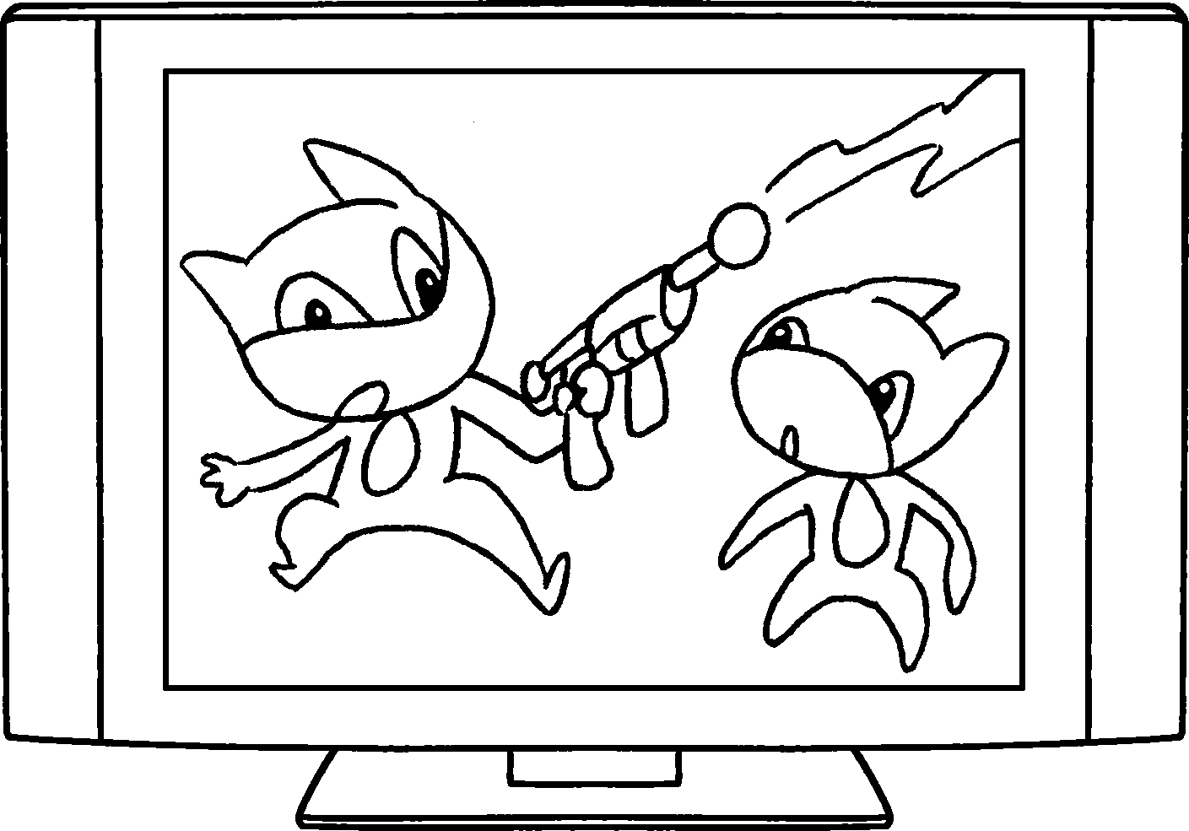 |  |  |  |  | 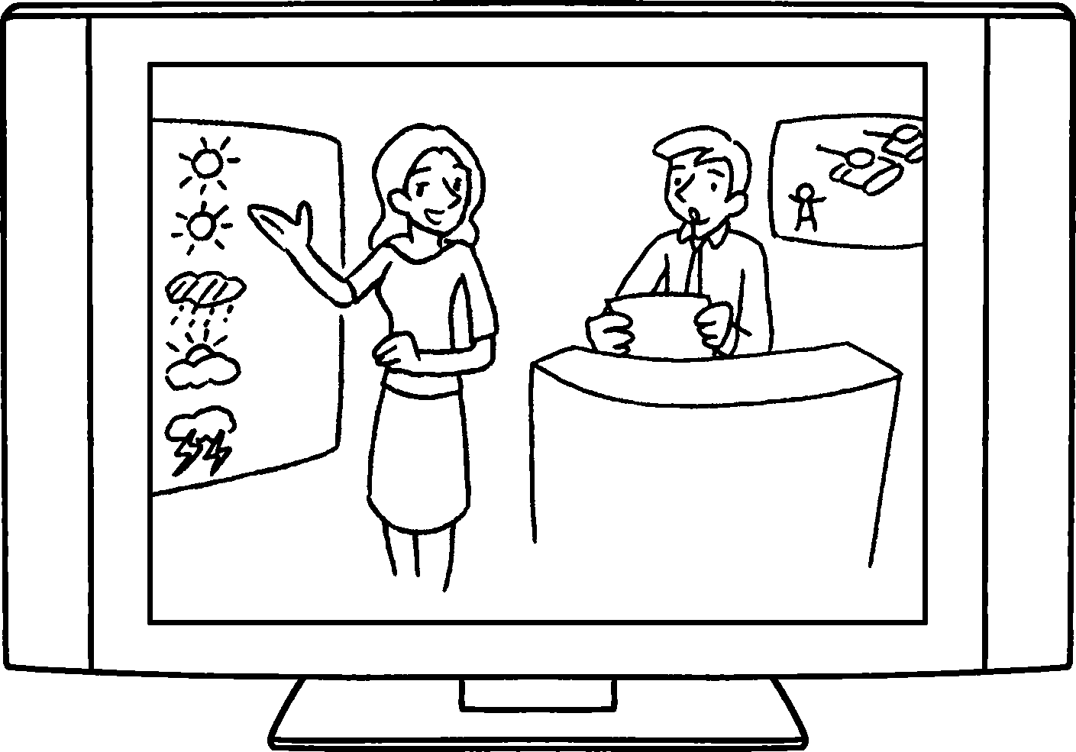

1 | a
2 | a
3
4
5
6
7
8


Book 4A Chapter 7 Graded Worksheets
Worksheet 1⬇⬇⬇
- sports programme
- cookery programme
- a drama
- a game show
- a documentary
- a cartoon
- a pop music show
8 the news and weather report

