Choose and write.

either | too |  | boring | exciting | informative
B
A
B
A
B
A
B
A
B
A
1 | 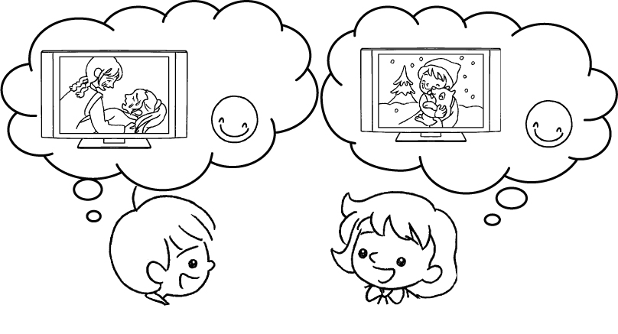 |  | A : I like dramas because they’re  touching.  B : I like them .
2 | 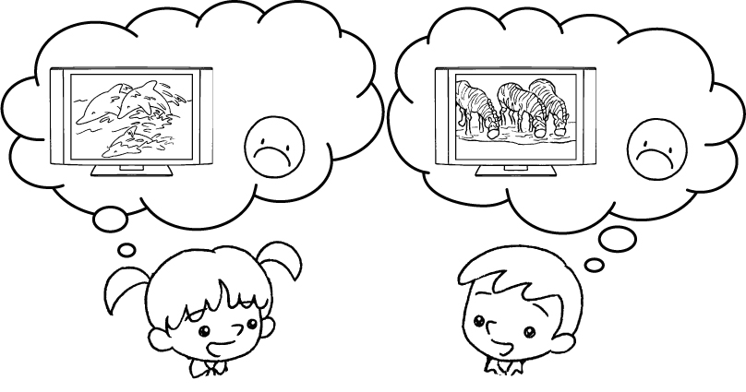 |  | A : I don’t like documentaries  because they’re boring.  B : I don’t like them .
3 | 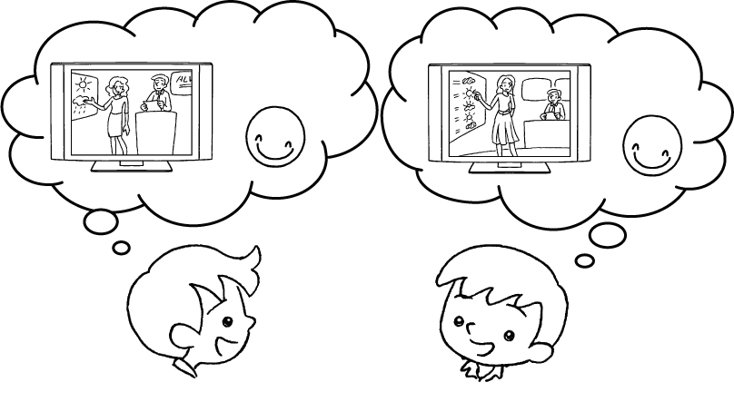 |  | A : I like the news and weather  reports because they’re  .  B : I like them .
4 | 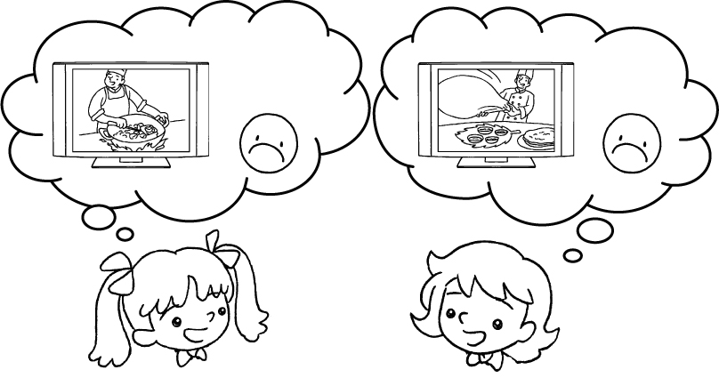 |  | A : I don’t like cookery  programmes because they’re  .  B : I don’t like them .
5 | 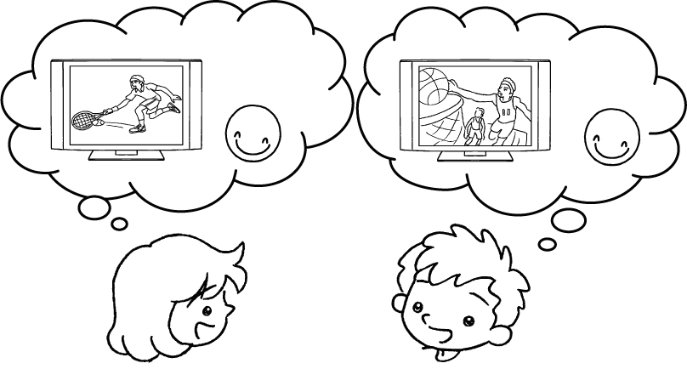 |  | A : I like sports programmes because they’re .  B : I like them .


Book 4A Chapter 7 Graded Worksheets
Worksheet 2⬇
- too
- either
- informative
too
- boring
either
- exciting
too

