Finish what the children say.

either | too
B
A
B
A
B
A
B
A
B
A
1 | 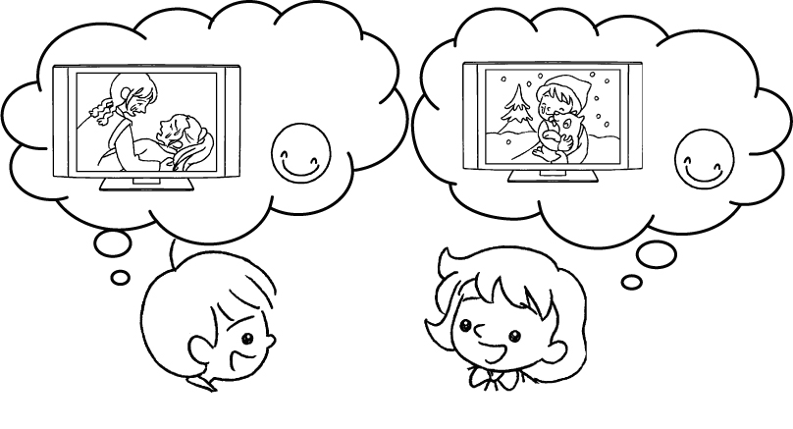 |  | A : I like dramas because they’re  touching.  B : I like them .
2 | 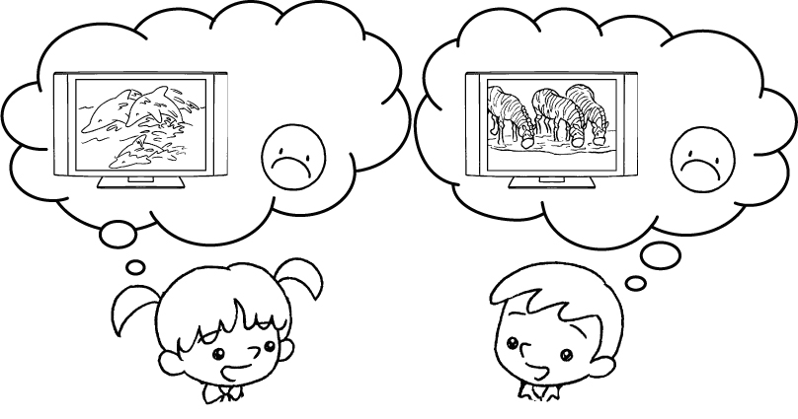 |  | A : I don’t like documentaries  because they’re boring.  B : I don’t like them .
3 | 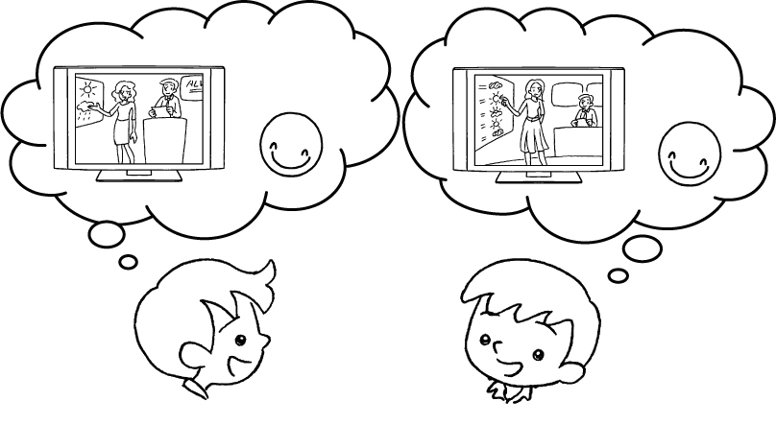 |  | A : I like the news and weather  reports because they’re  i .  B : I like .
4 | 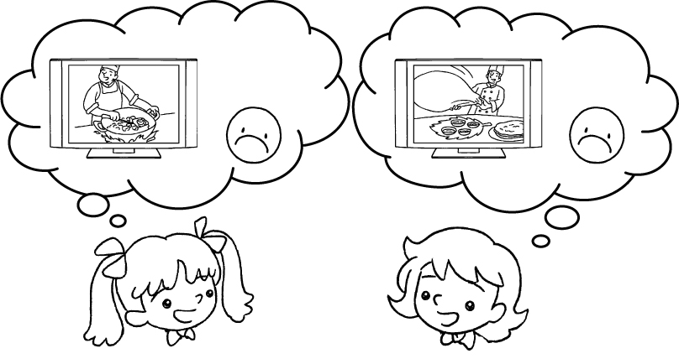 |  | A : I don’t like cookery  programmes because they’re  b .  B : I don’t like .
5 | 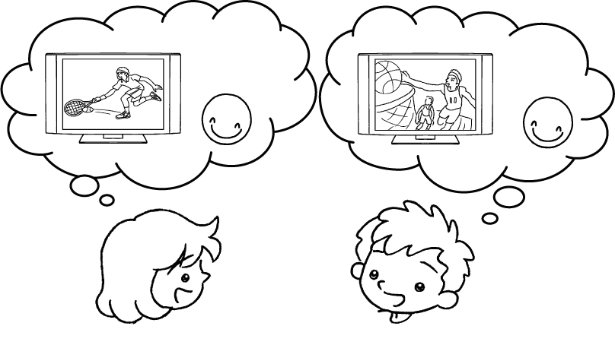 |  | A : I like sports programmes because they’re e .  B : I like .


Book 4A Chapter 7 Graded Worksheets
Worksheet 2⬇⬇
- too
- either
- informative
them too
- boring
them either
- exciting
them too

