Finish what the people say.
A
A
B
A
B
A

both | but | or

1 | 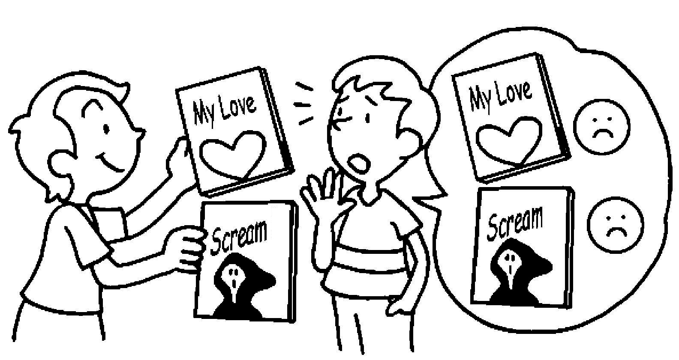 |  | A : I don’t like Scream  My Love.
2 | 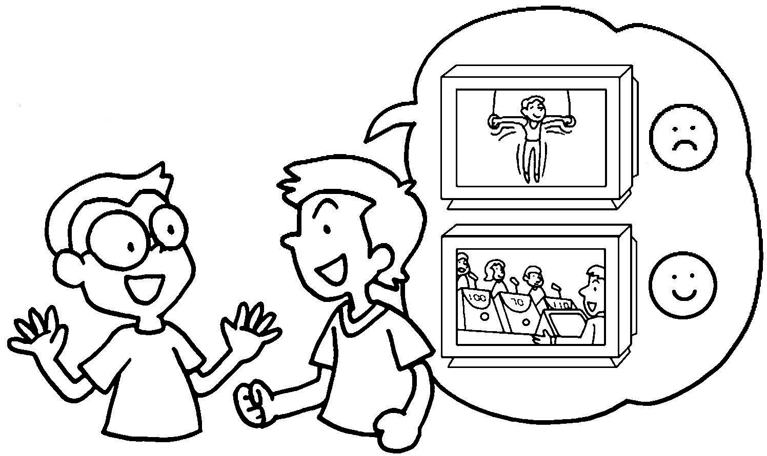 |  | A : I don’t like sports programmes  .
3 | 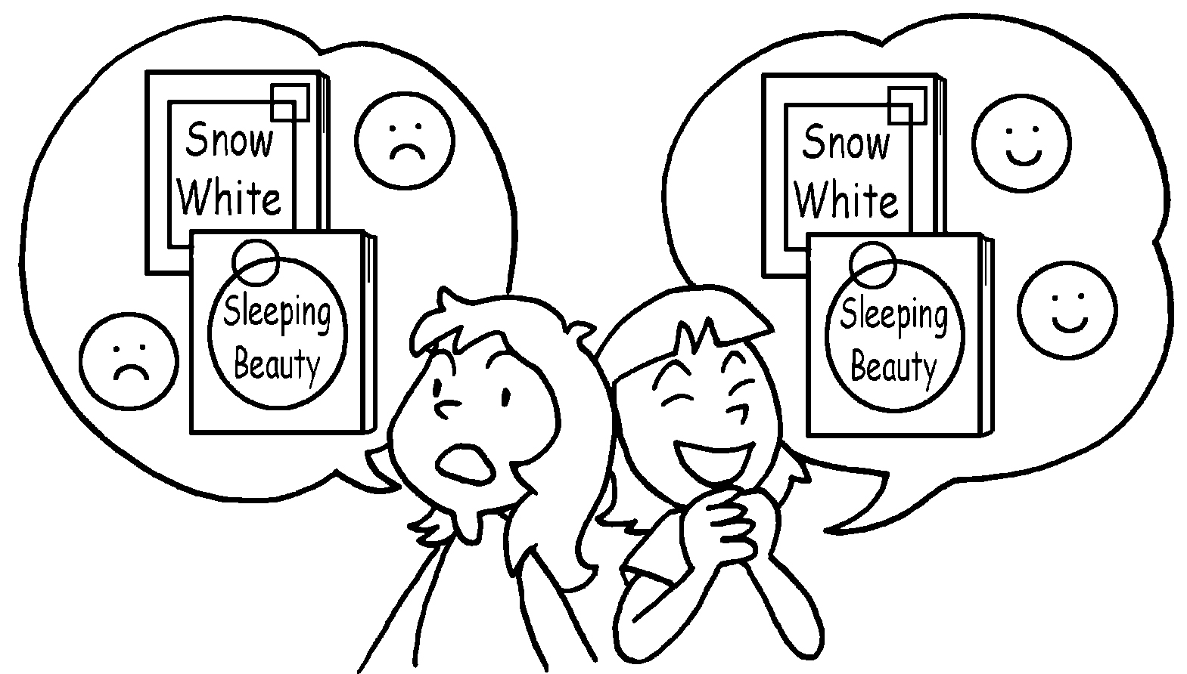 |  | A : I don’t like Snow White  Sleeping Beauty.  B : I like Snow White and Sleeping Beauty.
4 | 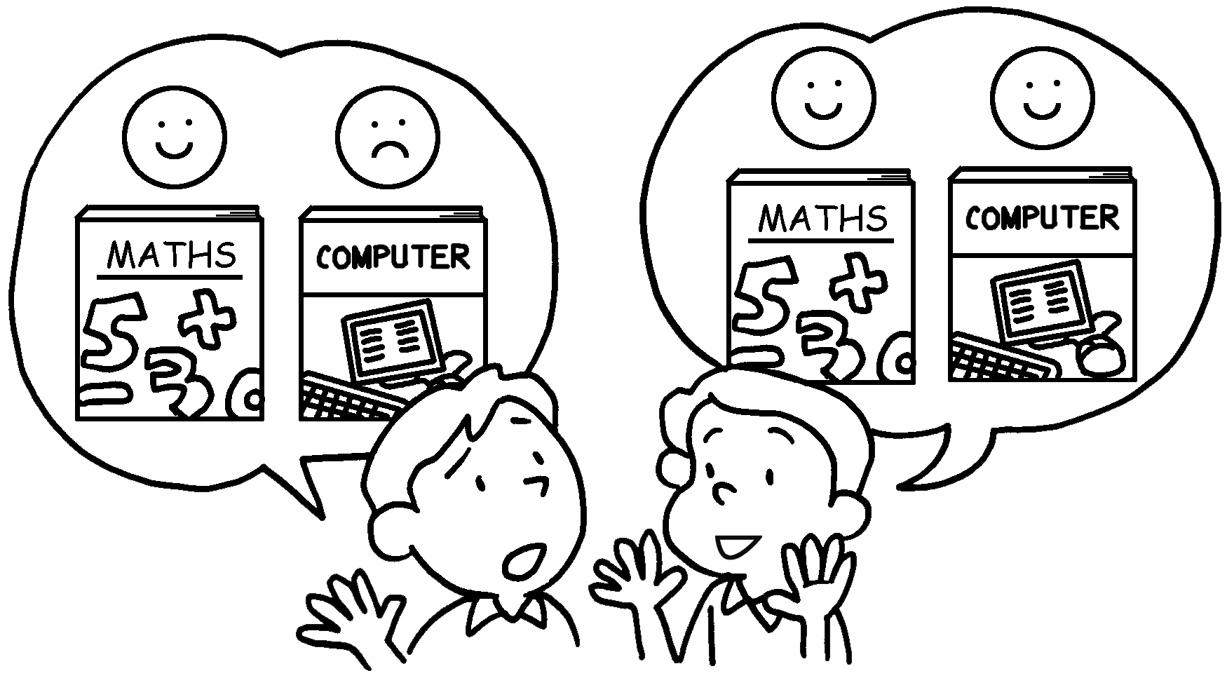 |  | A : I like Maths I don’t  like Computer Studies.  B :


Book 4A Chapter 7 Graded Worksheets
Worksheet 3⬇⬇⬇
- or
- but I like game shows
- or
both
- but
I like both Maths / Computer Studies and Computer Studies / Maths.

