- Favourite TV programmes
Do you like watching TV? What programmes do you like best? Read the story. What programme do the pets decide to watch?

The door closed behind the Wong family.

Sheba the cat turned on the TV. ‘Great! It’s Friends Forever!’ purred Sheba. ‘I love dramas. They’re touching.’

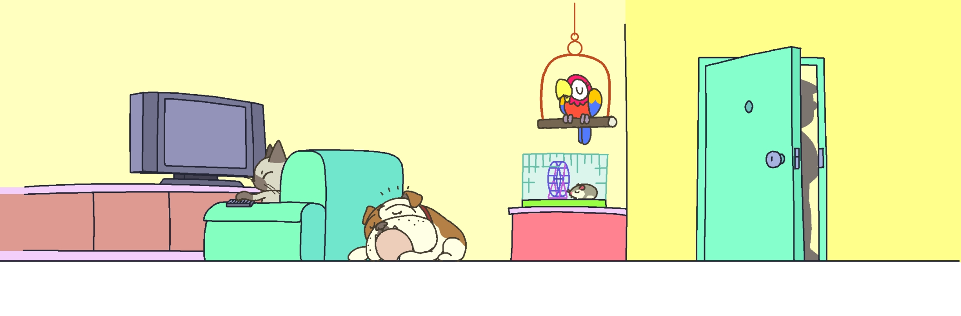

‘I don’t like dramas but I like sports programmes. They’re exciting,’ barked Winston.
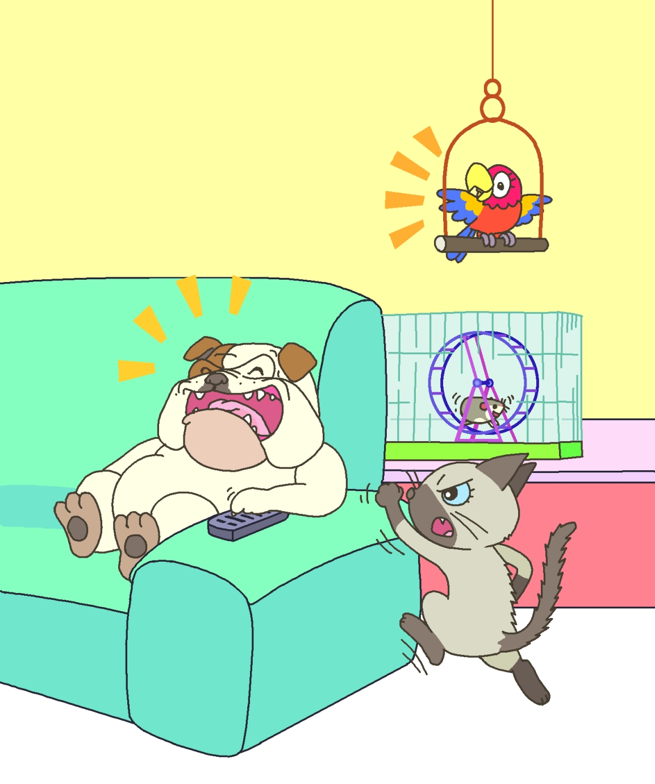
‘I like sports programmes too,’ said Tiny the hamster. ‘Really?’ said Winston. ‘Yes,’ said Tiny. ‘I love running!’ ‘I don’t like sports programmes,’ Sheba miaowed.

‘I don’t like sports programmes either,’ said Polly the parrot. ‘I like pop music shows because I can join in. Tweet, tweet, tweet!’

Winston put his paws over his ears. Polly stopped singing.
Book 4A Chapter 7
Simplified reading passage
‘Let’s watch the weather report then. It’s informative,’ Sheba said.

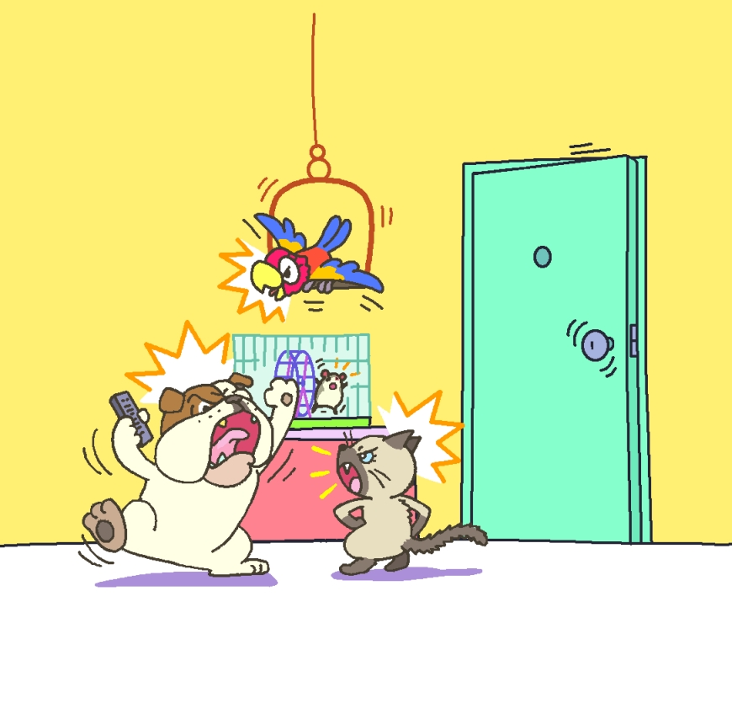
‘I like the news. I like documentaries too. Let’s watch World of Mice,’ said Tiny. ‘No!’ said Winston. ‘I don’t like the news. I don’t like documentaries either.’

‘I like both the news and documentaries,’ tweeted Polly. ‘I’m the boss here!’ Winston said. He grabbed the remote control from Sheba.

Just then the door opened. ‘Where’s my wallet?’ said Mr Wong.

