RP no: Century Gothic 15pt
(所有圈號用15pt)
Choose and write.

the Avenue of Stars | the Big Buddha
Hong Kong Wetland Park | Golden Bauhinia Square
1
2
3
4
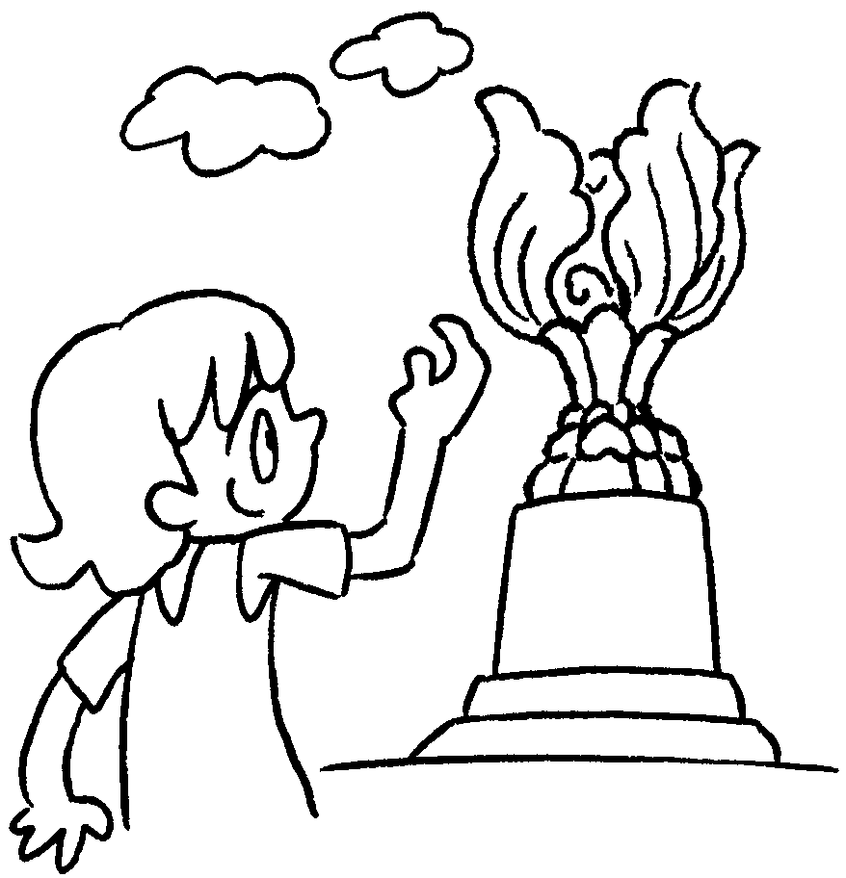 | 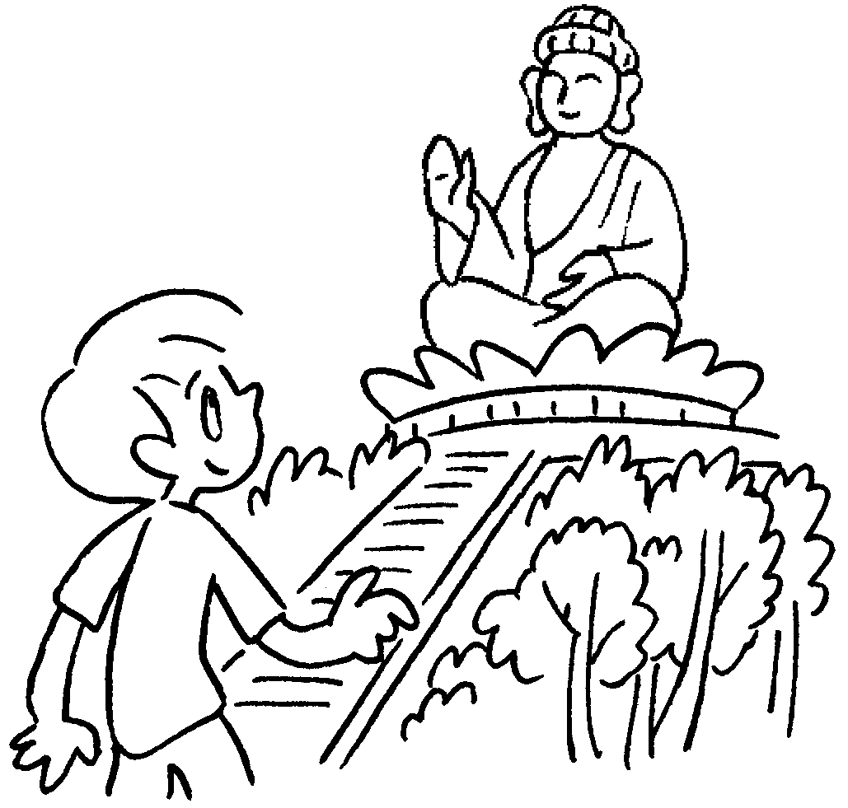 | 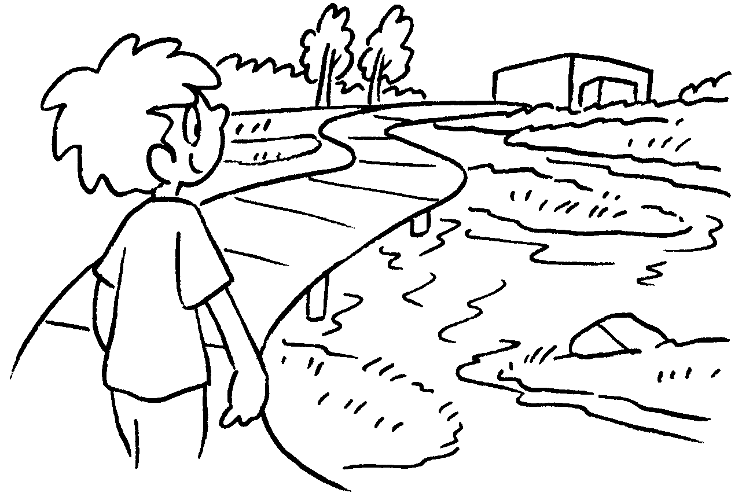 | 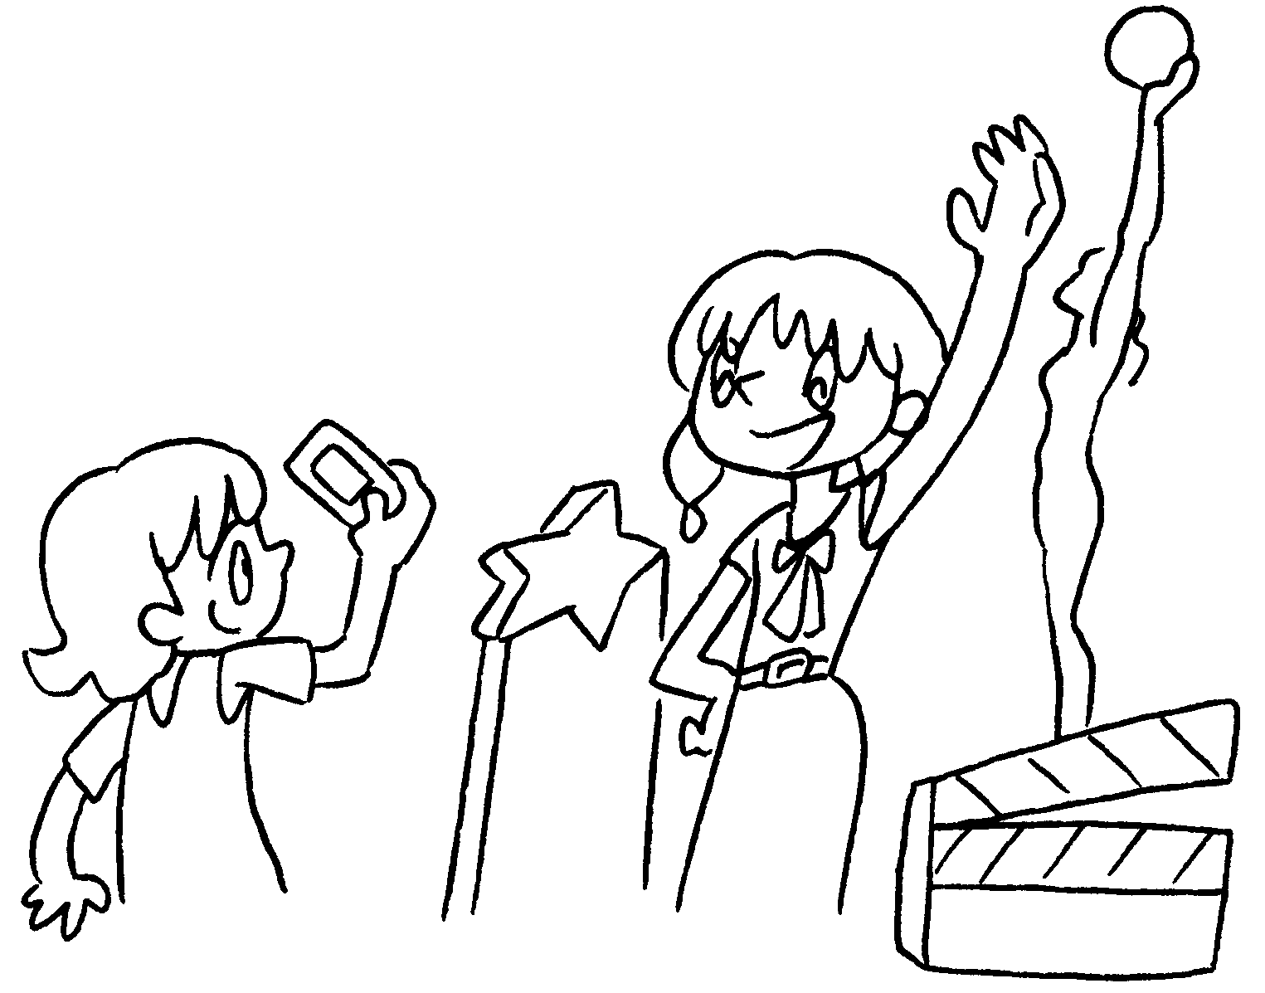
1 visit
2 visit
3 visit
4 take photos on

the birds in Mai Po | water sports | seafood
hiking | the view of Hong Kong
5
6
7
8
9
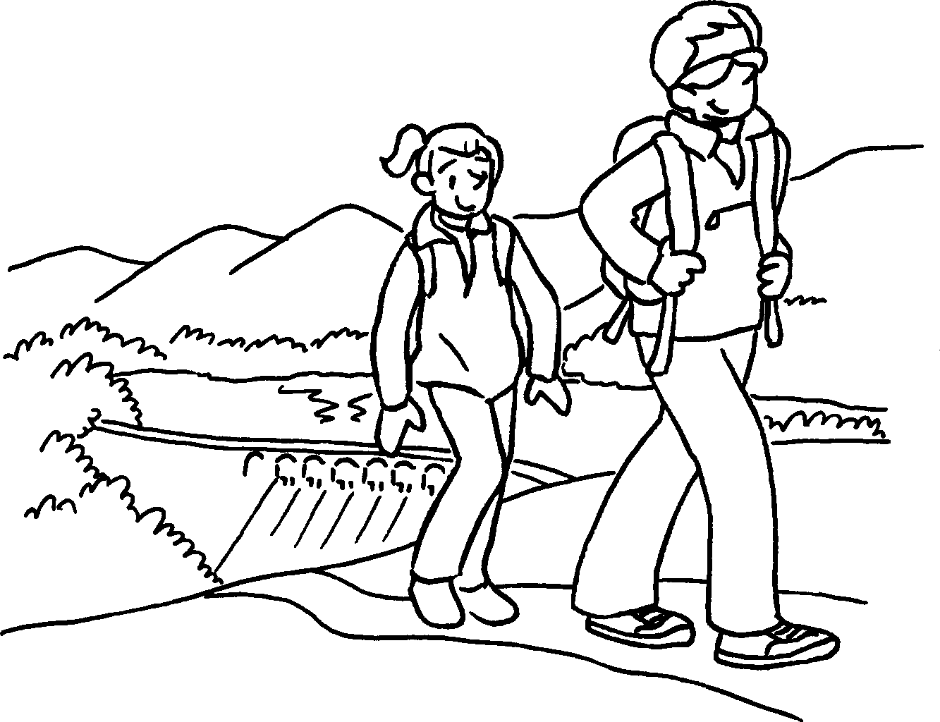 | 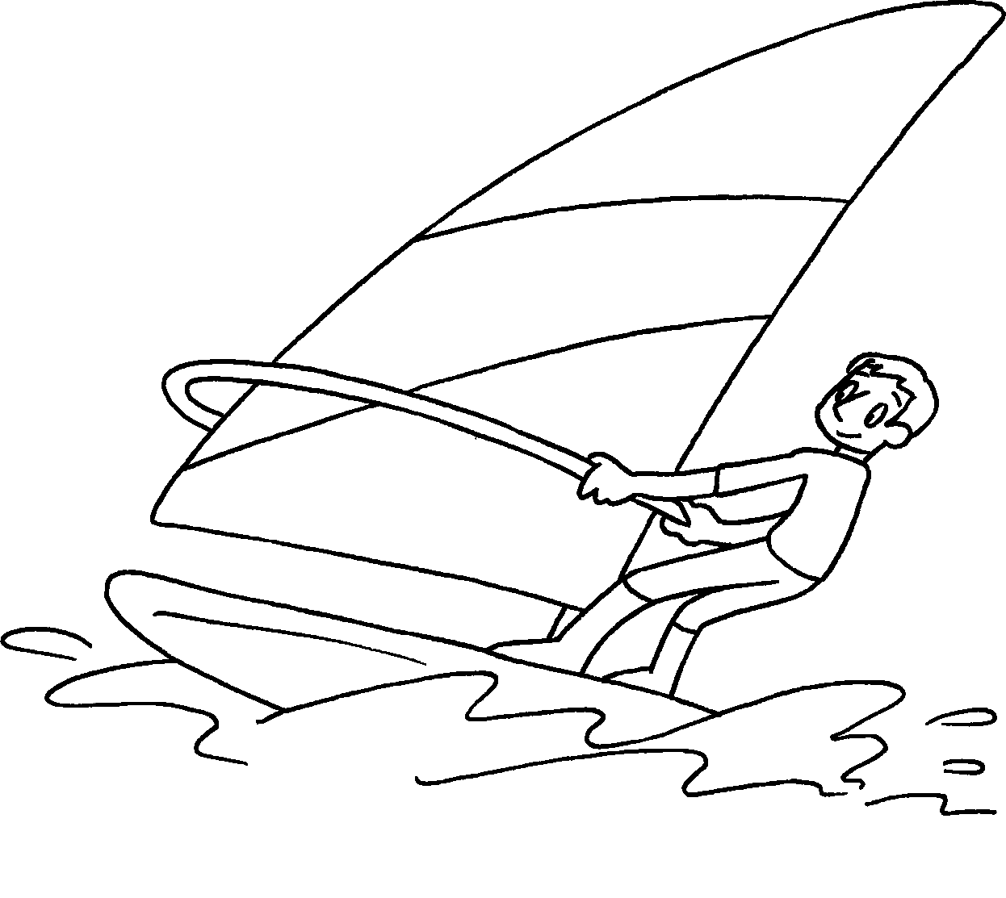 | 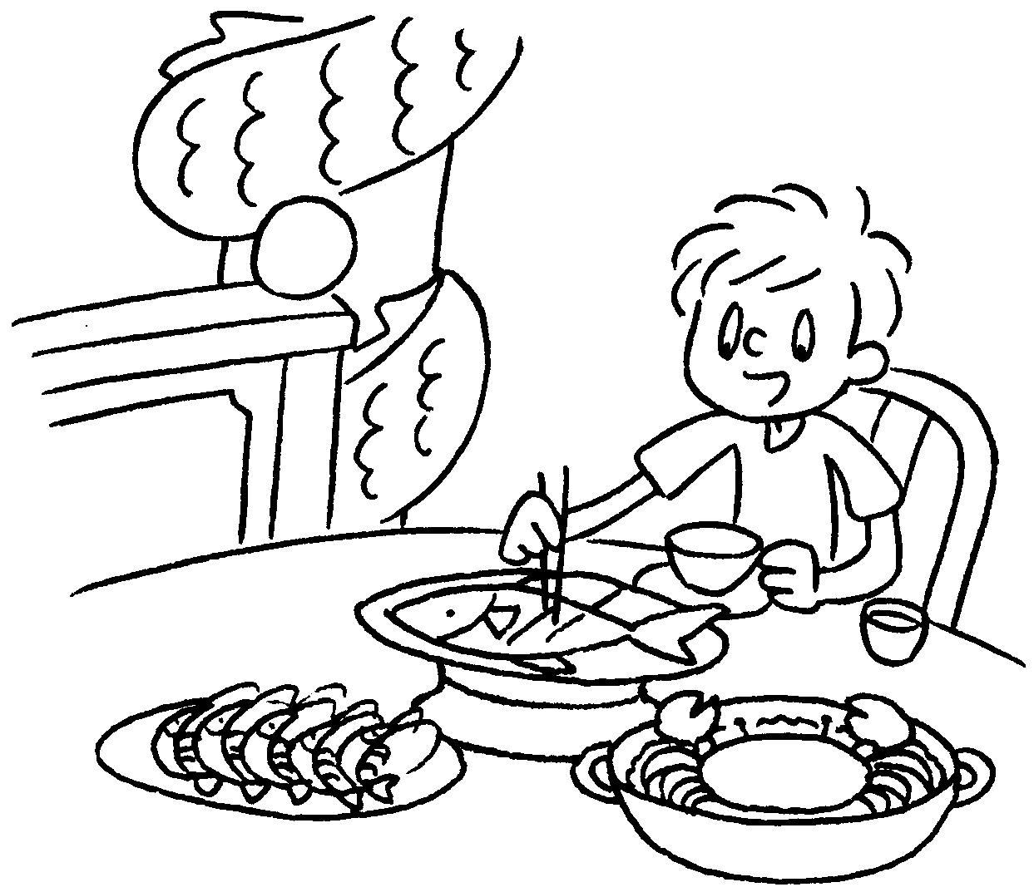 | 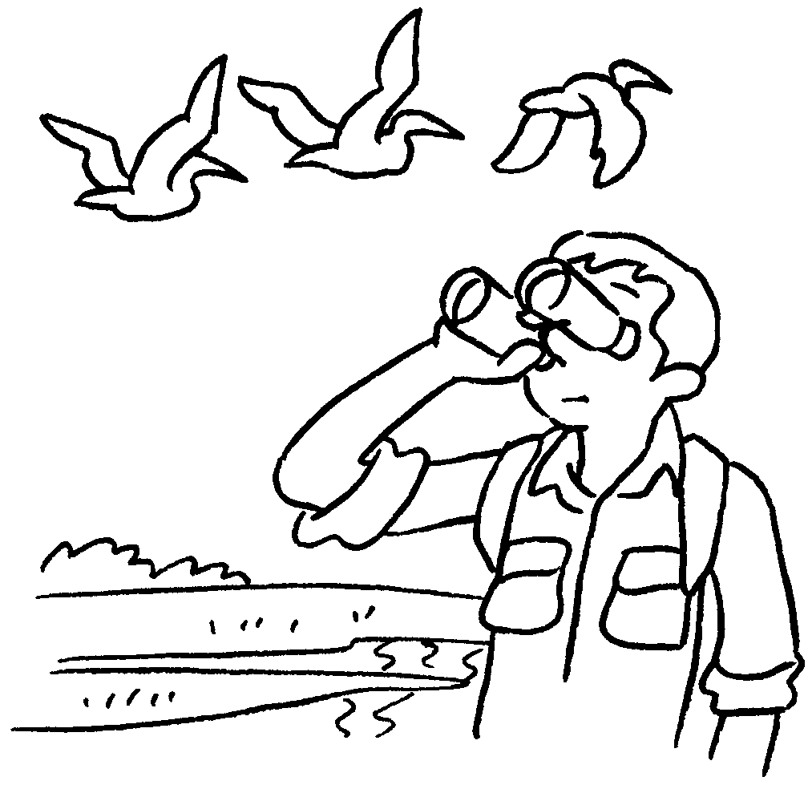 | 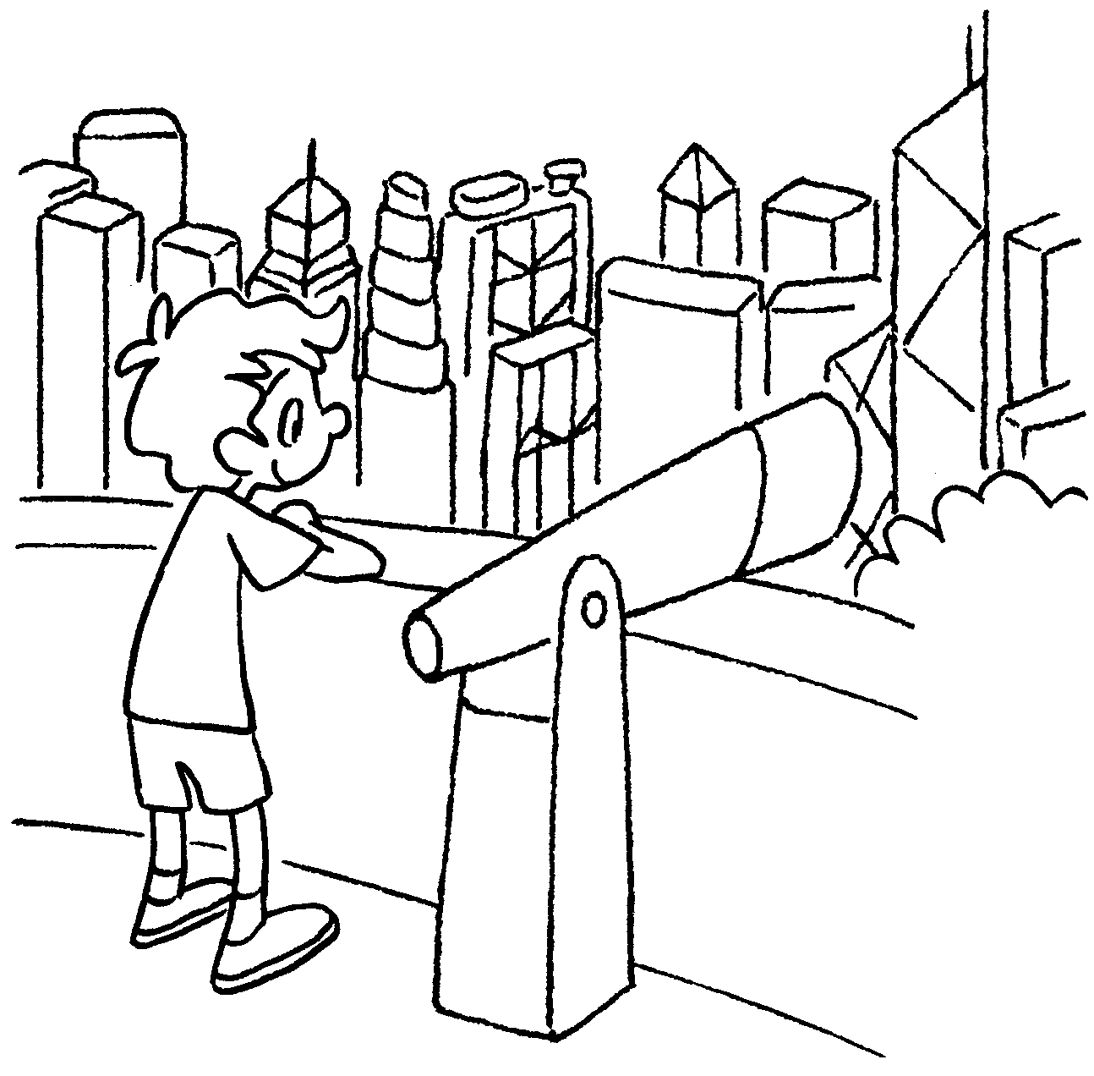

5 | go | 6 | do
7 | eat | 8 | watch
9 | look at

RP no: Century Gothic 15pt
(所有圈號用15pt)


Book 4B Chapter 1 Graded Worksheets
Worksheet 1⬇

Golden Bauhinia Square
- the Big Buddha
- Hong Kong Wetland Park
- the Avenue of Stars
- hiking
- water sports
- seafood
- the birds in Mai Po
- the view of Hong Kong

