RP no: Century Gothic 15pt
(所有圈號用15pt)

Choose and write.
RP no: Century Gothic 15pt
(所有圈號用15pt)

do eat go look at take photos on visit watch

the birds in Mai Po | Golden Bauhinia Square | seafood
the Big Buddha | Hong Kong Wetland Park | hiking
the Avenue of Stars | the view of Hong Kong | water sports
1
2
3
4
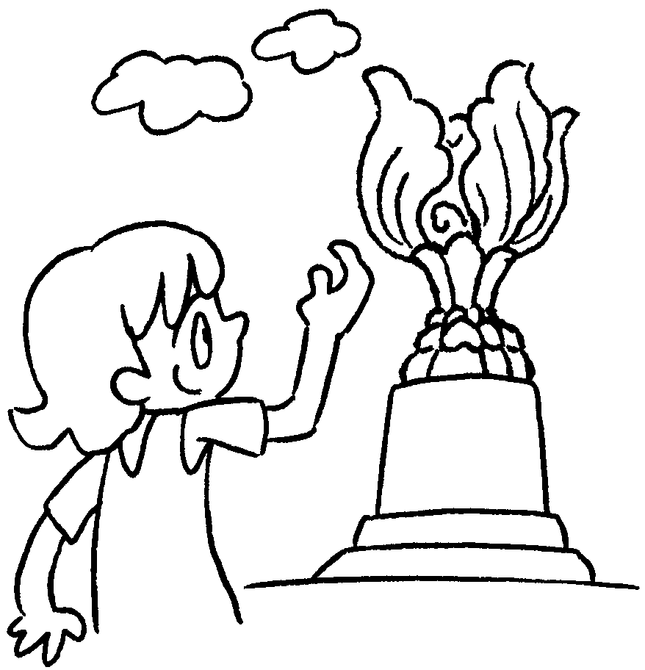 | 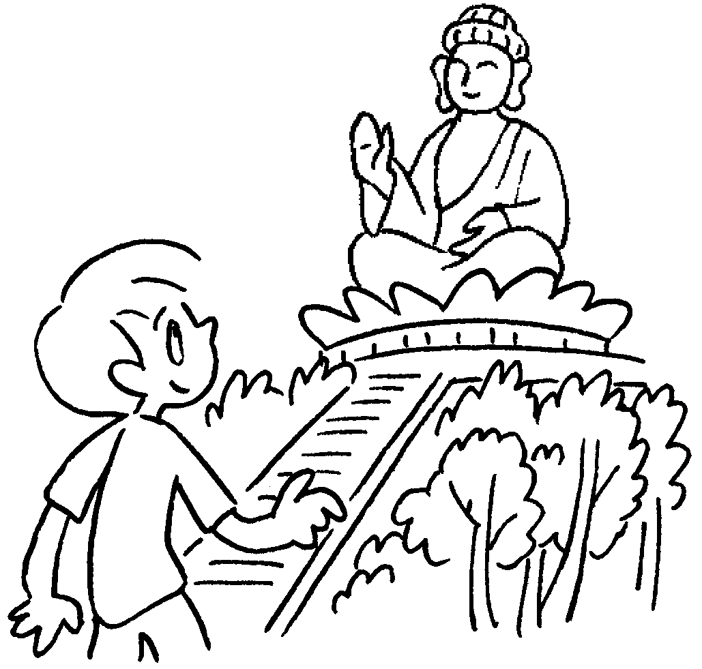 | 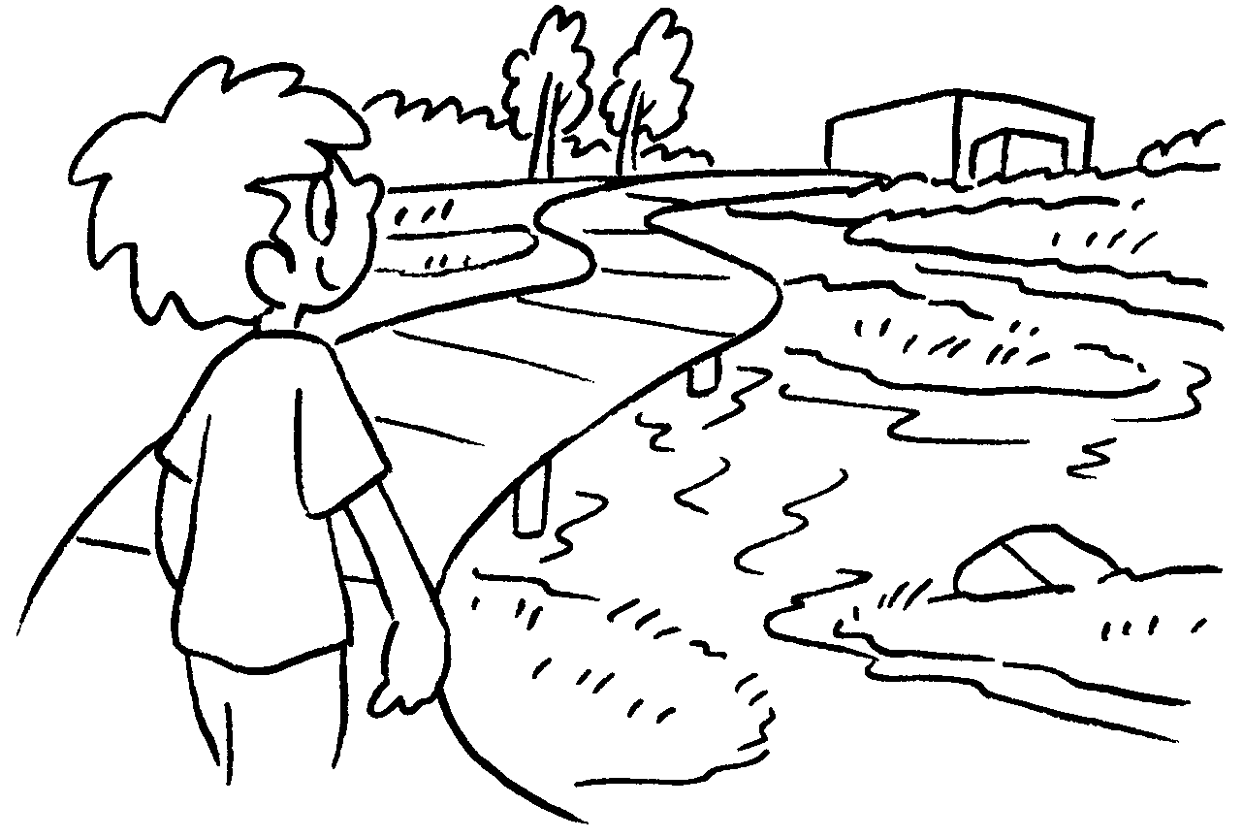 | 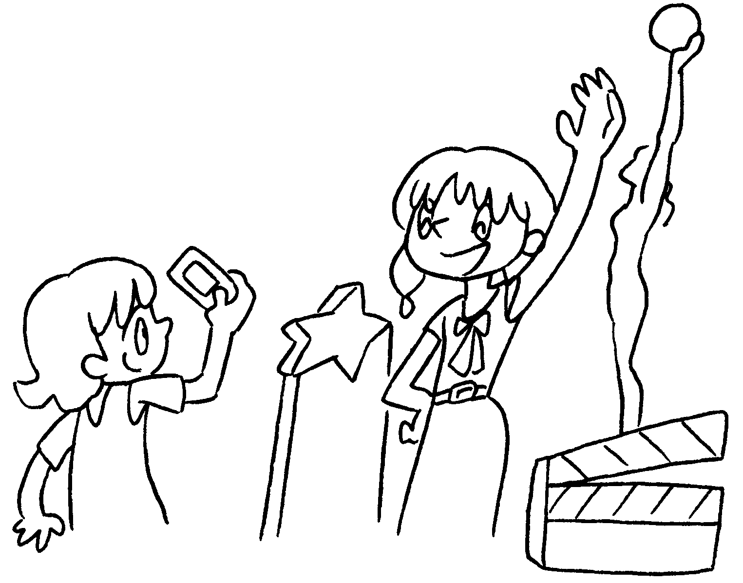
1 visit
2
3
4
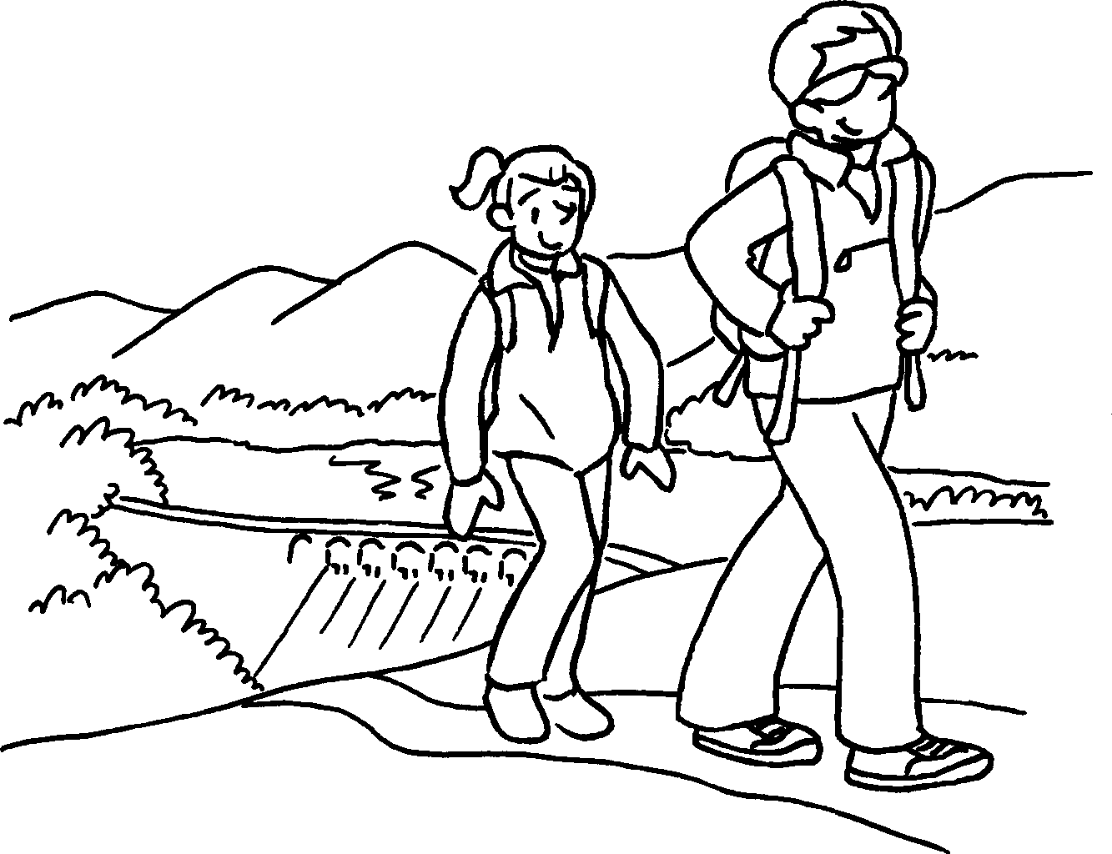  5  6  7  8  9 | 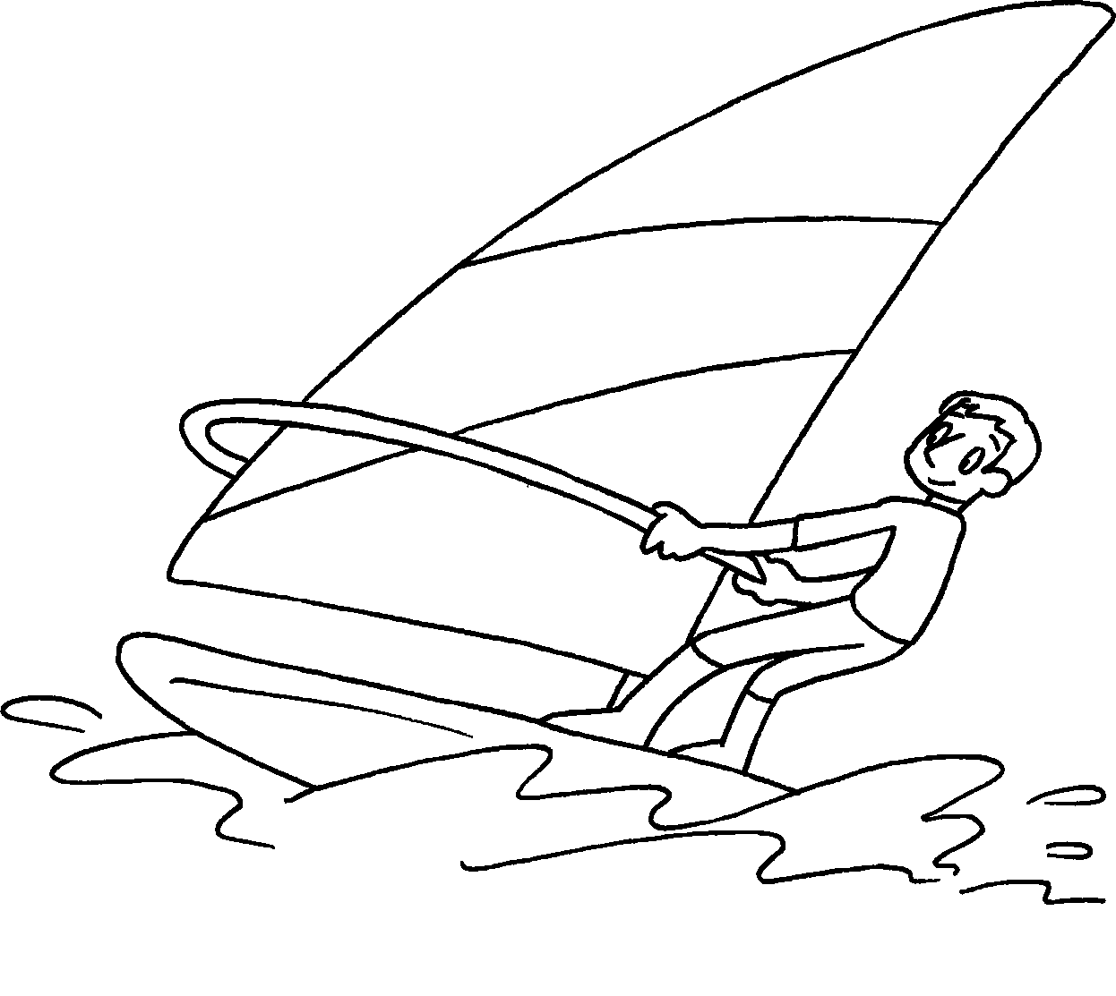 | 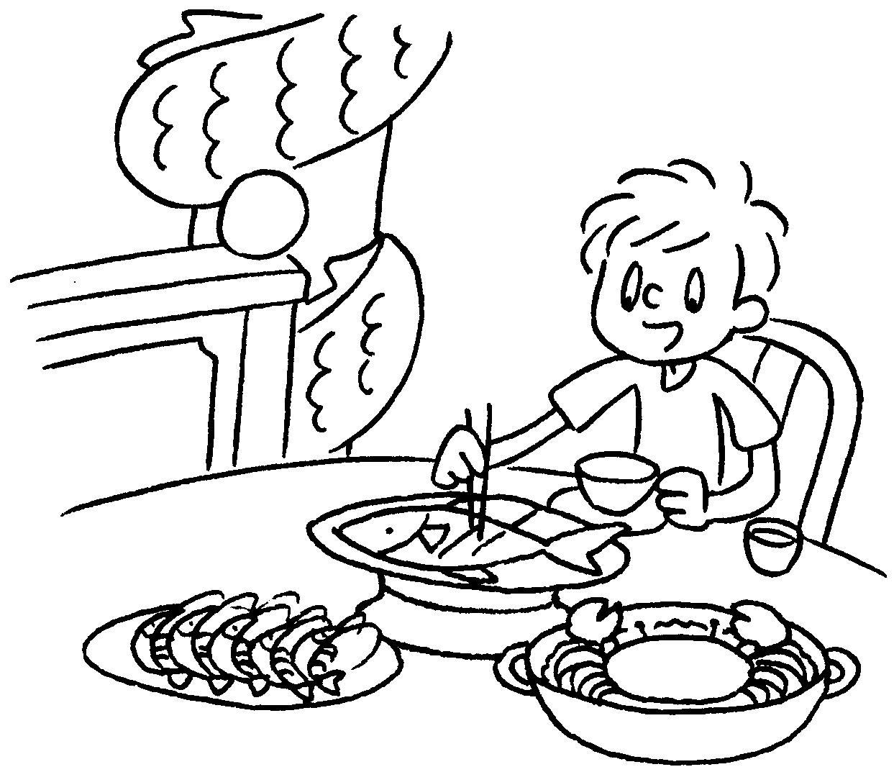 | 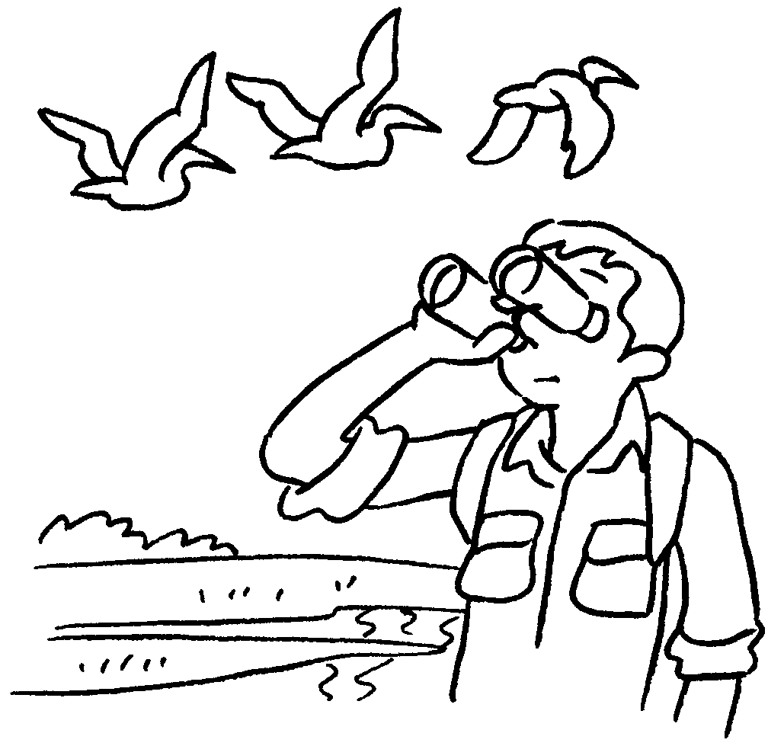 | 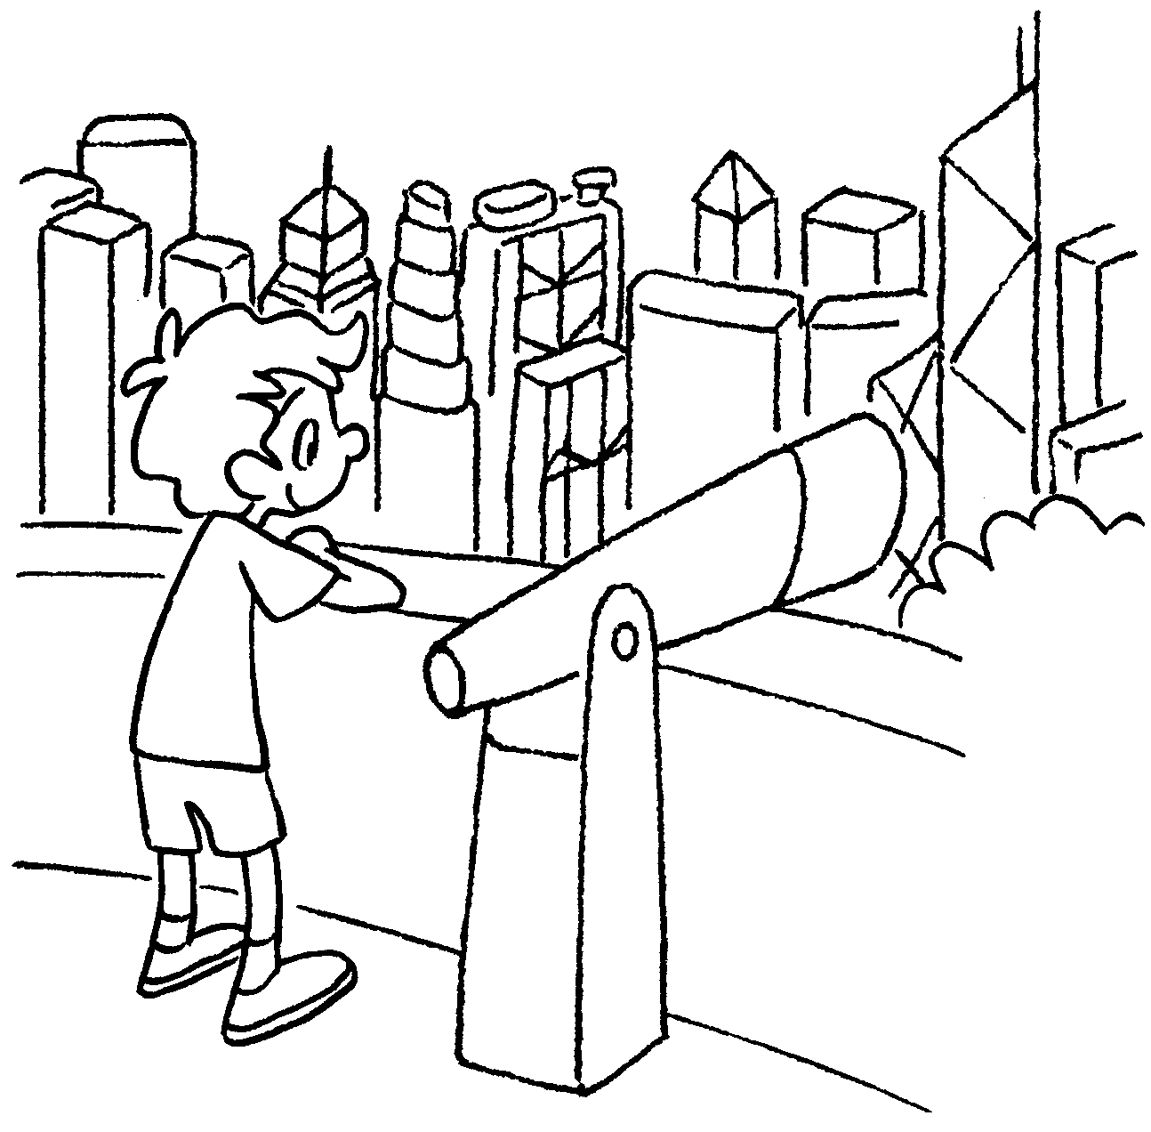

5 |  | 6
7 |  | 8
9

RP no: Century Gothic 15pt
(所有圈號用15pt)


Book 4B Chapter 1 Graded Worksheets
Worksheet 1⬇⬇

Golden Bauhinia Square
- visit the Big Buddha
- visit Hong Kong Wetland Park
- take photos on the Avenue of Stars
- go hiking
- do water sports
- eat seafood
- watch the birds in Mai Po
- look at the view of Hong Kong

