RP no: Century Gothic 15pt
(所有圈號用15pt)
What can the tourists do in Hong Kong? Write.

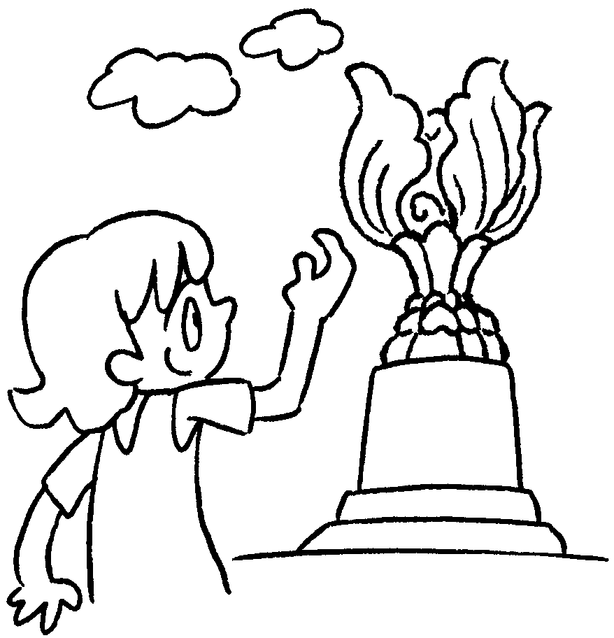  1  2  3  4 | 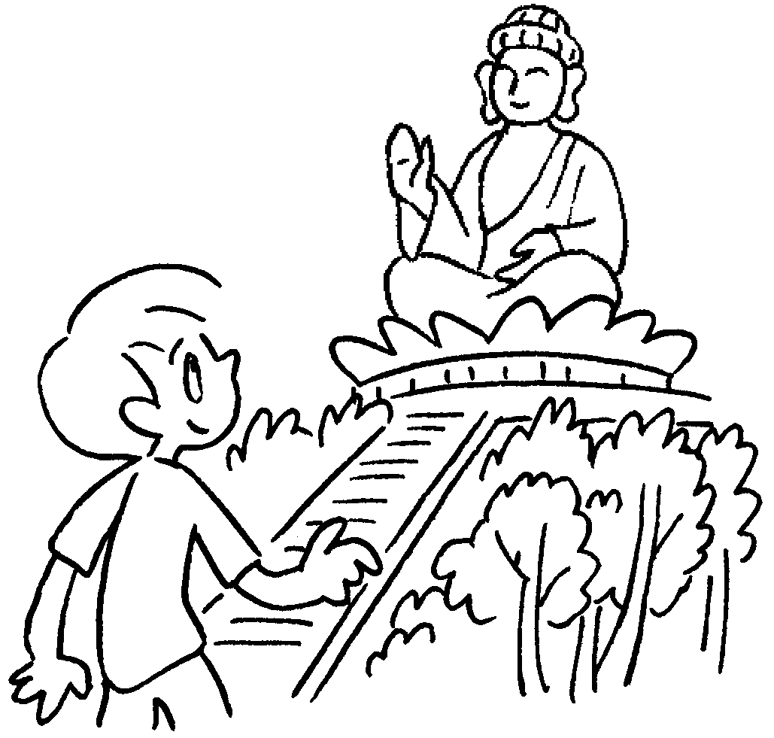 | 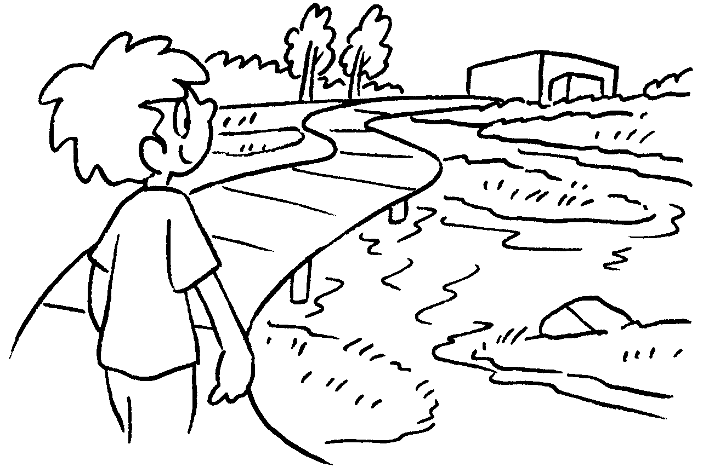 | 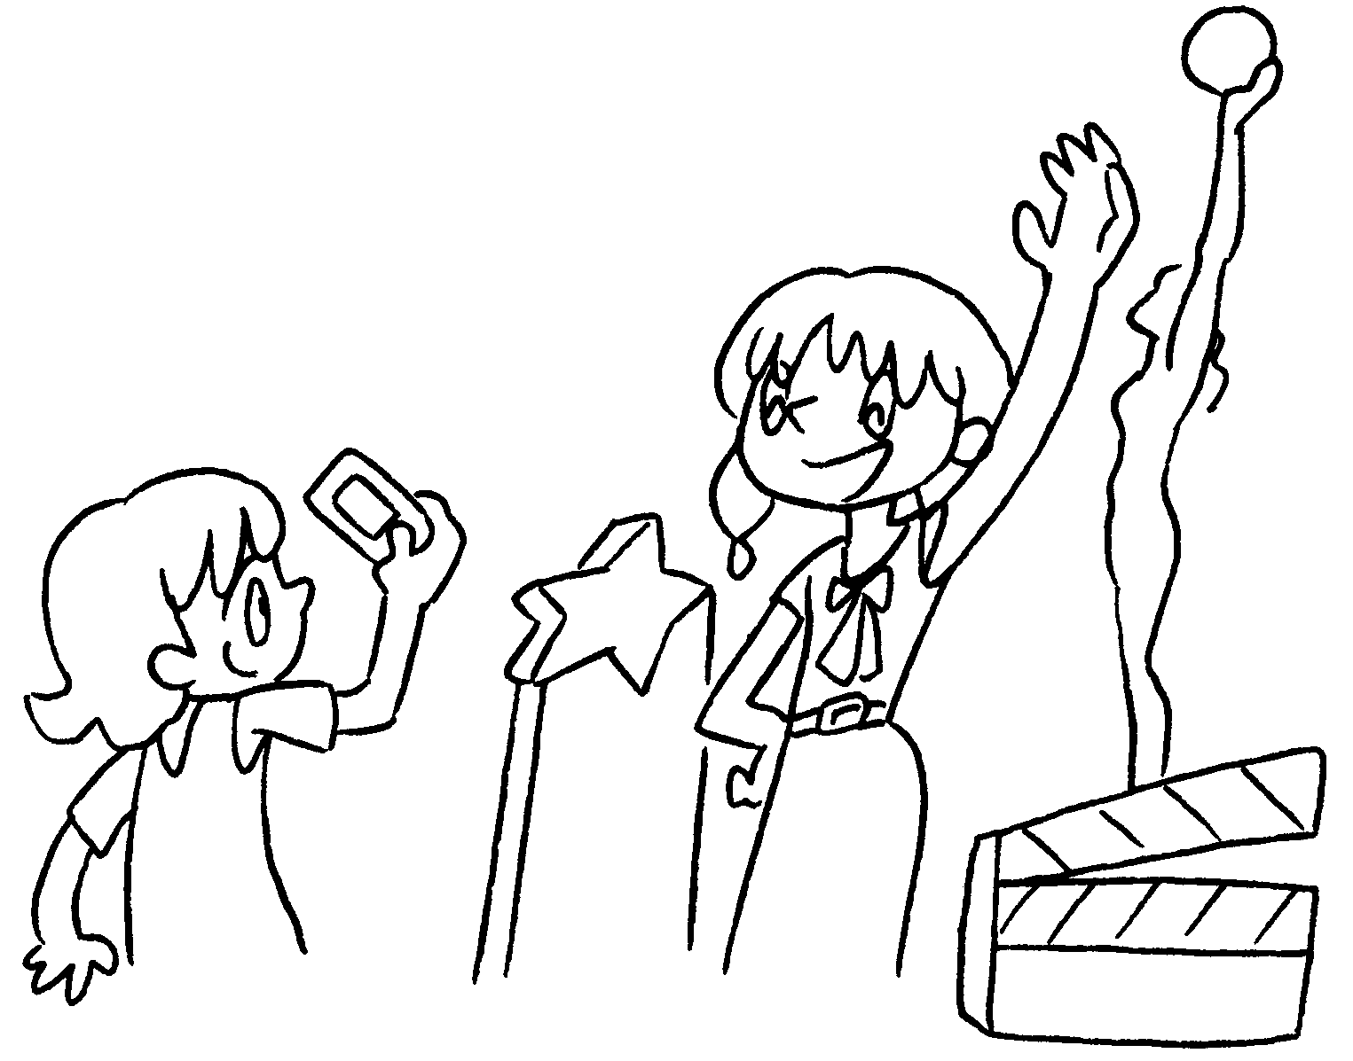
1 visit
2 visit
3 visit
4 take photos on

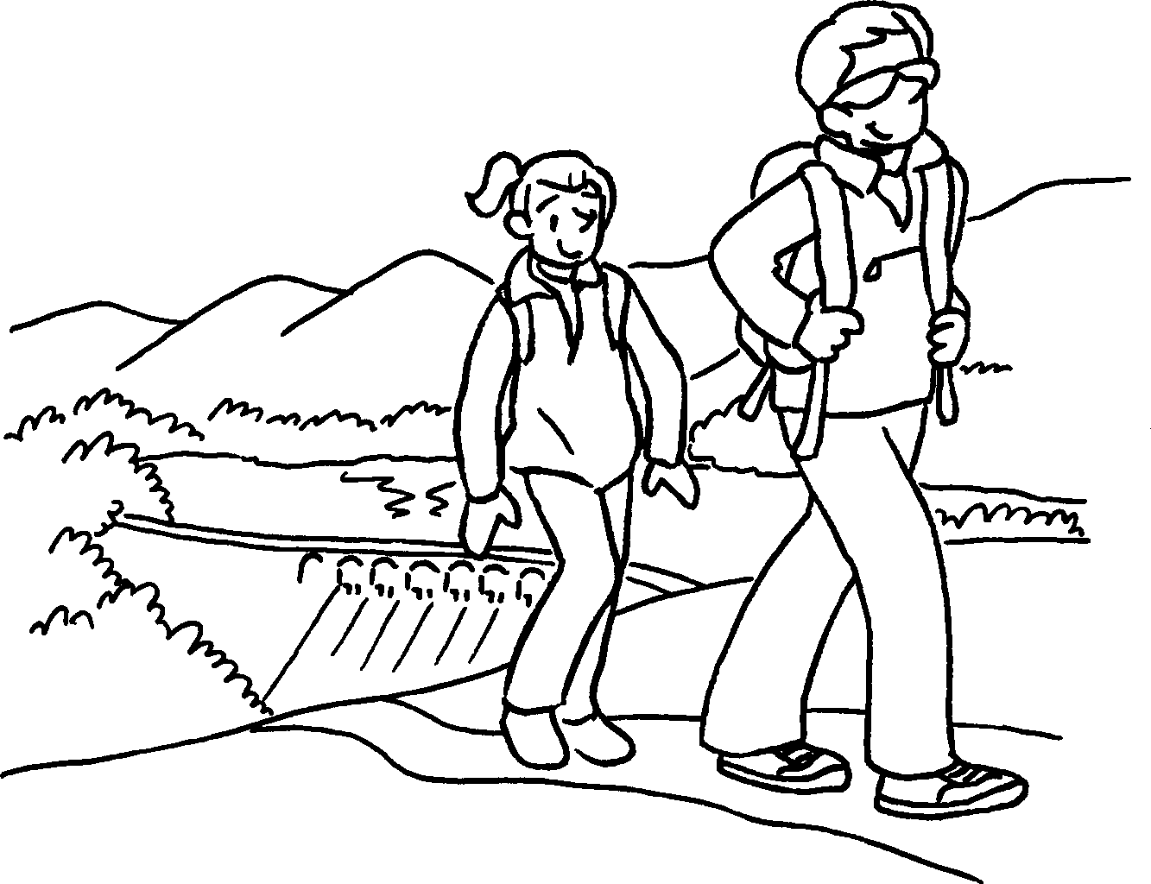  5  6  7  8  9 | 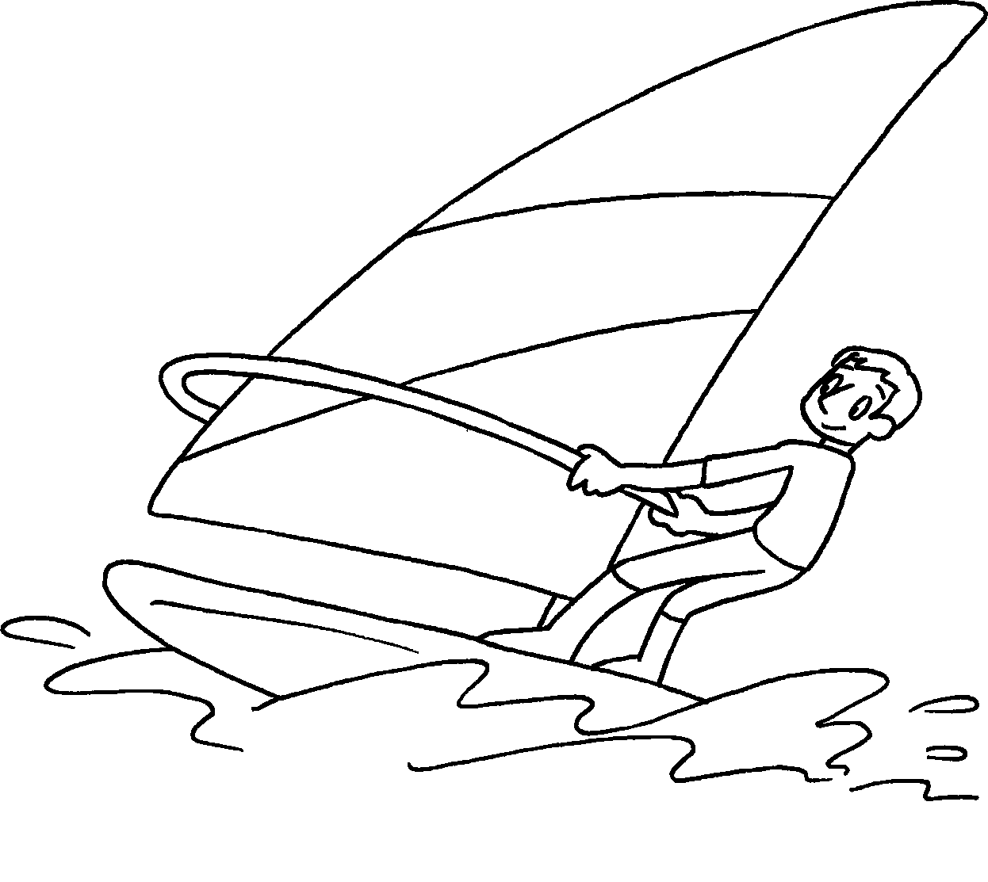 | 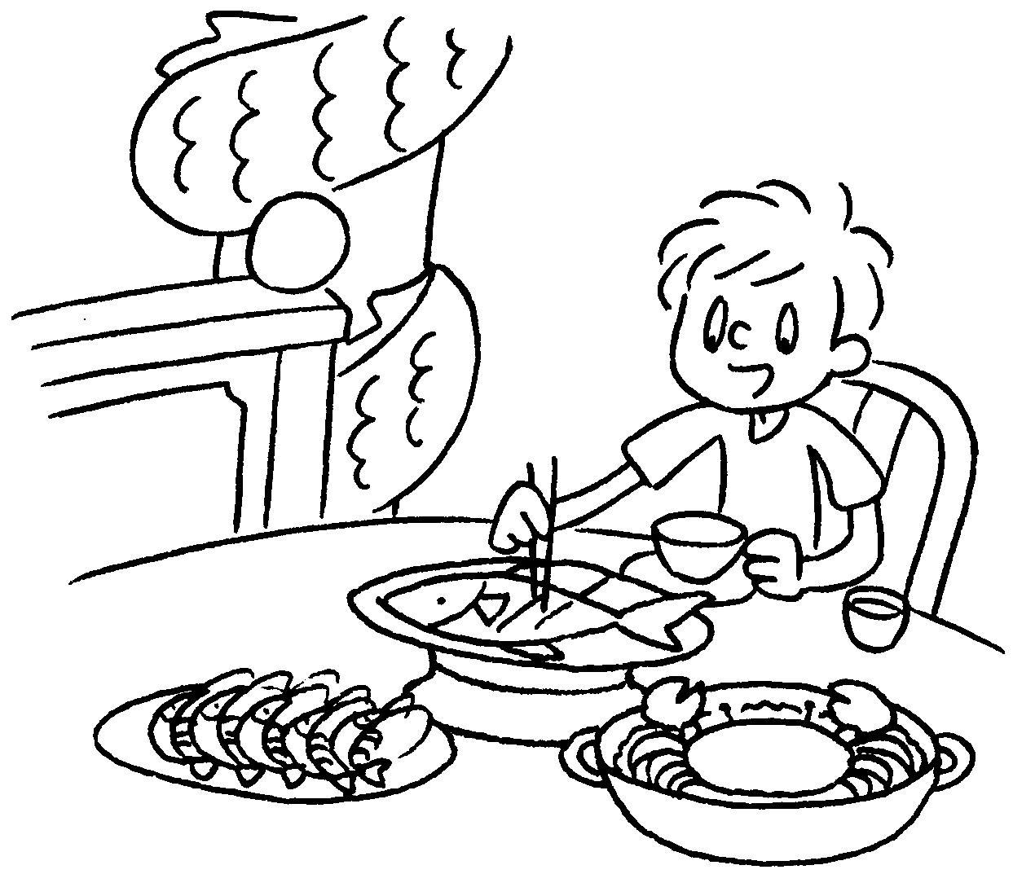 | 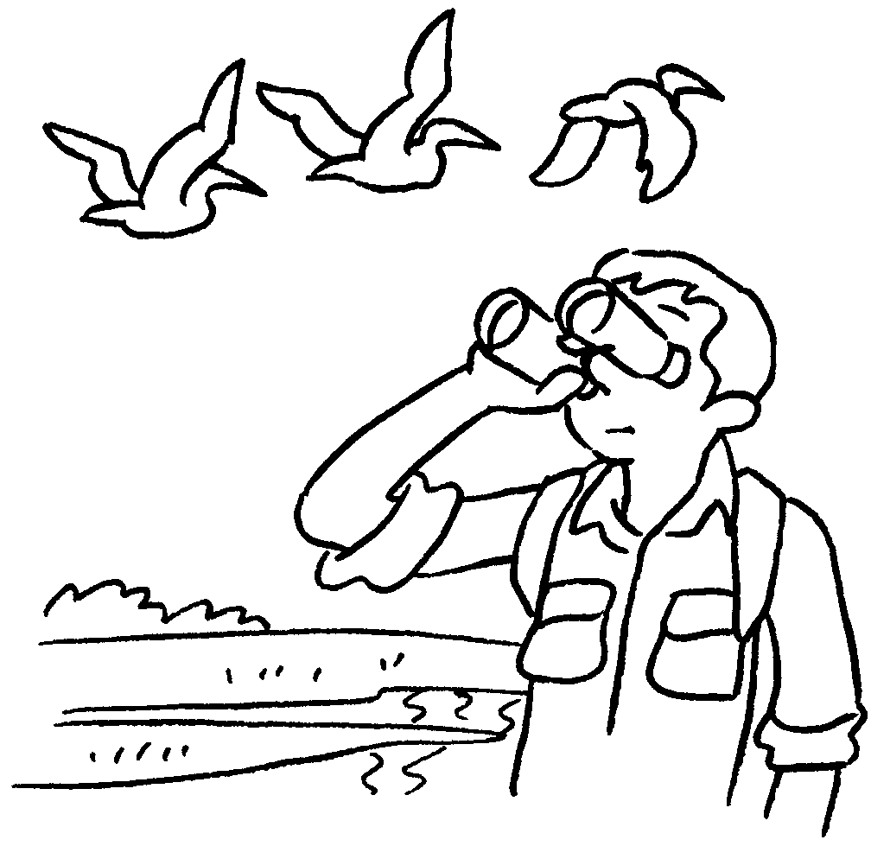 | 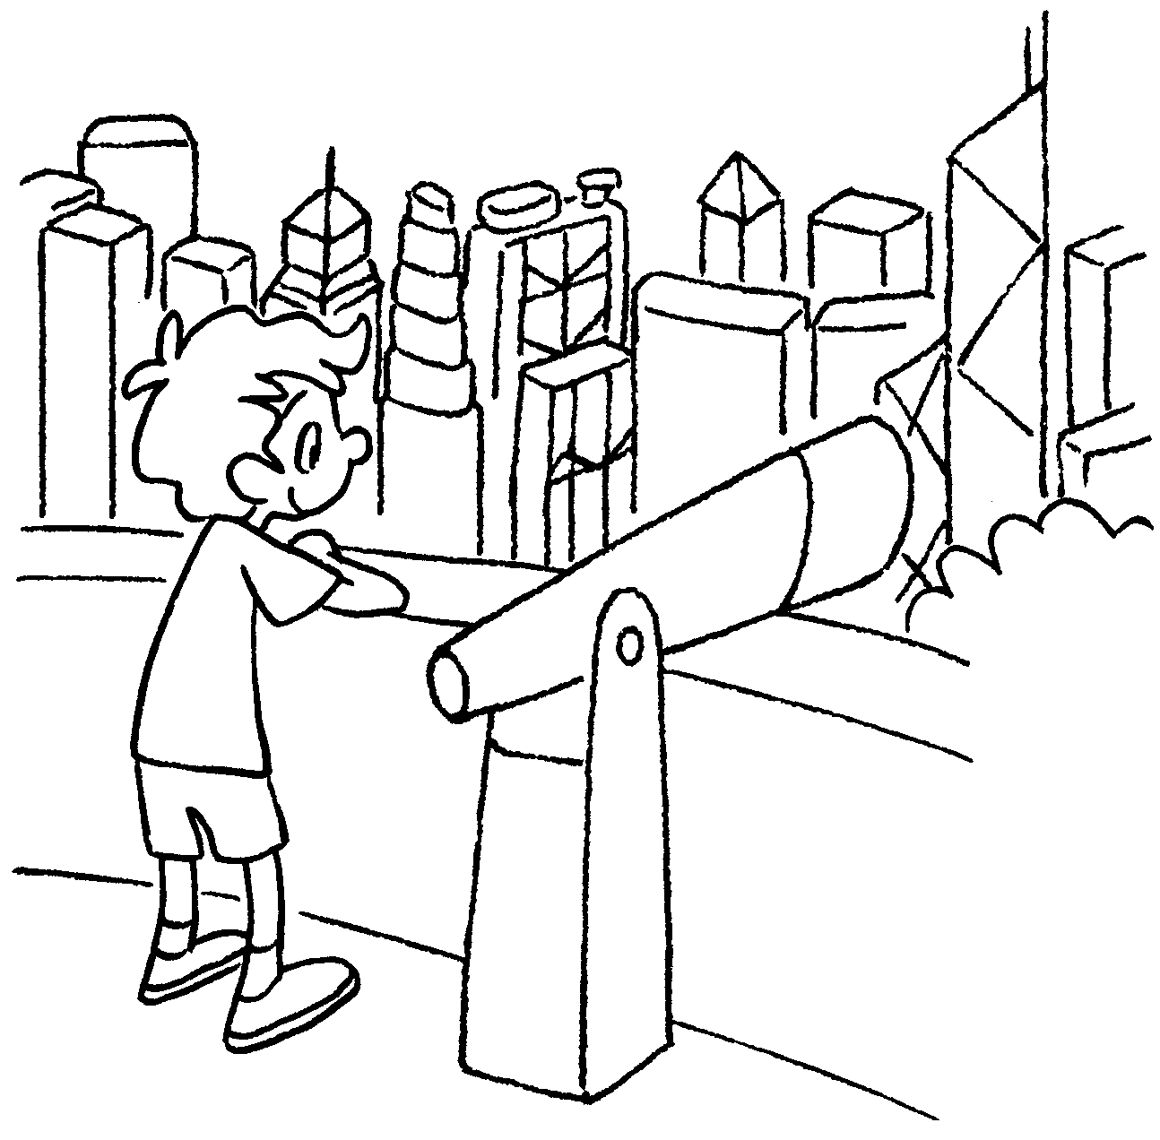

5 | go | 6 | do
7 | eat | 8 | watch the in
9 | look at of

Book 4B Chapter 1 Graded Worksheets
Worksheet 1⬇⬇⬇

Golden Bauhinia Square
- the Big Buddha
- Hong Kong Wetland Park
- the Avenue of Stars
- hiking
- water sports
- seafood
- birds Mai Po
- the view Hong Kong



