RP no: Century Gothic 15pt
(所有圈號用15pt)
Choose and write.

What | Where | will | do | go

B  A | 
1 |  | A : will you go on Monday?  B : I’ll go to Lantau Island.  A : will you do there?  B : I’ll visit the Big Buddha.
2 | 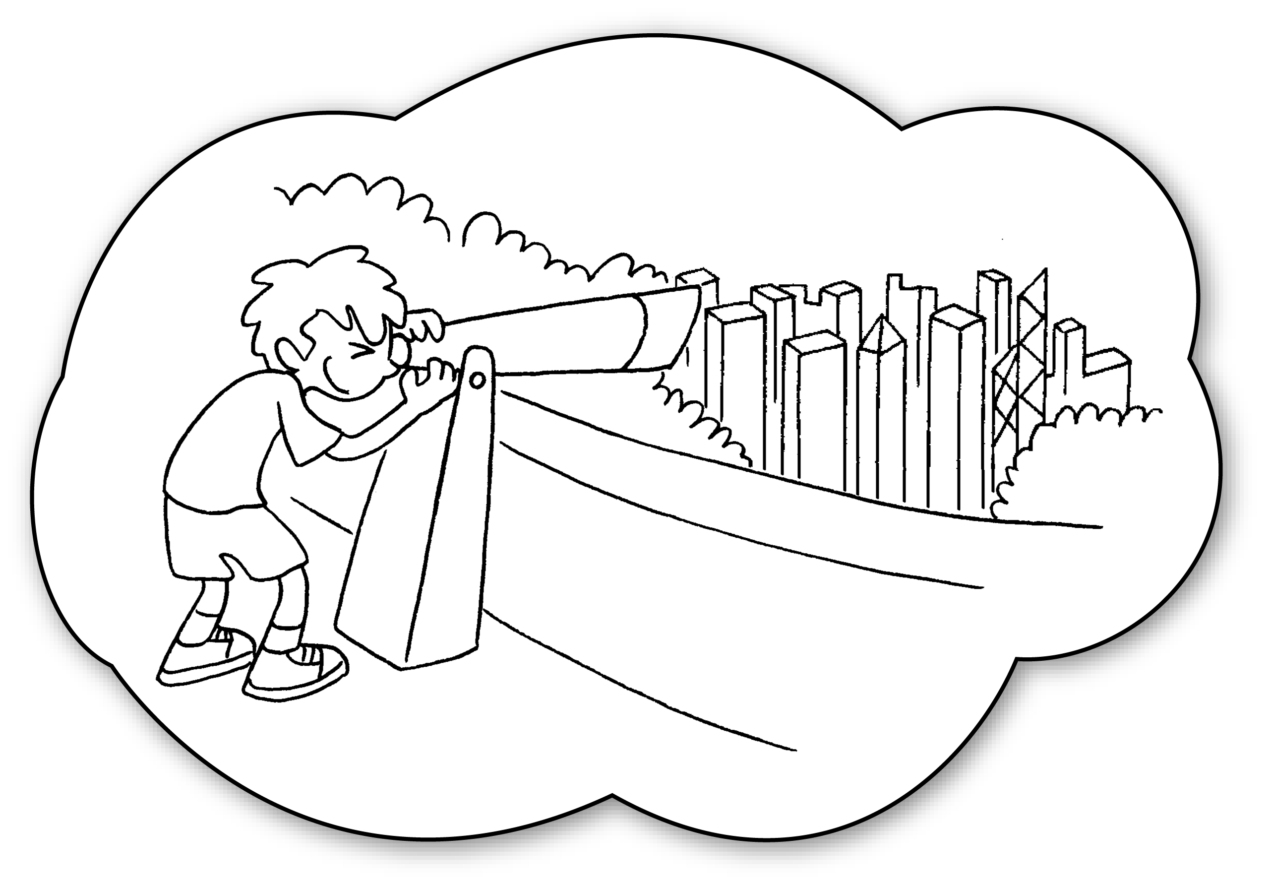 | A : will you  on Tuesday?  B : I’ll go to the Peak.  A : will you there?  B : I’ll look at the view of Hong Kong.
3 |  | A : you  on Wednesday?  B : I’ll go to Aberdeen.  A : you  there?  B : I’ll eat seafood.
RP no: Century Gothic 15pt
(所有圈號用15pt)


Book 4B Chapter 1 Graded Worksheets
Worksheet 2⬇
- Where
What
2 Where go
What do
3 Where will go
What will do

