RP no: Century Gothic 15pt
(所有圈號用15pt)
Finish what the children say.

What | Where

B  A | 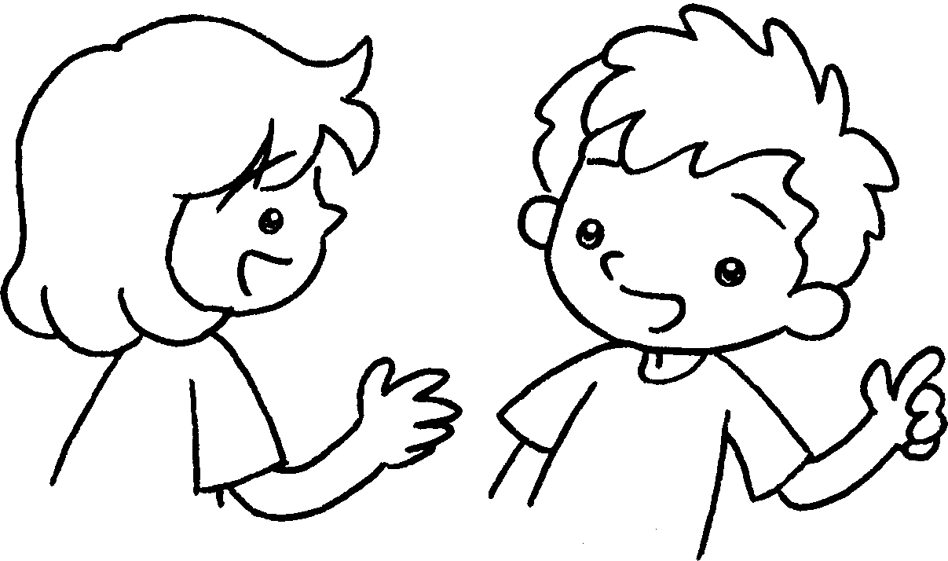
1 | 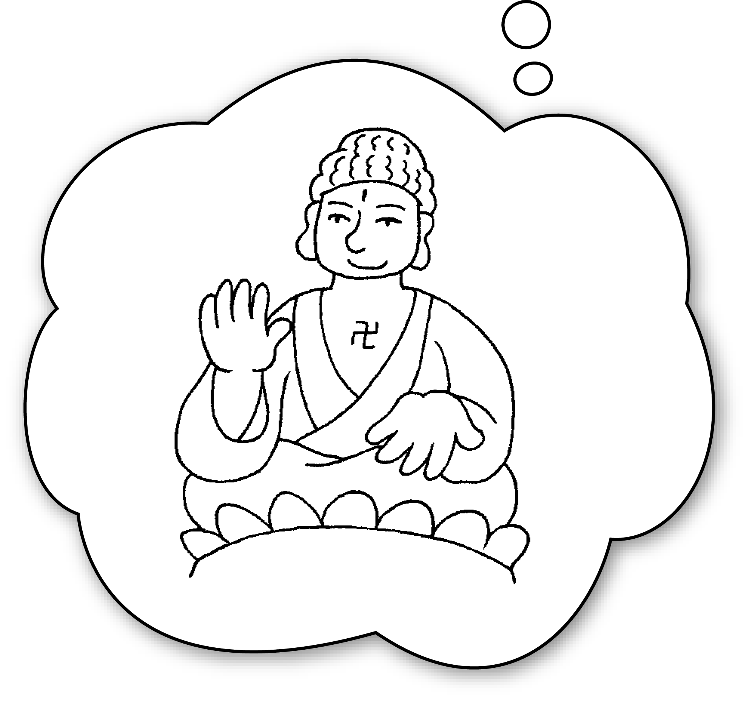  Lantau Island | A : will you go on Monday?  B : I’ll go to .  A : will you do there?  B : I’ll the Big Buddha.
2 | 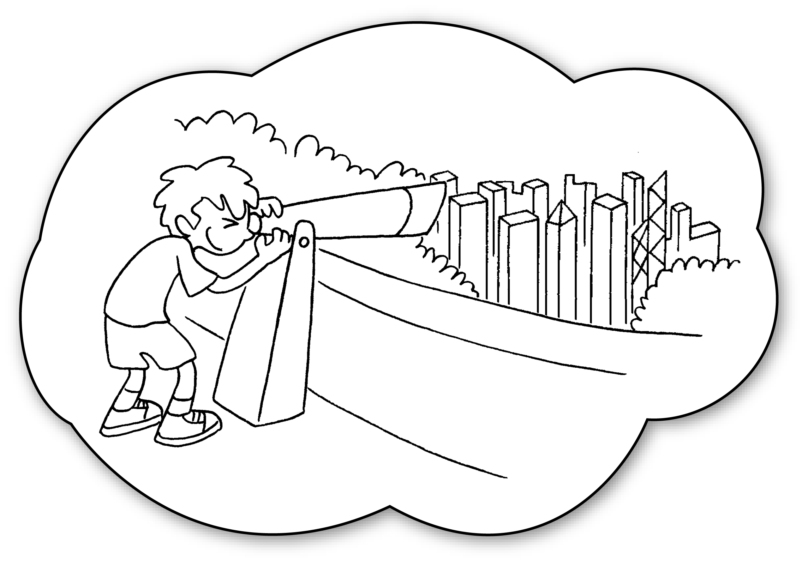  the Peak /  the view of Hong Kong | A : you  on Tuesday?  B : I’ll go to .  A : you do there?  B : I’ll .
3 | 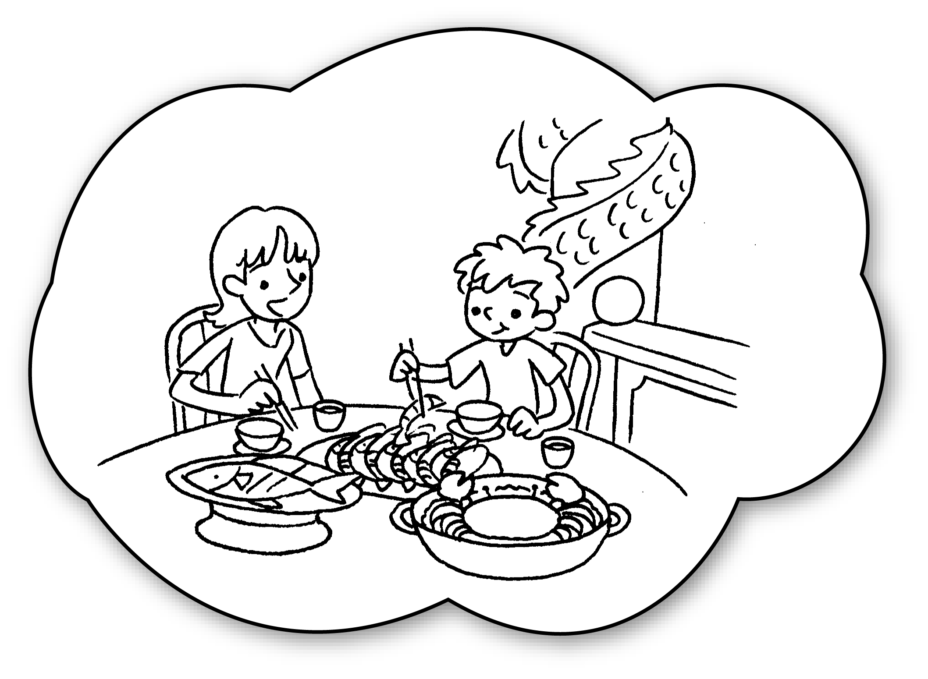  Aberdeen / seafood | A : you  on Wednesday?  B : I’ll go to .  A : there?  B :


Book 4B Chapter 1 Graded Worksheets
Worksheet 2⬇⬇
- Where
Lantau Island
What
visit
2 Where will go
the Peak
What will
look at the view of Hong Kong
3 Where will go
Aberdeen
What will you do
I’ll eat seafood.
(Accept any reasonable answers.)

