Finish what the children say.

B  A | 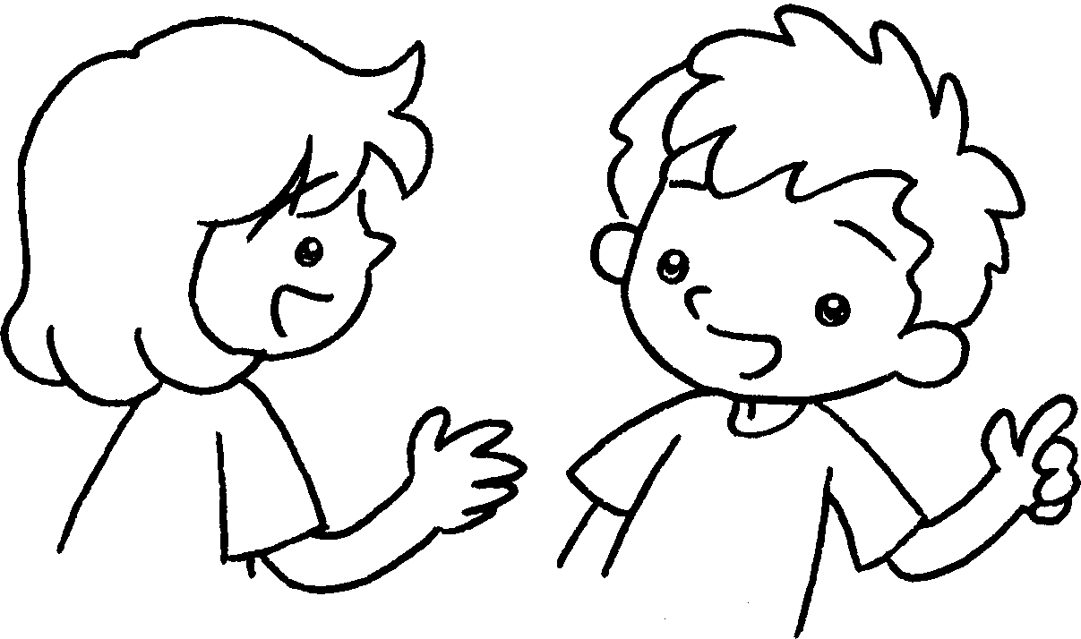
1 | 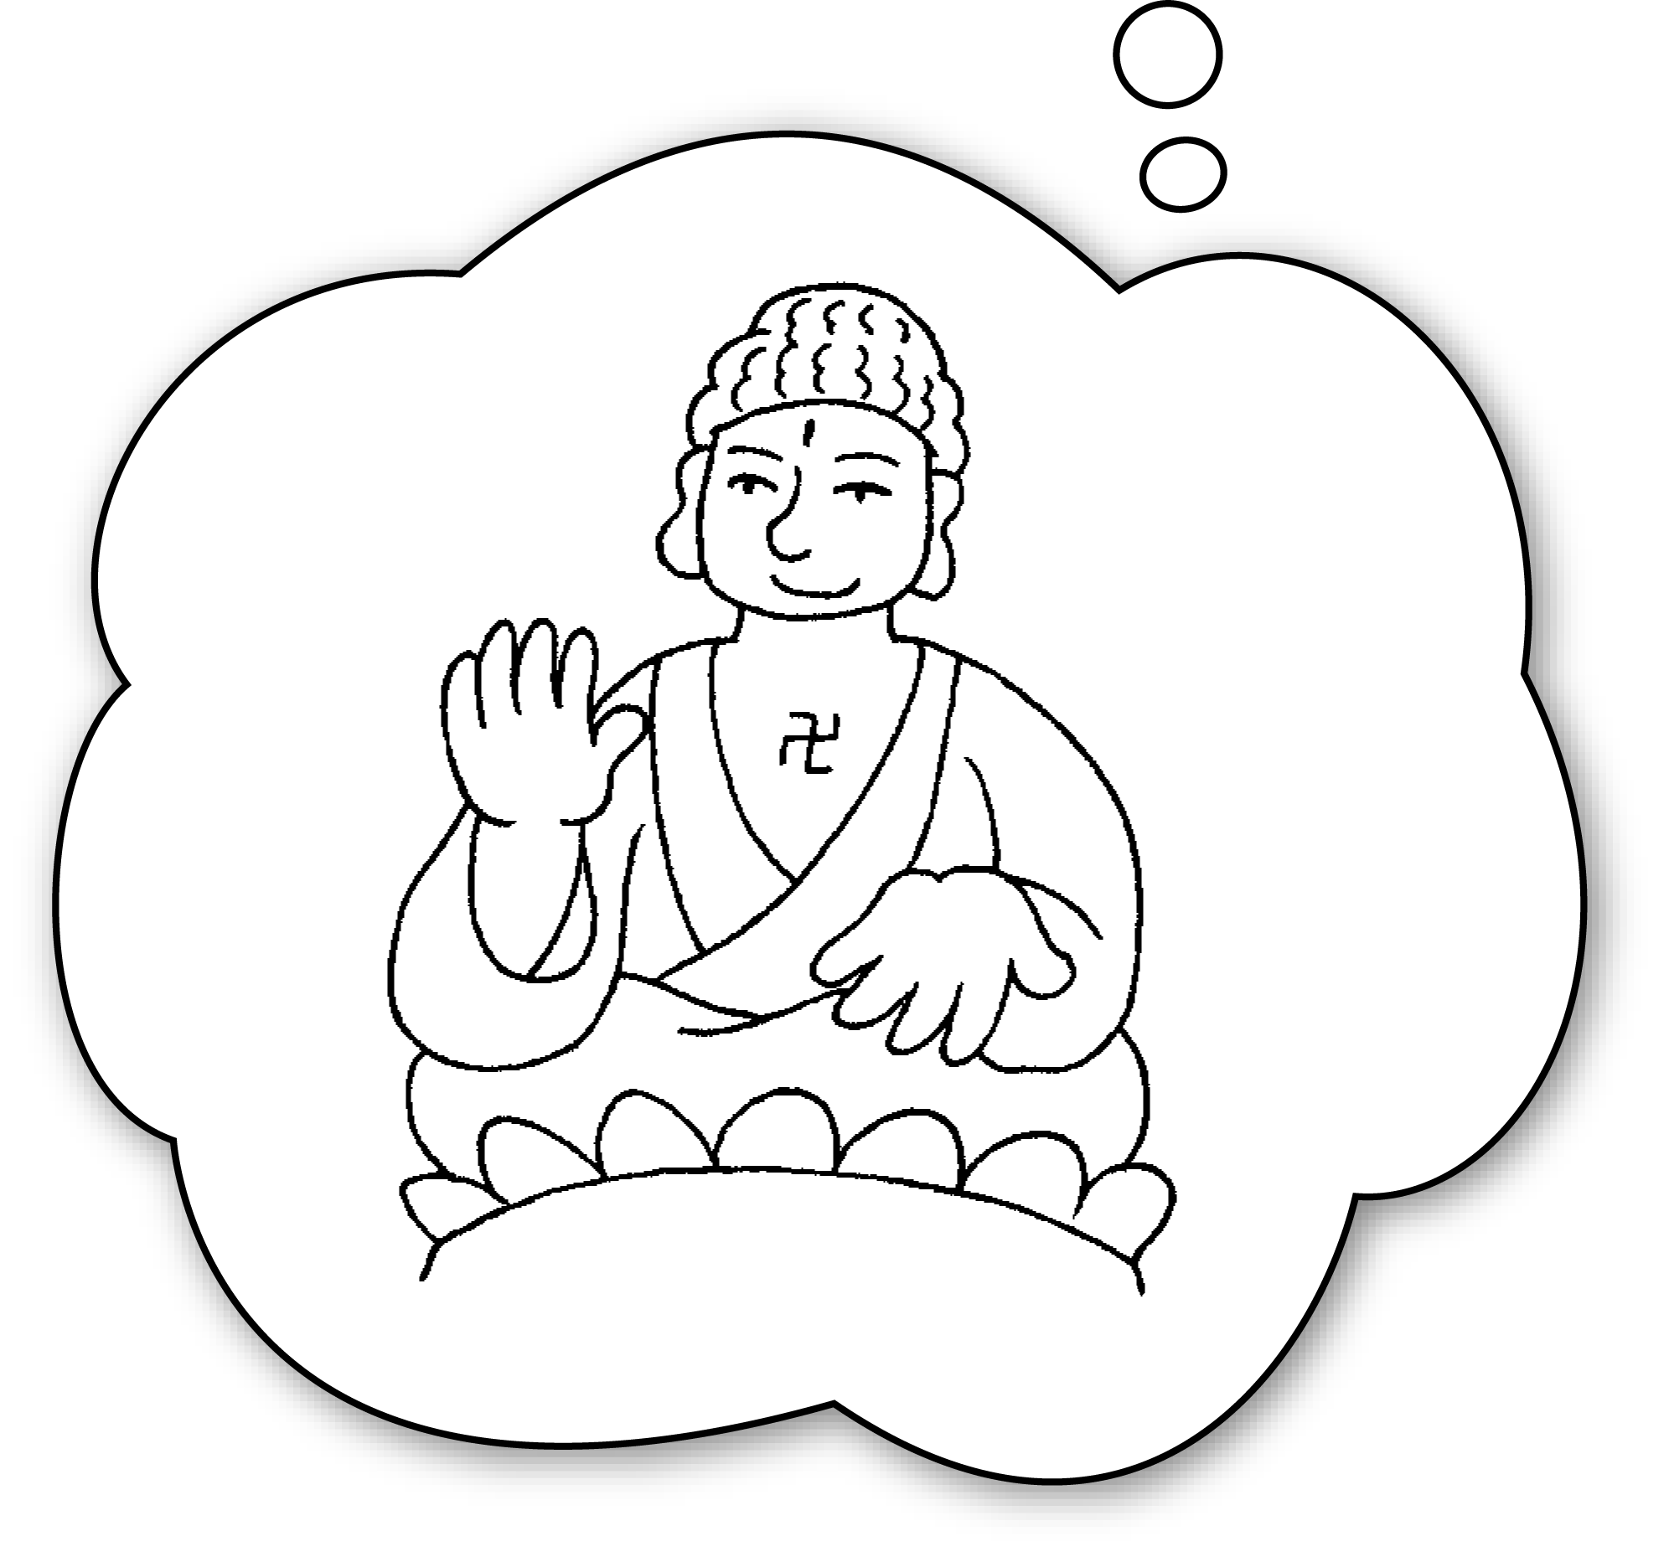  Lantau Island | A : Where will you on Monday?  B : I’ll go to .  A : What will you there?  B : I’ll the Big Buddha.
2 | 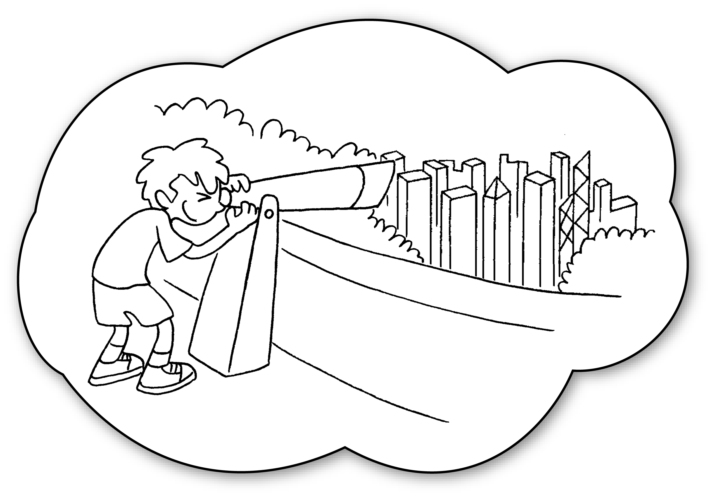  the Peak | A : you  on Tuesday?  B : I’ll go to .  A : you do there?  B : I’ll look at .
3 | 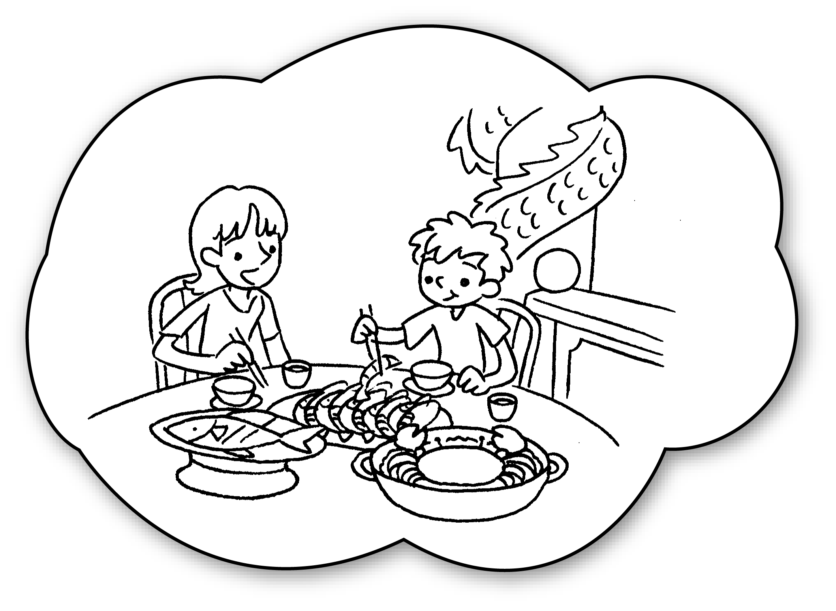  Aberdeen | A :  on Wednesday?  B : I’ll go to .  A : there?  B :

Book 4B Chapter 1 Graded Worksheets
Worksheet 2⬇⬇⬇
- go
Lantau Island
do
visit
2 Where will go
the Peak
What will
the view of Hong Kong
3 Where will you go

Aberdeen
What will you do
I’ll eat seafood.
(Accept any reasonable answers.)

