Choose and write.

B  A | 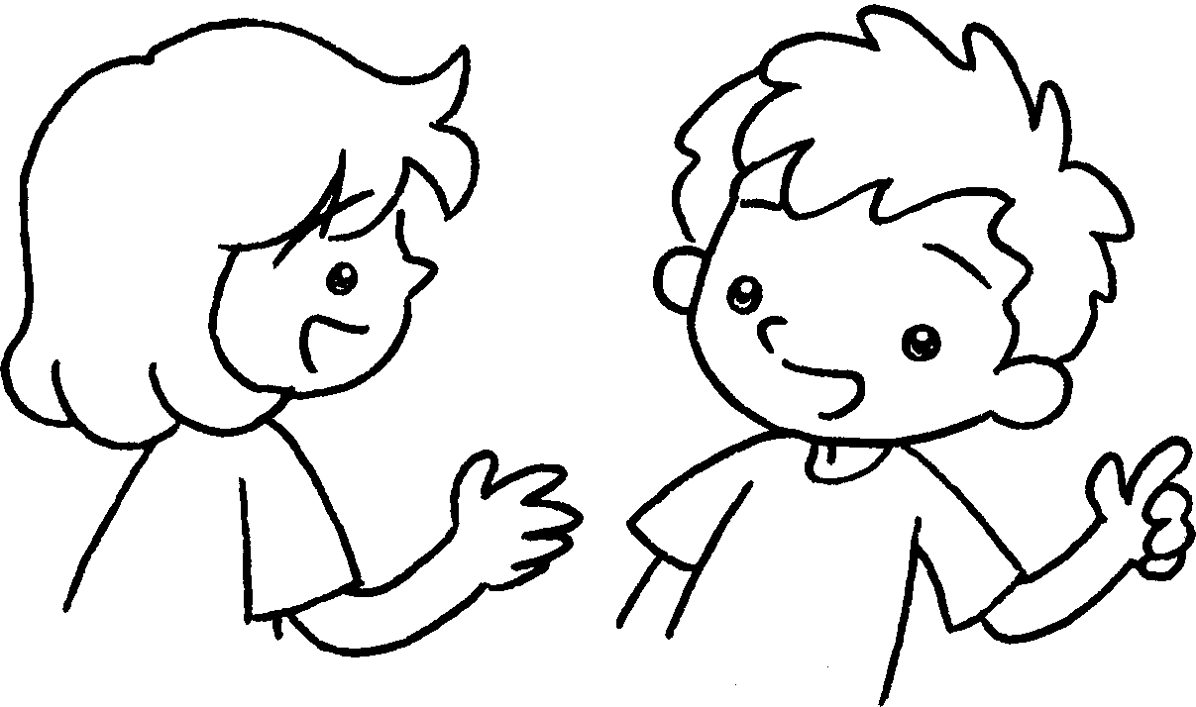 | No  won’t  Yes  will
1  ✓ | 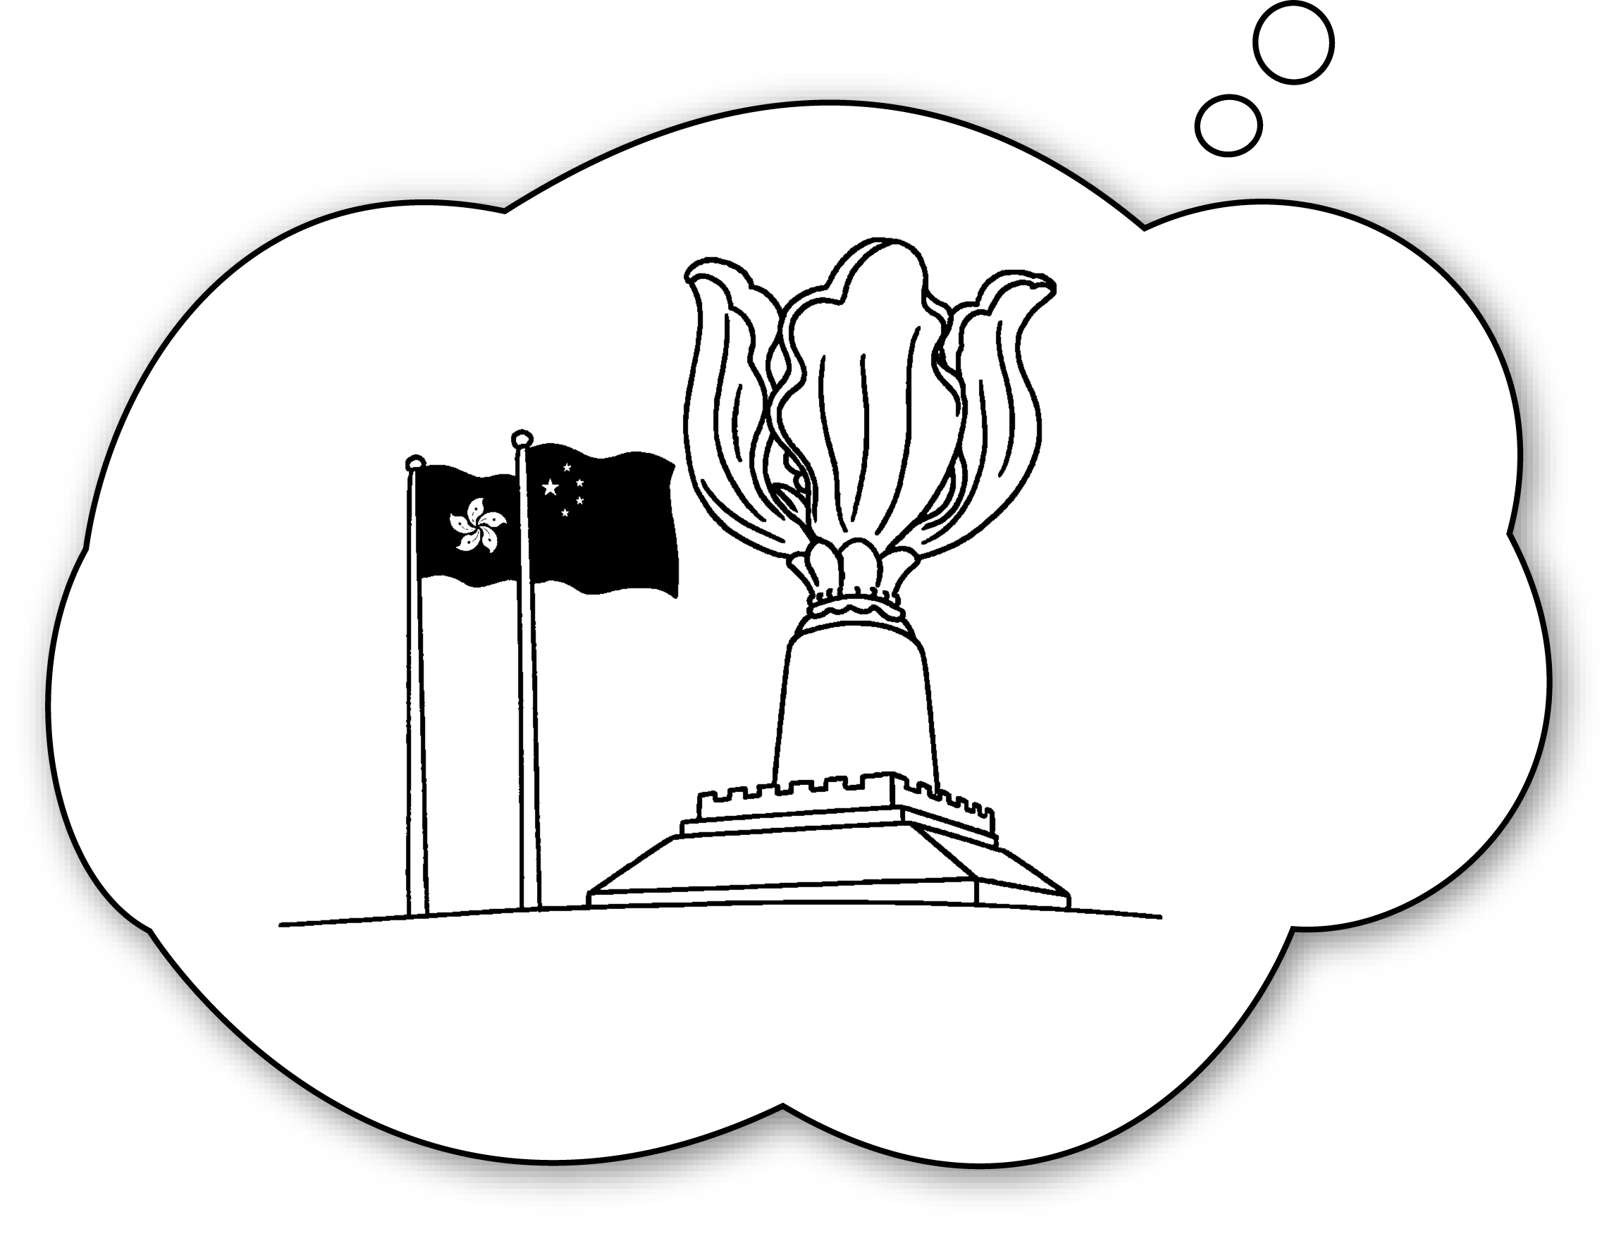 | A : you go to Wan Chai?  B : Yes, I will.
2  ✗ | 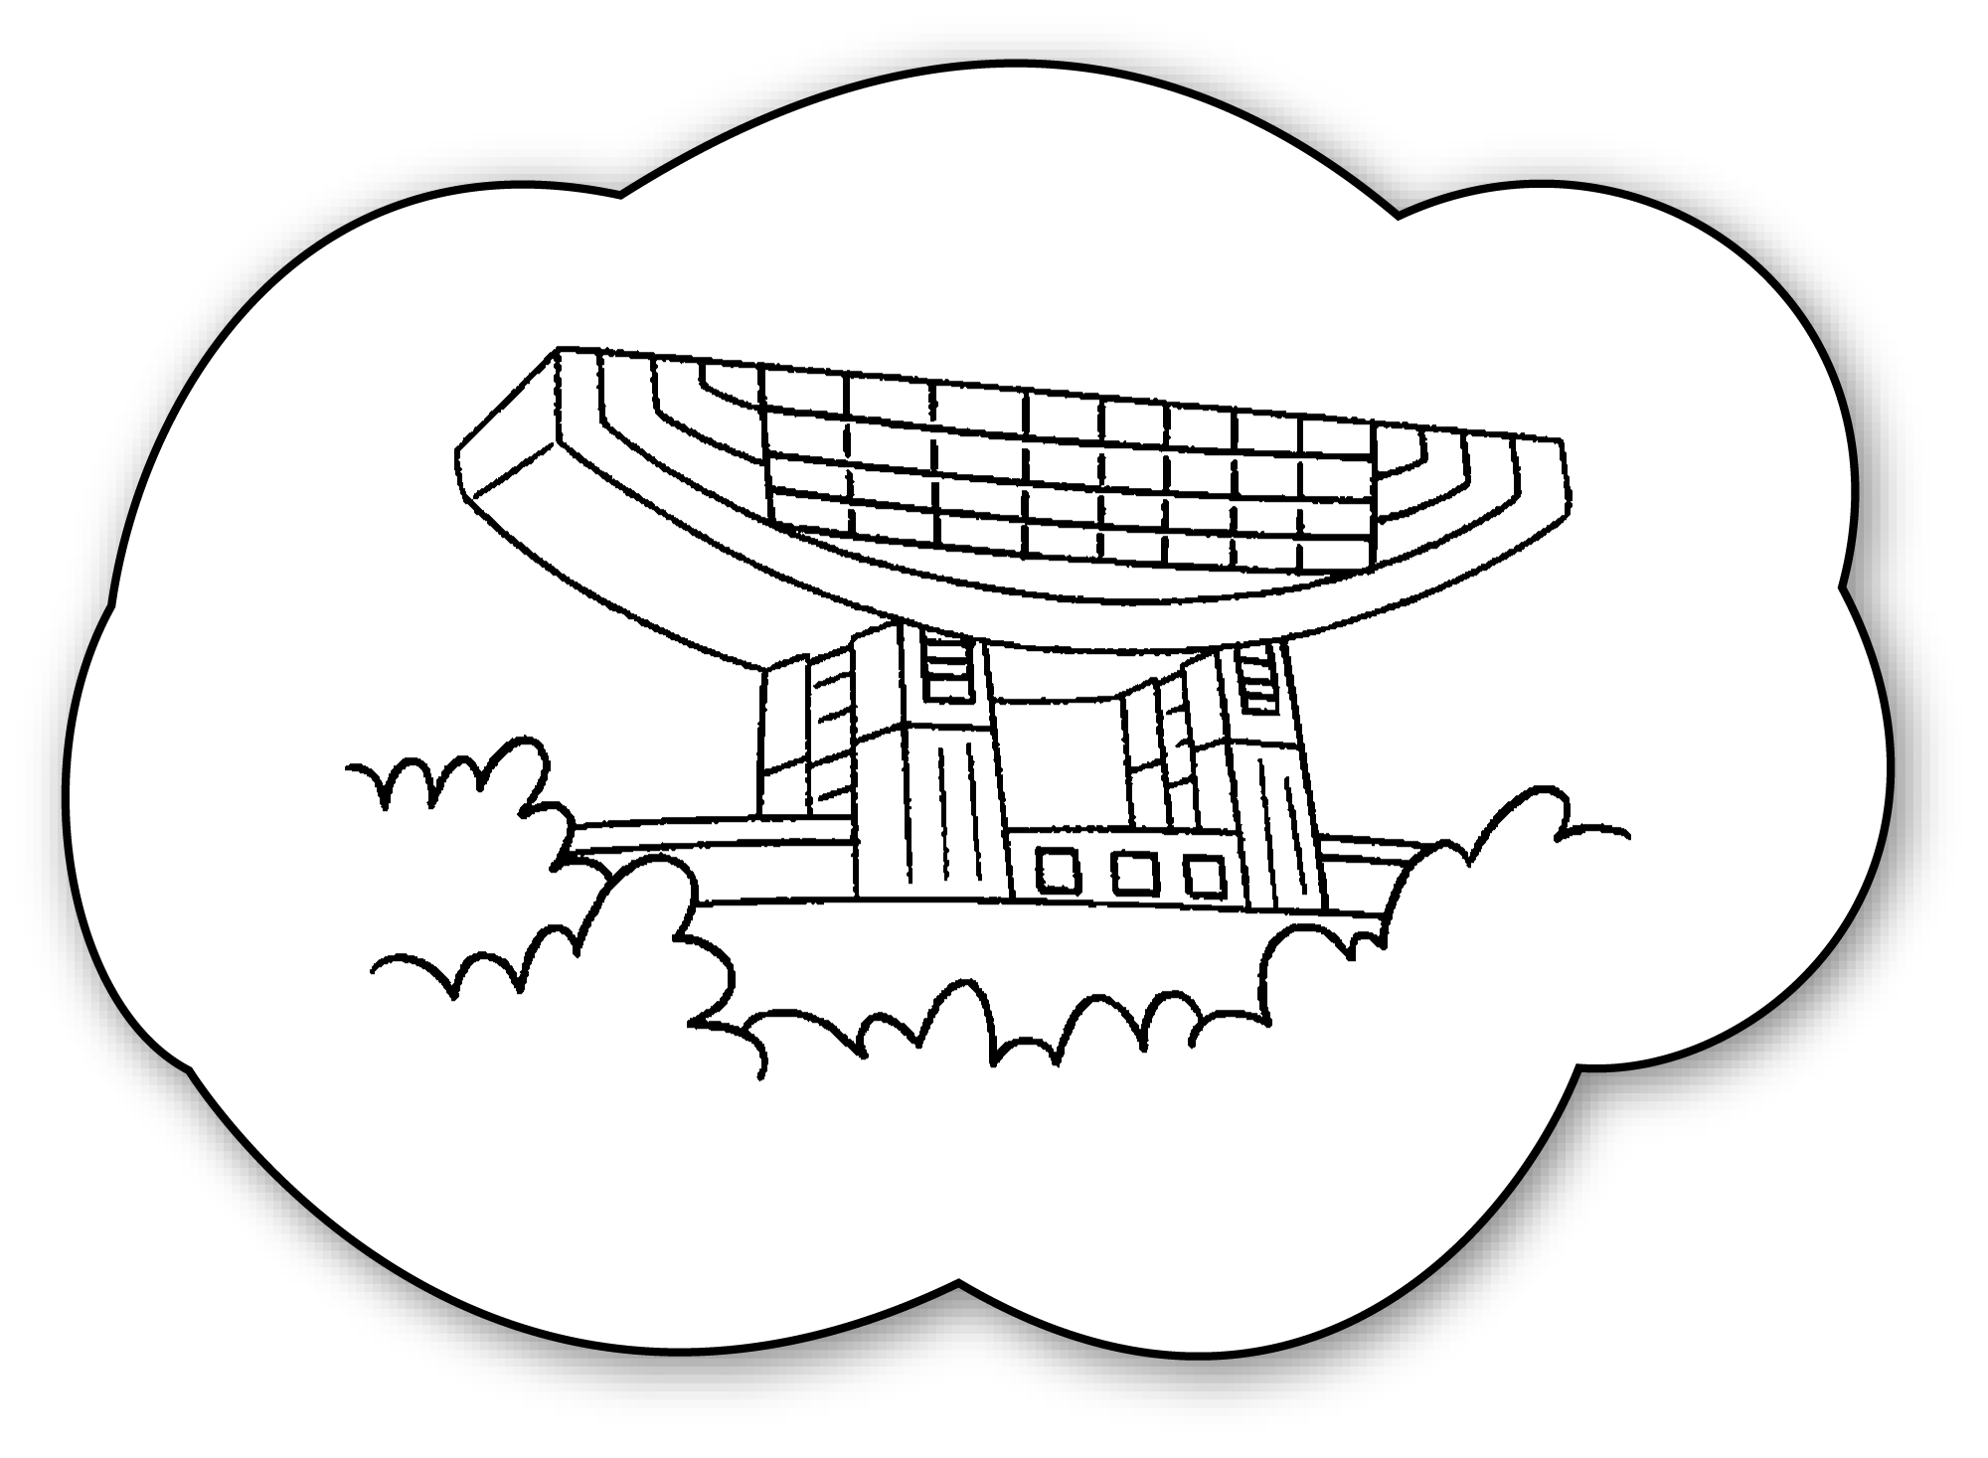 | A : Will you go to the Peak?  B : , I .
3  ✓ | 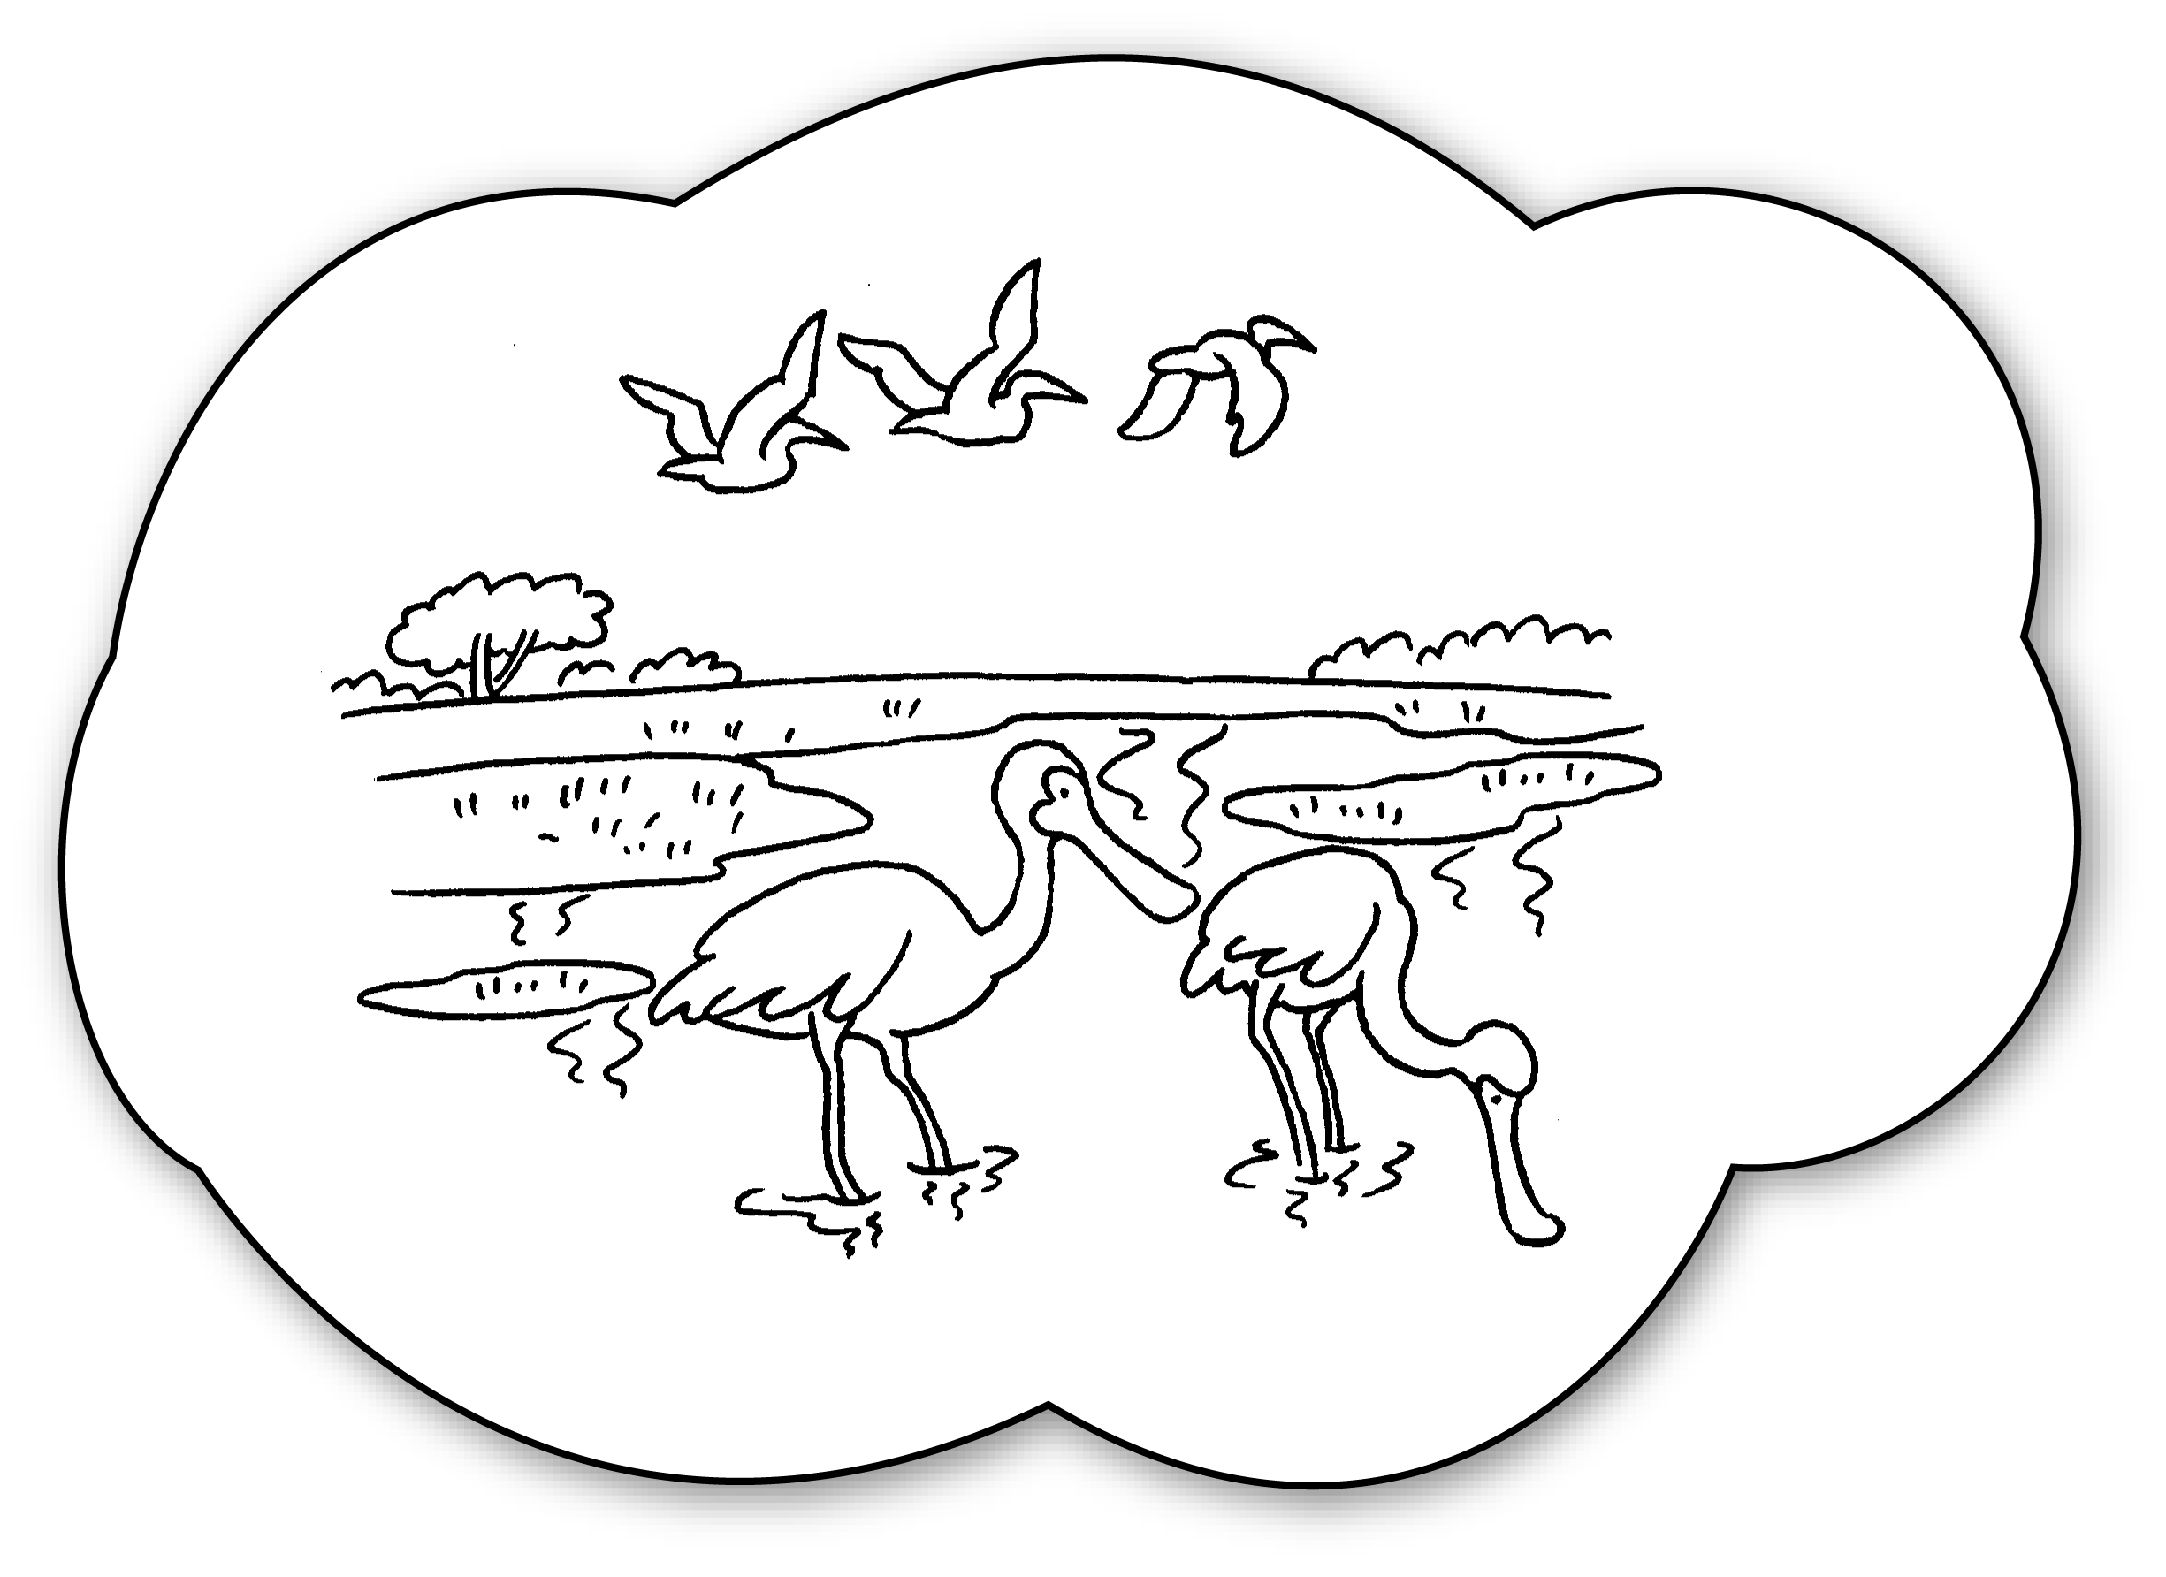 | A : Will you go to Mai Po?  B : , I .
4  ✓ | 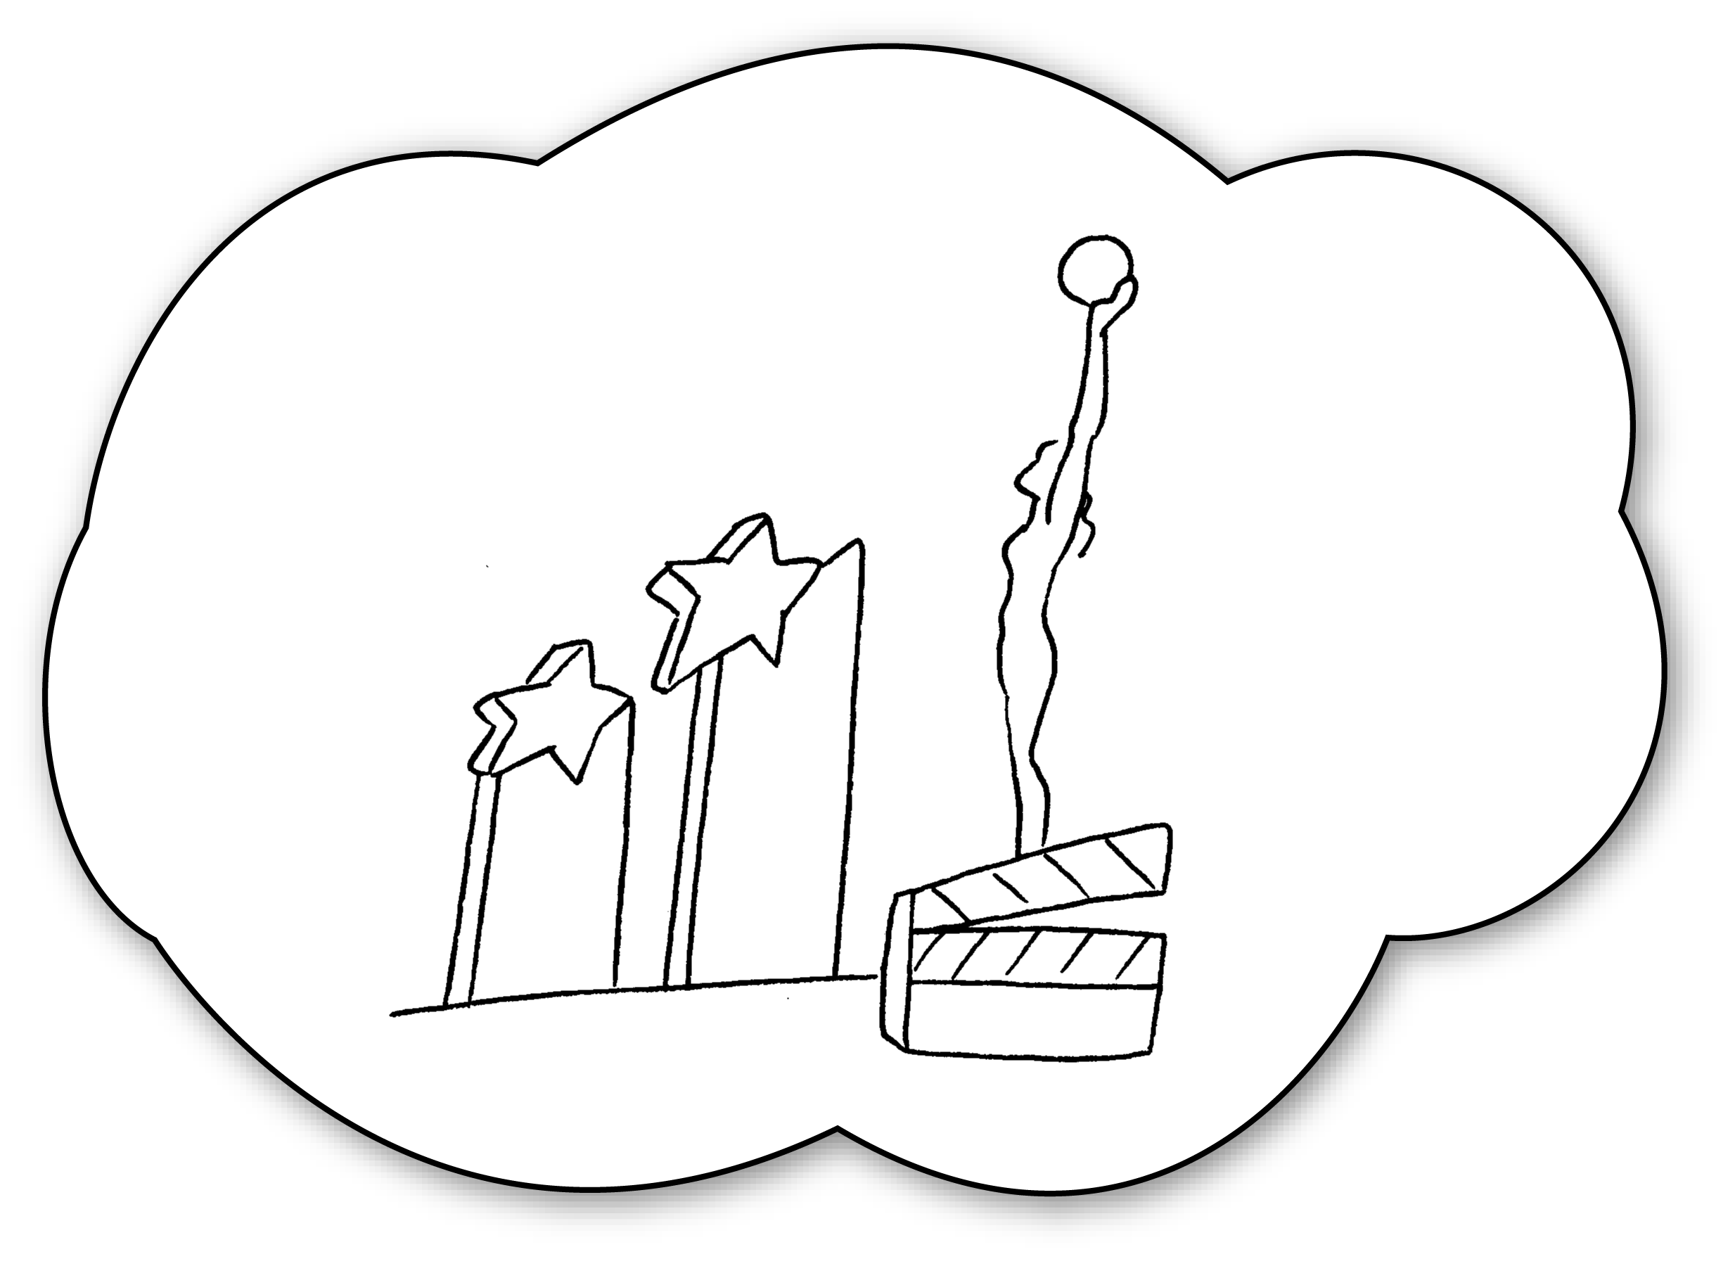 | A : you go to Tsim Sha Tsui?  B : , I .
5  ✗ | 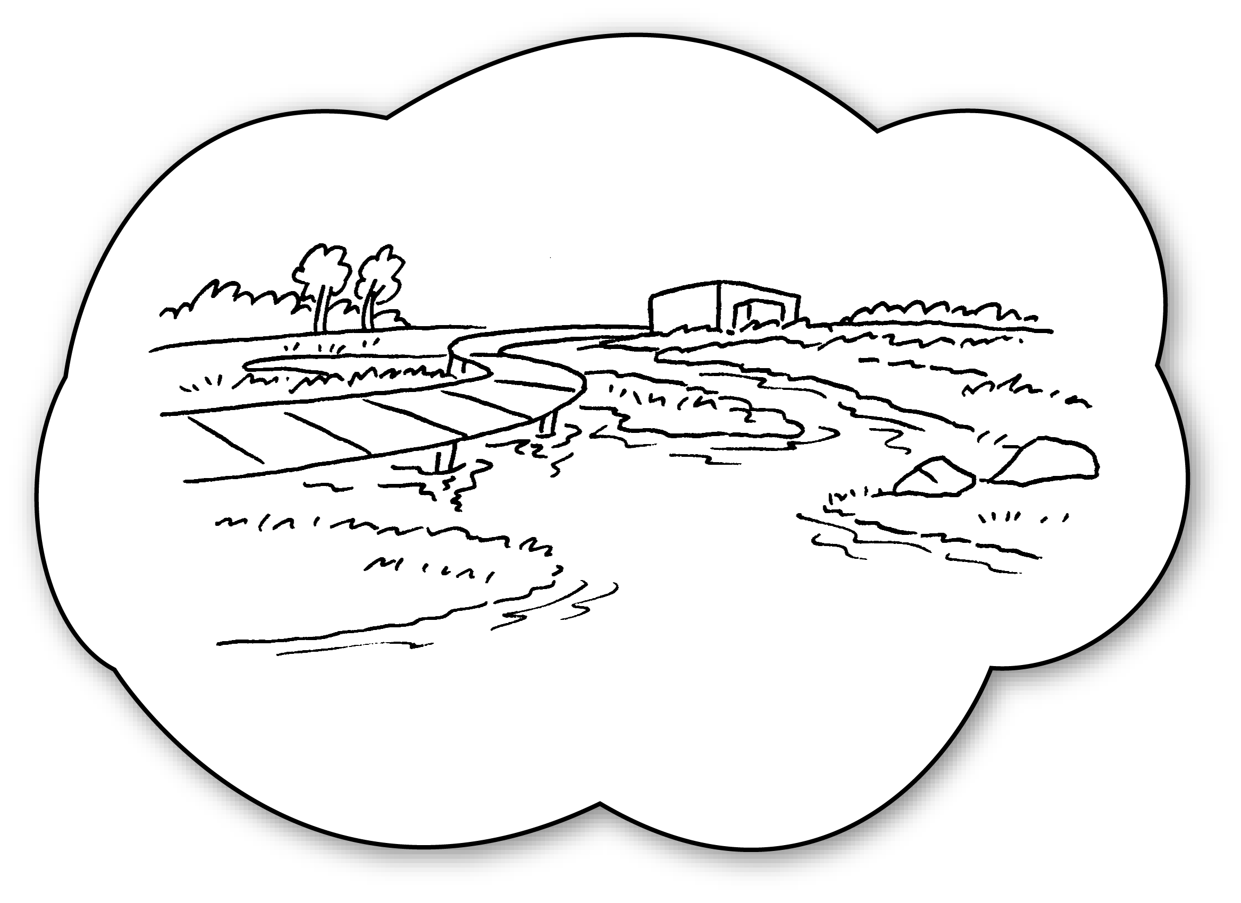 | A : you go to Tin Shui Wai?  B : , I .


Book 4B Chapter 1 Graded Worksheets
Worksheet 3⬇
- Will
- No won’t
- Yes will
- Will
Yes will
- Will
No won’t

