Finish what the children say.

B  A | 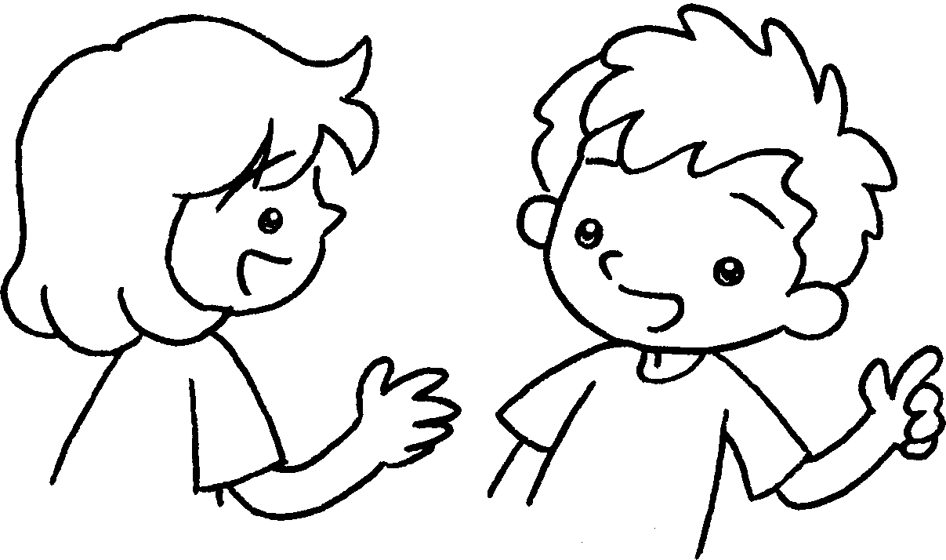 | won’t  will
1  ✓ | 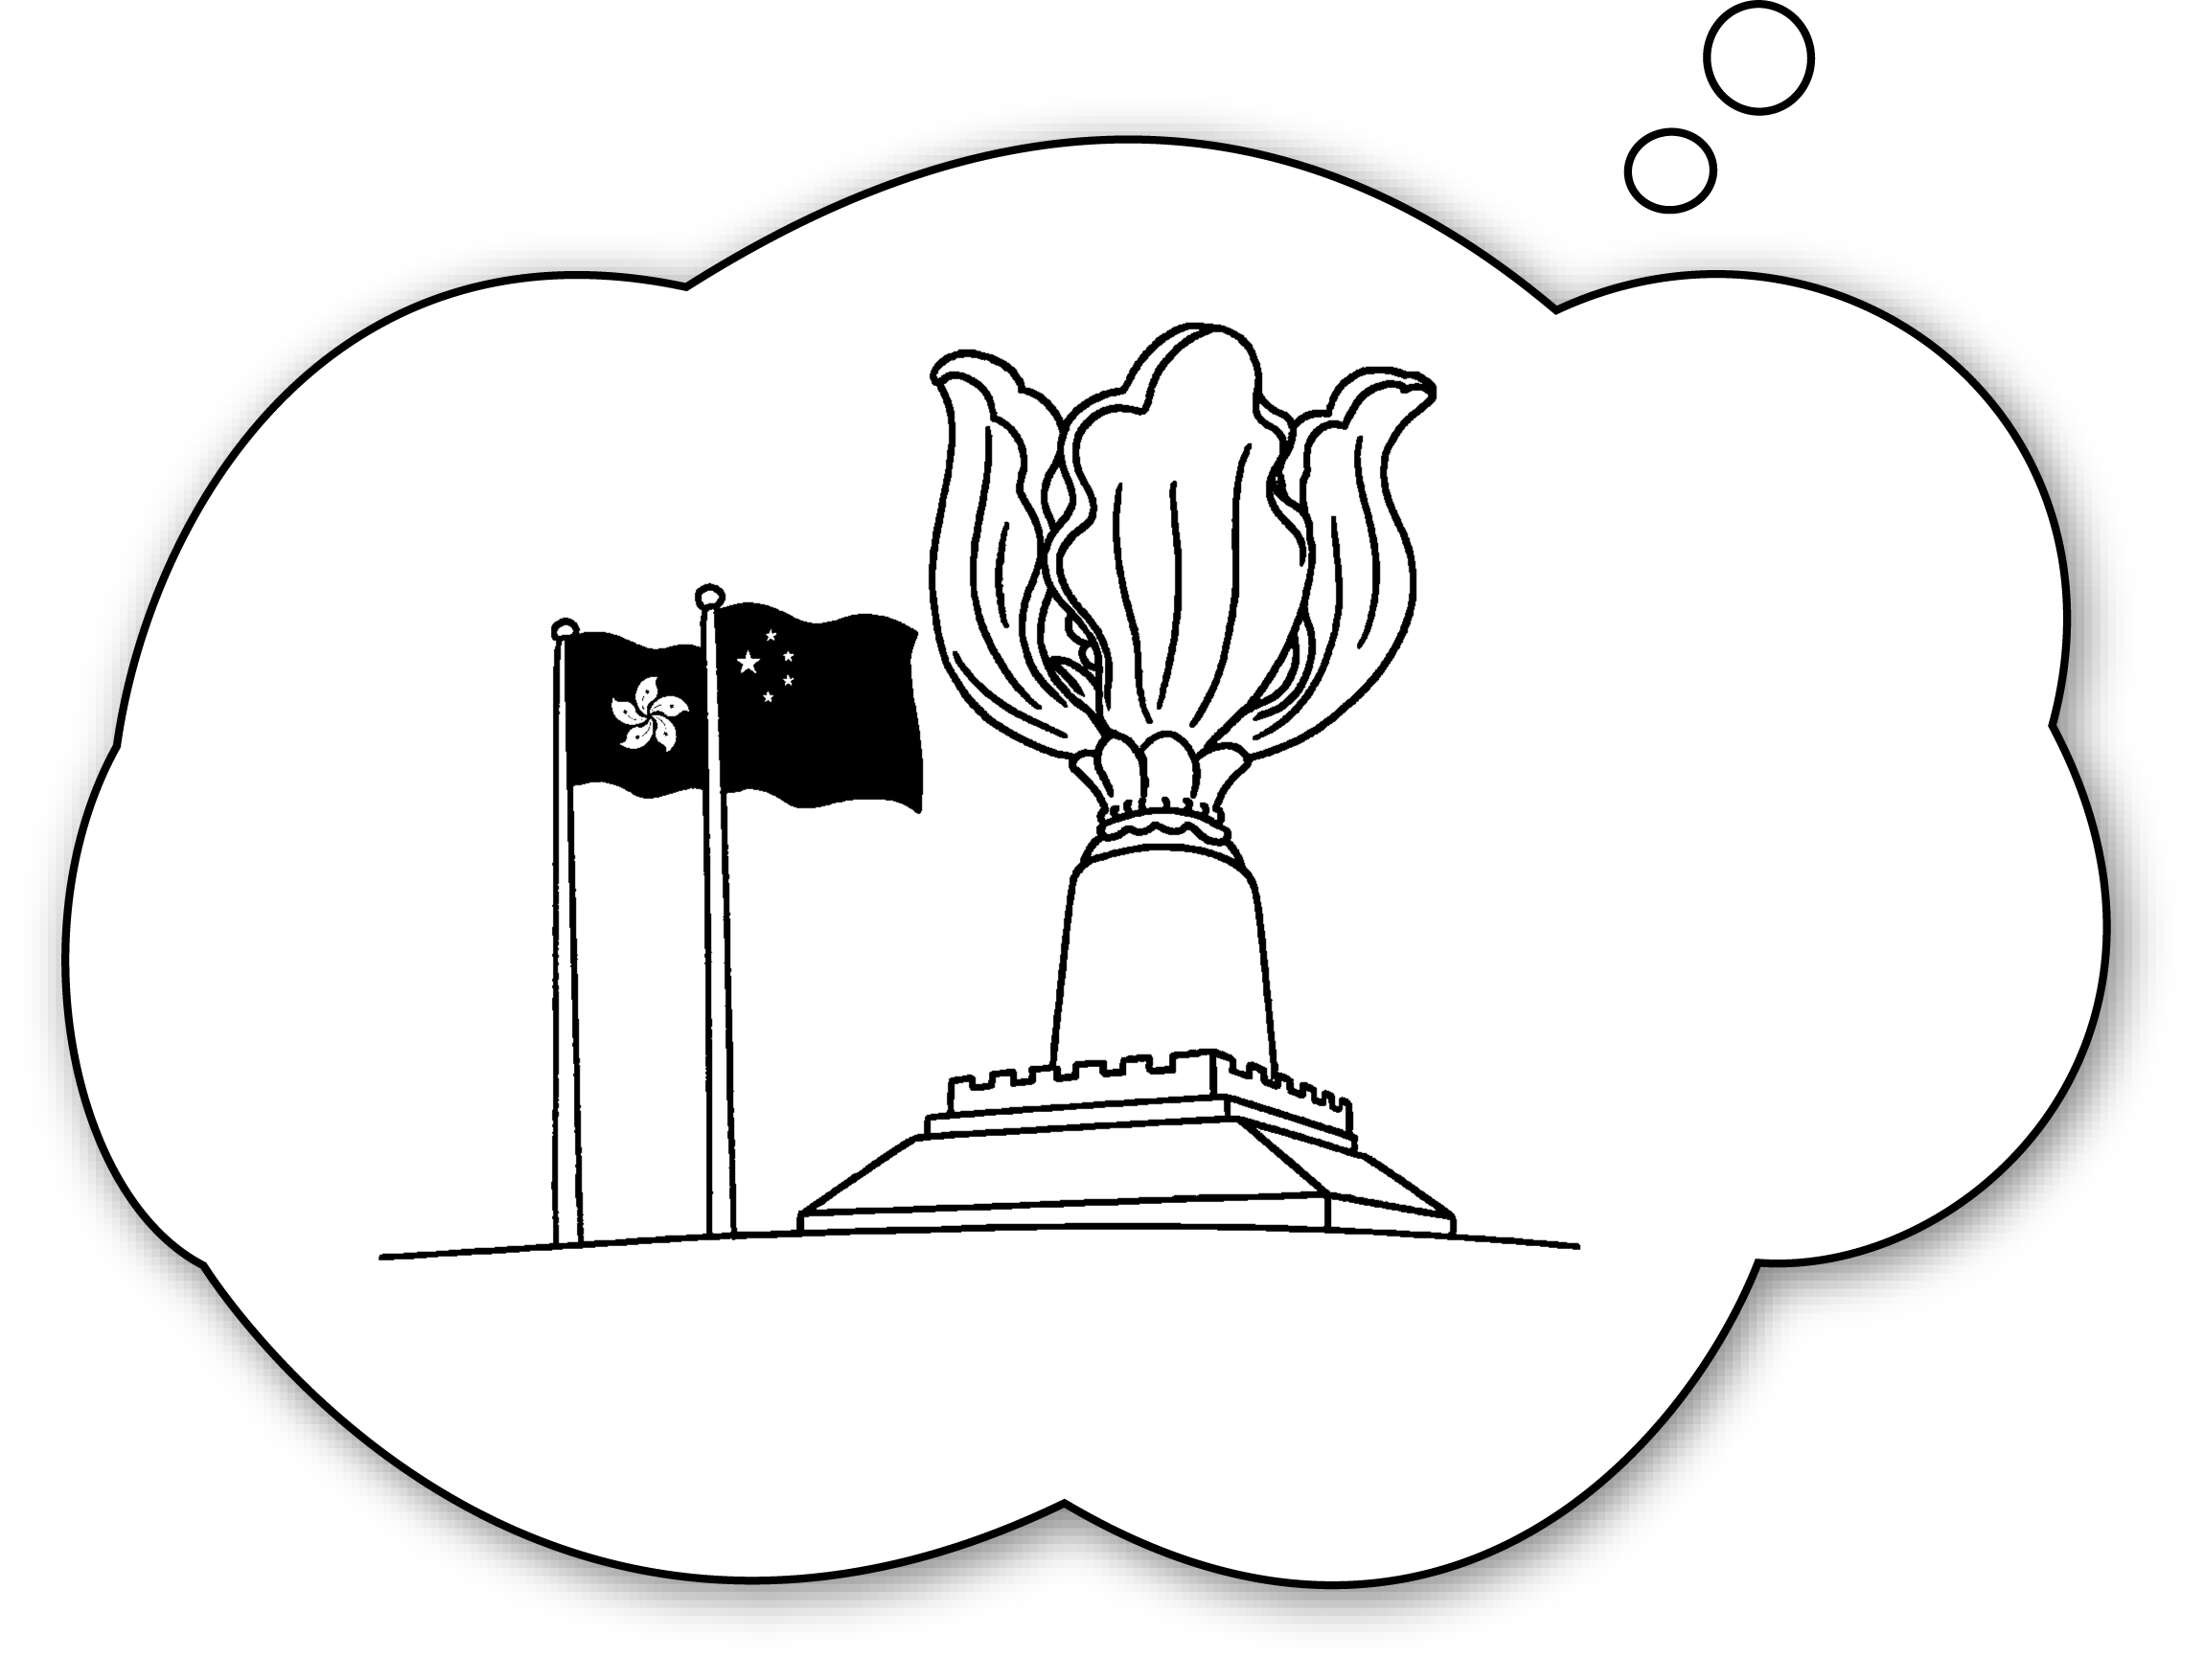 | A : you go to Wan Chai?  B : Yes, I will.
2  ✗ | 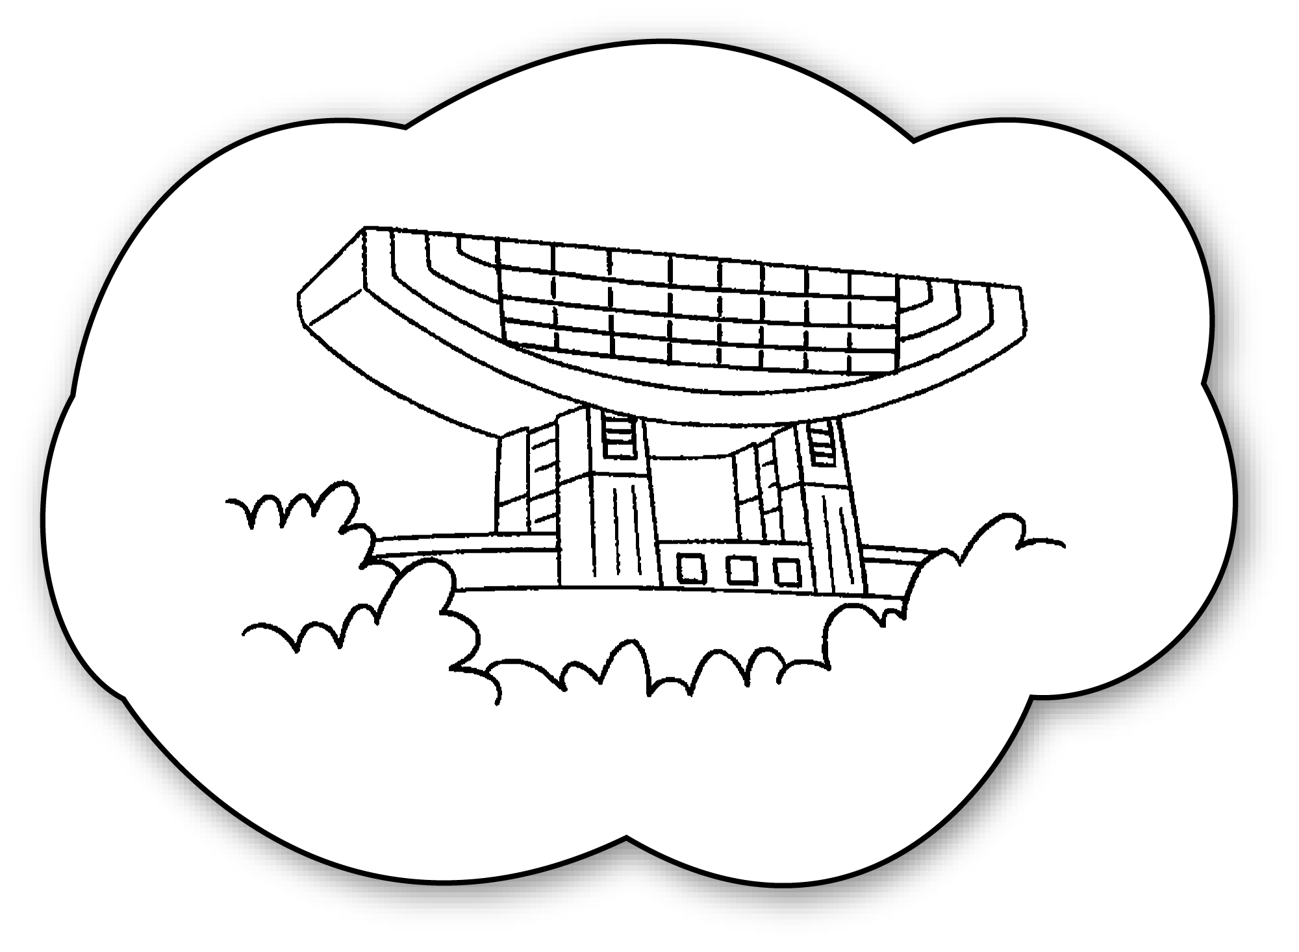  the Peak | A : Will you go to ?  B : , I .
3  ✓ | 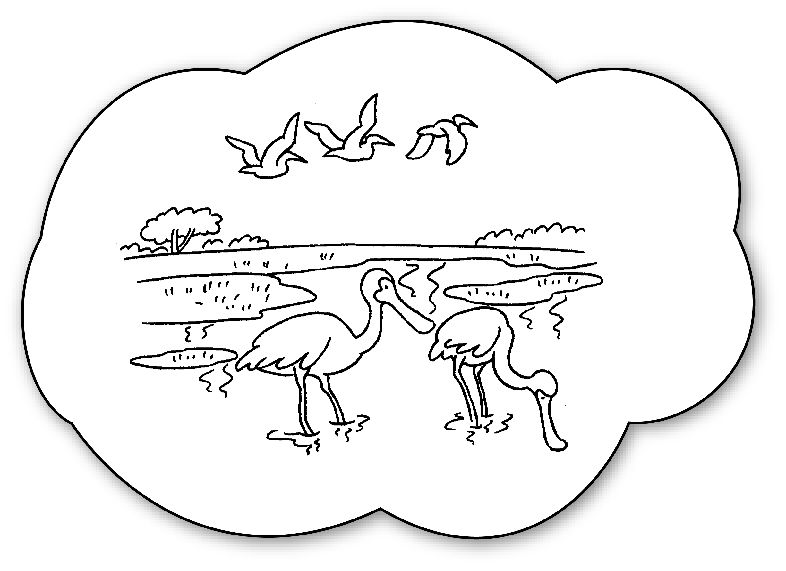  Mai Po | A : you go to  ?  B : , I .
4  ✓ | 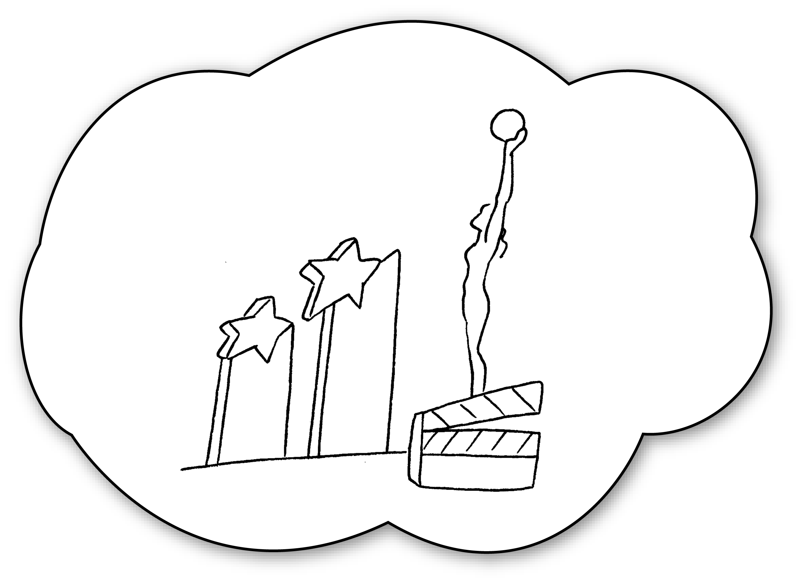  Tsim Sha Tsui | A : _____________________________________  _____________________________________  B : _____________________________________
5  ✗ | 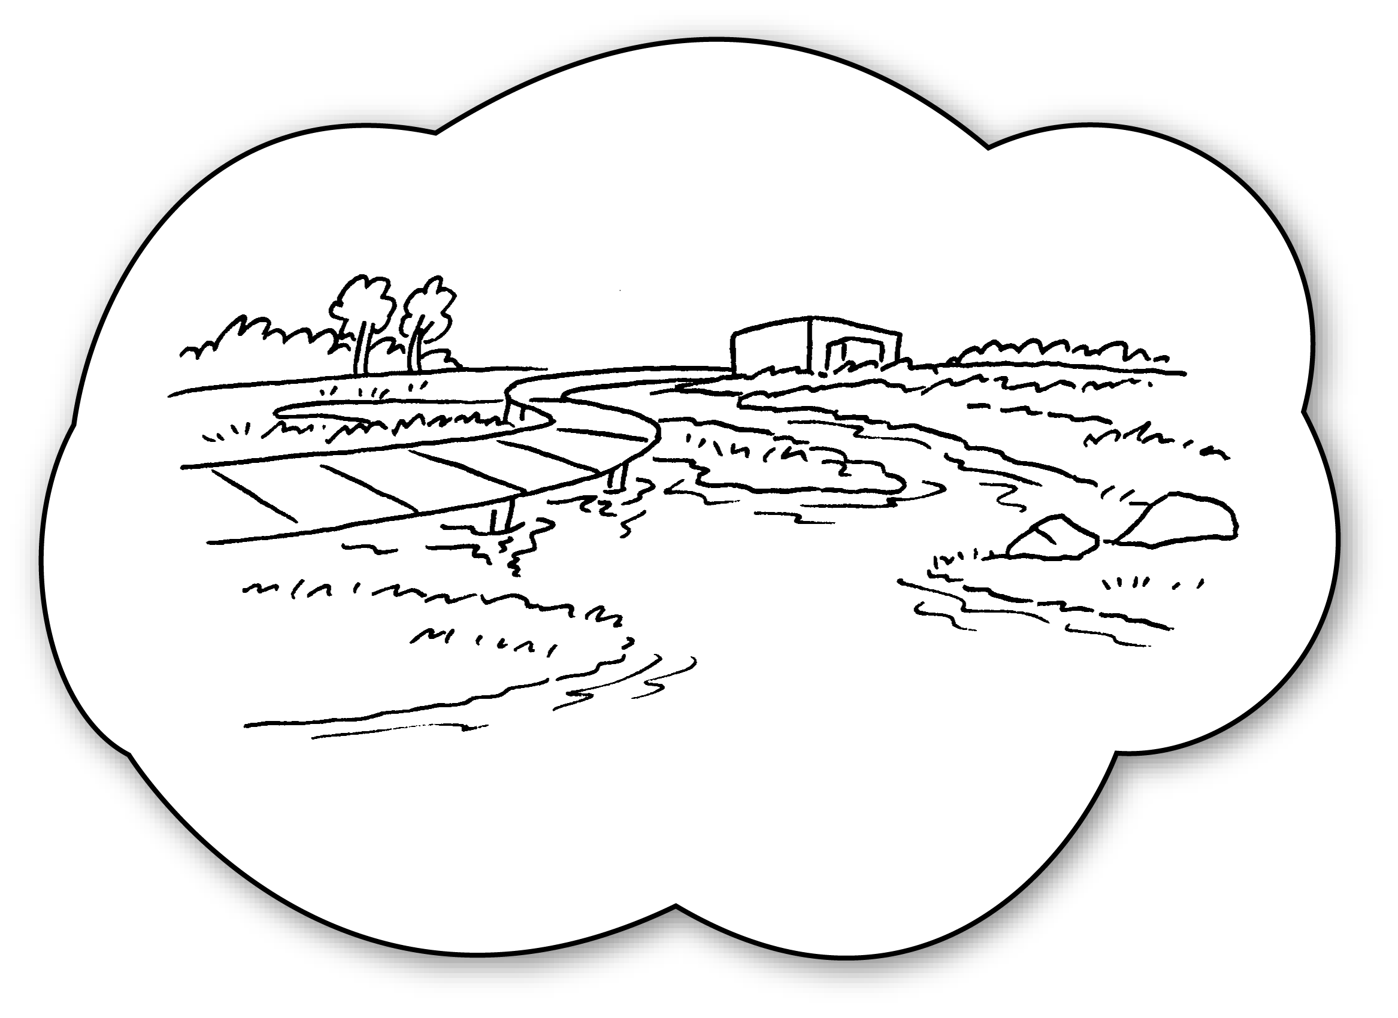  Tin Shui Wai | A : _____________________________________  _____________________________________  B : _____________________________________


Book 4B Chapter 1 Graded Worksheets
Worksheet 3⬇⬇
- Will
- the Peak
No won’t
3 Will Mai Po
Yes will
4 Will you go to Tsim Sha Tsui?
Yes, I will.
5 Will you go to Tin Shui Wai?
No, I won’t.

