Finish what the children say.

B  A | 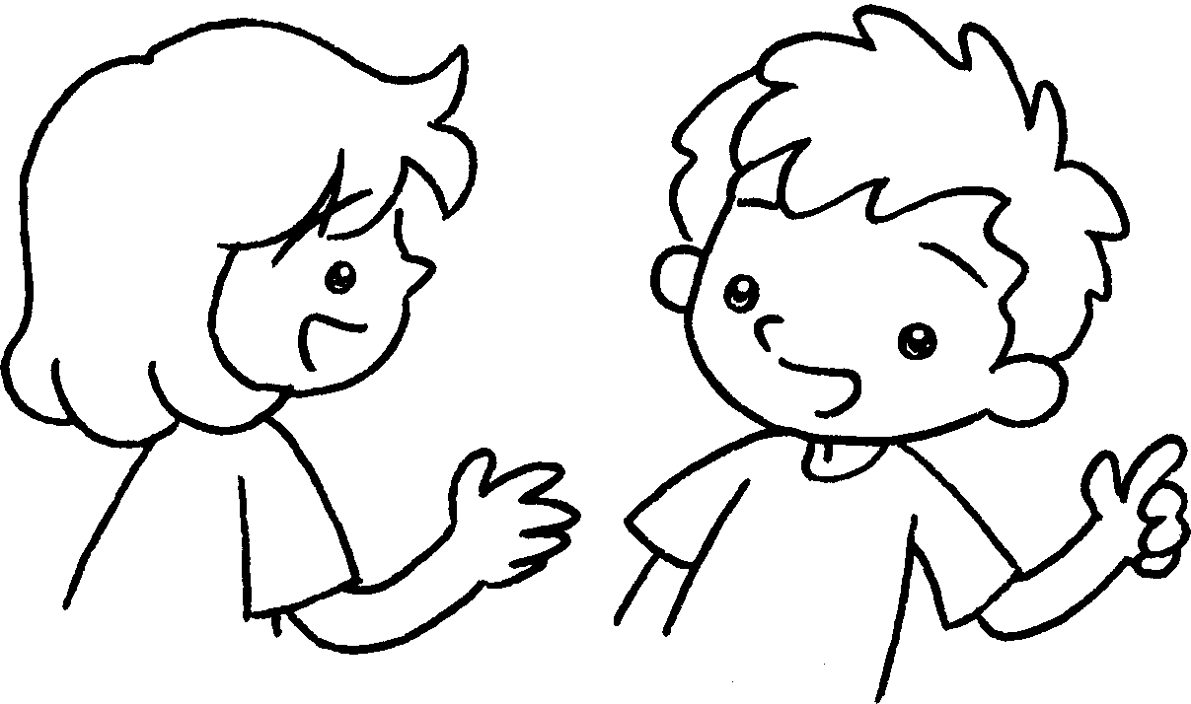 | Tsim Sha Tsui Mai Po  Tin Shui Wai the Peak
1  ✓ | 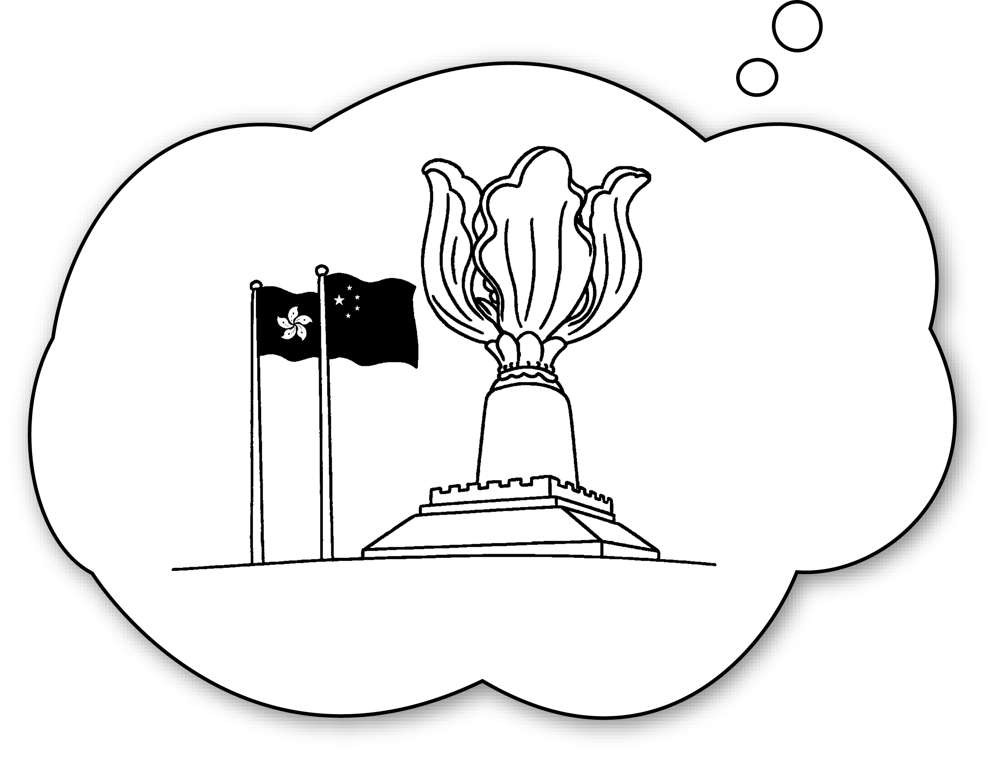 | A : you go to Wan Chai?  B : Yes, I will.
2  ✗ | 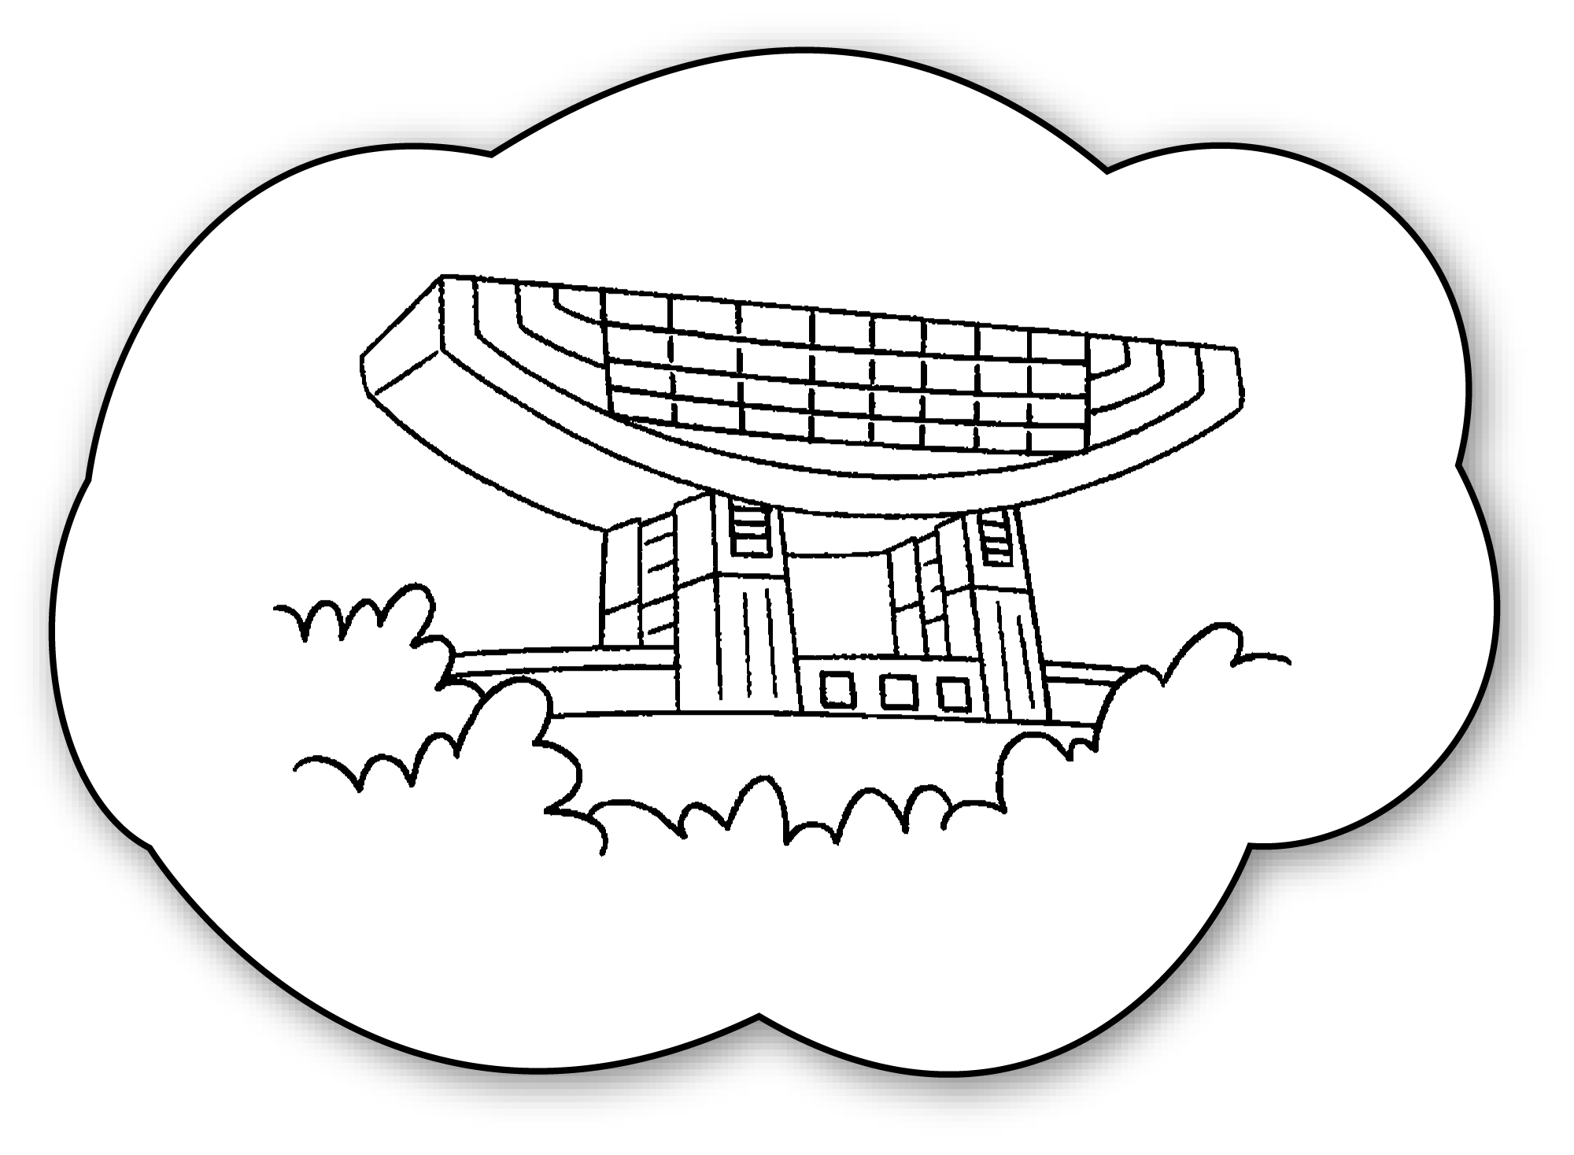 | A : you go to  ?  B : , I won’t.
3  ✓ | 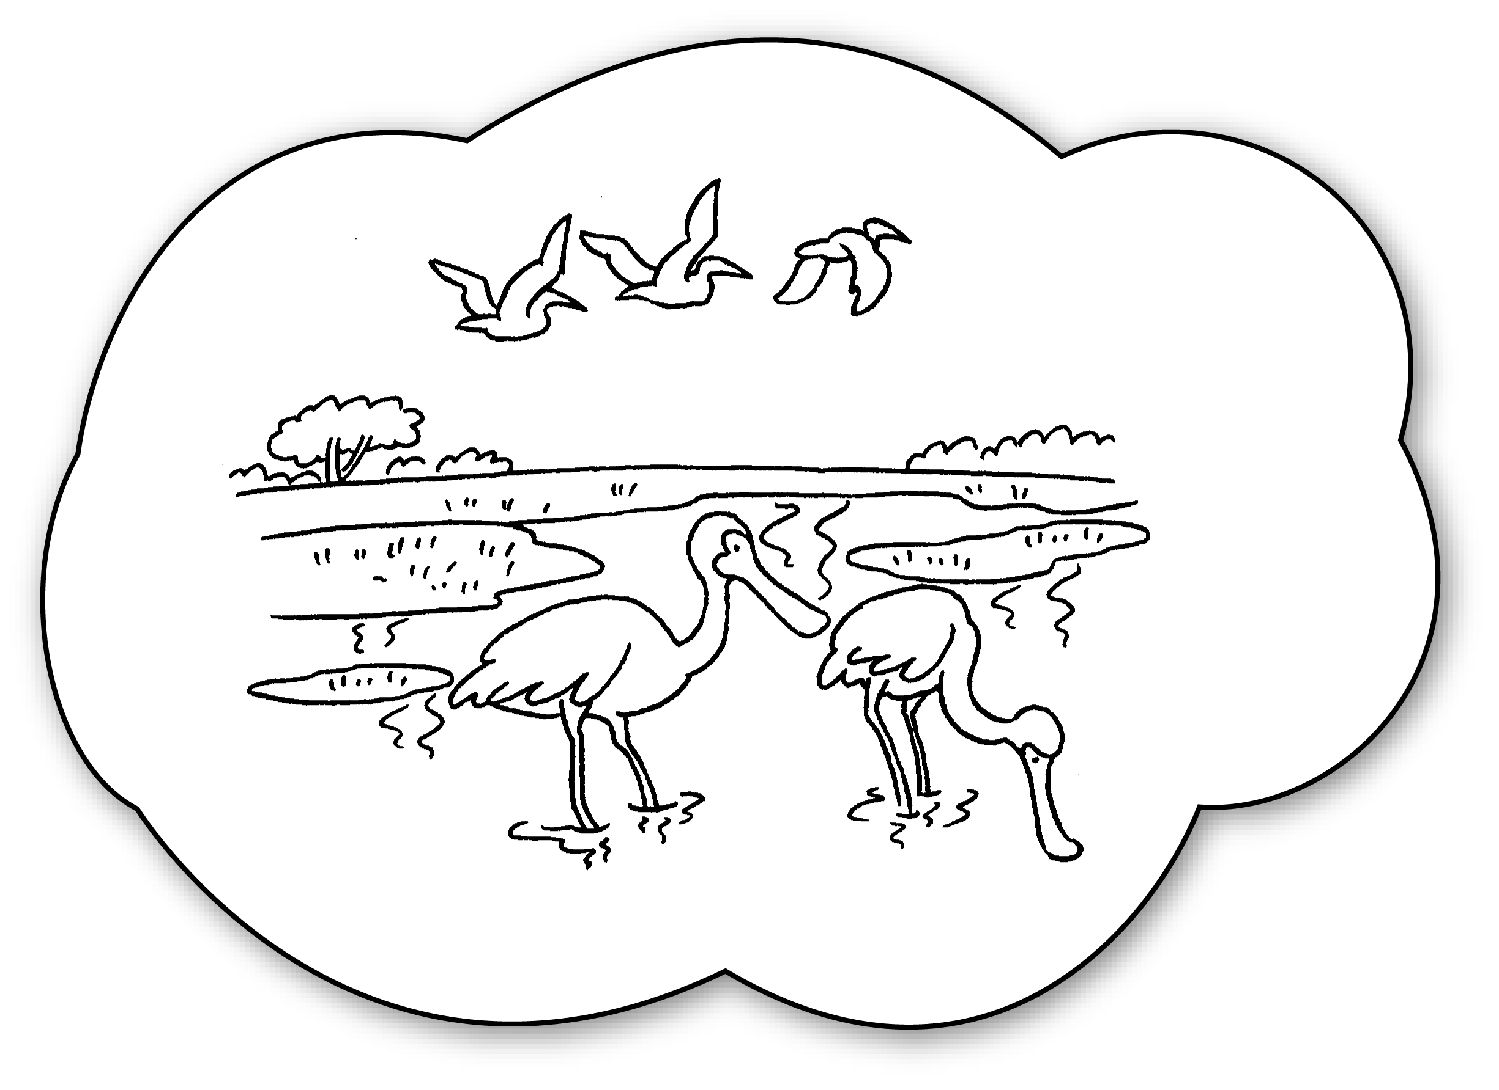 | A : go to  ?  B : , I .
4  ✓ | 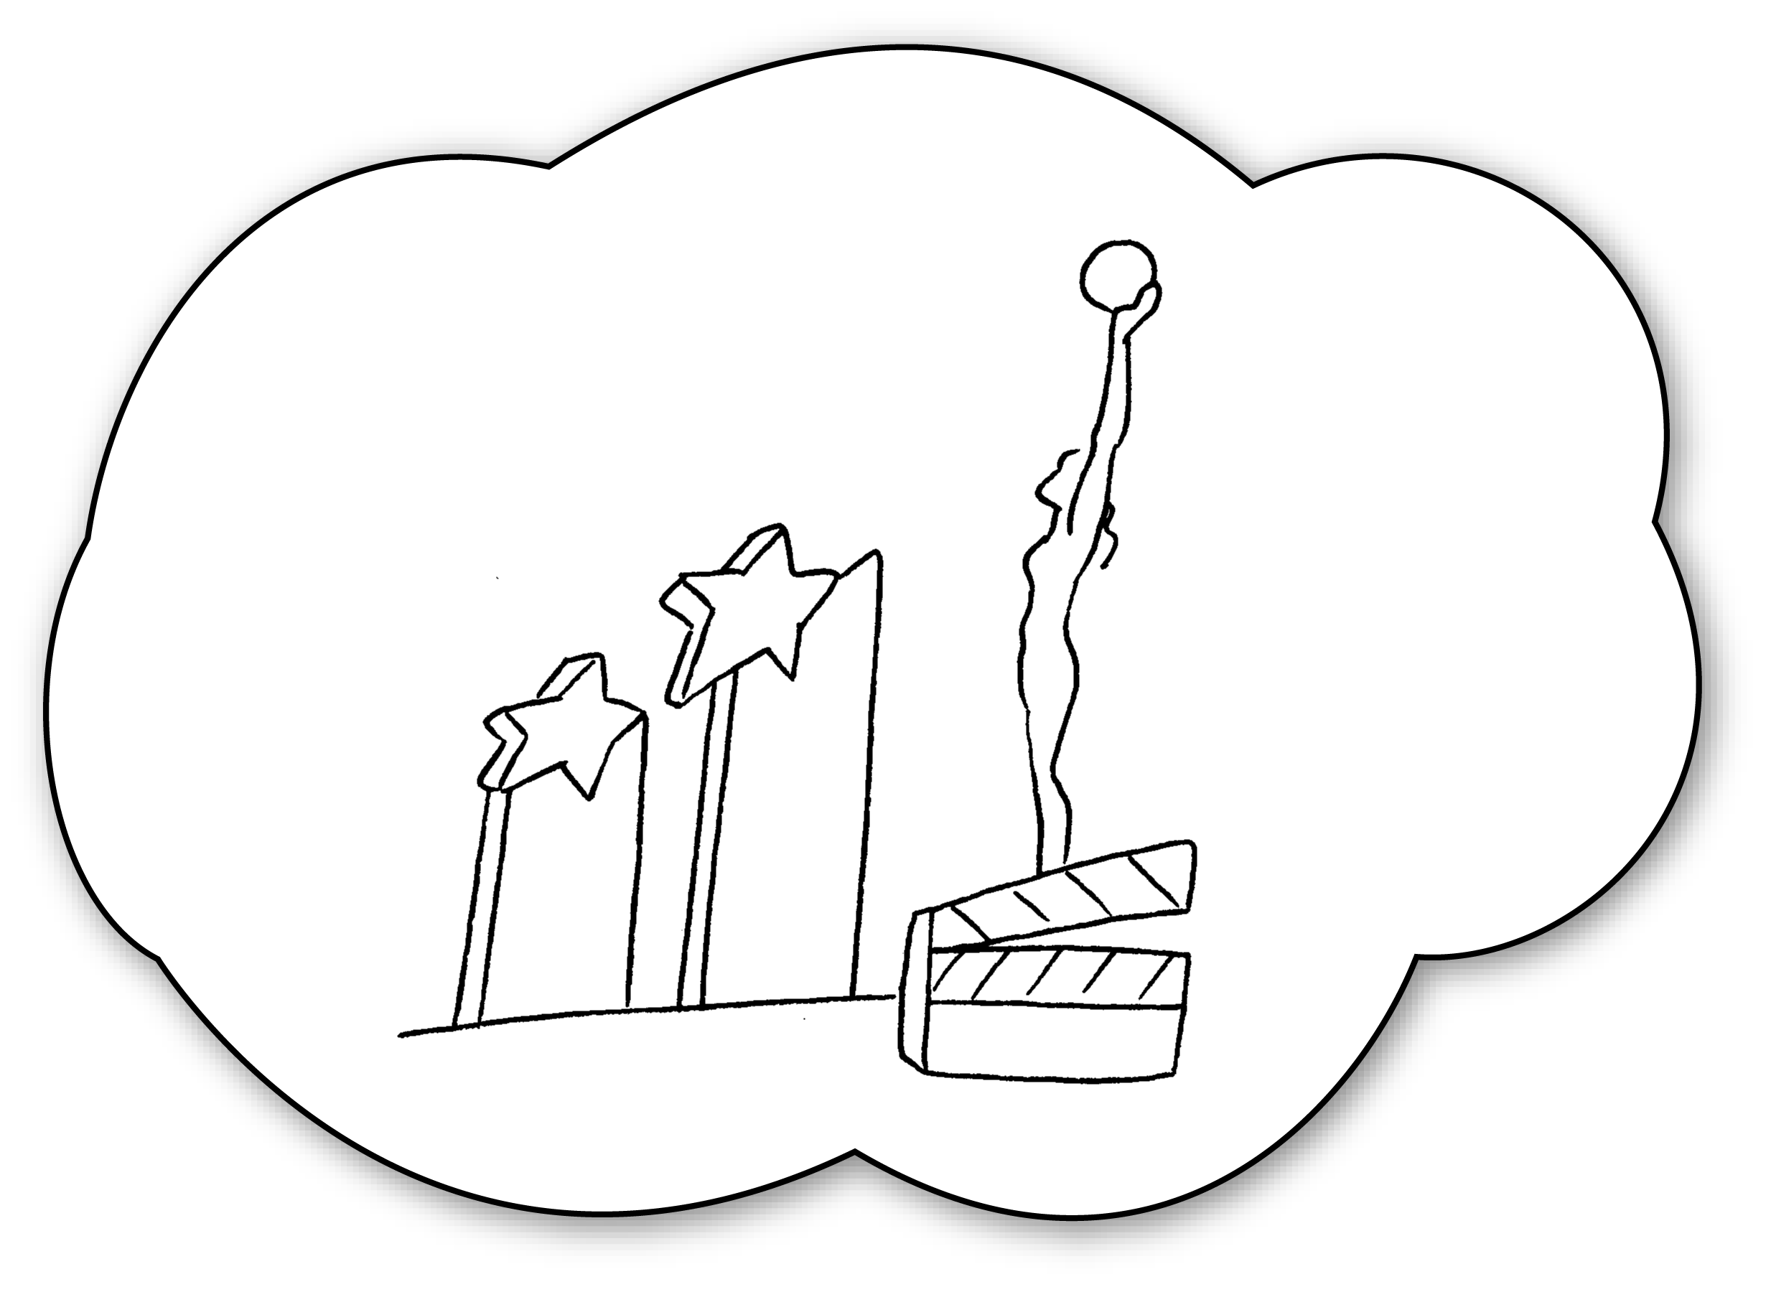 | A : _____________________________________  _____________________________________  B : _____________________________________
5  ✗ | 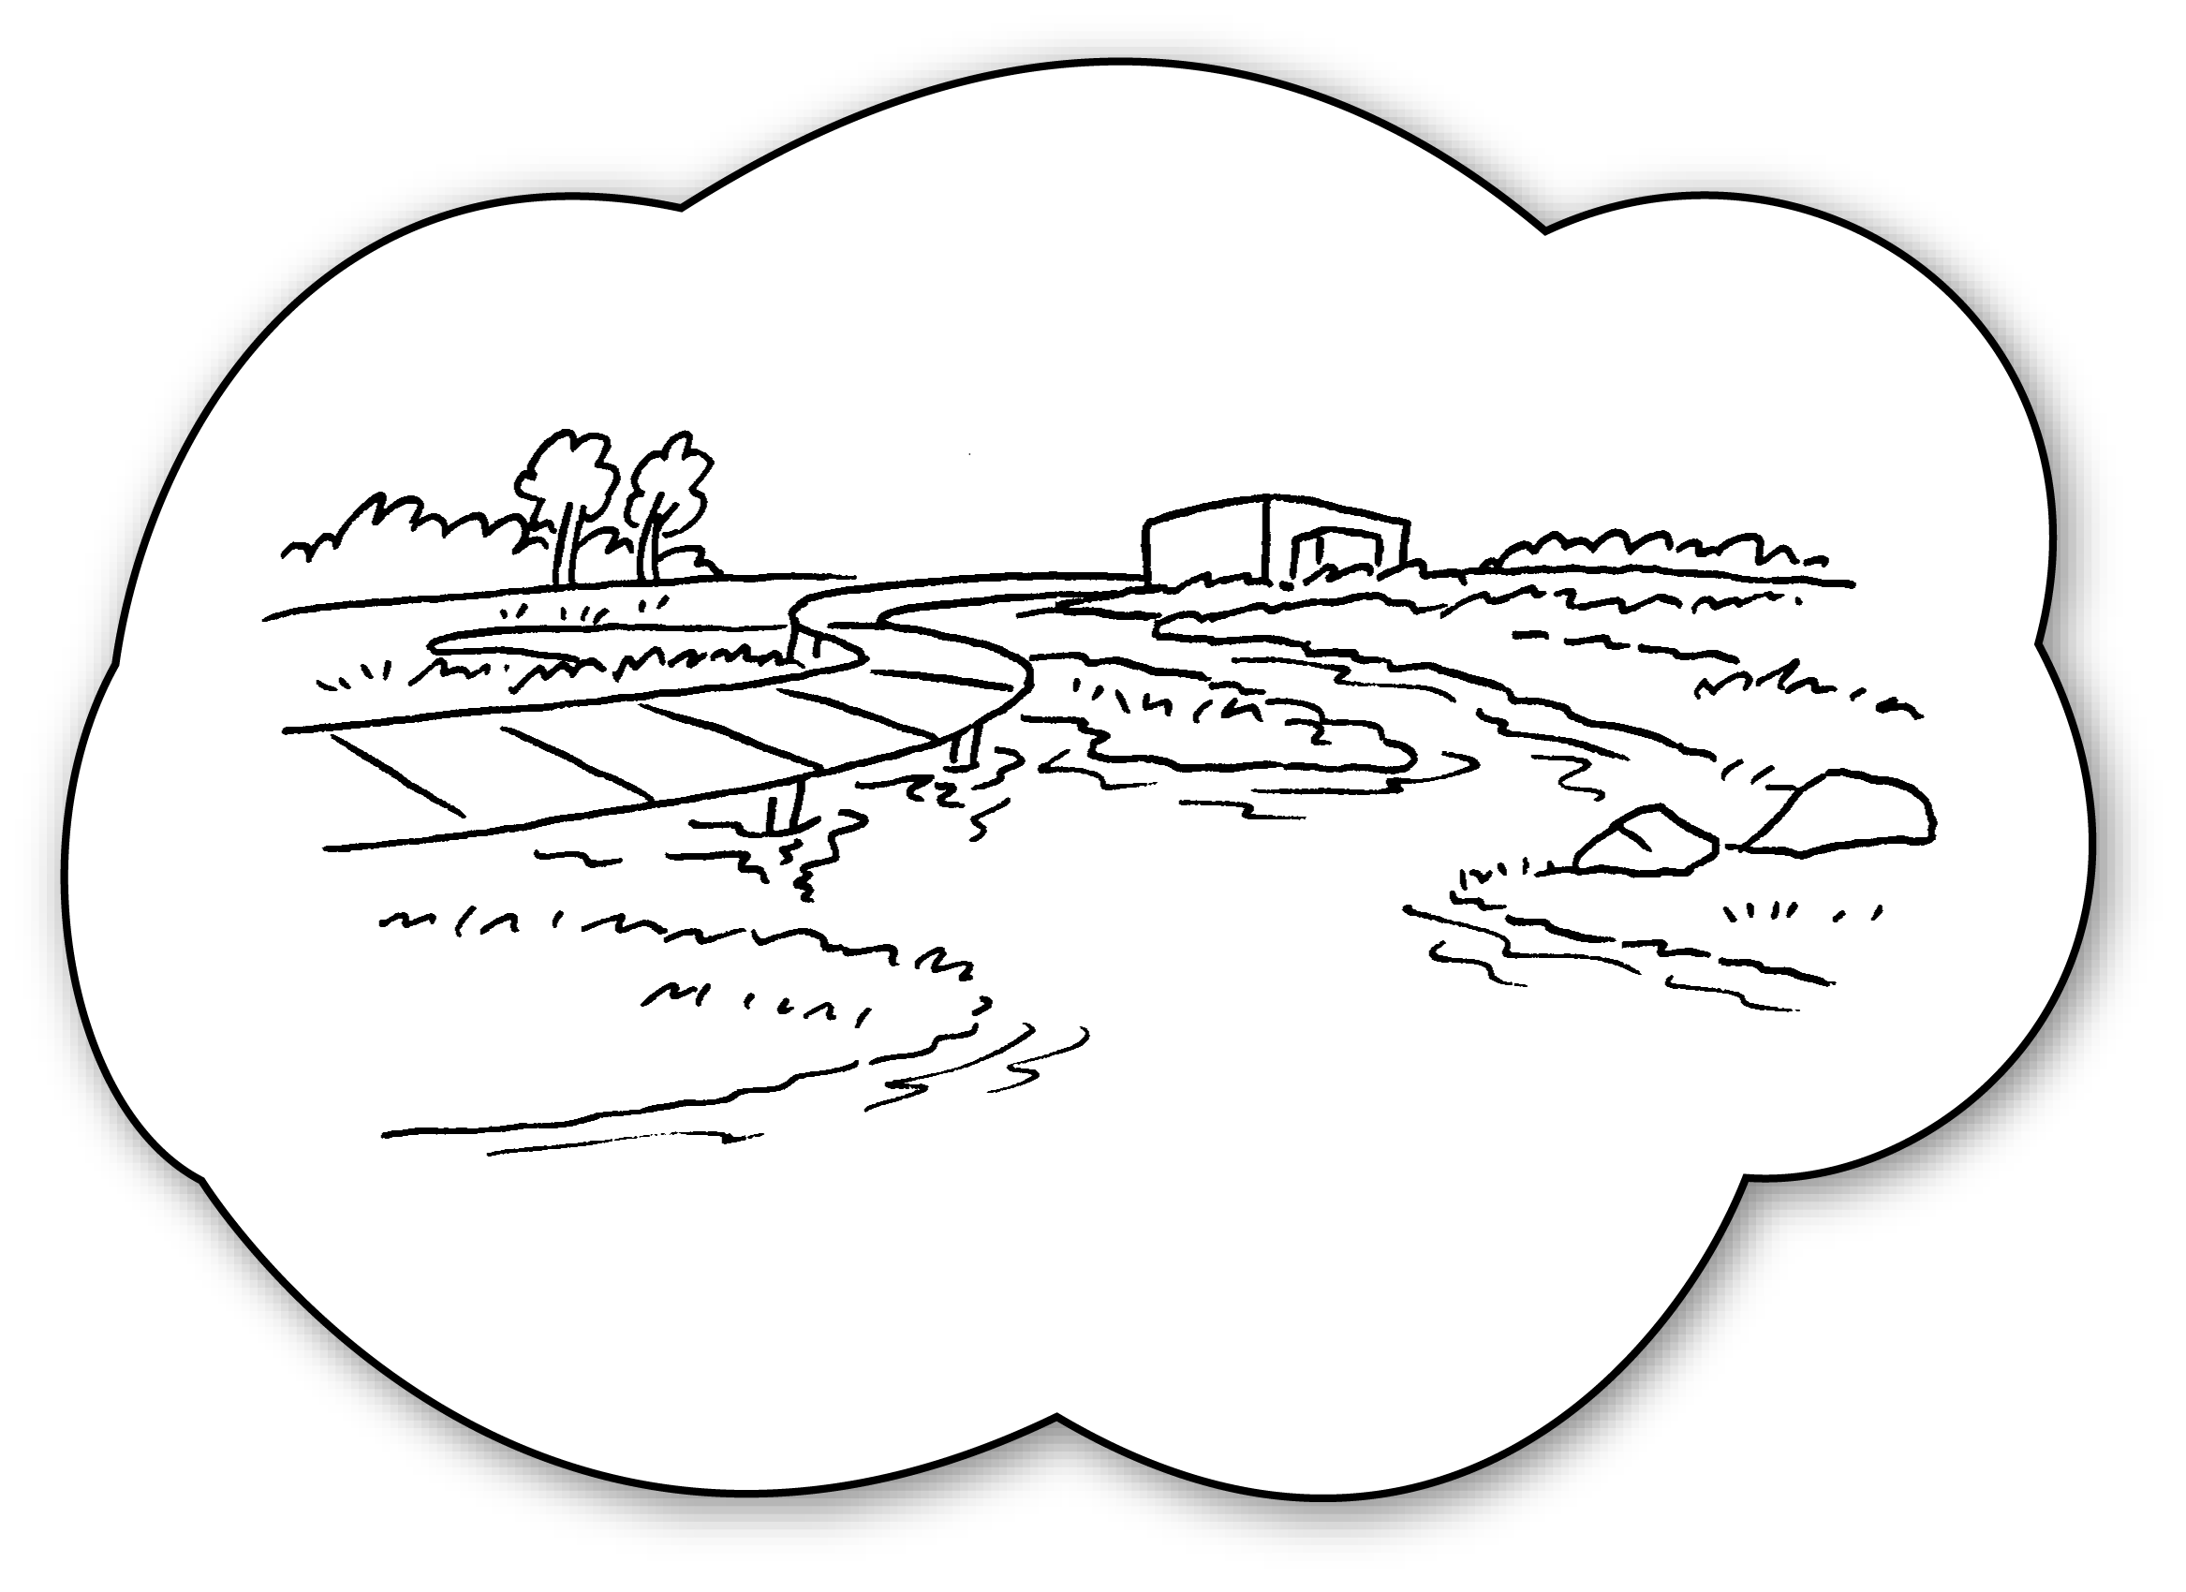 | A : _____________________________________  _____________________________________  B : _____________________________________

Book 4B Chapter 1 Graded Worksheets
Worksheet 3⬇⬇⬇
- Will
- Will the Peak
No
3 Will you Mai Po
Yes will
4 Will you go to Tsim Sha Tsui?
Yes, I will.
5 Will you go to Tin Shui Wai?
No, I won’t.

