Choose and write.

bakery | clinic | convenience store
health and beauty store | department store | MTR station
news-stand | post office | sports centre

1  4  7 | 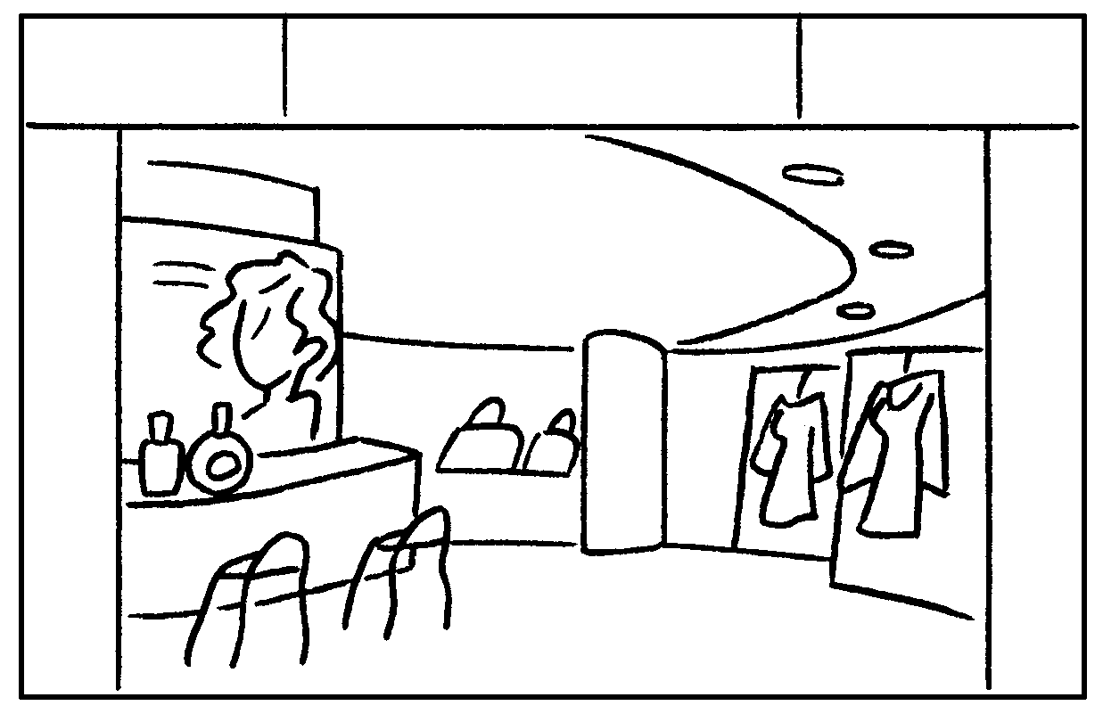 | 2  5  8 | 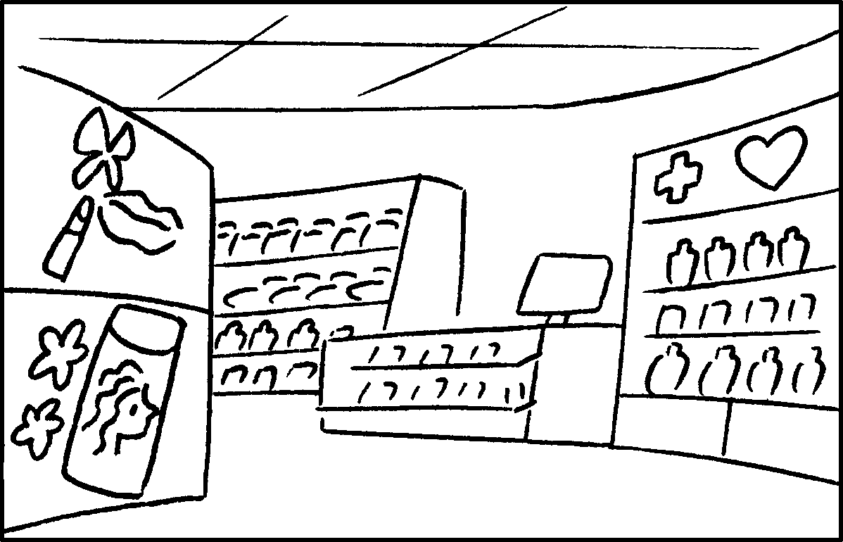 | 3  6  9 | 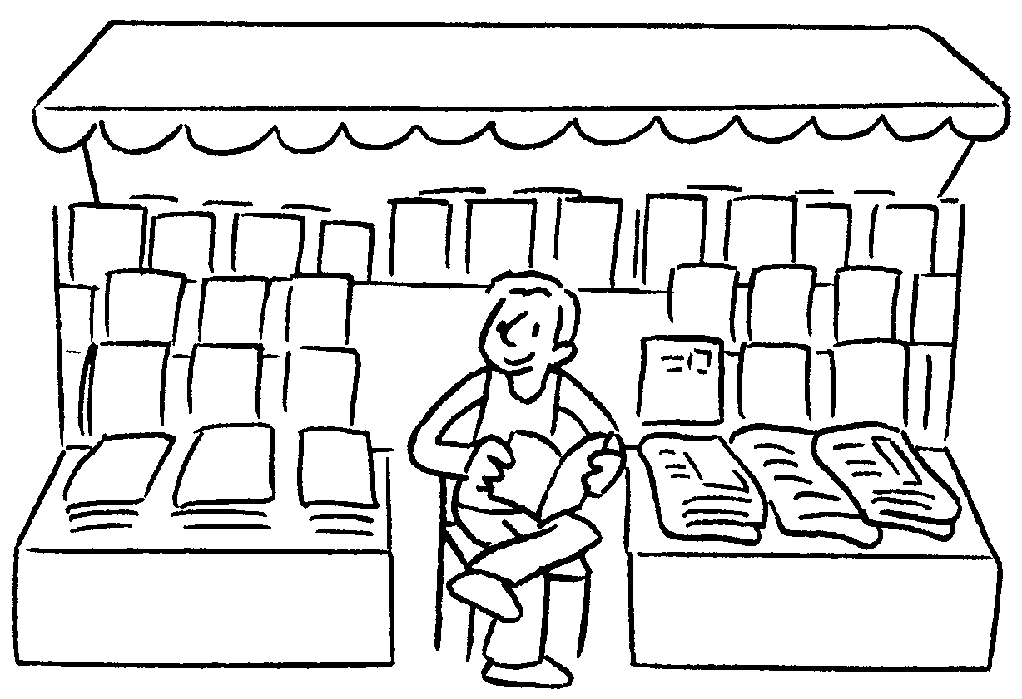
 | 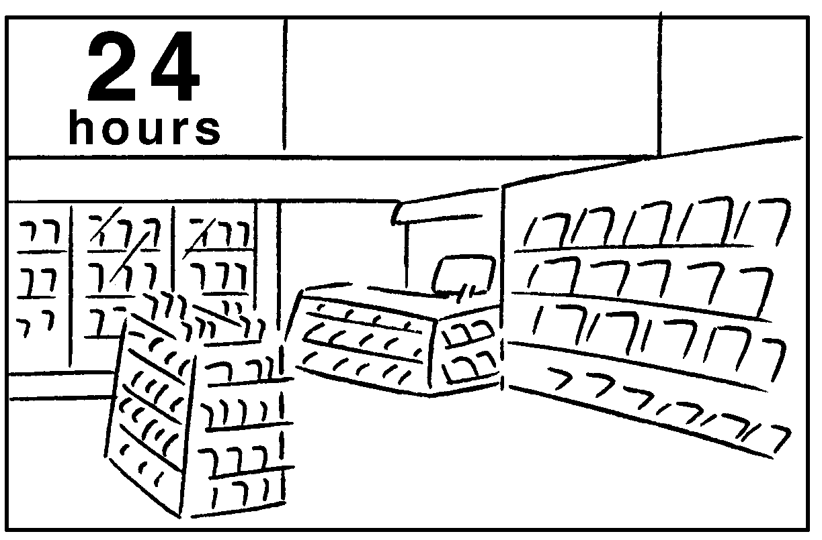 |  | 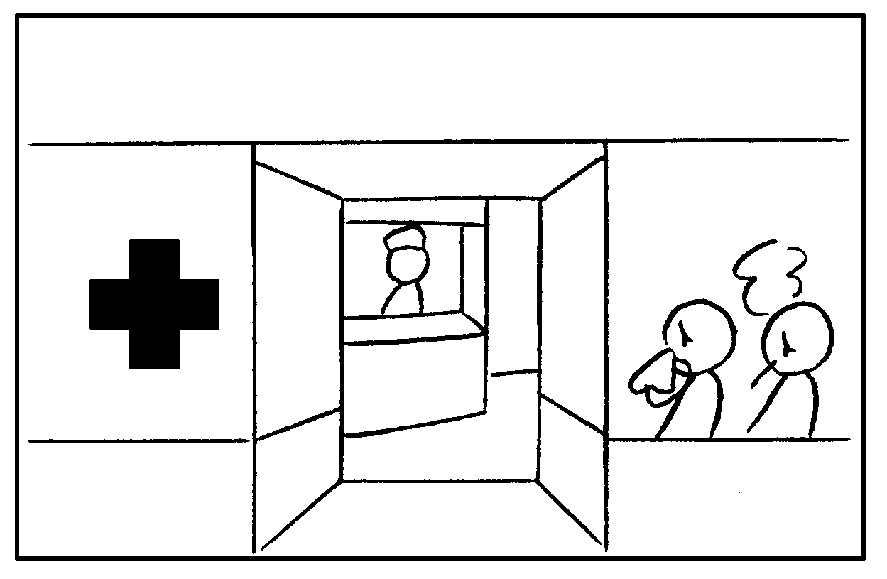 |  | 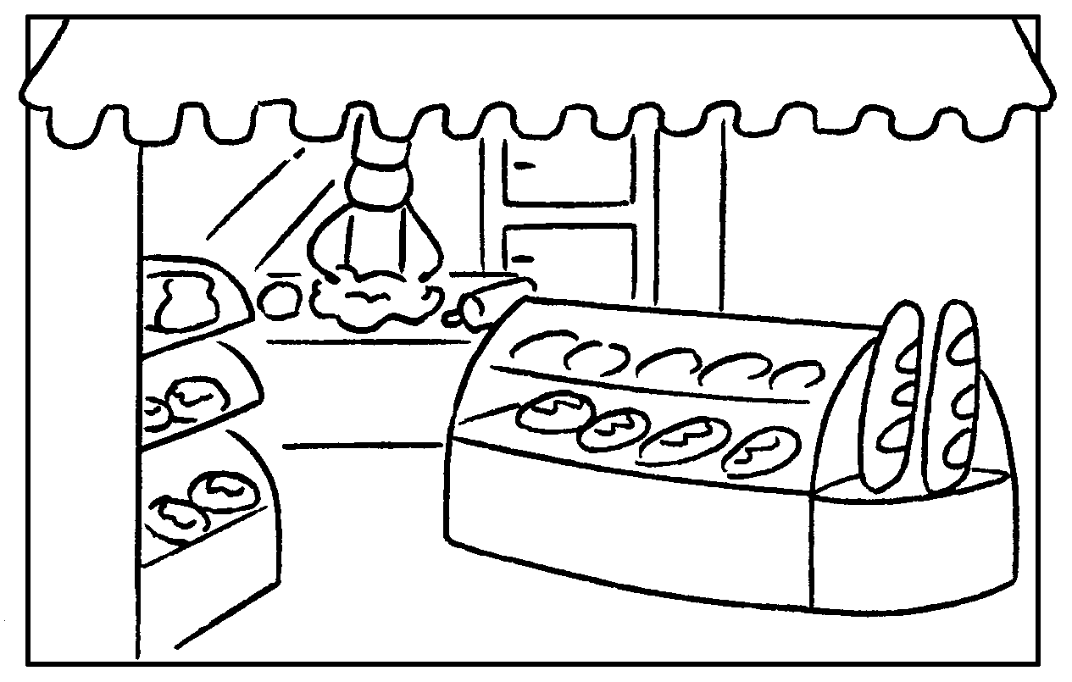
Local Airmail | 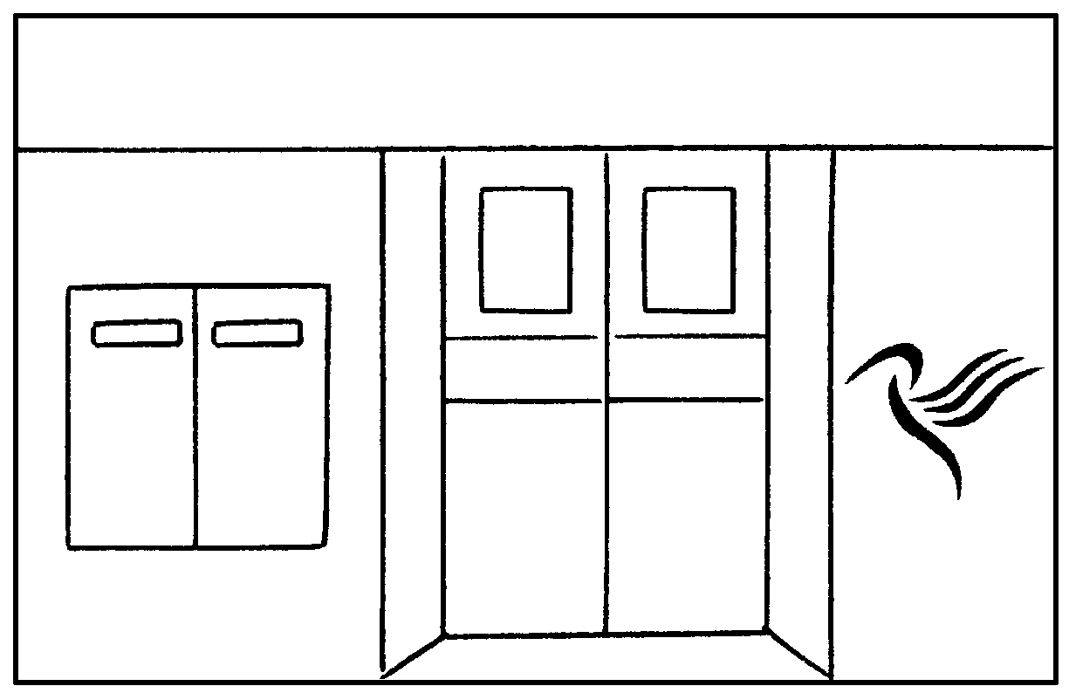 |  | 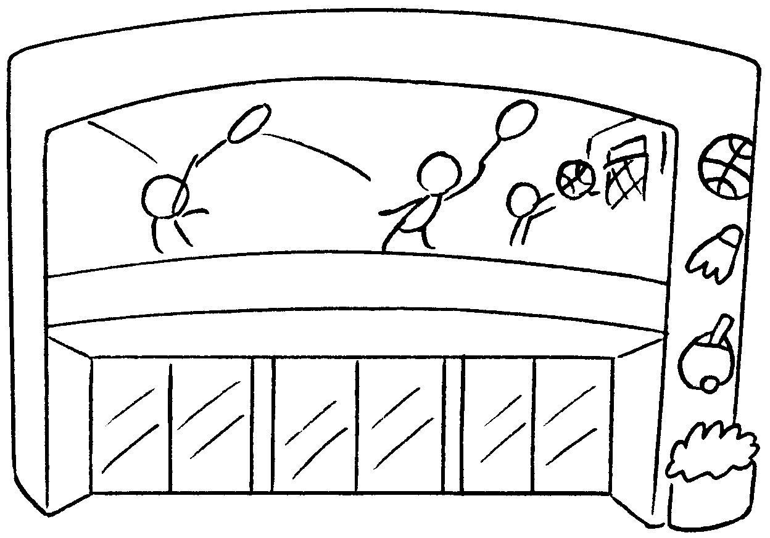 |  | 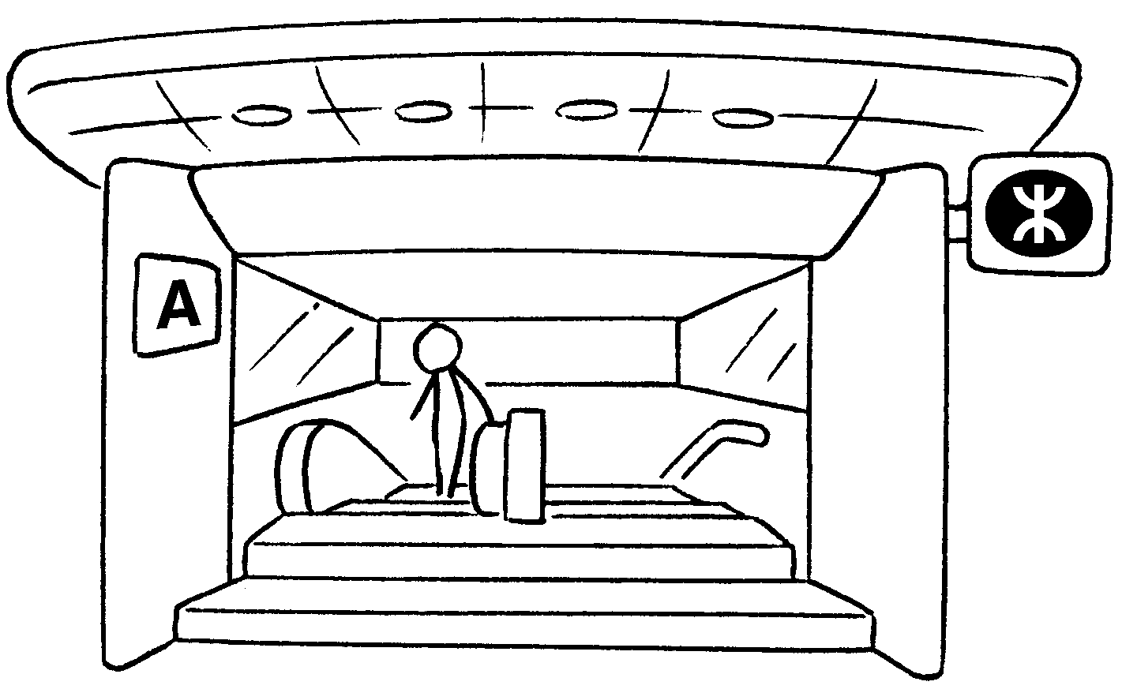

1 | a
2 | a
3 | a
4 | a
5 | a
6 | a
7 | a
8 | a
9 | an


Book 4B Chapter 2 Graded Worksheets
Worksheet 1⬇
- department store
- health and beauty store
- news-stand
- convenience store
- clinic
- bakery
- post office
- sports centre
- MTR station

