Circle the correct answers.

1 | 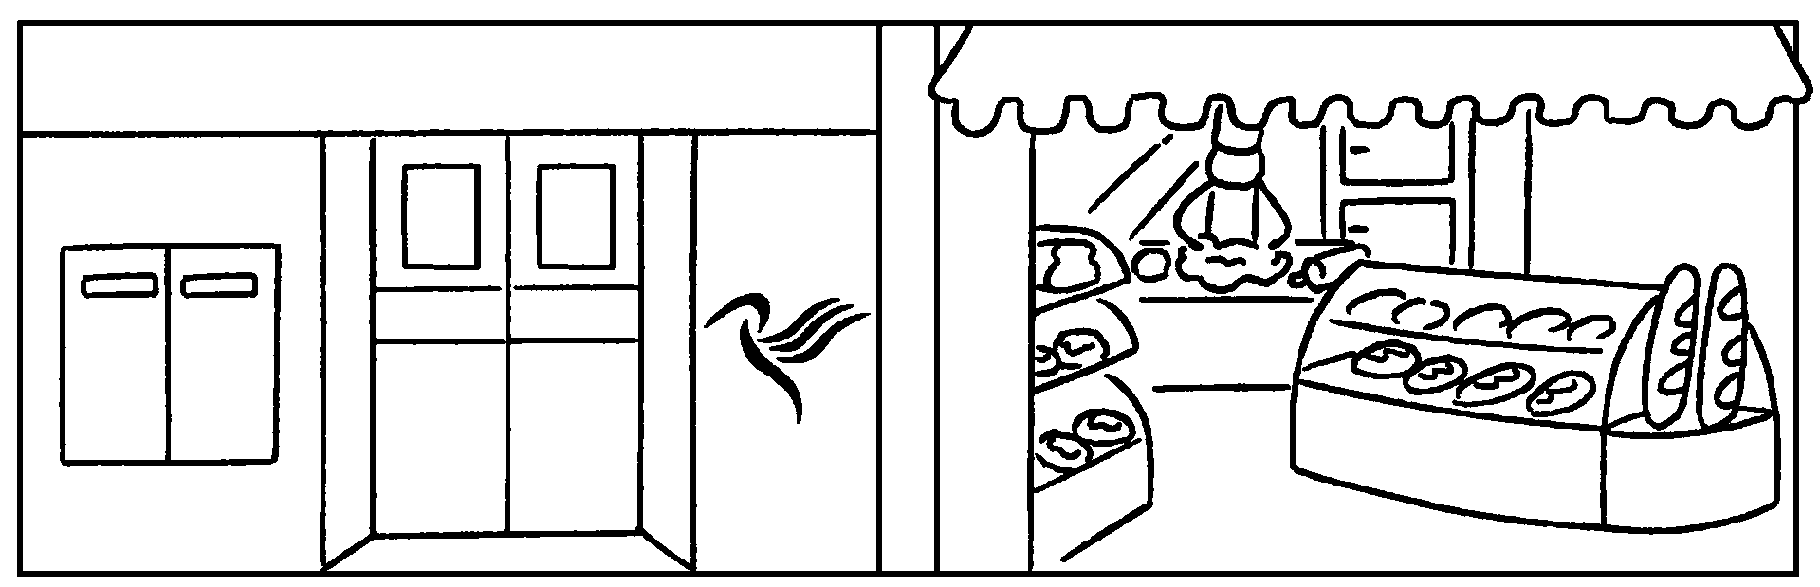 | The post office is ( opposite / in front of / next to ) the bakery.
2  … | 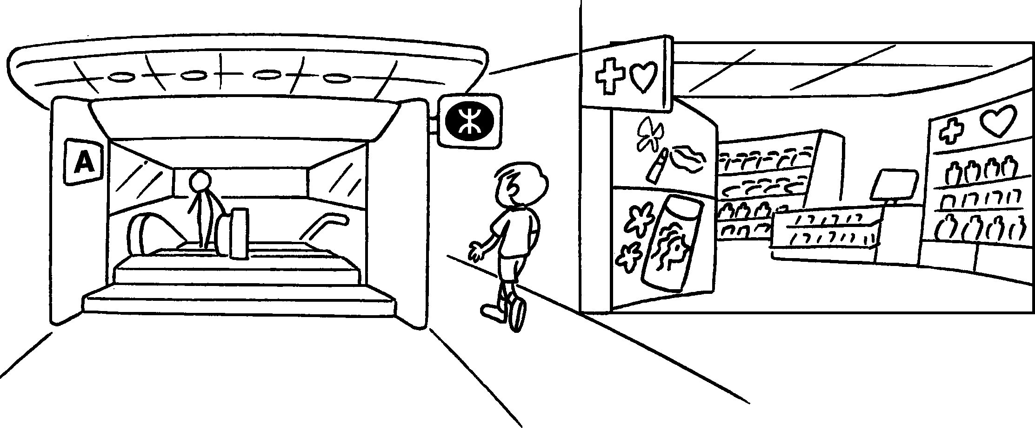 | The MTR station is ( on my left /  on my right / behind me ) .
3 | 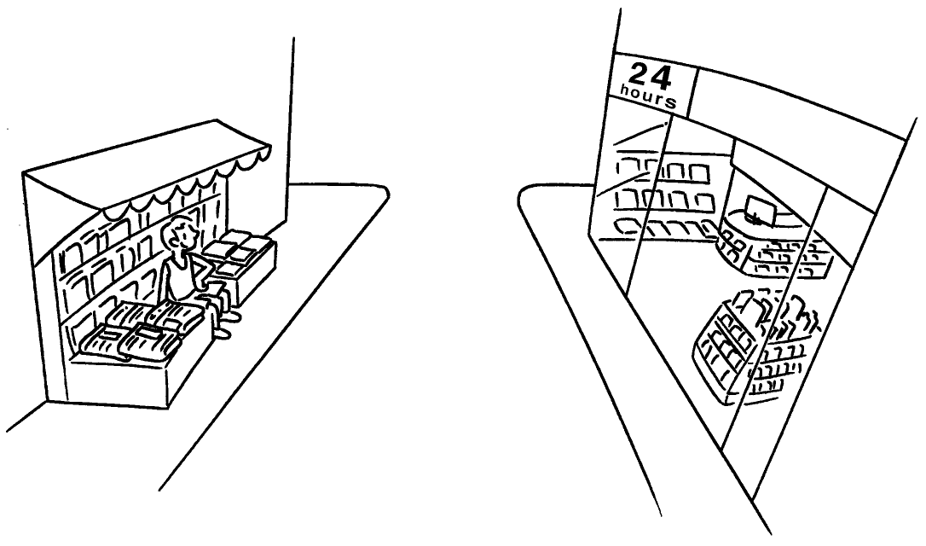 | The news-stand is ( behind / opposite / next to ) the convenience store.
4 | 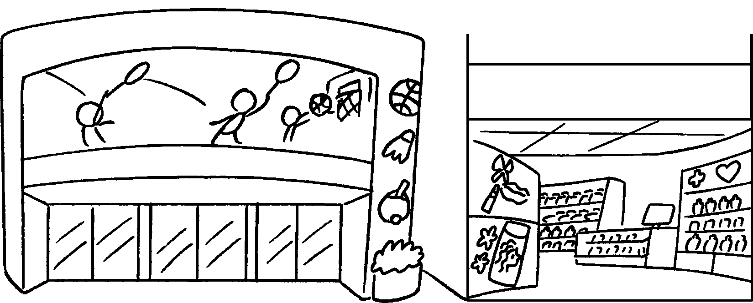 | The sports centre is ( in front of / next to / behind ) the health and beauty store.
5  … | 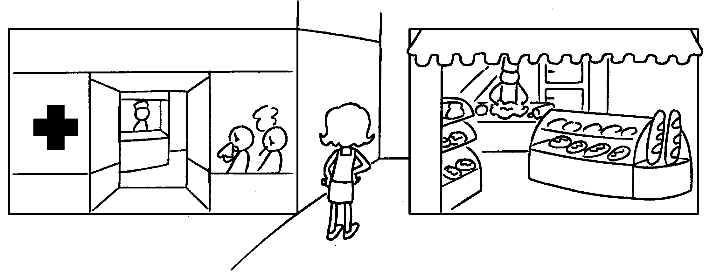 | The bakery is ( on my right / behind me / on my left ) .



Book 4B Chapter 2 Graded Worksheets
Worksheet 2⬇
- ( opposite / in front of / next to )
- ( on my left / on my right / behind me )
- ( behind / opposite / next to )
- ( in front of / next to / behind )
- ( on my right / behind me / on my left )

