Where are they? Write.

1 | 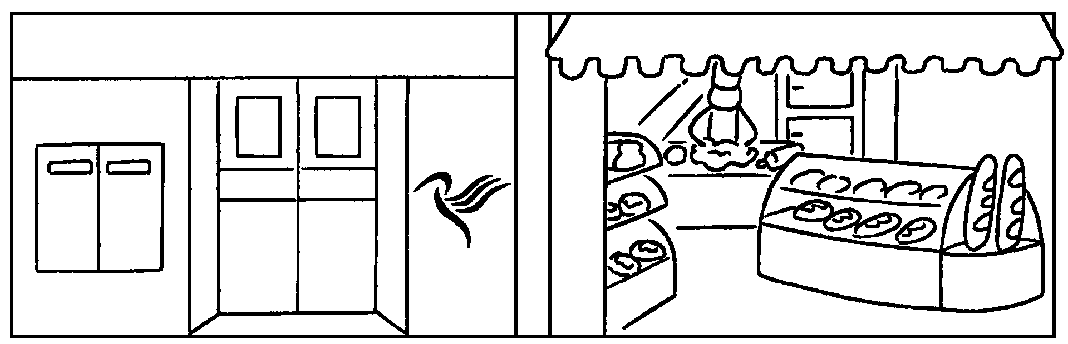 | The post office is the bakery.
2  … | 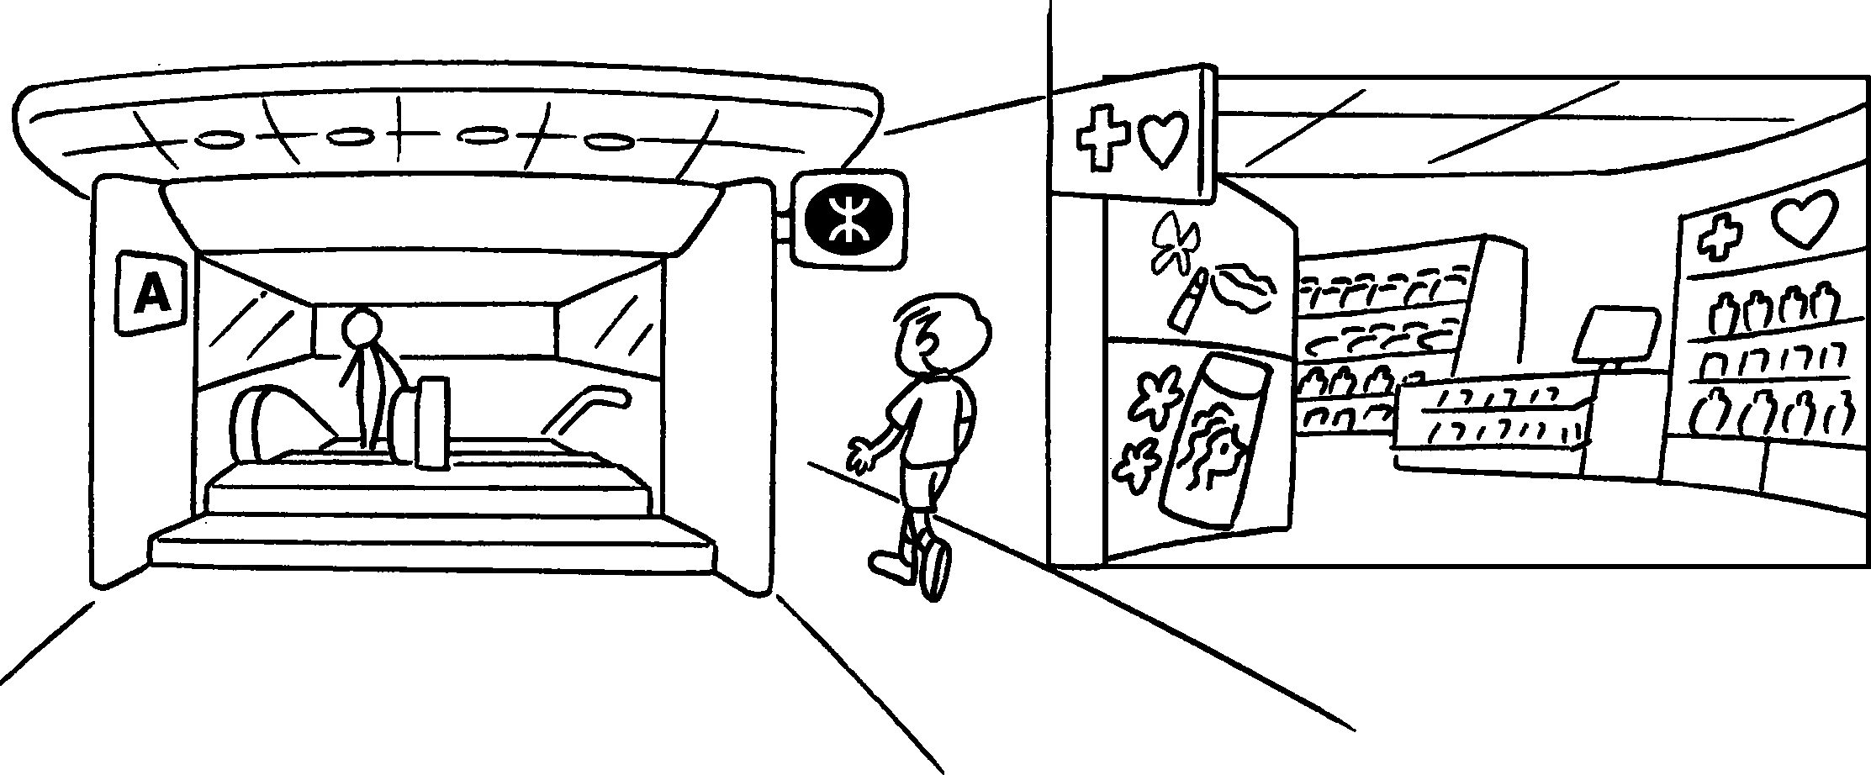 | The MTR station is my  .
3 | 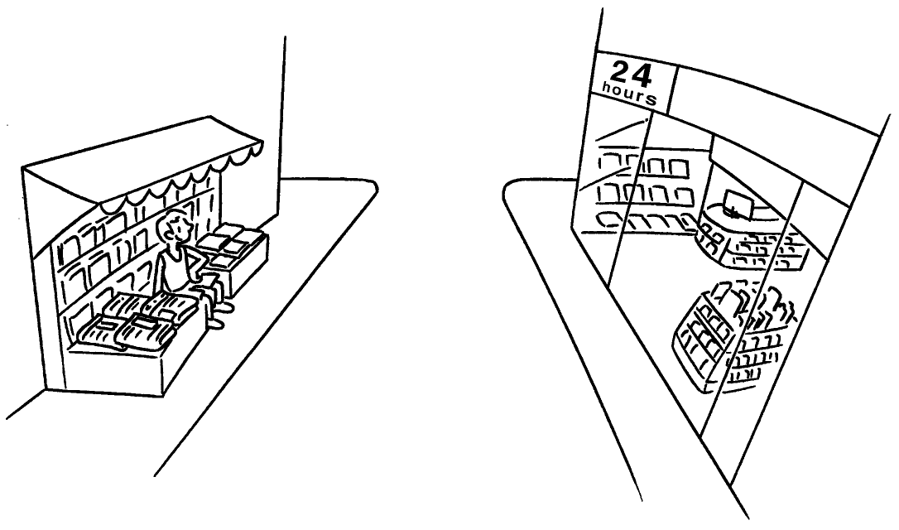 | The news-stand is the convenience store.
4 | 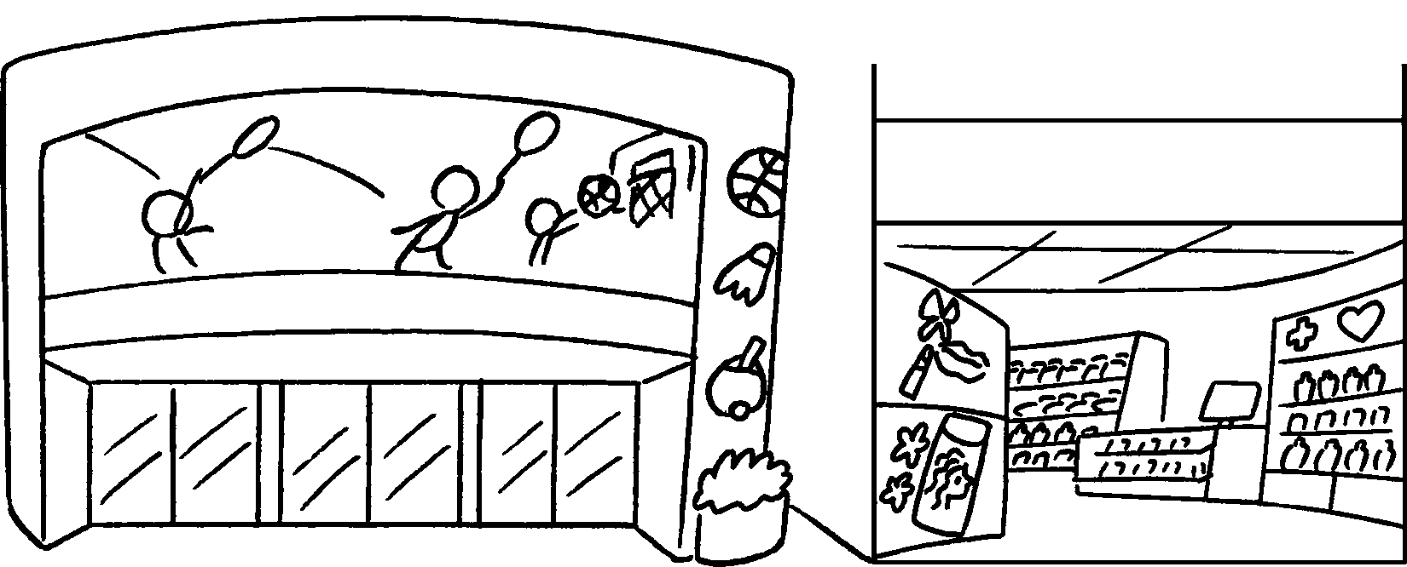 | The sports centre is the health and beauty store.
5  … | 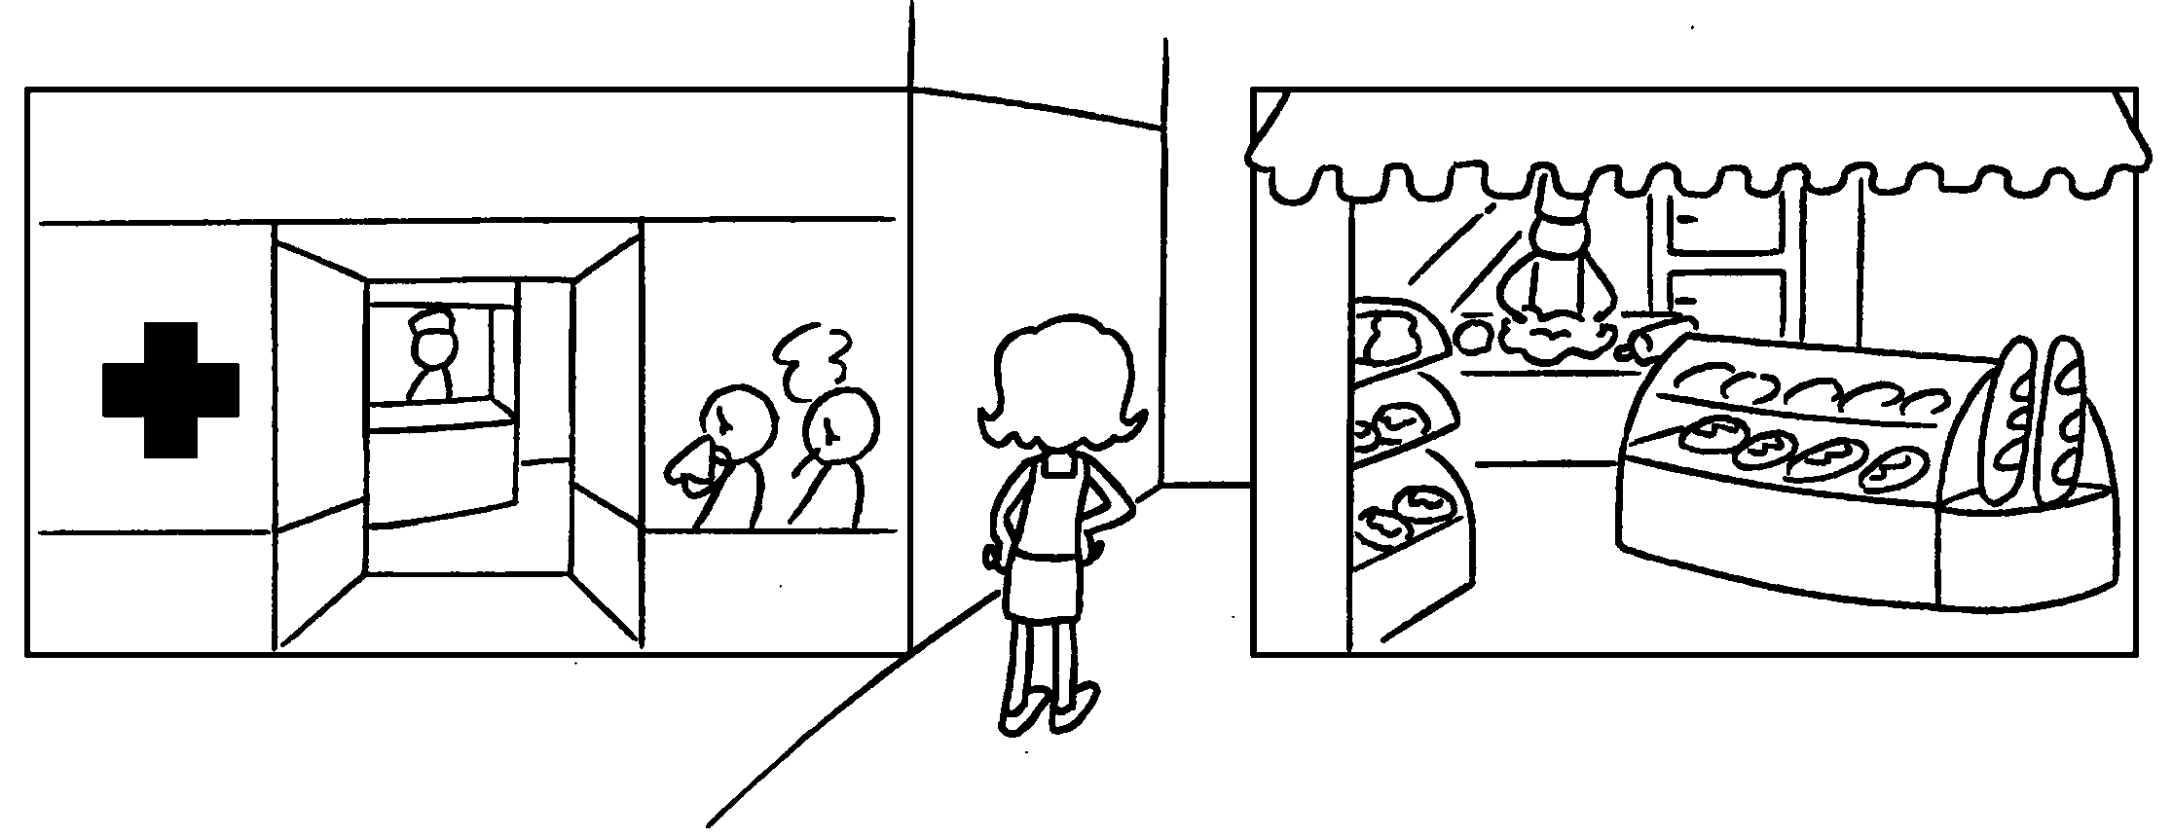 | The bakery is .



Book 4B Chapter 2 Graded Worksheets
Worksheet 2⬇⬇⬇
- next to
- on left
- opposite
- next to
- on my right

