Choose and write.
Walk straight ahead
Walk across the road
Turn left
Turn right
Go out of
1 | 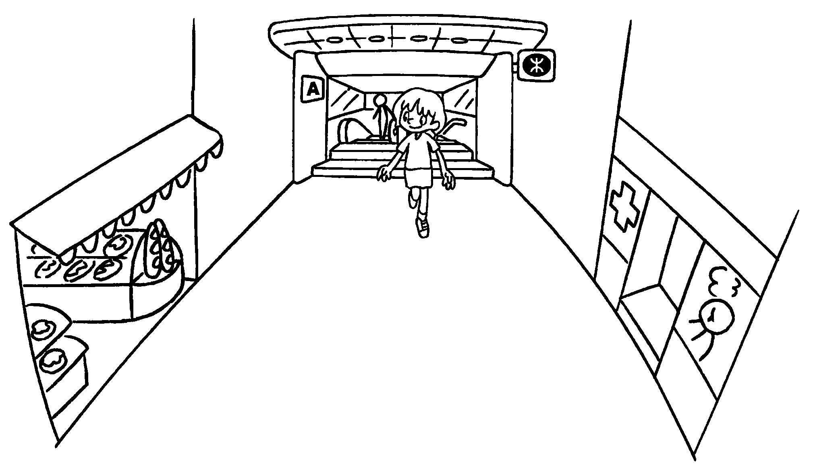 | the MTR station.  The bakery is opposite the clinic.
2 | 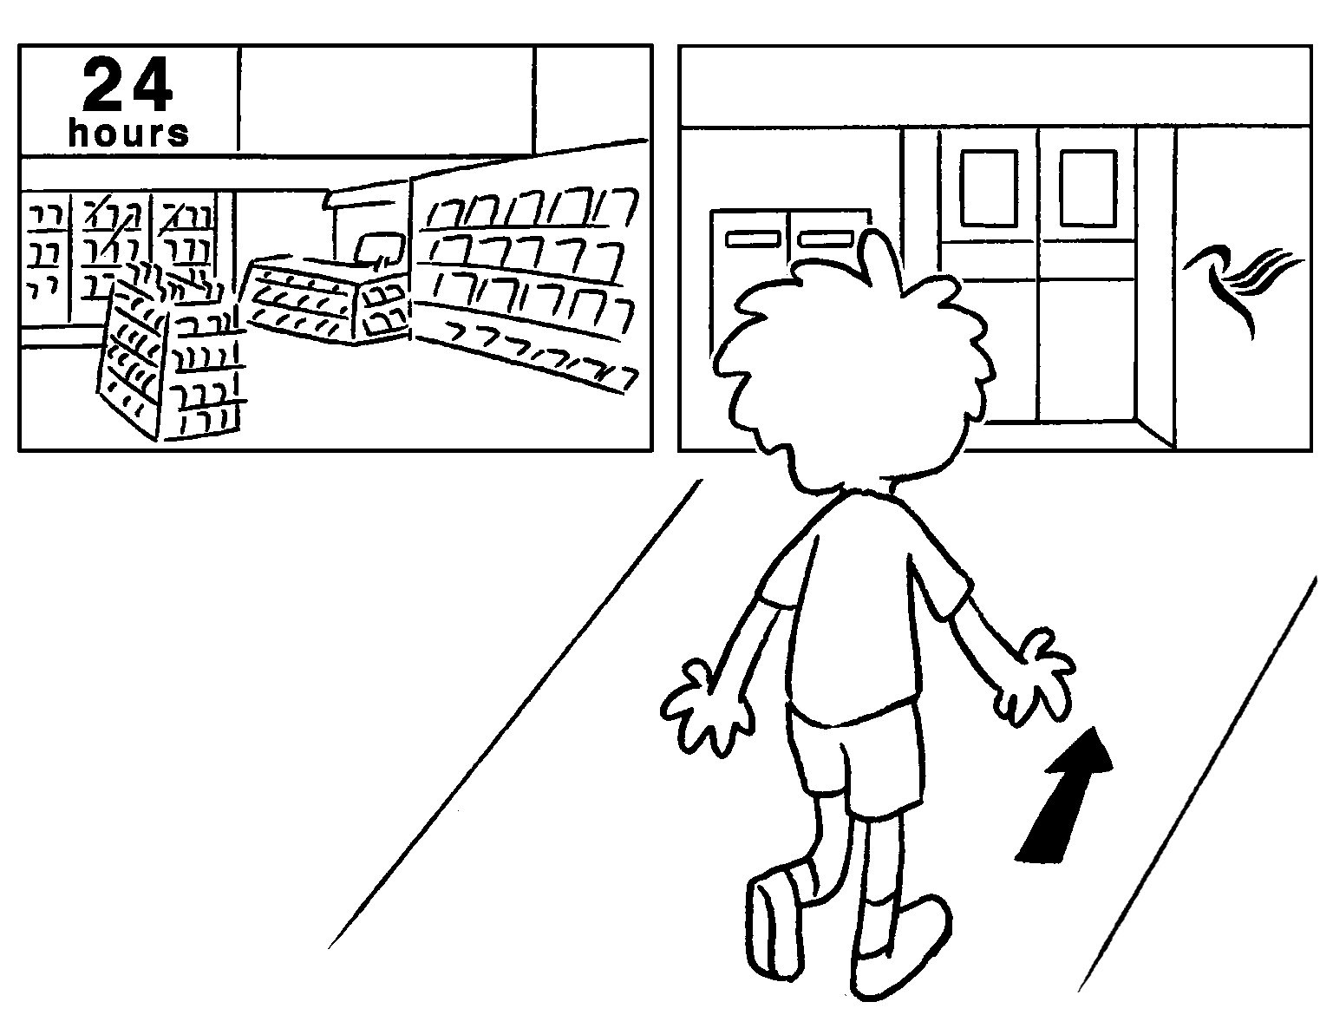 | .  The convenience store is next to the post office.
3 | 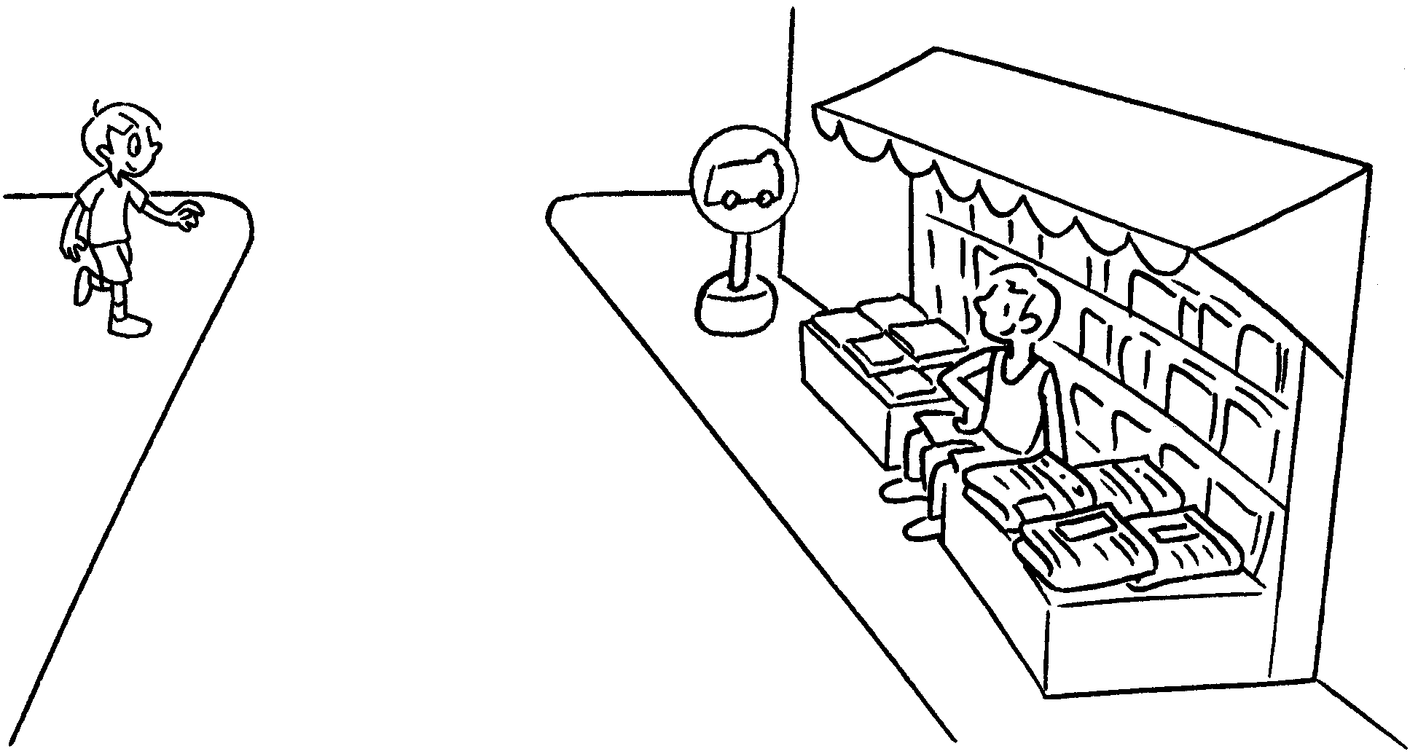 | .  The minibus stop is next to the news-stand.
4 | 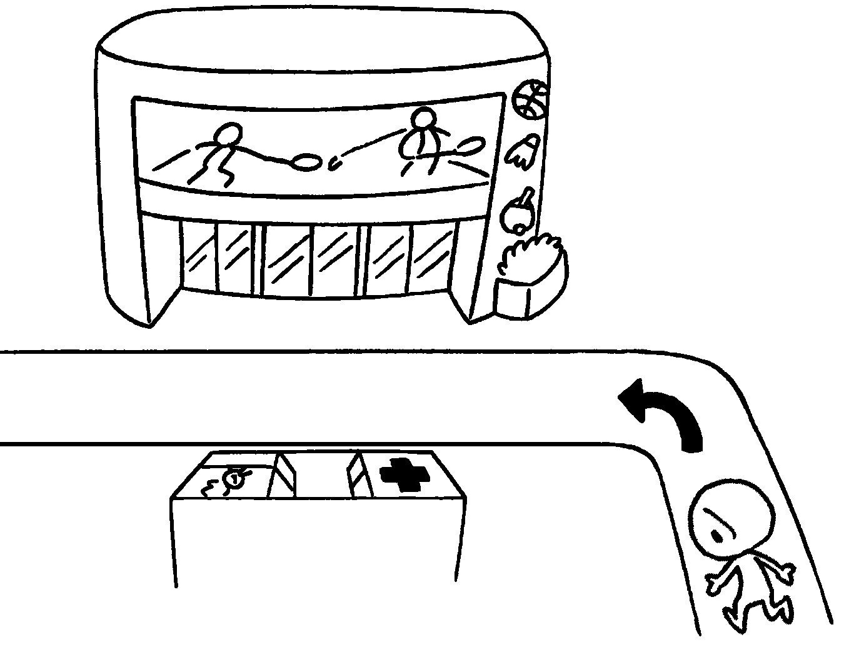  Apple Street | into Apple Street.  The clinic is opposite the sports centre.
  5 | 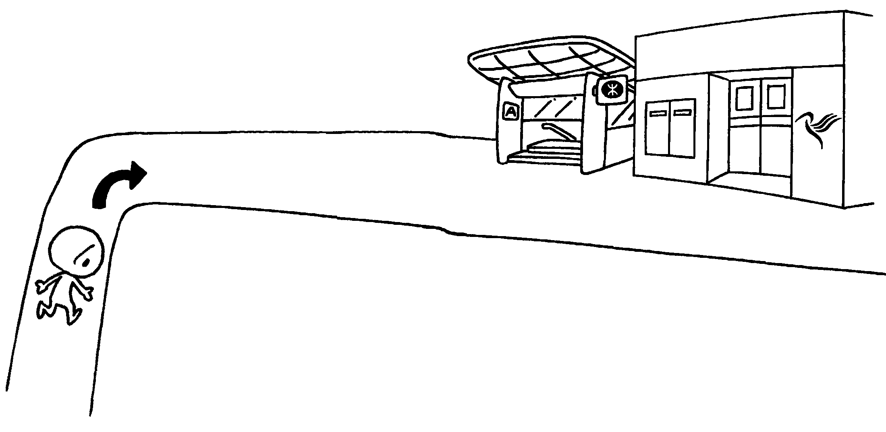 | into Mango Street.  The MTR station is next to the post office.



Book 4B Chapter 2 Graded Worksheets
Worksheet 3⬇
- Go out of
- Walk straight ahead
- Walk across the road
- Turn left
- Turn right

