Finish the directions.

1 | 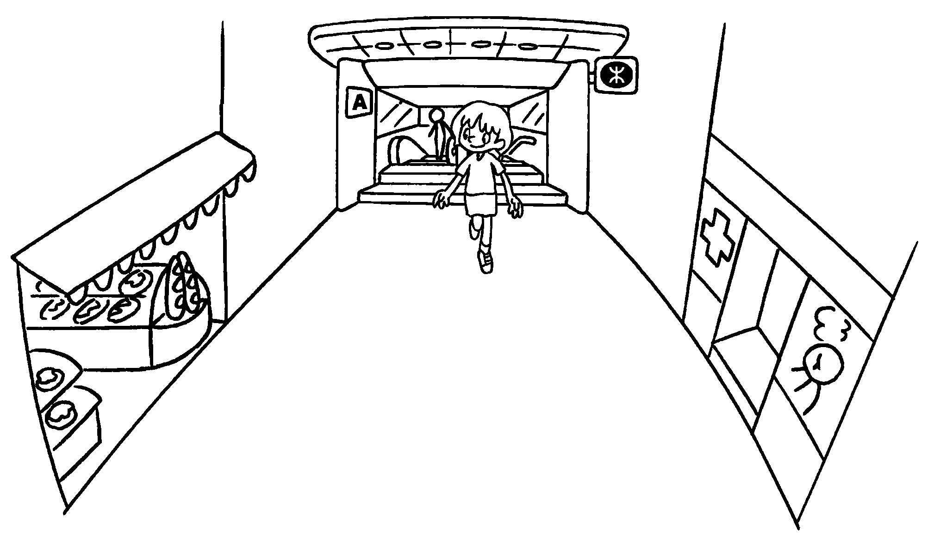 | Go ____________ _______  the MTR station.  The bakery is opposite the clinic.
2 | 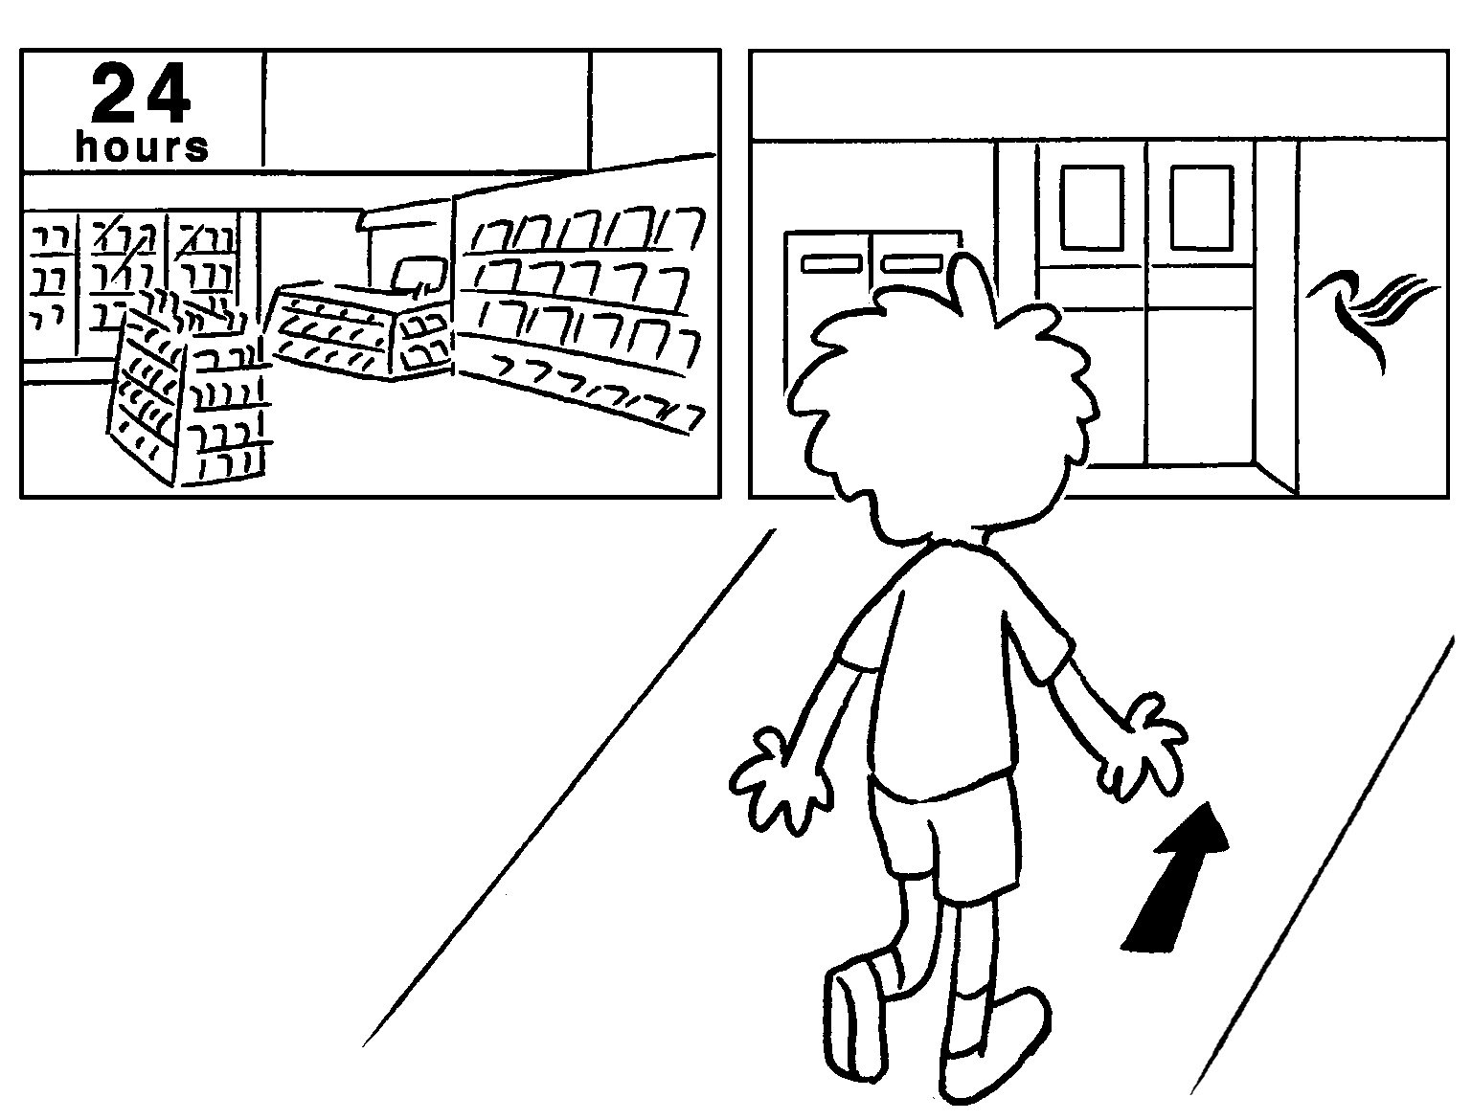 | __________ _________________ ahead.  The convenience store is next to the  ___________ ______________ .
3 | 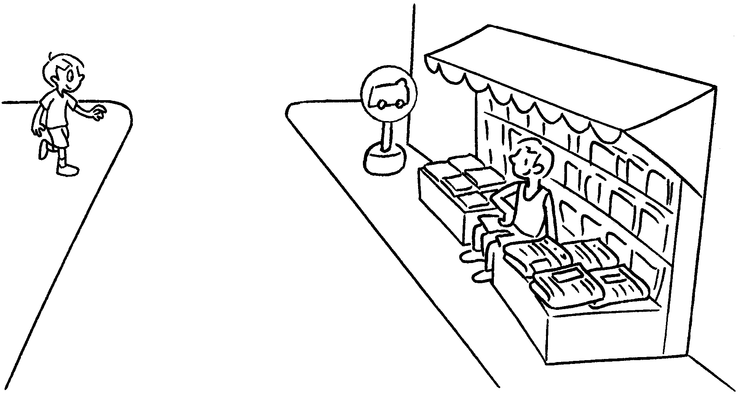 | __________________________ the road.  The minibus stop is __________________ the news-stand.
4 | 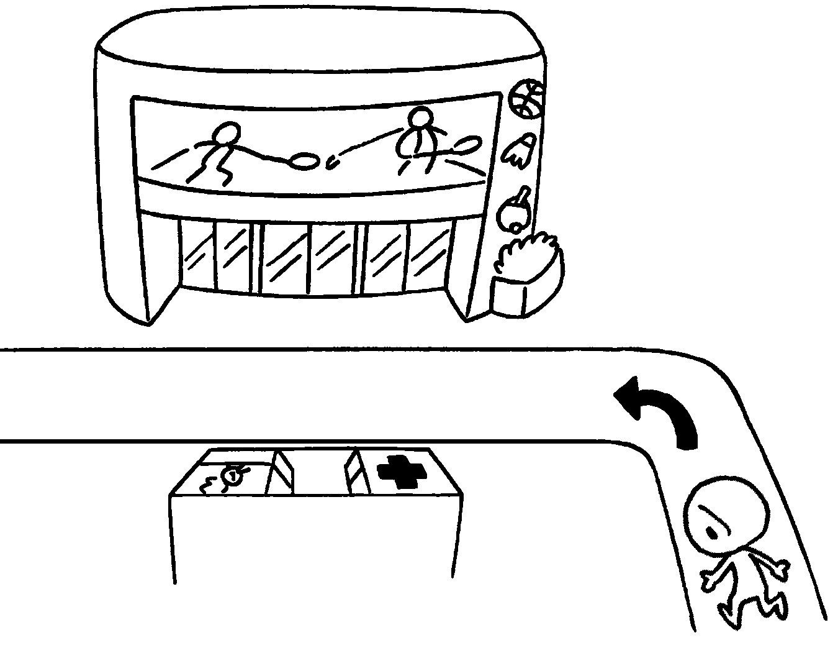  Apple Street | Turn _____________ into Apple Street.  The clinic is ________________ the sports centre.
  5 | 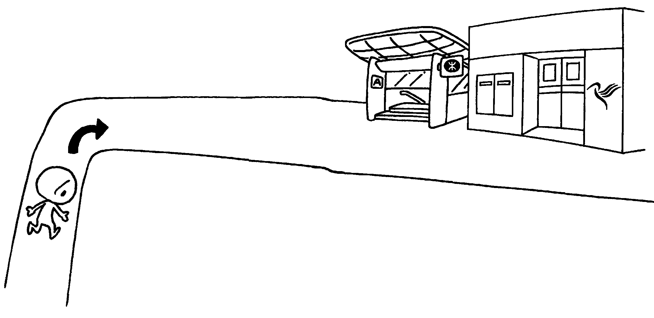 | _________________________ into  Mango Street.  _________________________ is next to the post office.



Book 4B Chapter 2 Graded Worksheets
Worksheet 3⬇⬇⬇
- out of
- Walk straight
post office
- Walk across
next to
- left
opposite
- Turn right
The MTR station

