Task — Planning a trip and writing an e-mail to a friend
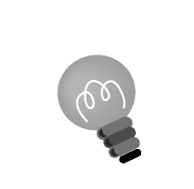
1 Discuss with your partner where to go with Gary when he comes to Hong Kong in July. Plan a one-day trip for him using the table below.
Hints: Think about i) one place to visit in the morning and one / two places to visit in the afternoon;
ii) how to get to the places from the meeting place (can be any MTR station), e.g. take the MTR, bus, ferry …;
iii) what you and Gary can do at each place.

 | morning | afternoon
Sat

2 Write an e-mail reply to Gary using the ideas from your plan.
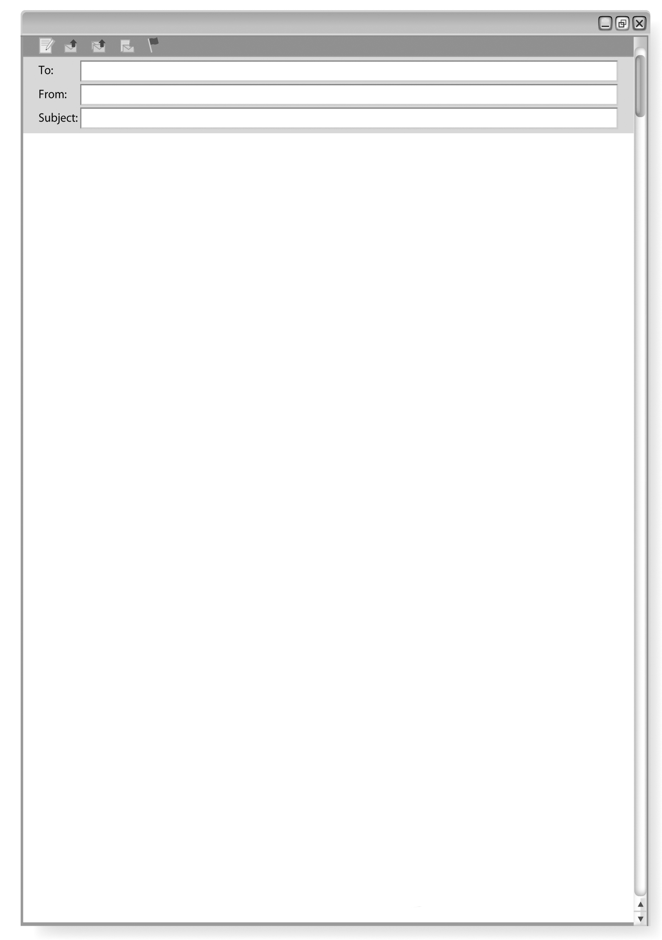

Gary
_______________
re: My trip to HK

,
We can’t wait to see you in July! We have a good plan.

We can meet at .

You can take a look at the map attached to this e-mail.

From,

Paragraph 2:
Write about your plan using the future tense.

Paragraph 3:
Write about the meeting place and time, and the directions on how to get
to Jordan MTR Station using the map below.

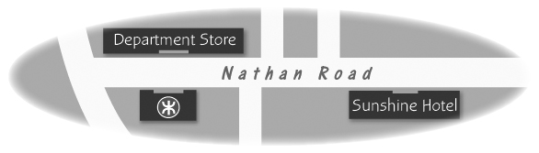
Checklist for Ch 2 Task

Check your writing and tick (✓).

Checking for ourselves | ☺ ☺ | ☺ | ☹
- We can plan a trip using notes.
- We can expand our notes into sentences and paragraphs to write an e-mail.
- We used the correct format to begin and end an e-mail, e.g. Dear Gary, Talk to you later. From,
- We used the future tense to write about plans, e.g. We will take the Peak Tram to the Peak.
- We gave directions on how to get to a place.
- We spelt all the words correctly (checked spellings using the textbook or dictionary).
- We used the correct punctuation, e.g. capital letters to begin names of people, places, months …

Now ask another pair of pupils to check your writing and tick (✓).

Checking by ( ____________________ ) | ☺ ☺ | ☺ | ☹
- Do we understand our classmates’ writing?
- Are the ideas put into paragraphs?
- Did our classmates use complete sentences?
- Did our classmates use the correct format to write an e-mail?
- Did our classmates use the future tense correctly?
- Did our classmates give directions correctly?
- Did our classmates spell all the words correctly?
- Did our classmates use the correct punctuation?
Remember to make changes to your writing before you hand it in.

