RP no: Century Gothic 15pt
(所有圈號用15pt)
Choose and write.
macaroni | noodles | spaghetti

1 | 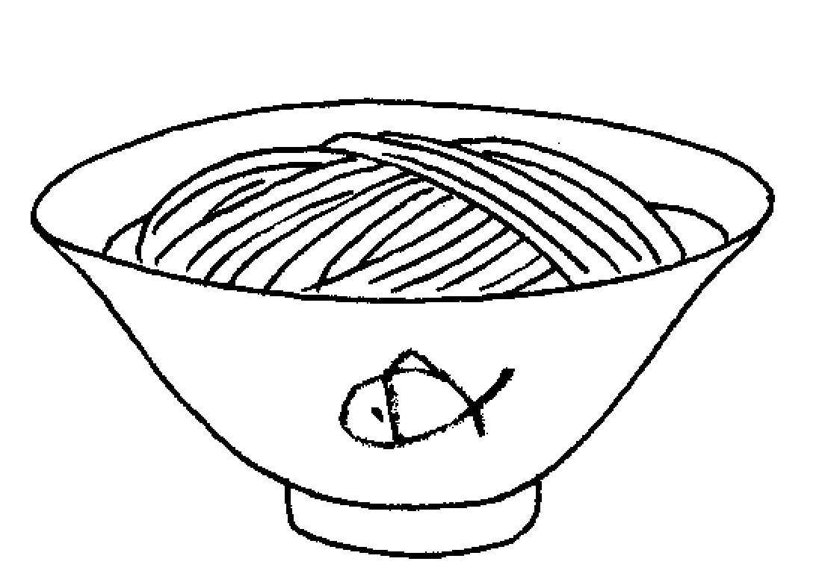 | 2 | 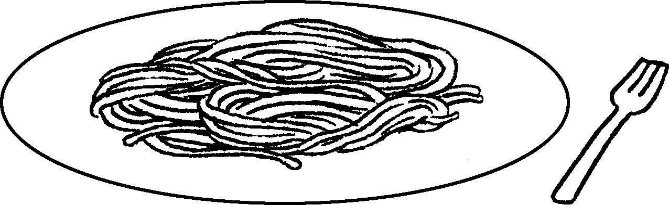  3 |  | 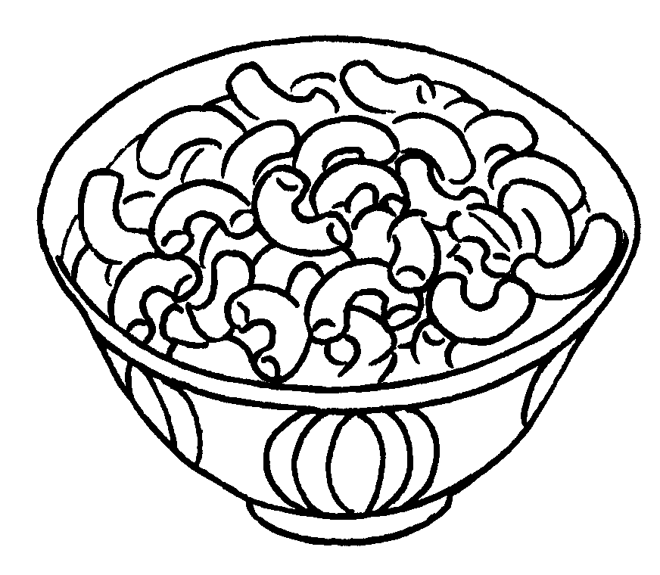

broccoli | carrots | lettuce | peas

4 | 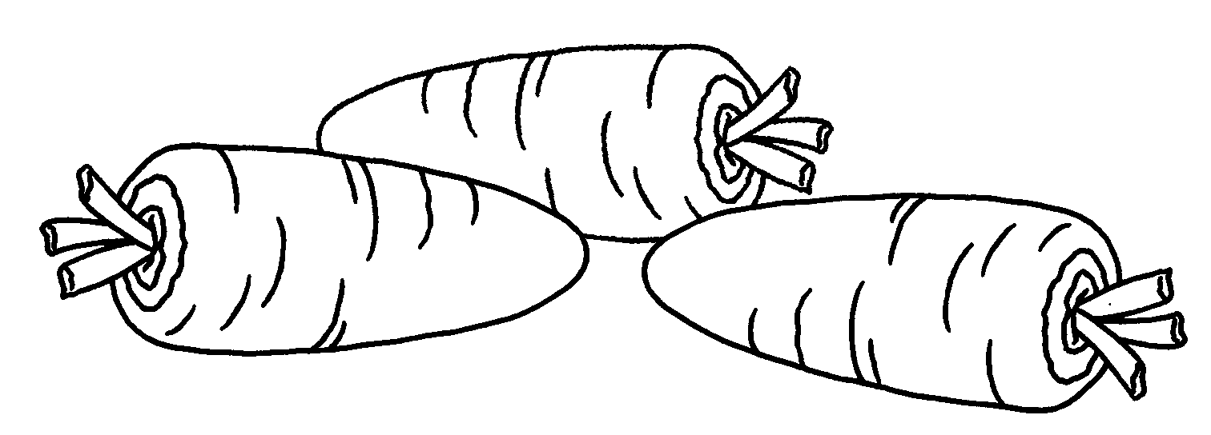  5 |  | 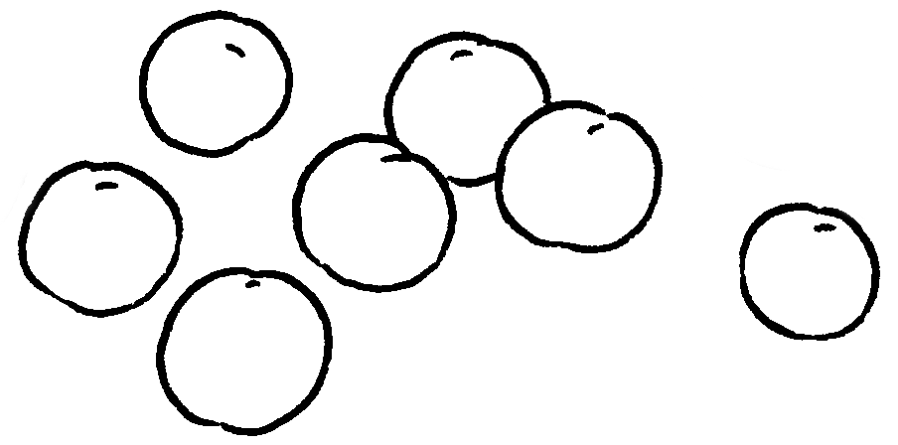
6 | 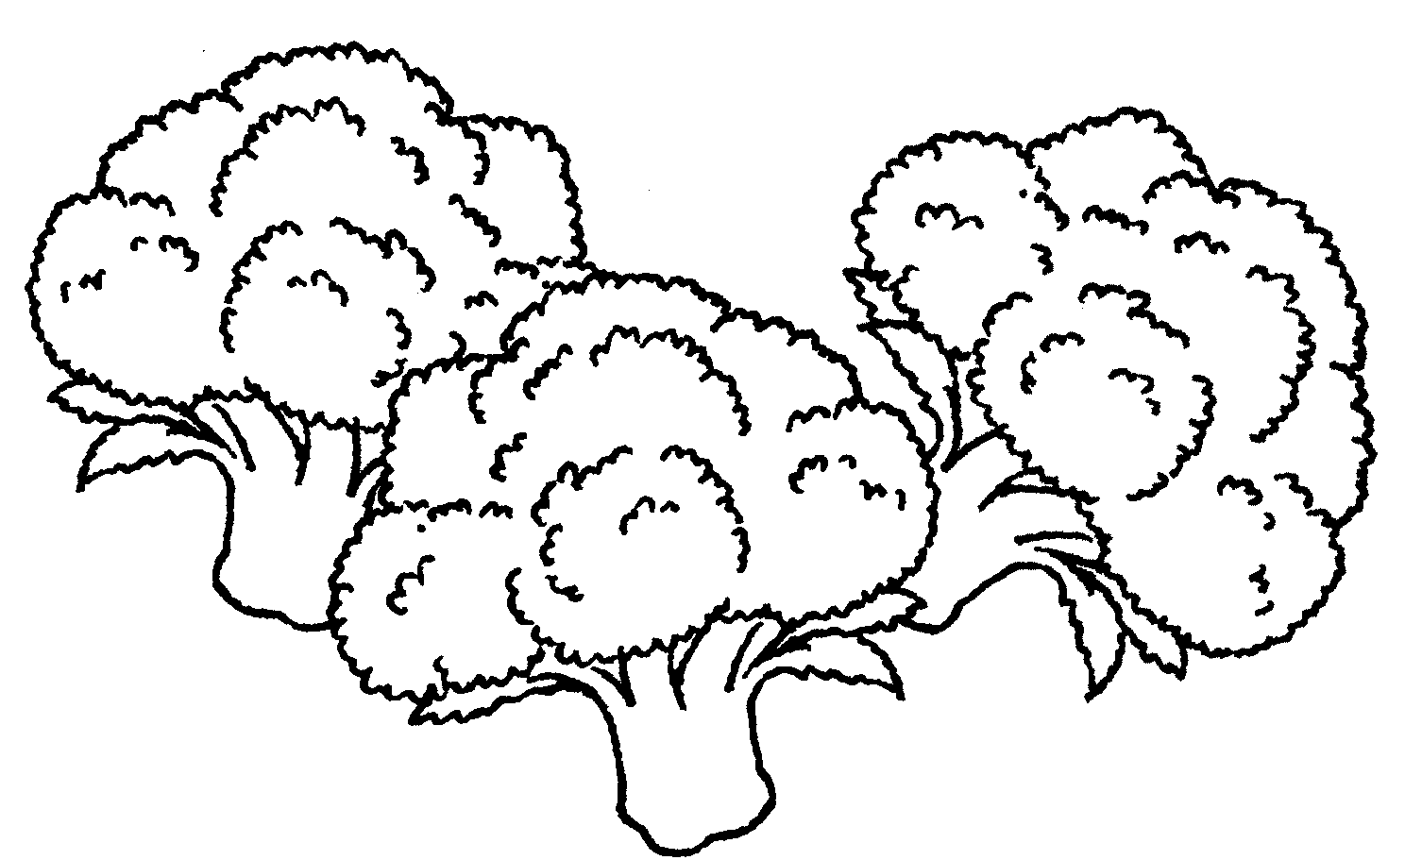  7 |  | 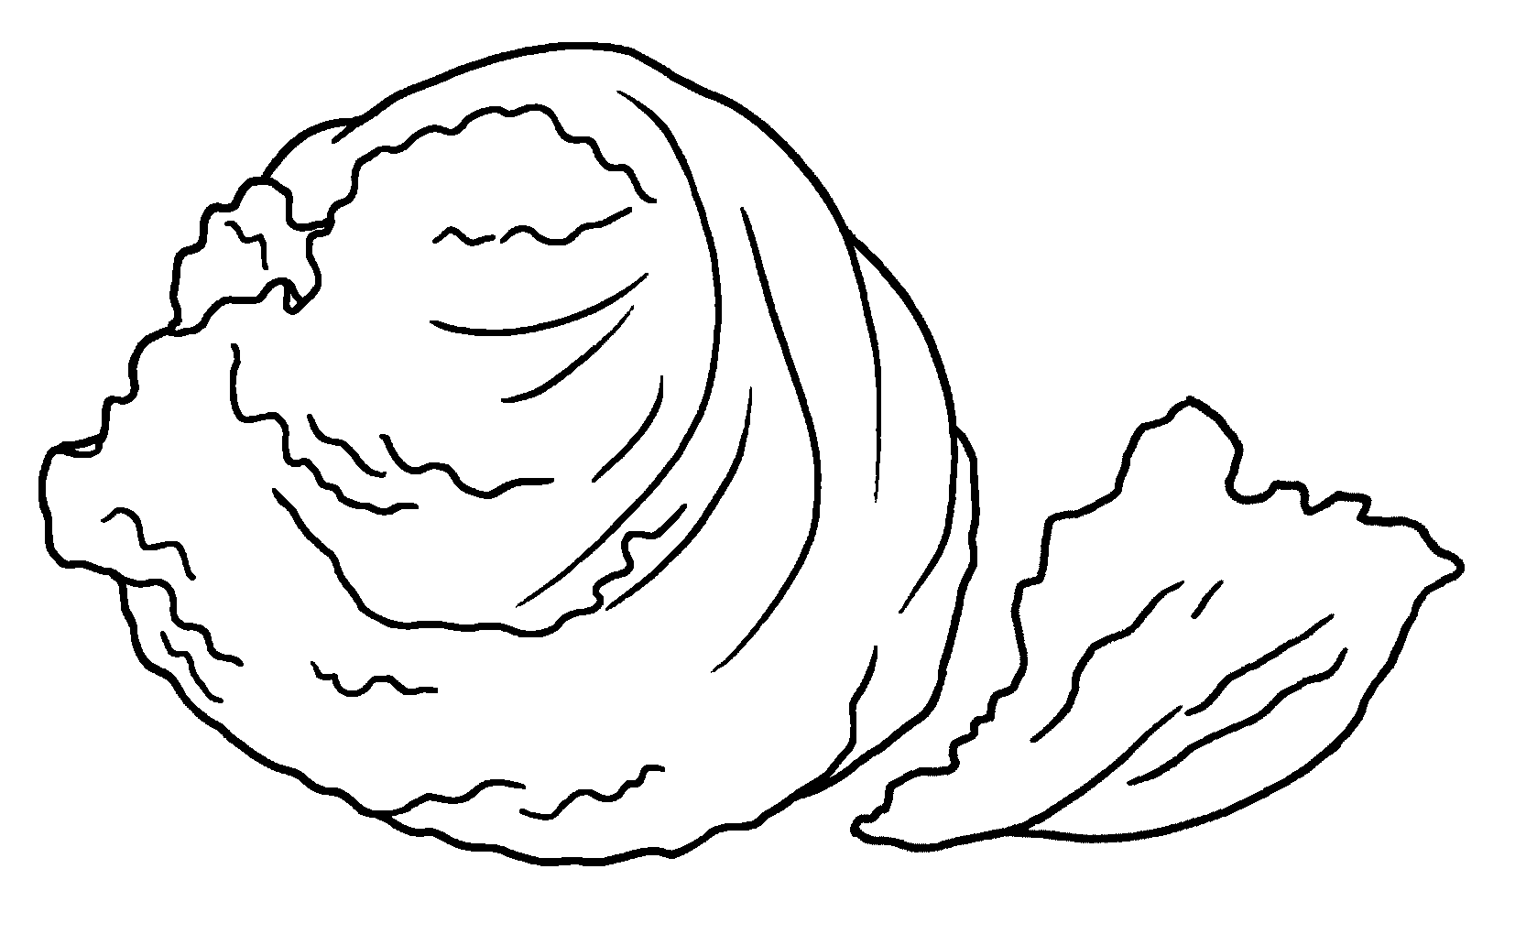

pork | steak
8
 | 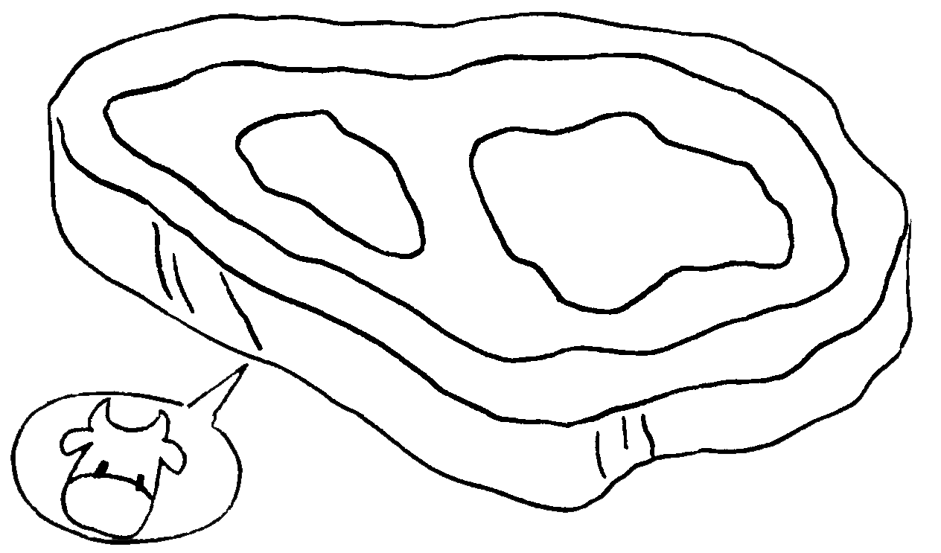  9 |  | 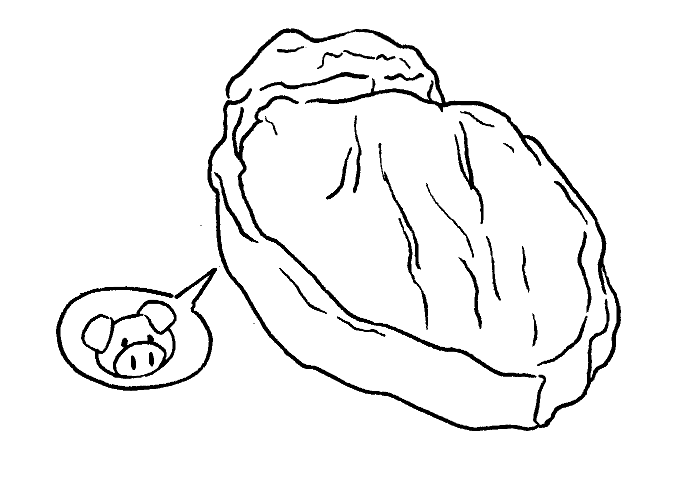

longans | lychees

10 | 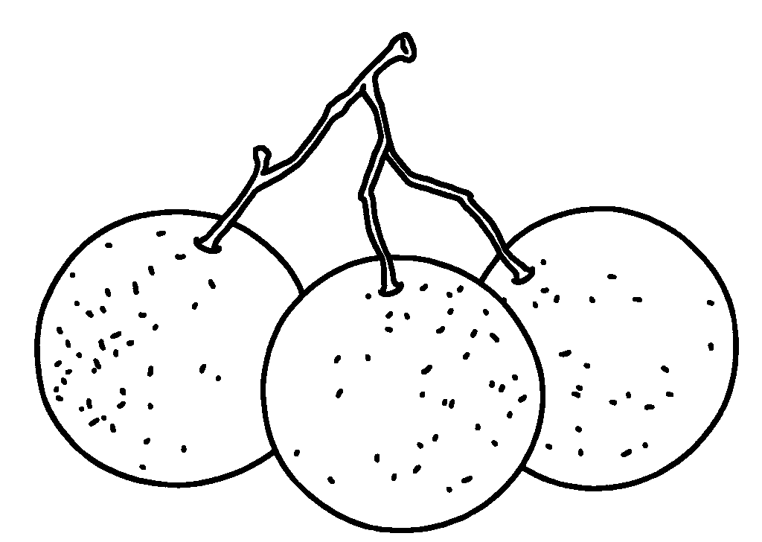  11 |  | 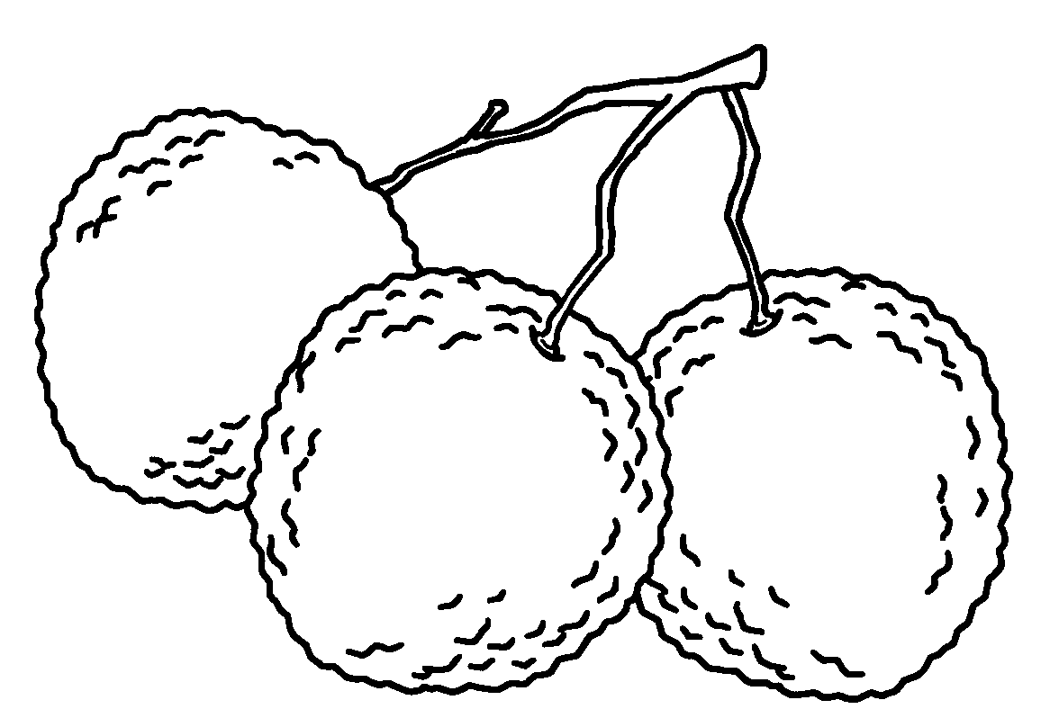
RP no: Century Gothic 15pt
(所有圈號用15pt)


Book 4B Chapter 3 Graded Worksheets
Worksheet 1⬇
- noodles
- spaghetti
- macaroni
- carrots
- peas
- broccoli
- lettuce
- steak
- pork
- longans
- lychees

