RP no: Century Gothic 15pt
(所有圈號用15pt)
What food can you see? Write.

1 | 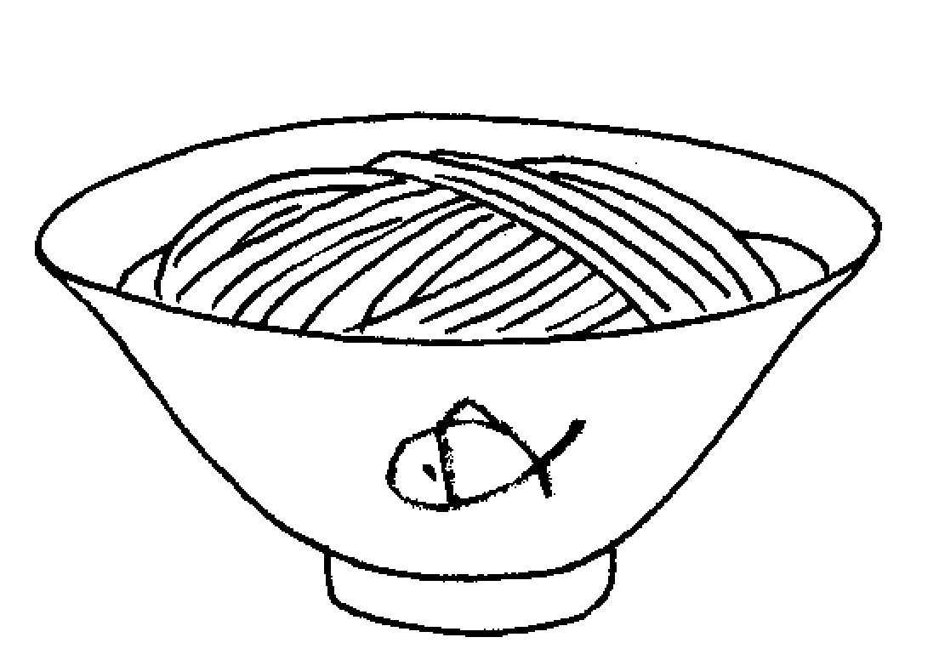 | 2 | 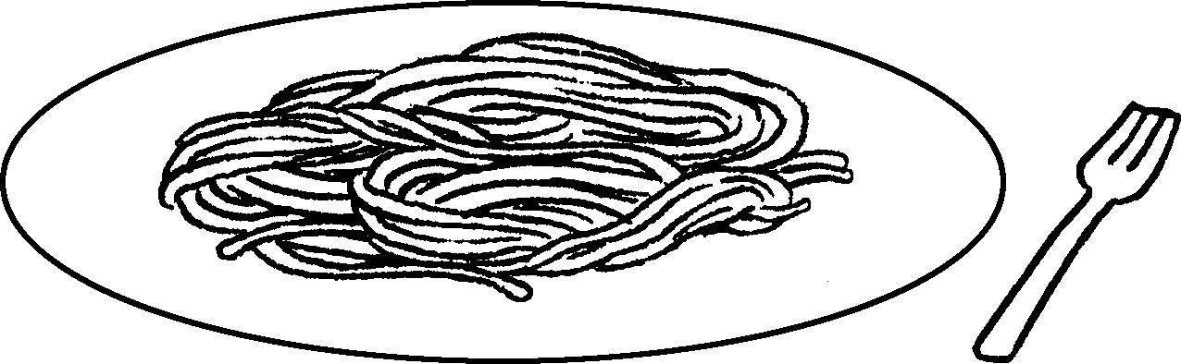  3 |  | 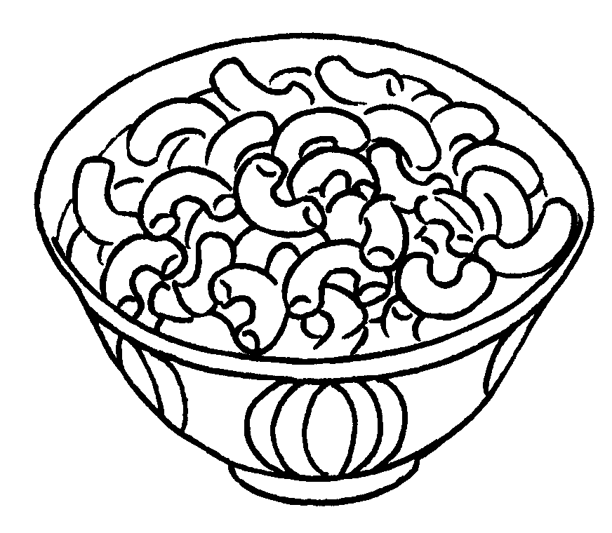
 | n |  | s |  | m

4 | 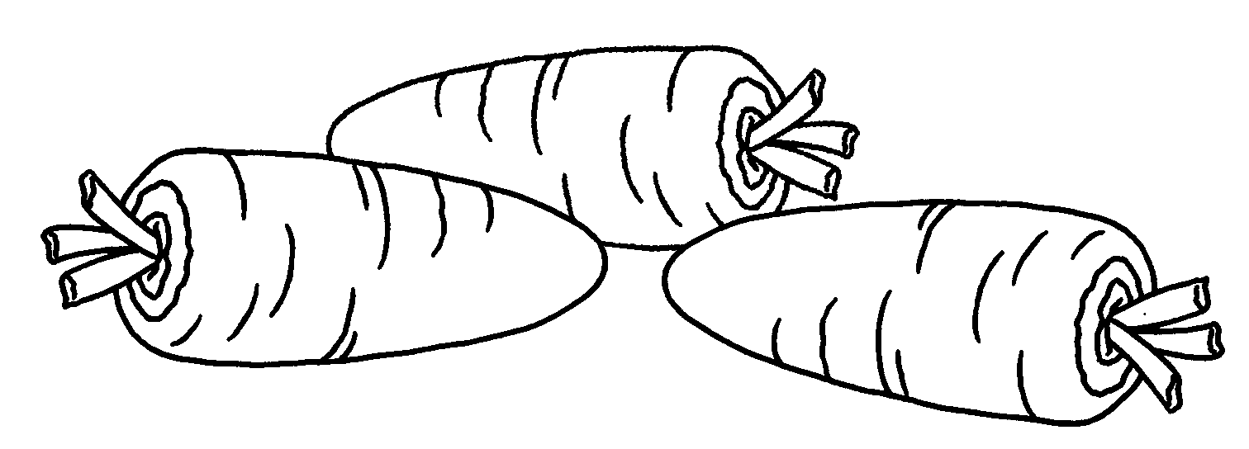  5 |  | 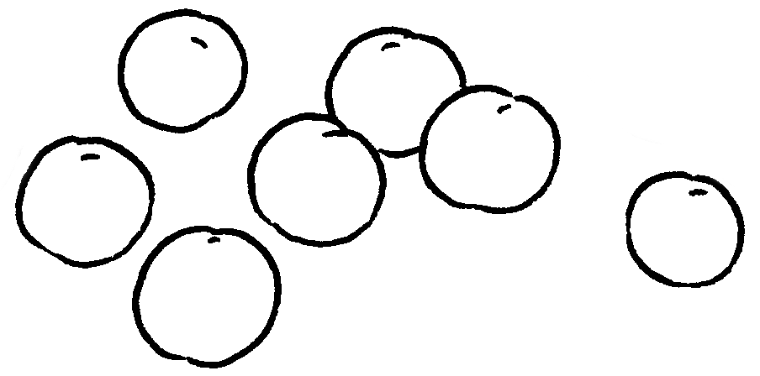
 | c |  | p

6 | 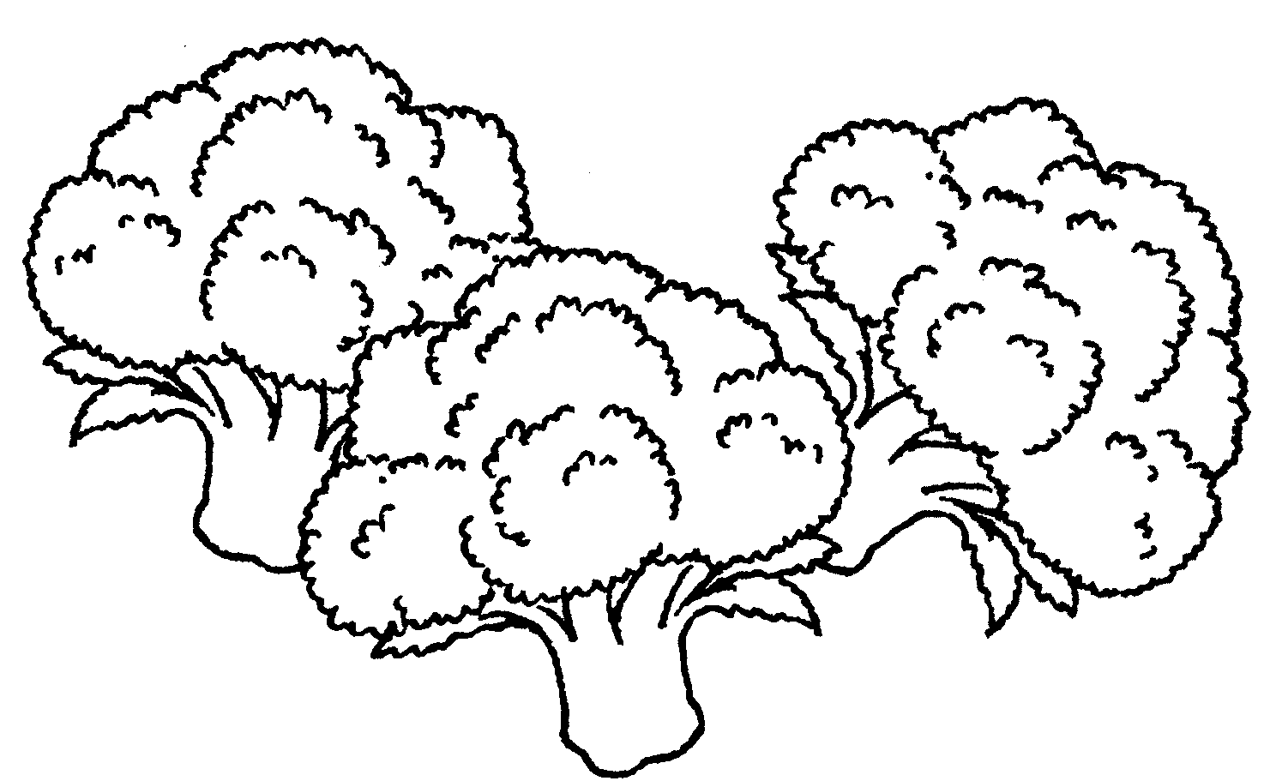  7 |  | 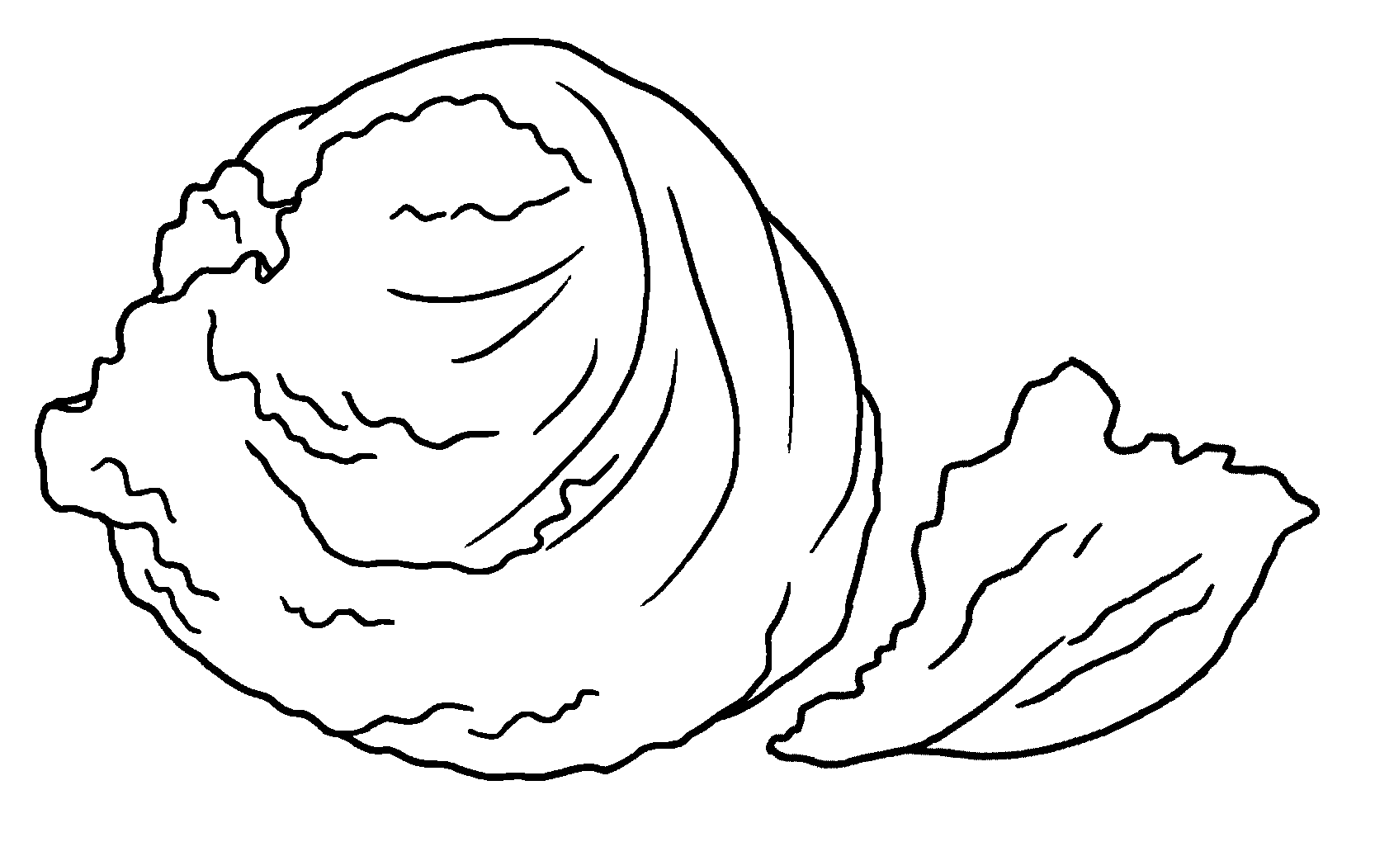
 | b |  | l

8
 | 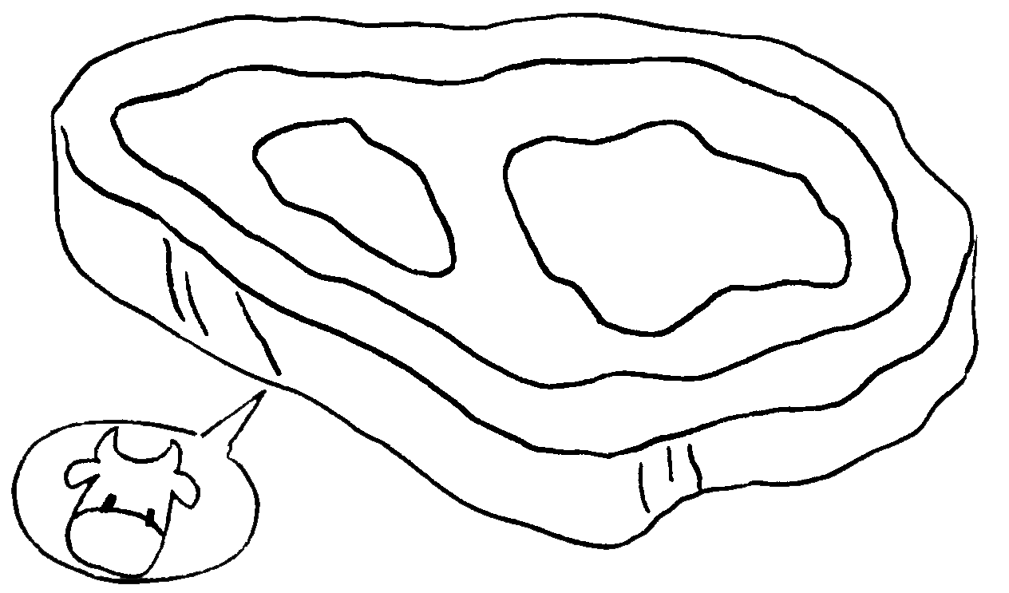  9 |  | 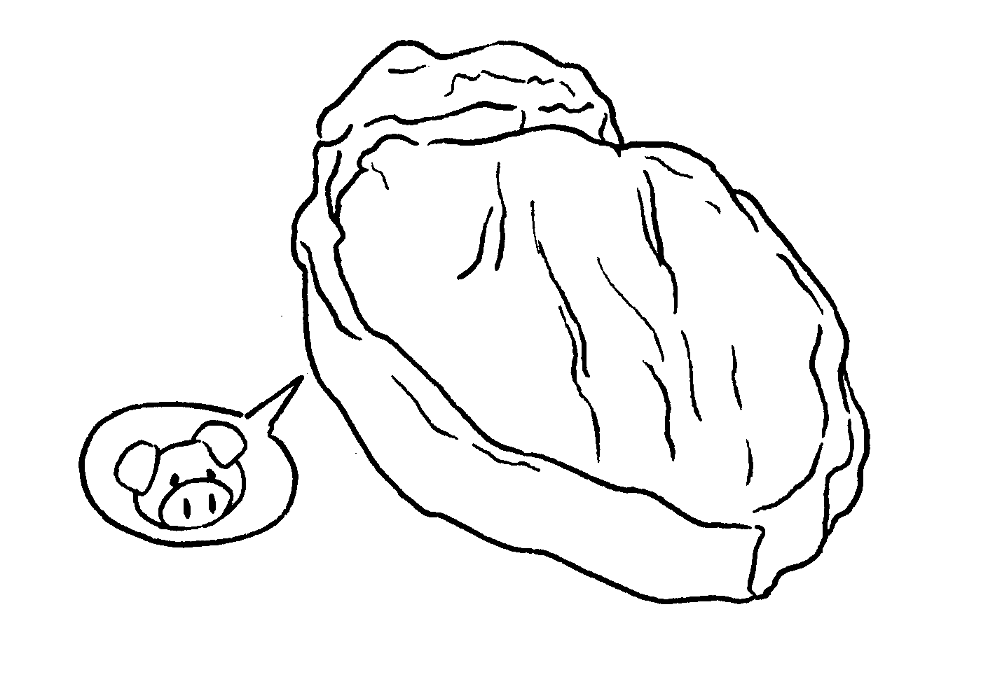
 | s |  | p

10 | 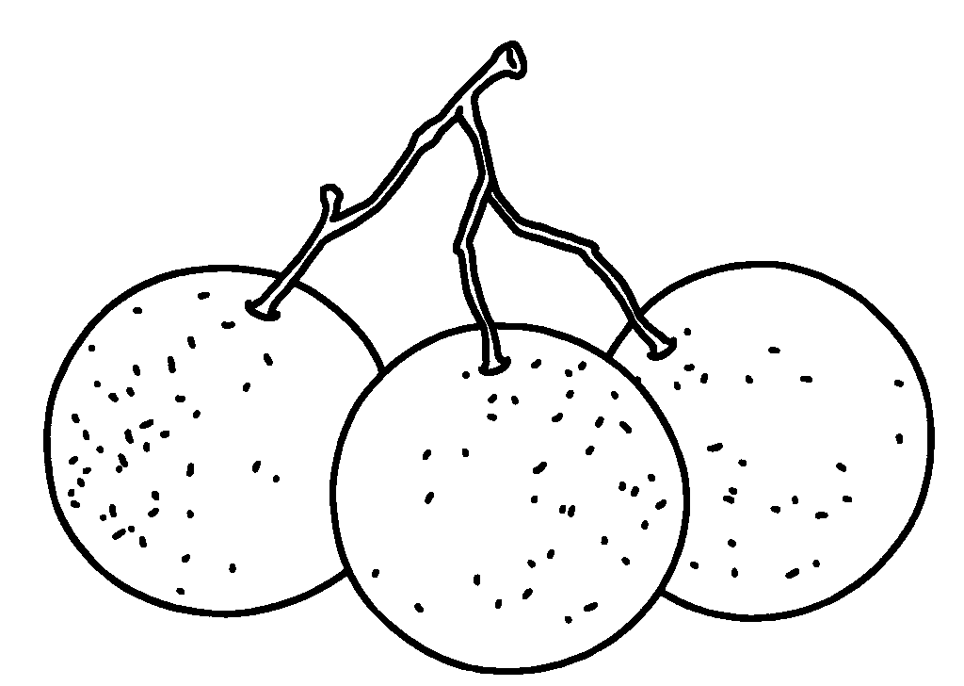  11 |  | 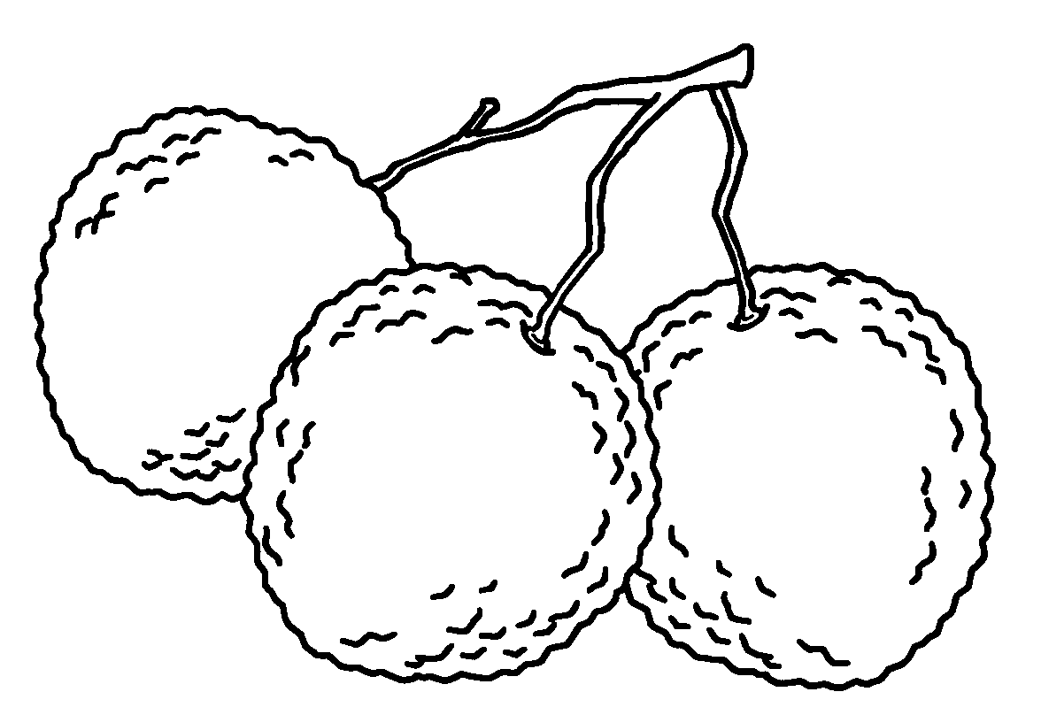
 | l |  | l
RP no: Century Gothic 15pt
(所有圈號用15pt)


Book 4B Chapter 3 Graded Worksheets
Worksheet 1⬇⬇
- noodles
- spaghetti
- macaroni
- carrots
- peas
- broccoli
- lettuce
- steak
- pork
- longans
- lychees

