RP no: Century Gothic 15pt
(所有圈號用15pt)
Circle the correct answers.

1 |  | Tom is eating ( a lot of / a few ) carrots.
2 | 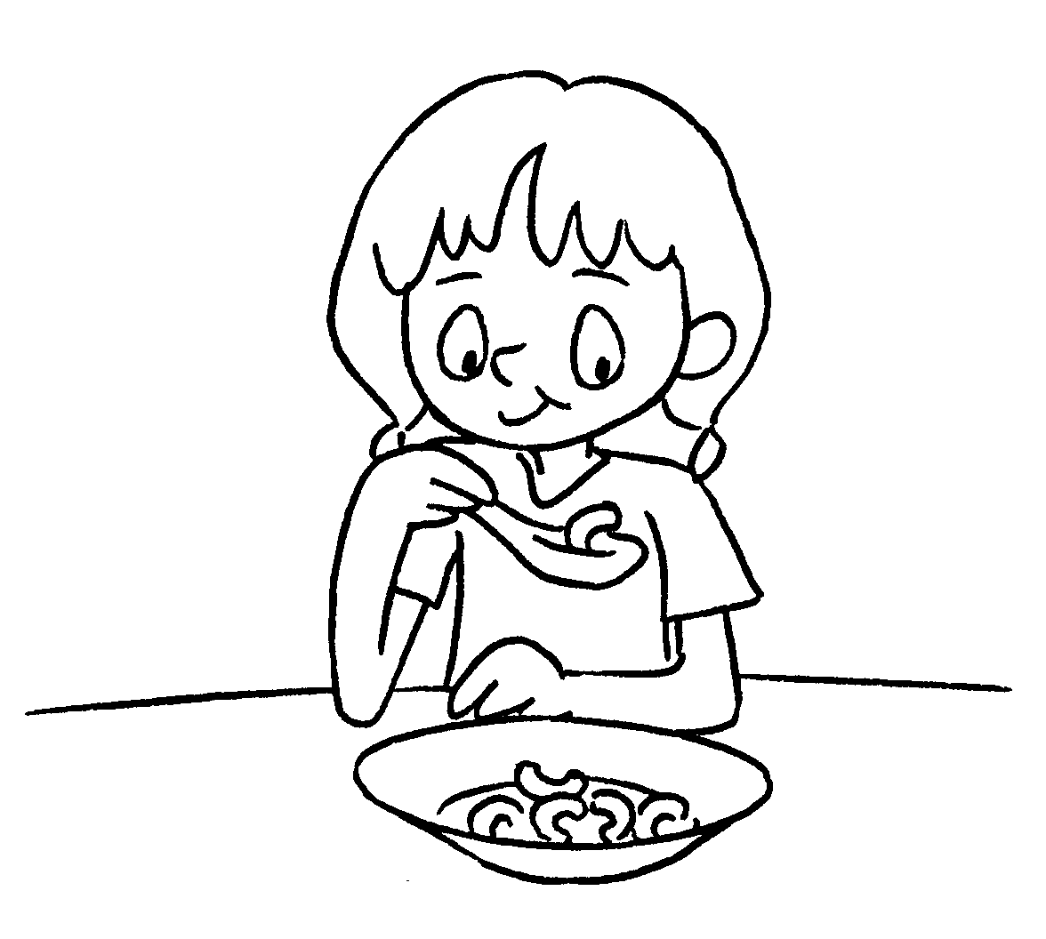 | Sally is eating ( a few / a little ) macaroni.
3 | 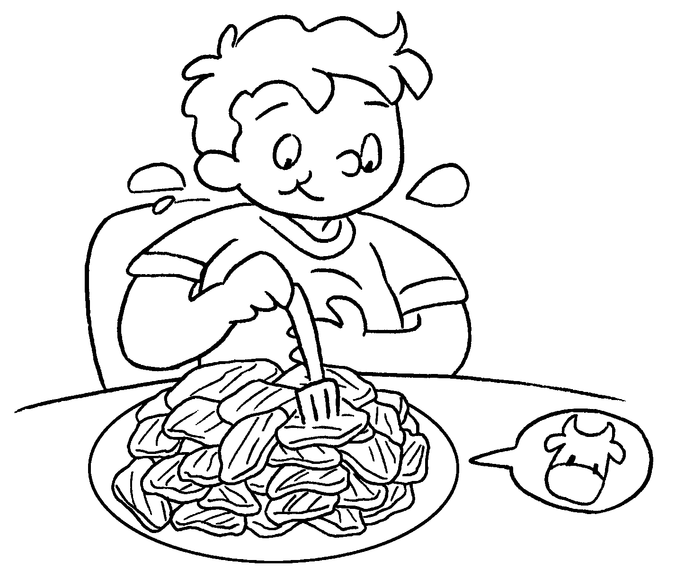 | Sam is eating ( a little / a lot of ) beef.
4 | 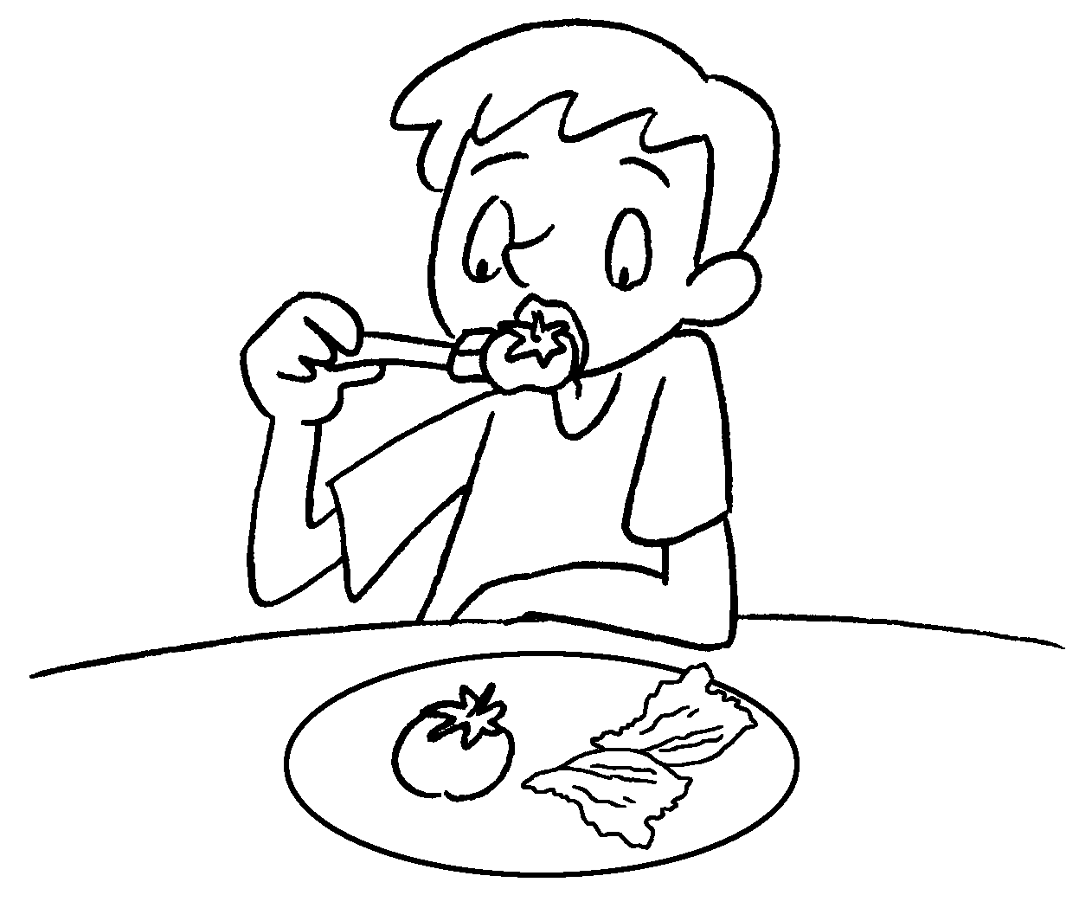 | Jerry is eating ( a few / a little ) tomatoes and ( a few / a little ) lettuce.
5 | 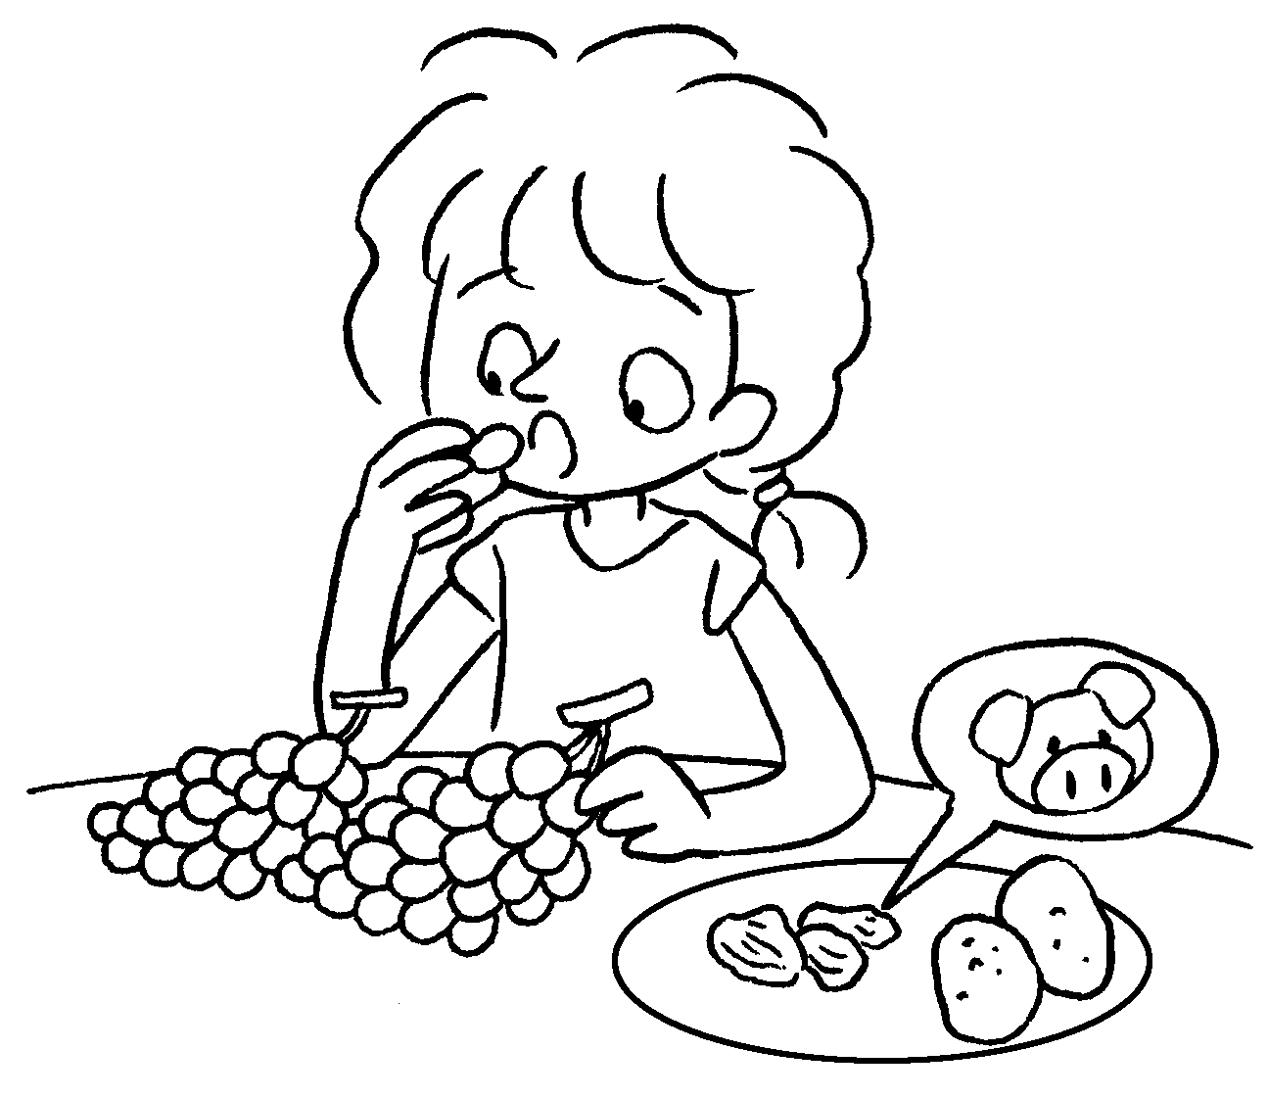 | Ruby is eating ( a few / a little / a lot of ) grapes, ( a few / a little / a lot of ) pork and  ( a few / a little / a lot of ) potatoes.


Book 4B Chapter 3 Graded Worksheets
Worksheet 2⬇
- ( a lot of / a few )
- ( a few / a little )
- ( a little / a lot of )
- ( a few / a little ) ( a few / a little )
- ( a few / a little / a lot of ) ( a few / a little / a lot of ) ( a few / a little / a lot of )

