Fill in the blanks.

a lot of | a few | a little

1 | 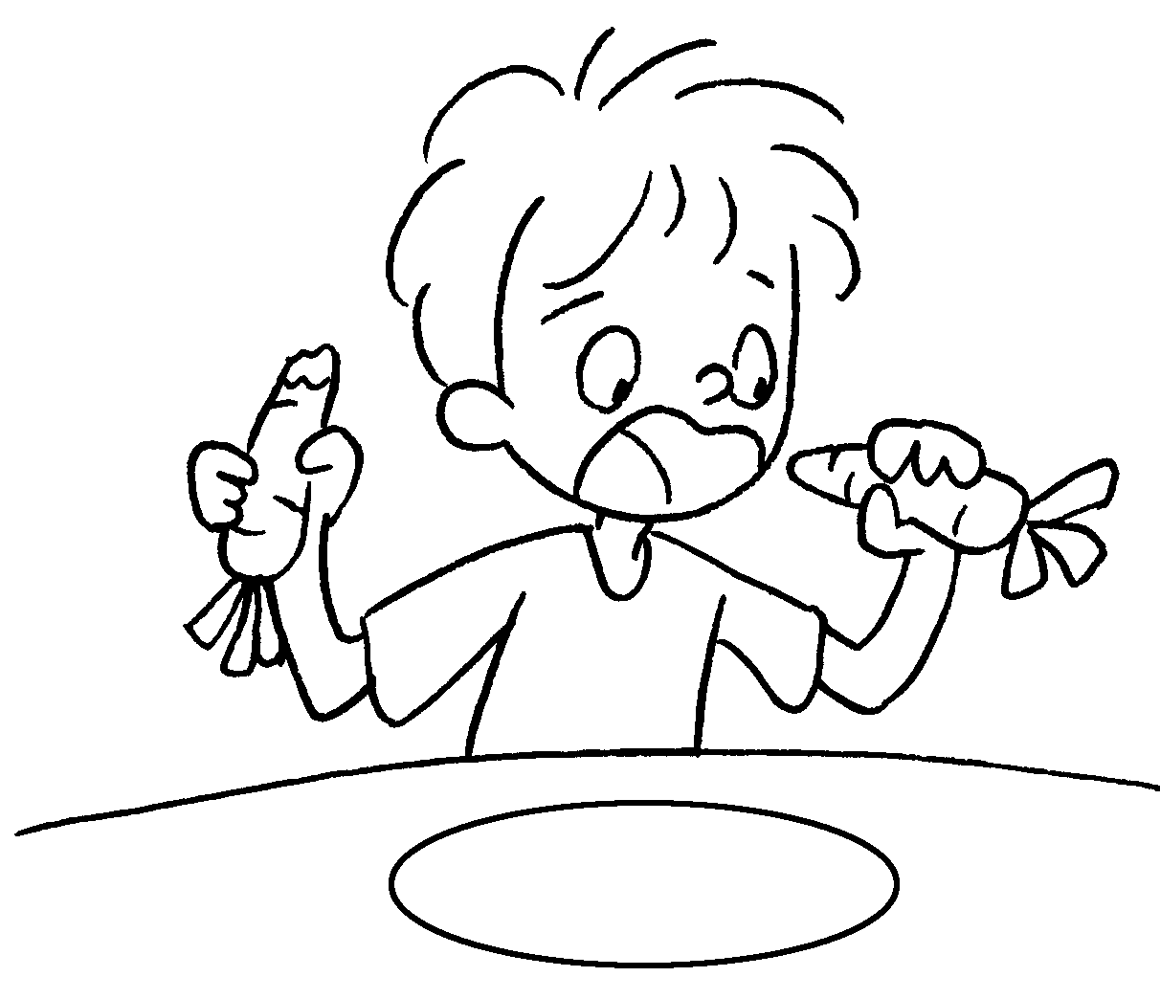 | Tom is eating carrots.
2 | 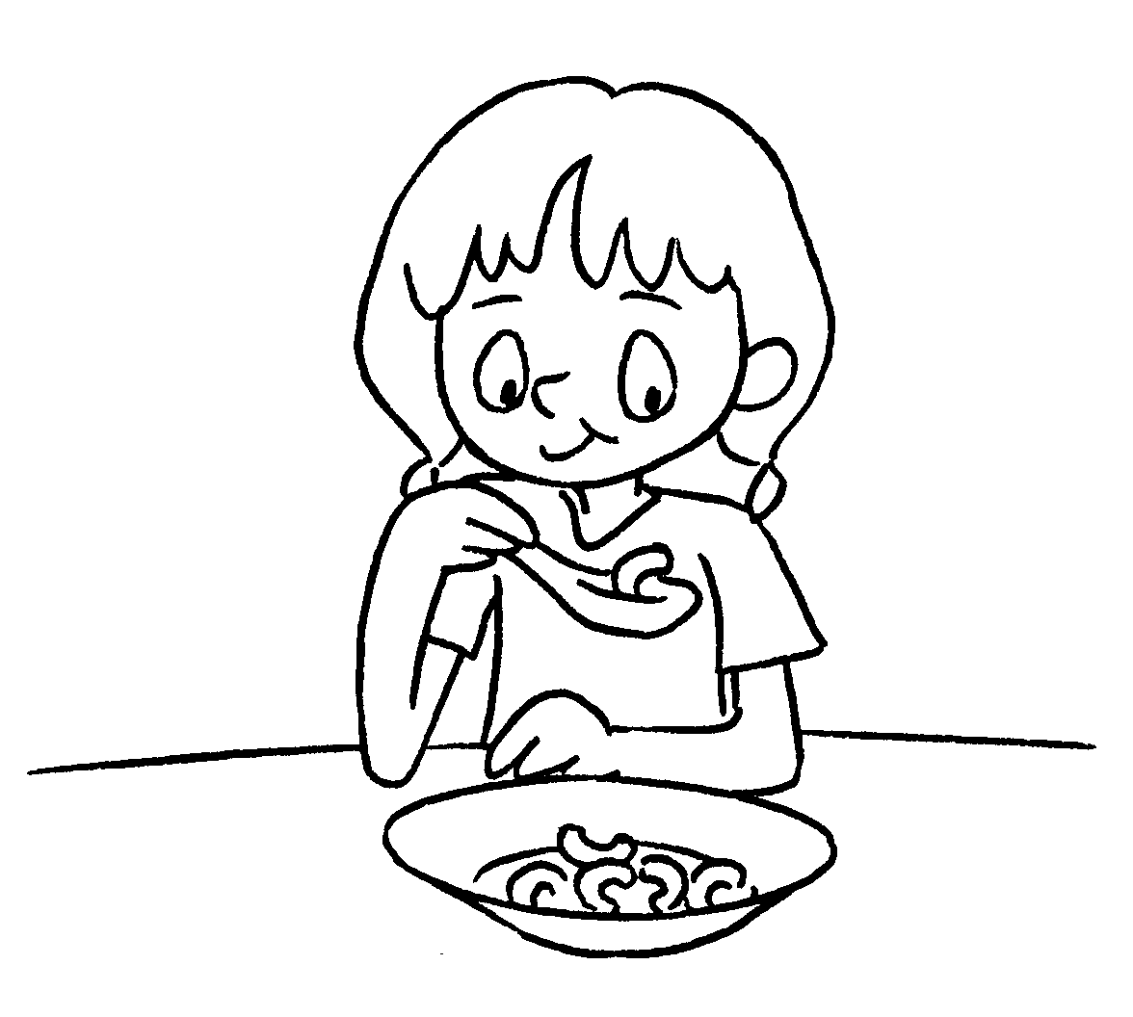 | Sally is eating macaroni.
3 | 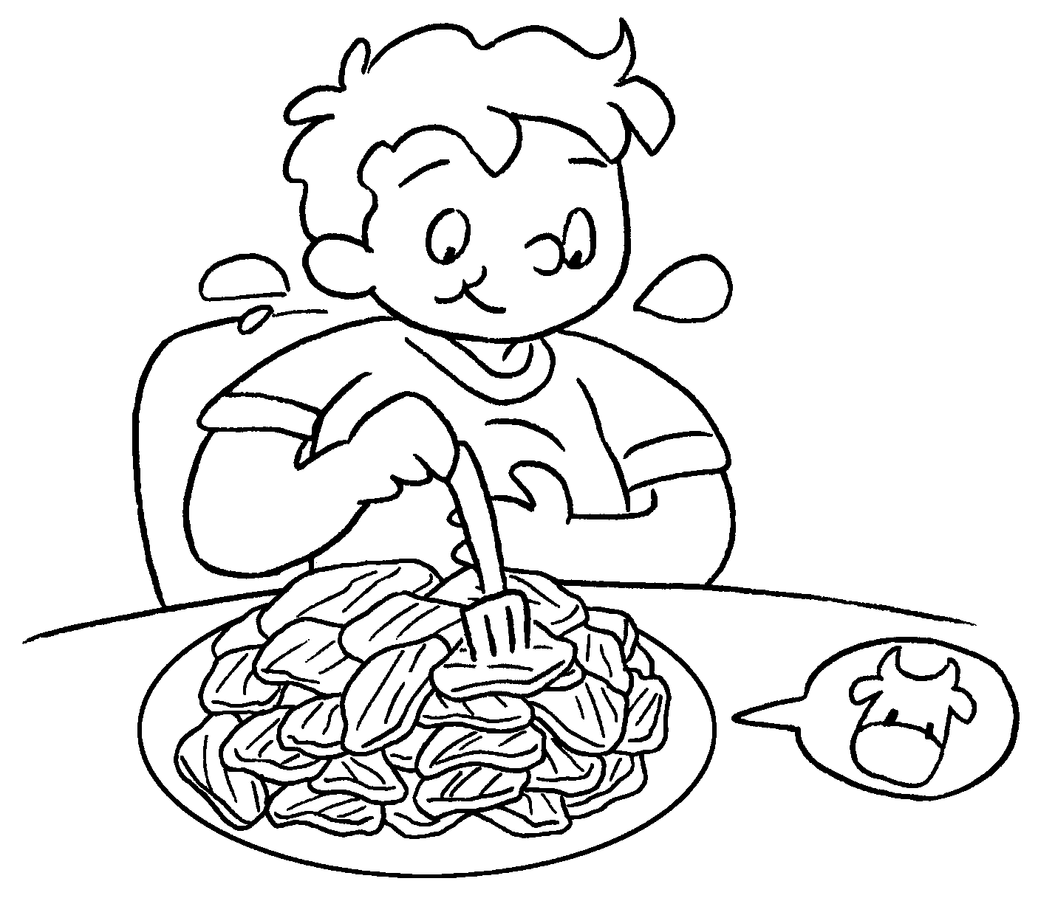 | Sam is eating beef.
4 | 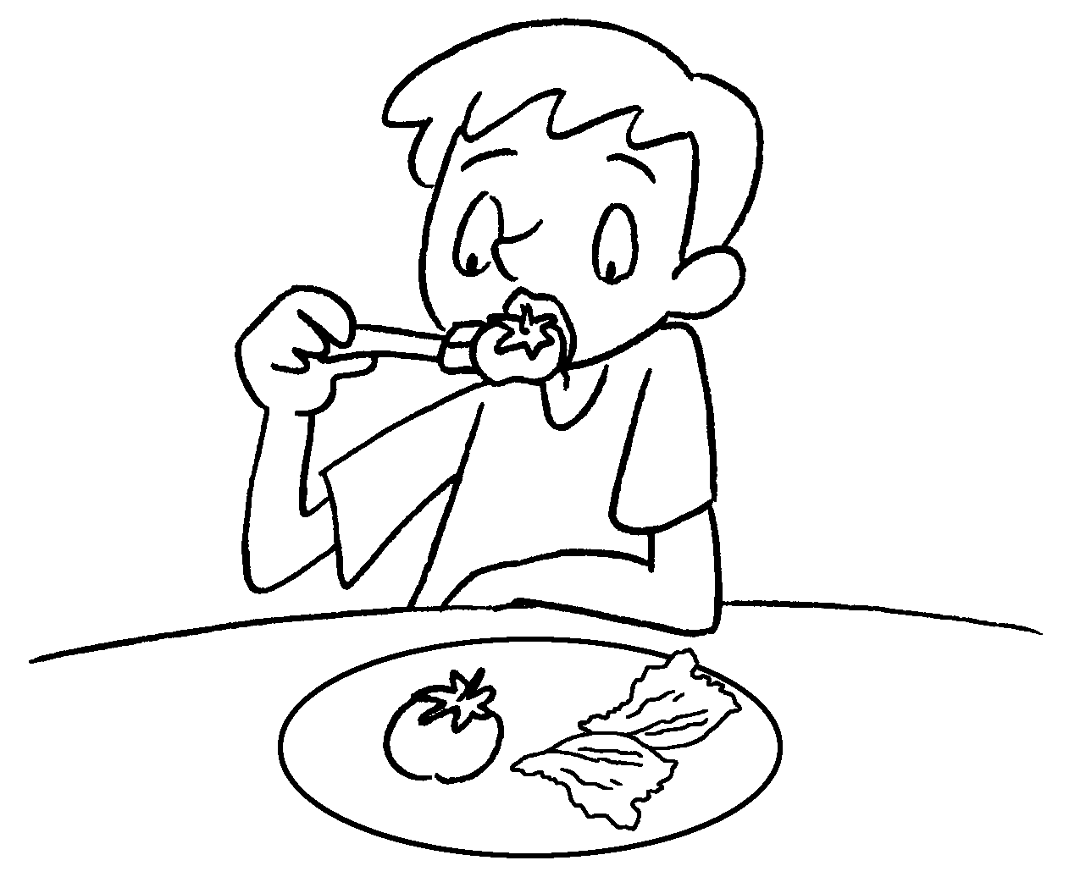 | Jerry is eating and .
5 | 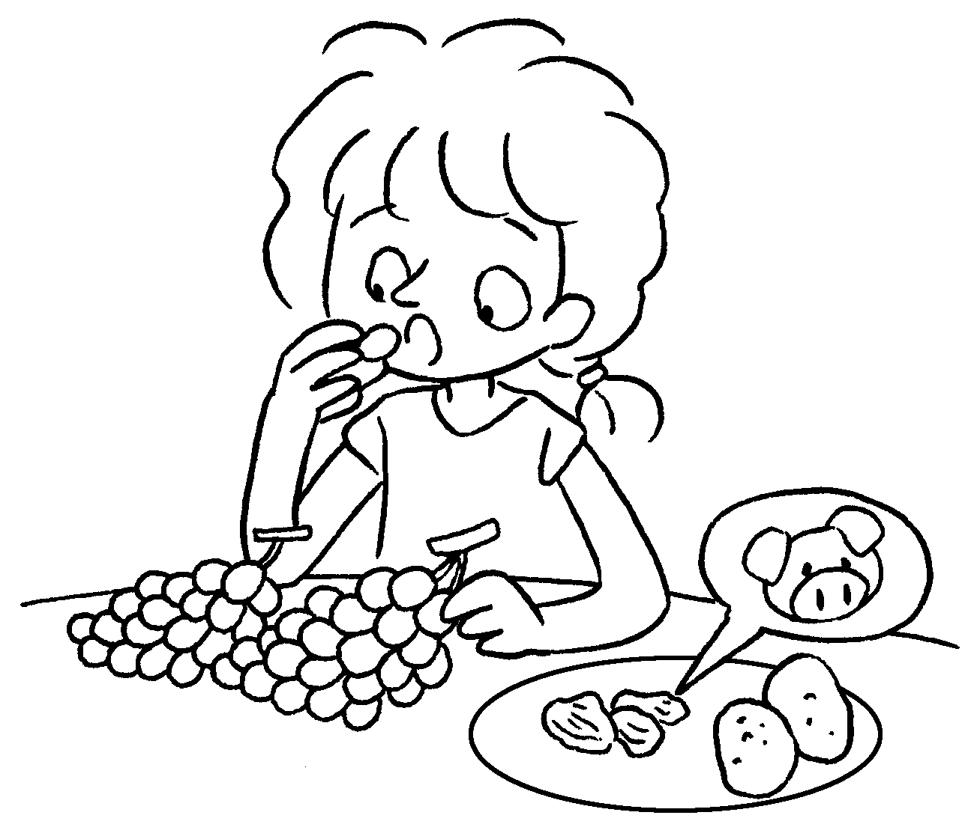 | Ruby is eating ,  and  .


Book 4B Chapter 3 Graded Worksheets
Worksheet 2⬇⬇⬇
- a few
- a little
- a lot of
- a few tomatoes a little lettuce
(The answers can be given in any order.)
- a lot of grapes a little pork a few potatoes
(The answers can be given in any order.)

