Circle and write.

1 | 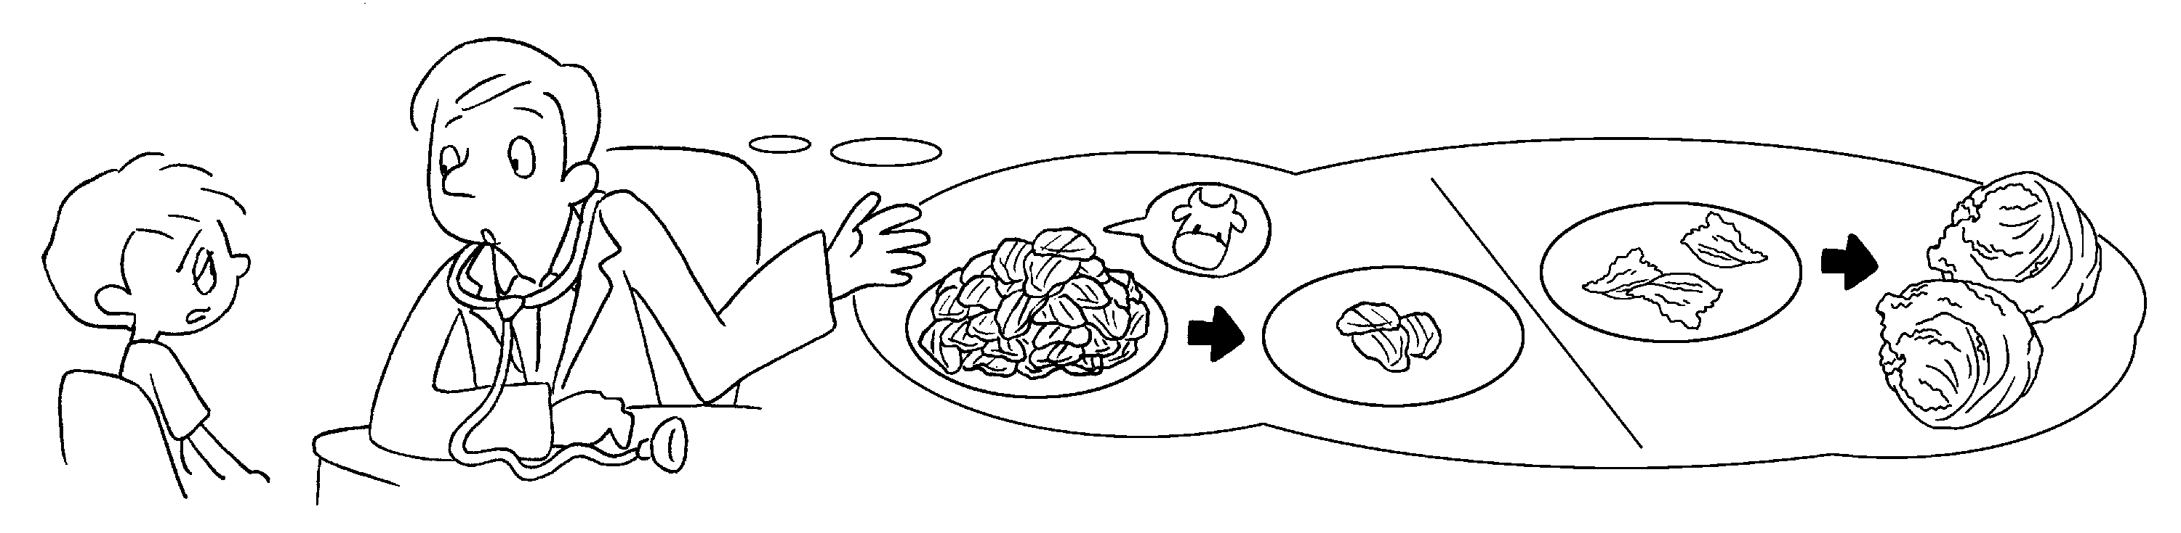
You need to eat ( less / more ) beef.
You need to eat ( less / more ) lettuce.
2 | 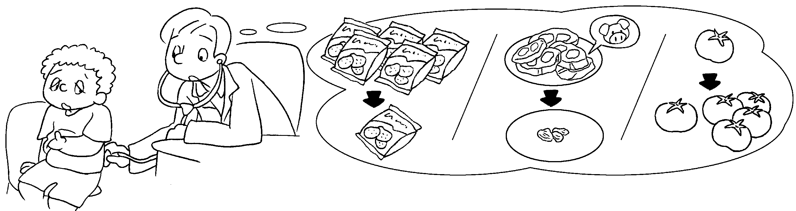
You need to eat ( less / fewer ) potato chips.
You need to eat ( less / fewer ) pork.
You need to eat ( more / fewer ) tomatoes.
3 | 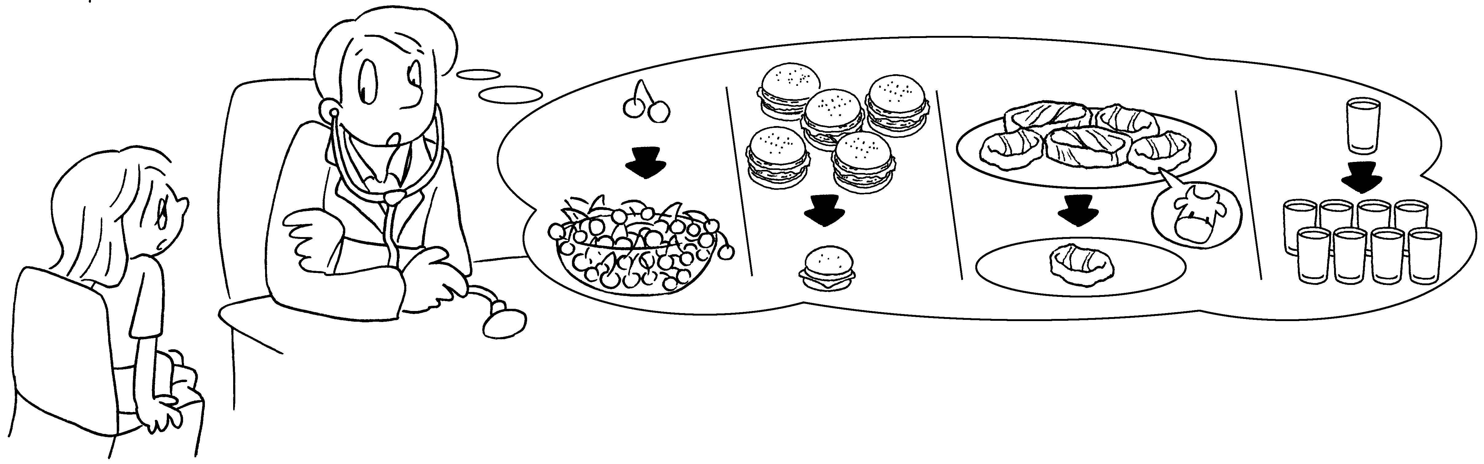
You eat ( more / less / fewer ) cherries,
( more / less / fewer ) hamburgers and ( more / less / fewer ) steak.
You drink ( more / less / fewer ) water.



Book 4B Chapter 3 Graded Worksheets
Worksheet 3⬇
- ( less / more )
( less / more )
- ( less / fewer )
( less / fewer )
( more / fewer )
- need to ( more / less / fewer )
( more / less / fewer ) ( more / less / fewer )
need to ( more / less / fewer )

