Choose and write.
need to | more | fewer | less

1 | 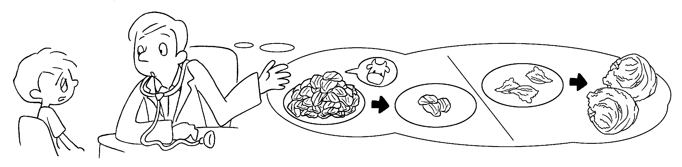
You need to eat beef.
You need to eat lettuce.
2 | 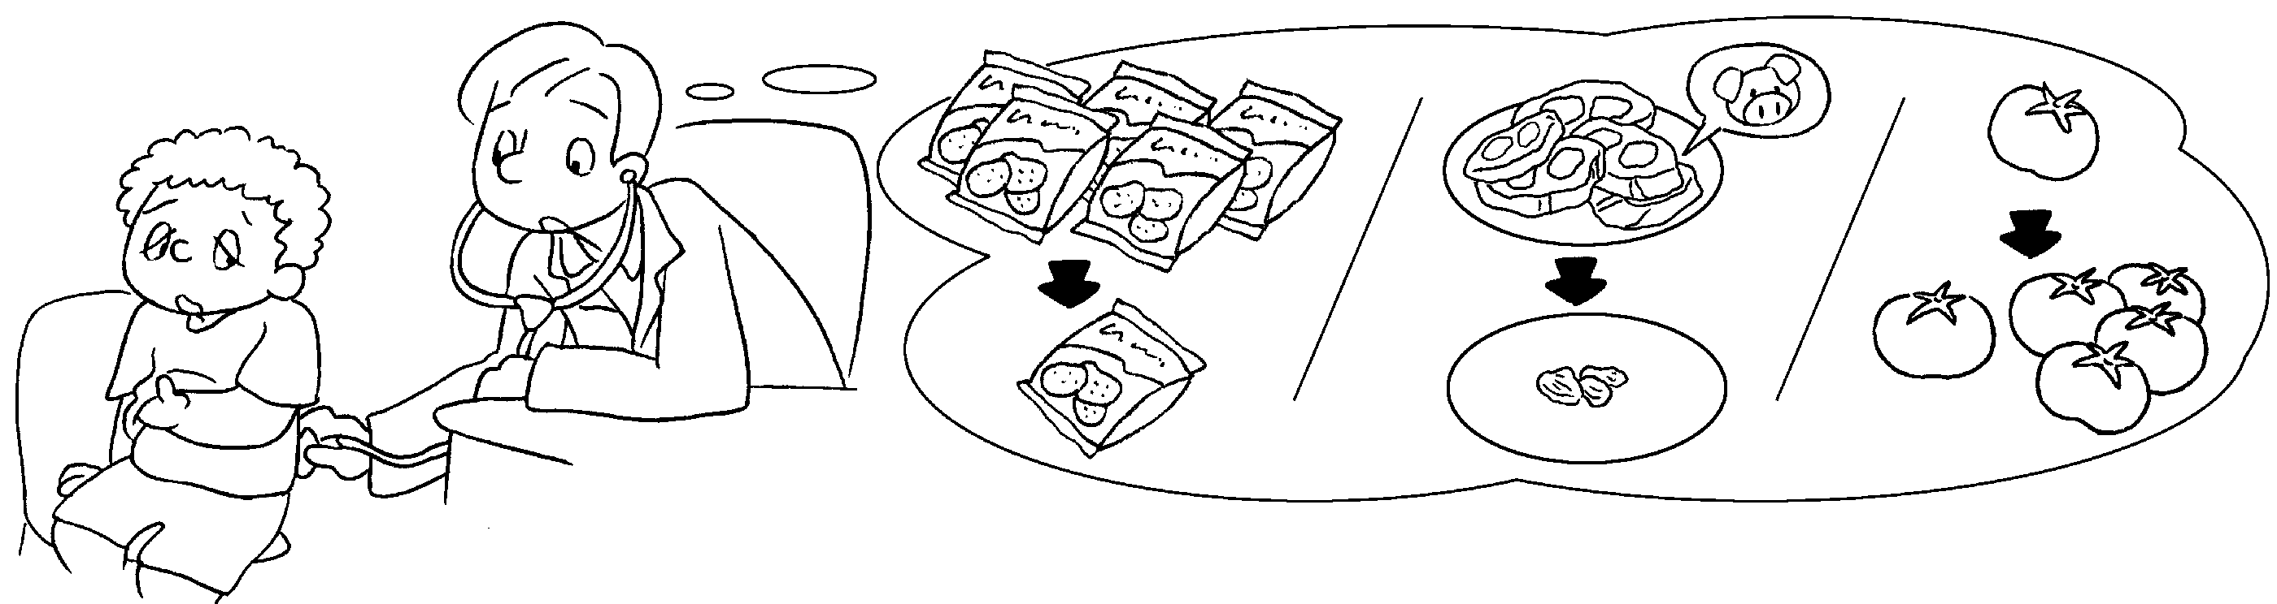
You eat potato chips.
You eat pork.
You eat tomatoes.
3 | 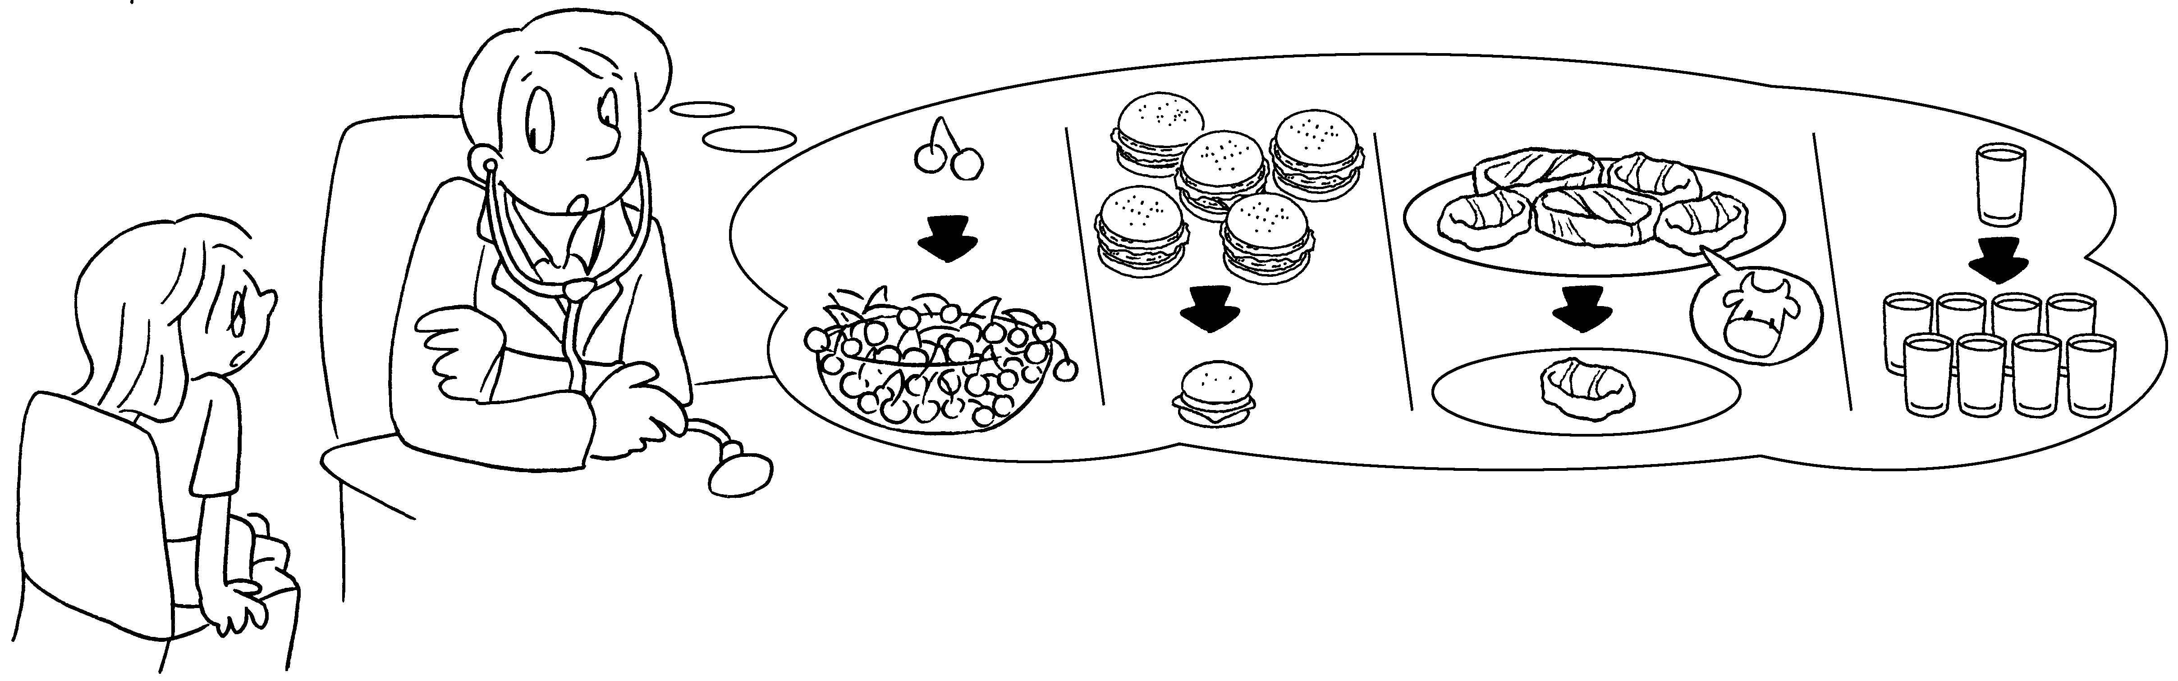
You eat cherries,
hamburgers and steak.
You drink water.



Book 4B Chapter 3 Graded Worksheets
Worksheet 3⬇⬇
- less
more
2 need to fewer
need to less
need to more
3 need to more
fewer less
need to more

