Fill in the blanks.

1 | 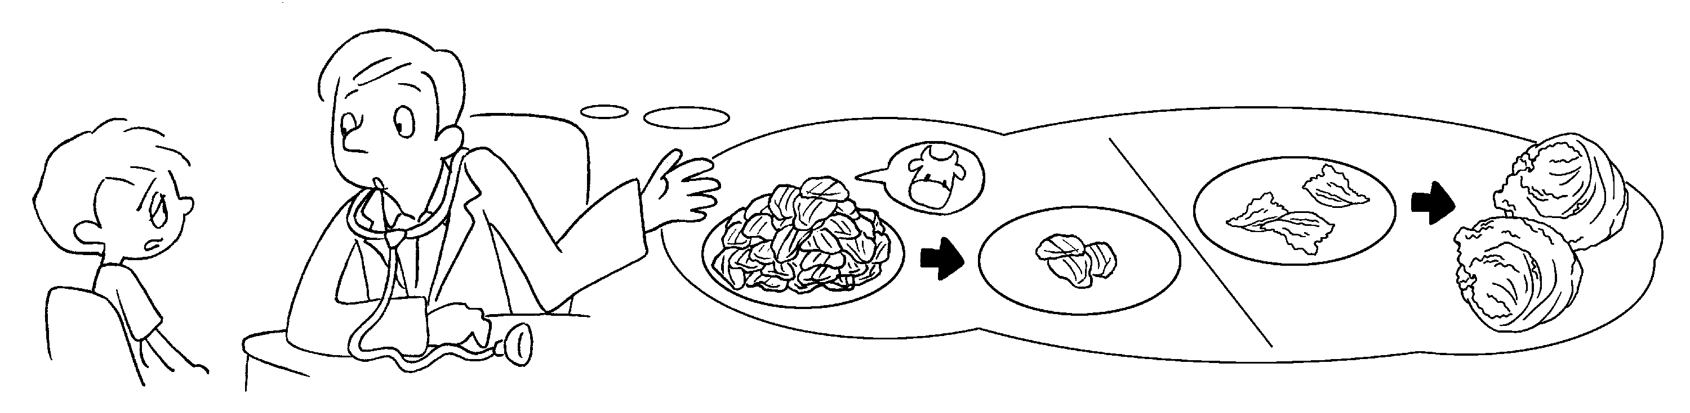
You need to eat beef.
less
You need to eat lettuce.
2 | 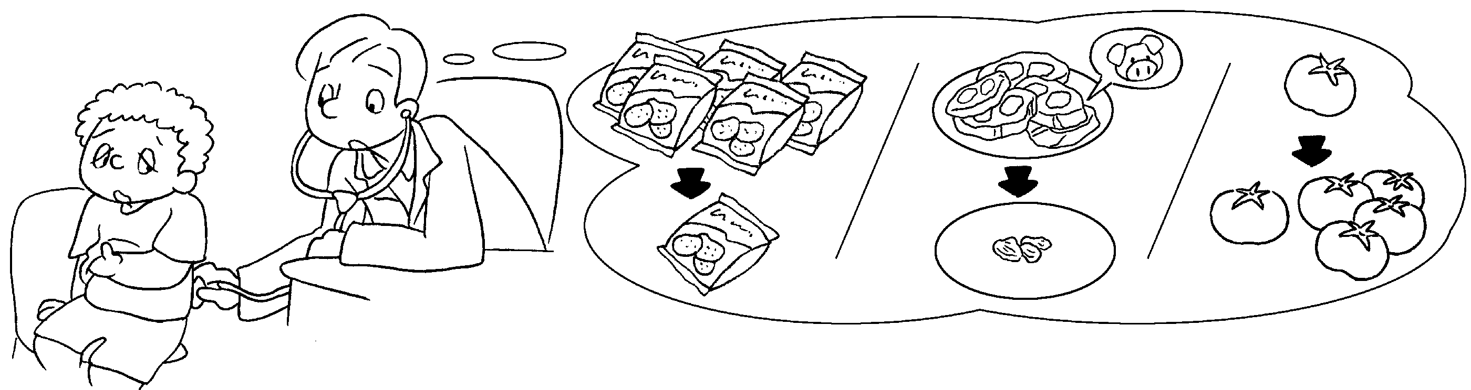
You eat potato chips.
You eat p .
You eat t .
3 | 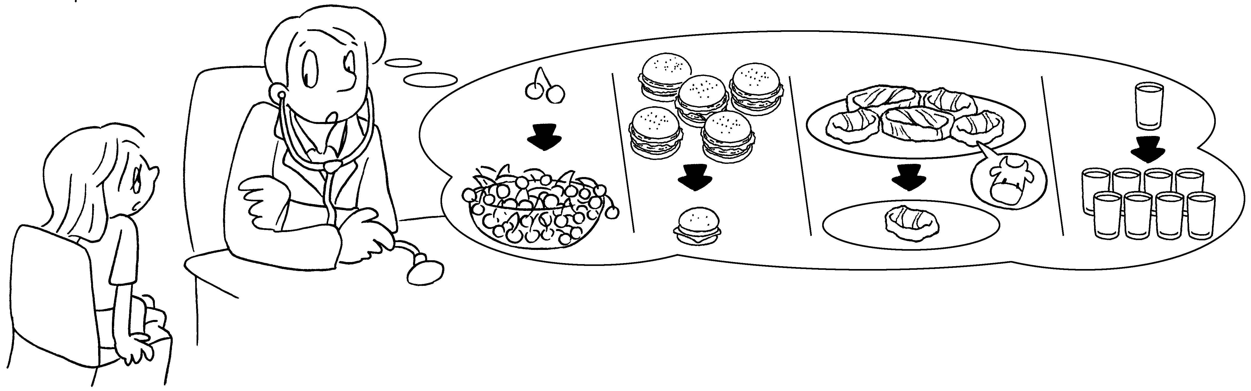
You eat c ,
h and s .
You drink w .



Book 4B Chapter 3 Graded Worksheets
Worksheet 3⬇⬇⬇
- more
2 need to fewer
need to less pork
need to more tomatoes
3 need to more cherries
fewer hamburgers less steak
need to more water

