Choose and write.
is
are
good
bad
for
1 | 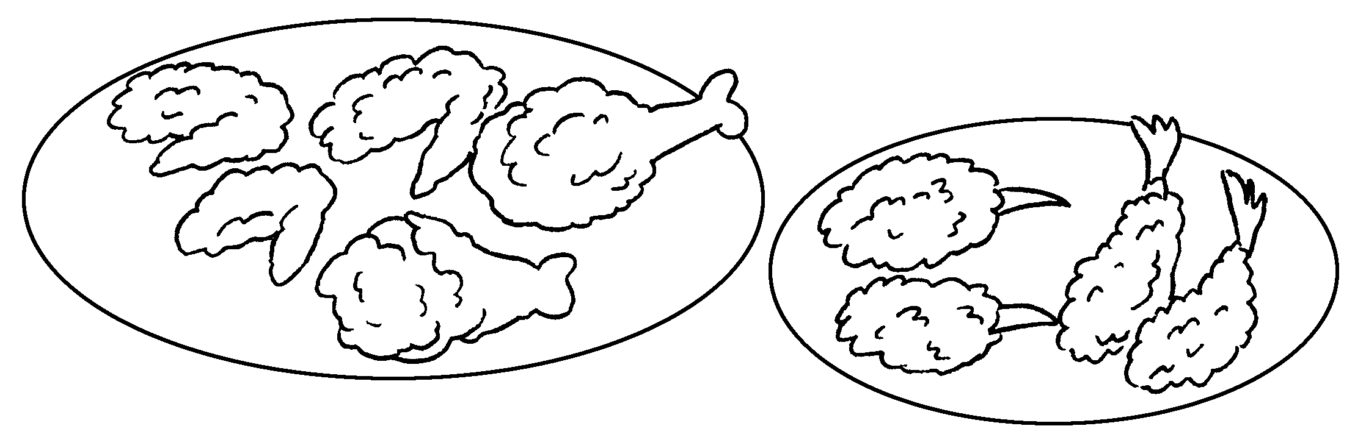 |  | Fried food is  us.
2 | 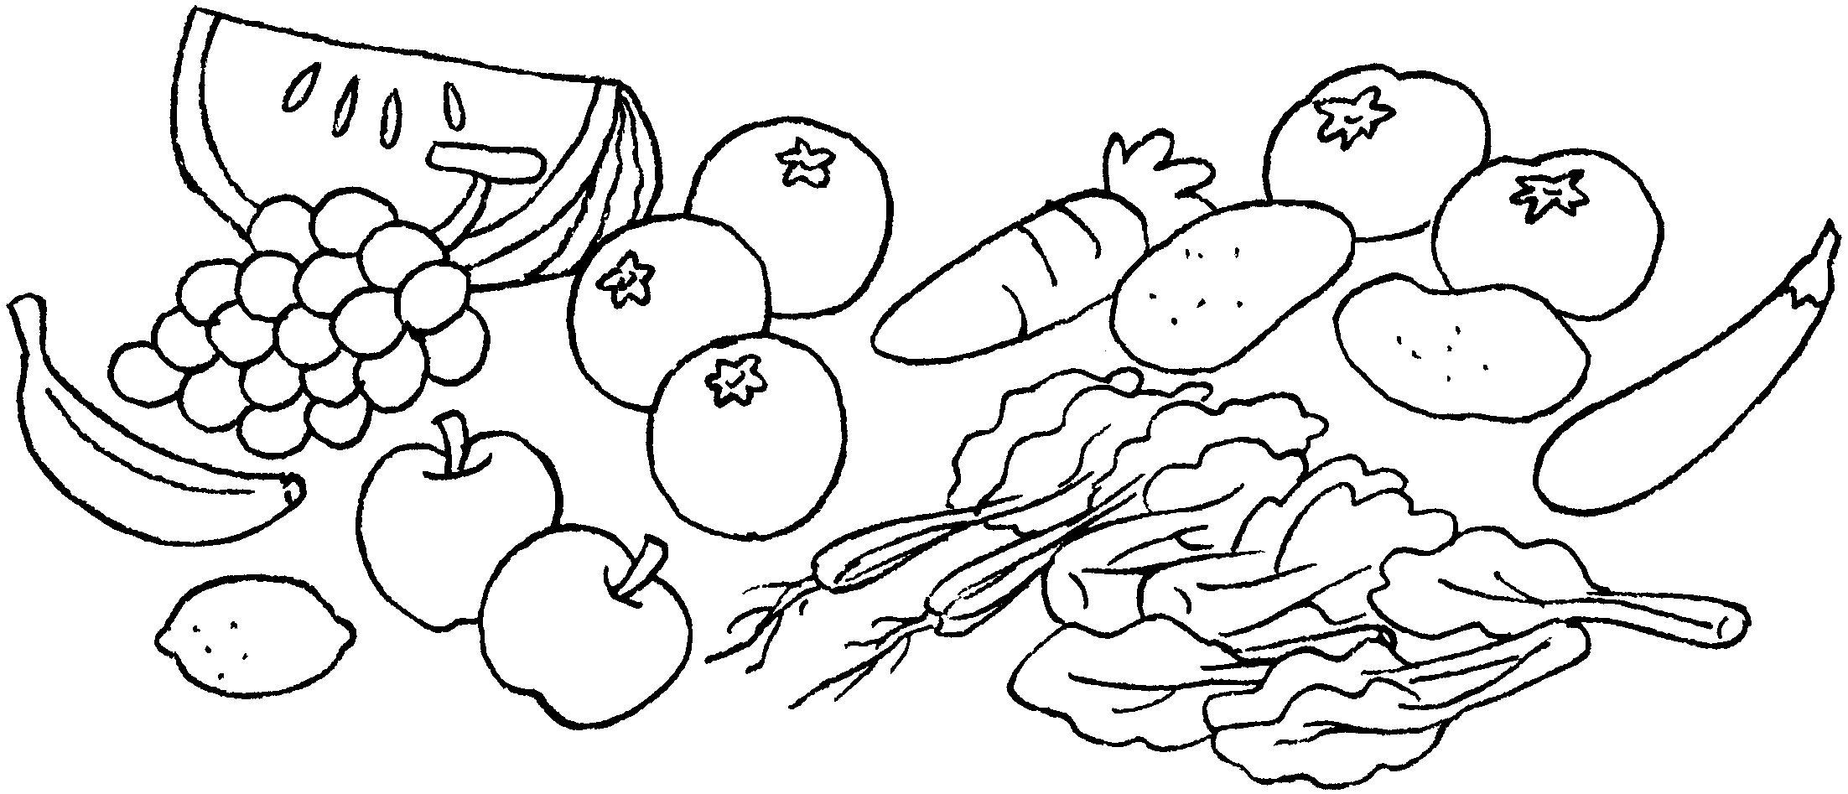 |  | Fruit and vegetables are  us.
3 | 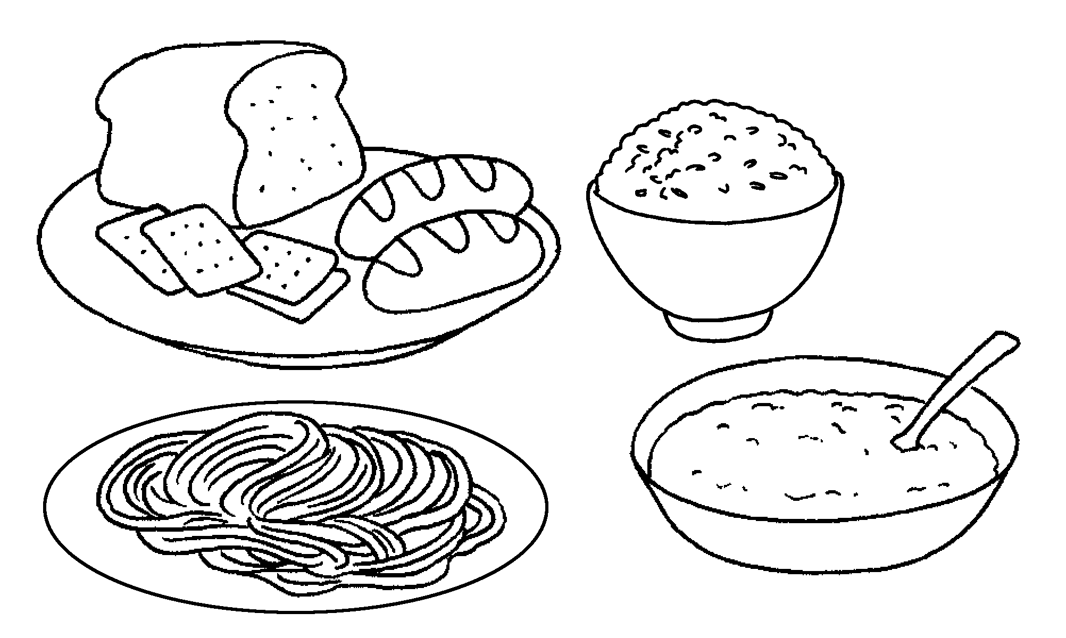 | 
4 | 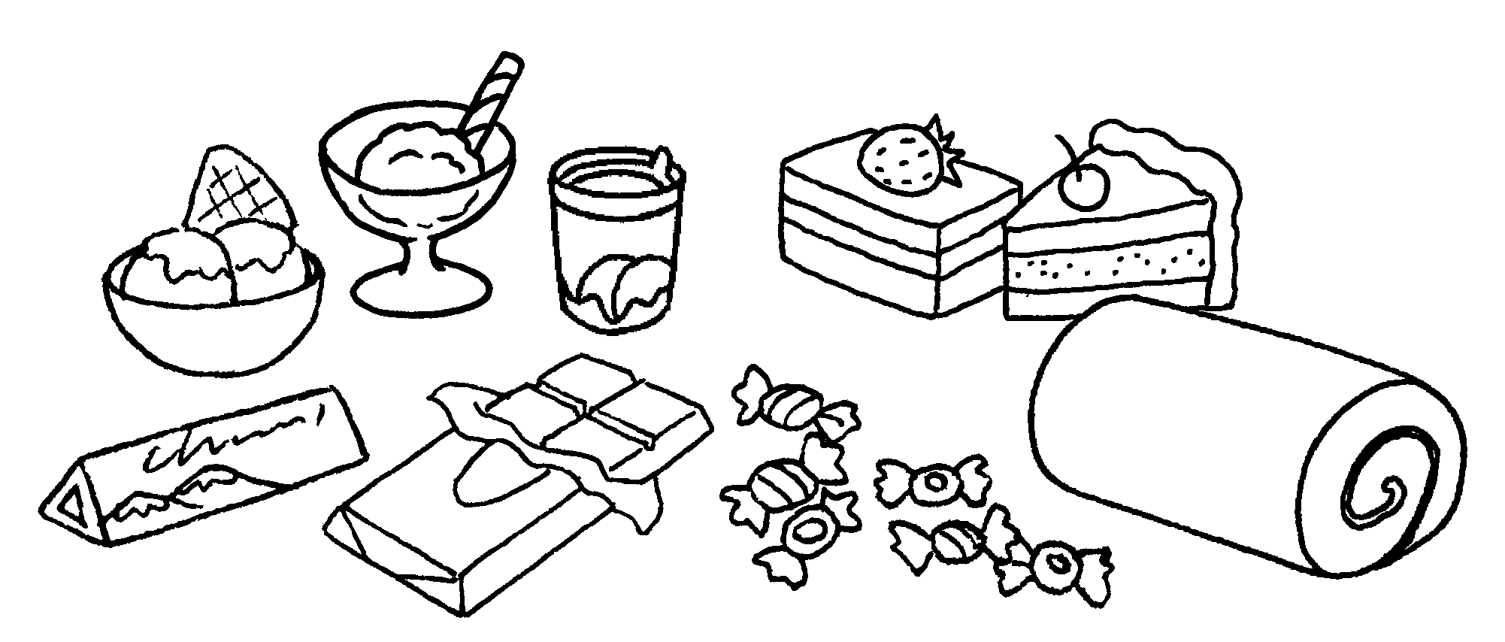 |  | Grain products  us.  Sugary food  us.
5 | 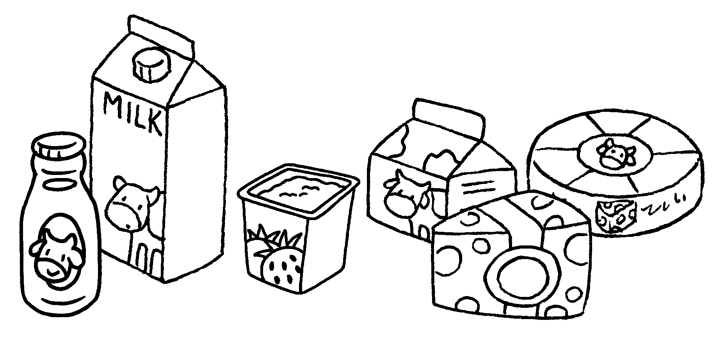 |  | Dairy products  us.
6 | 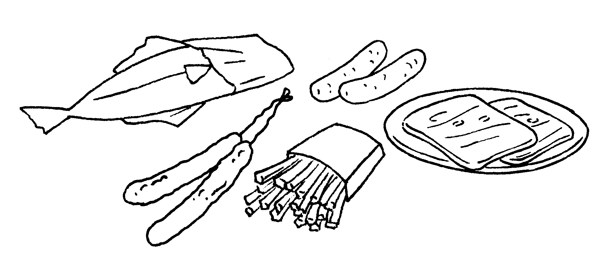 |  | Salty food  us.


Book 4B Chapter 4 Graded Worksheets
Worksheet 2⬇
- bad for
- good for
- are good for
- is bad for
- are good for
- is bad for

