Finish what they say.
sugary food
dairy products
good
bad
grain products
salty food

1 | 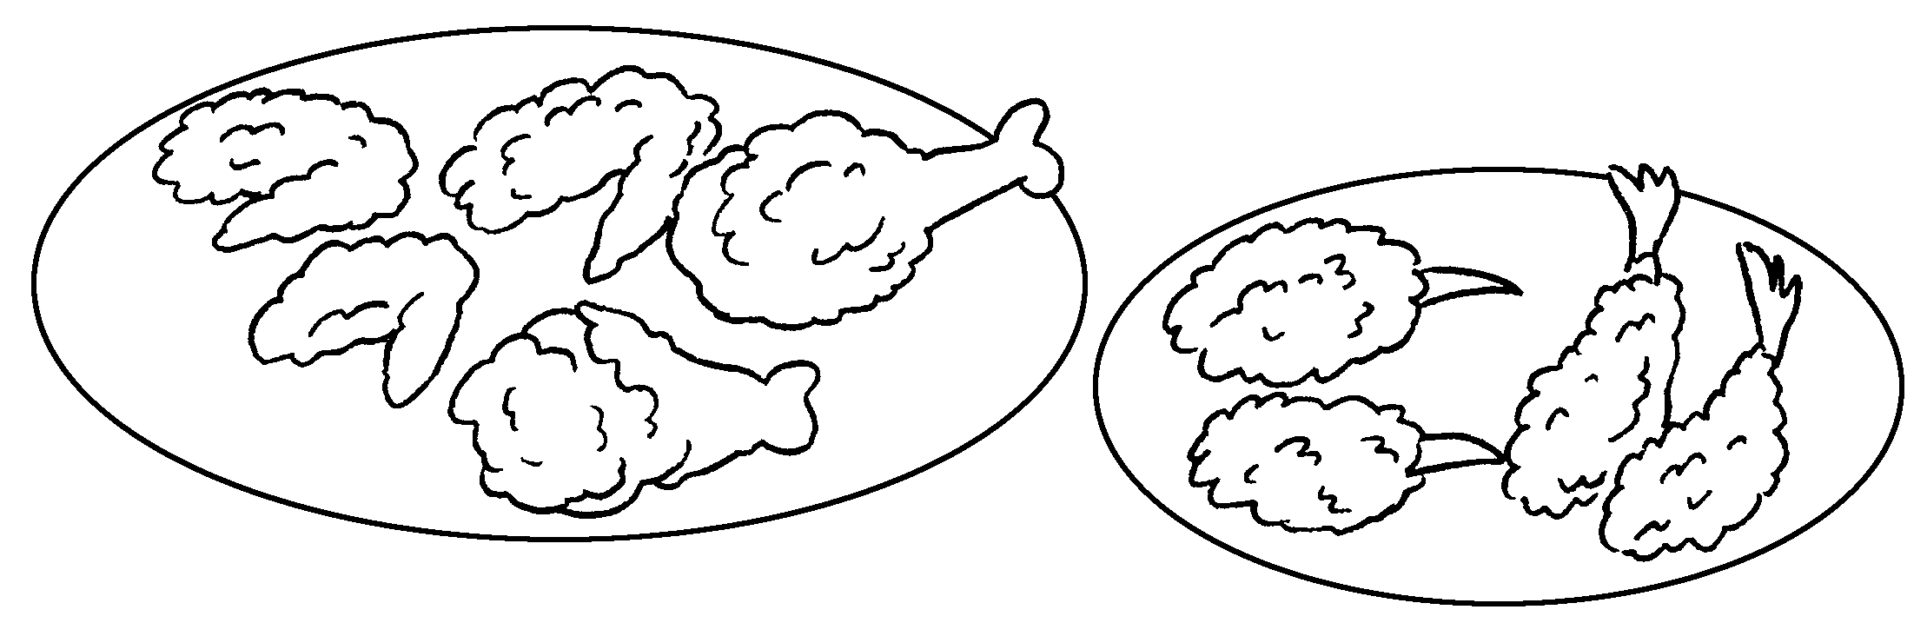 |  | Fried food is  for us.
2 | 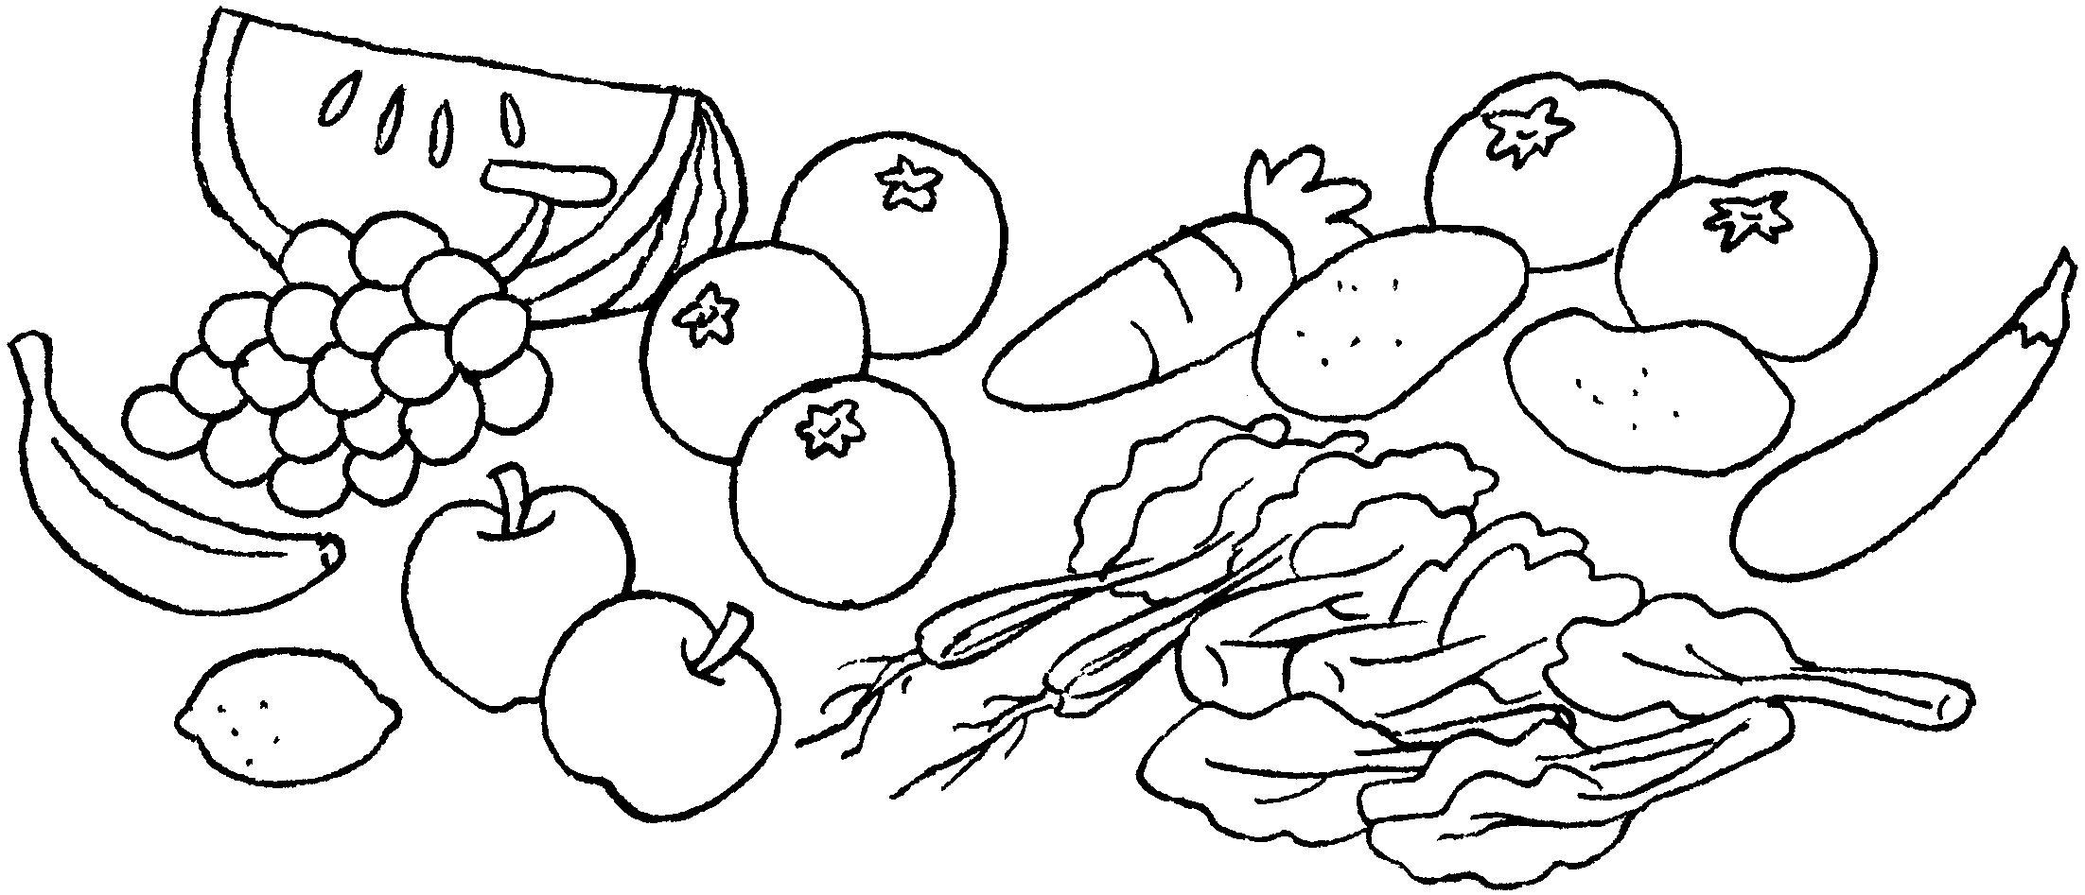 |  | Fruit and vegetables are  us.
3 | 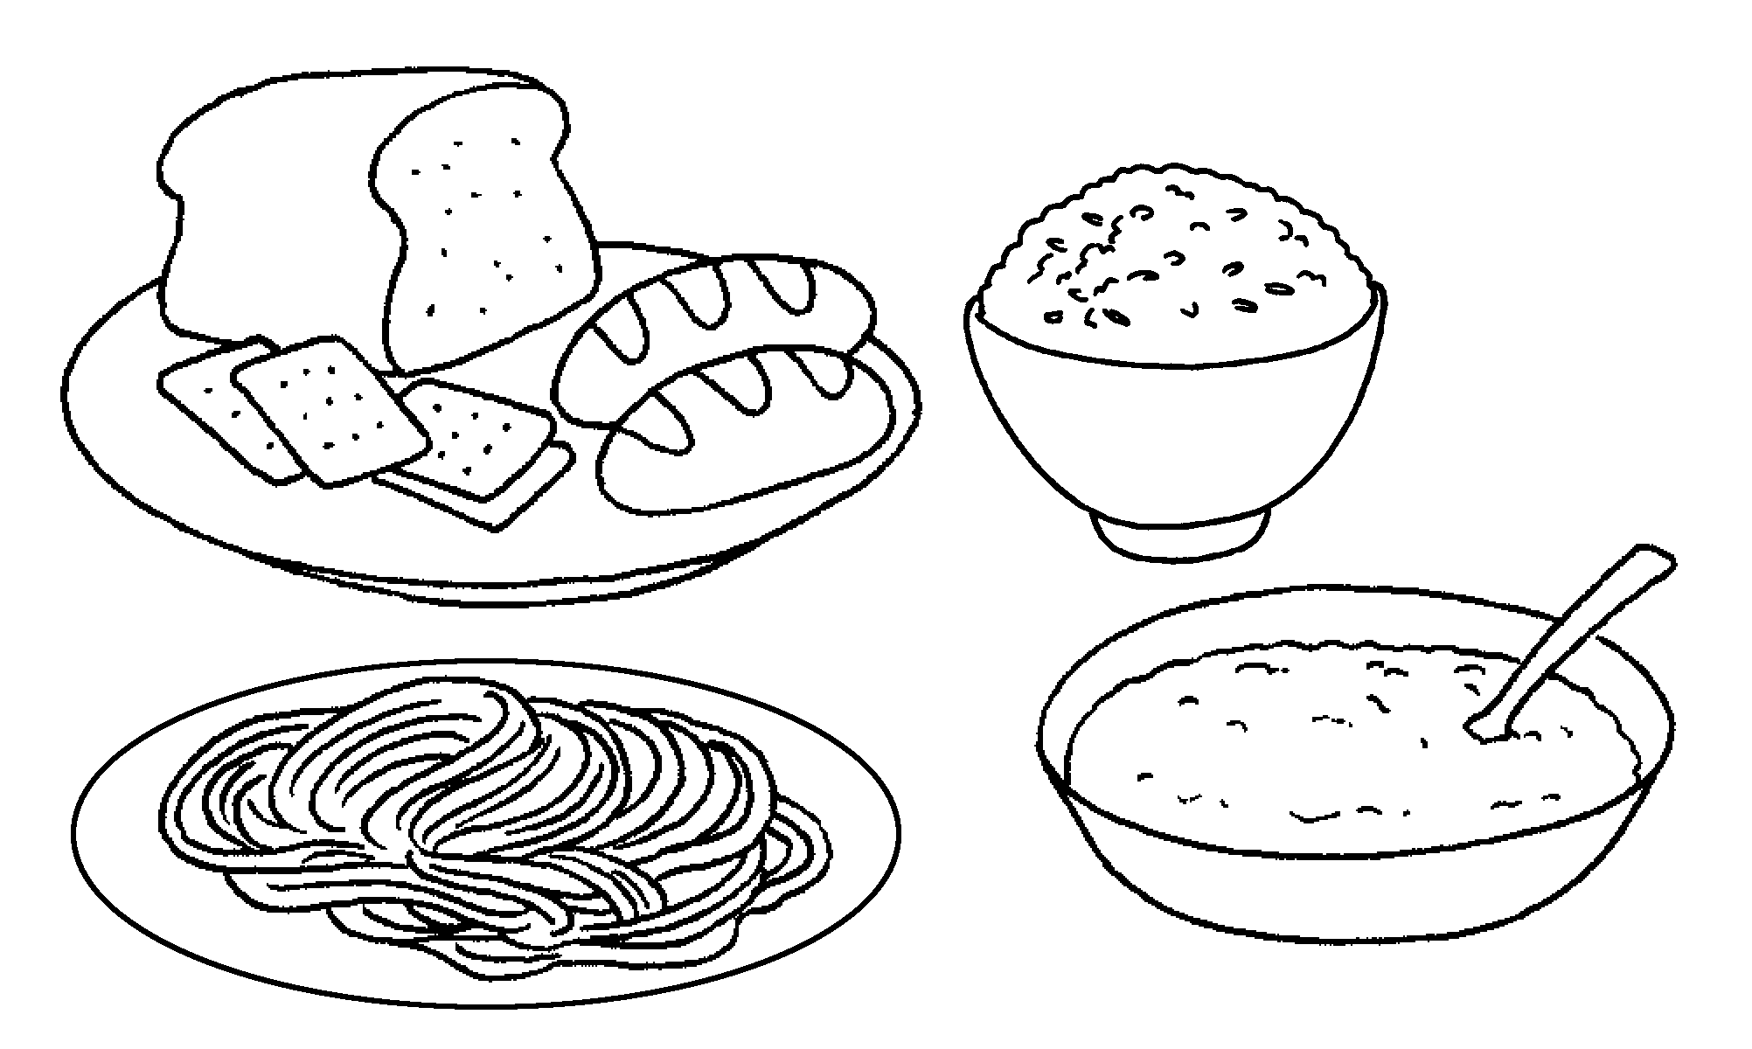 |  | are  us.
4 | 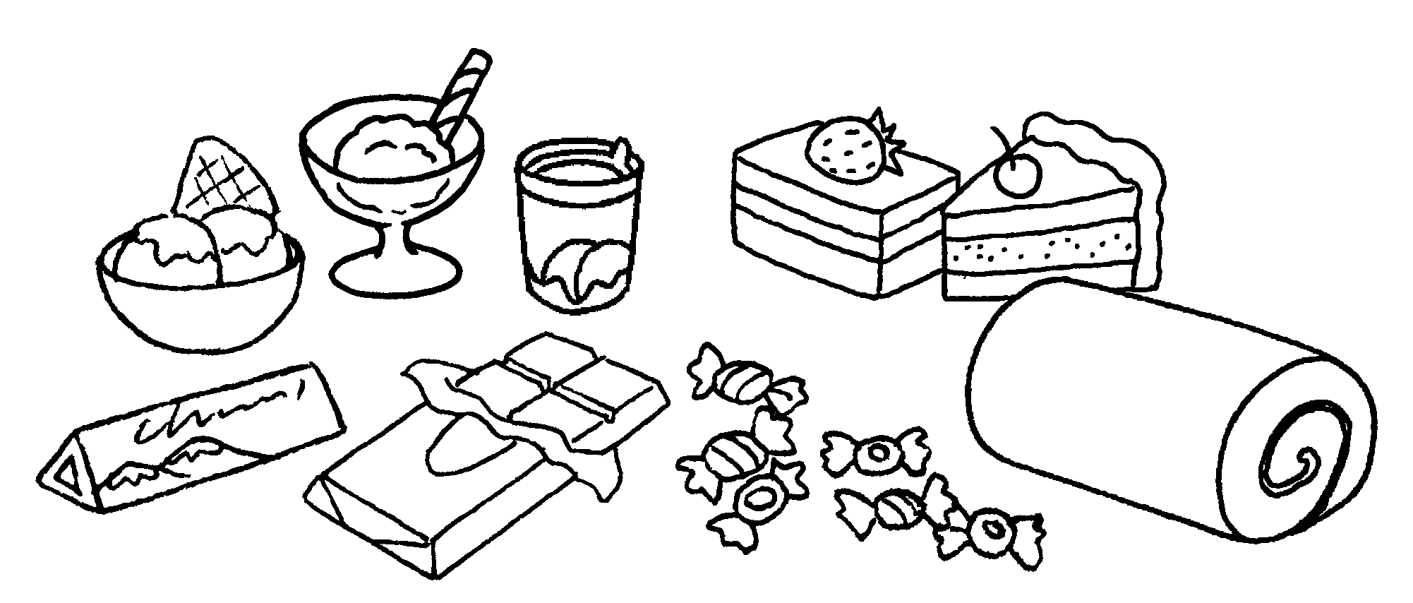 | 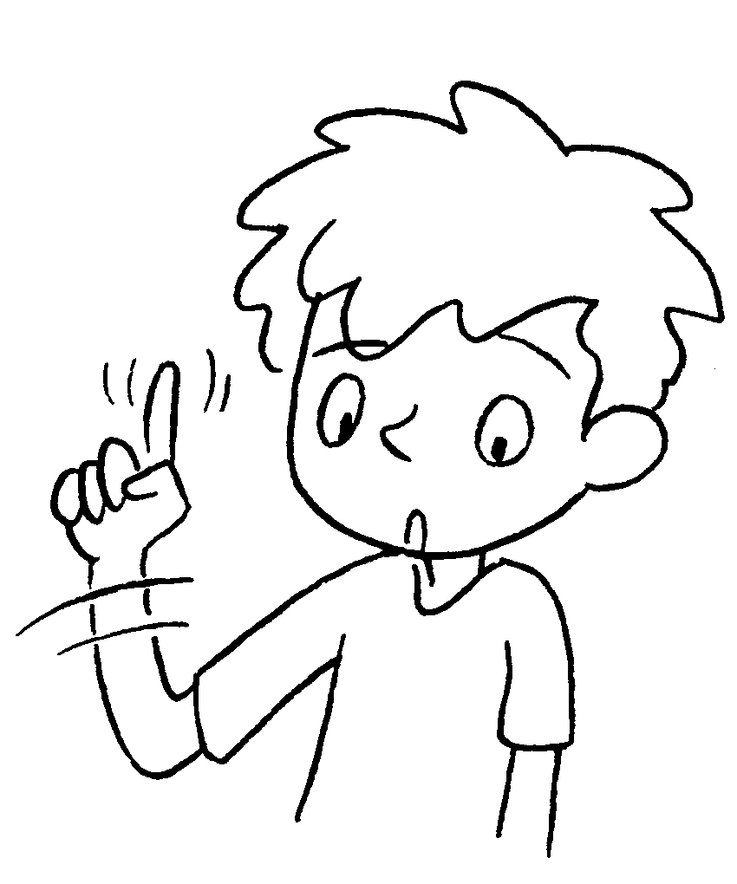 | is  us.
5 | 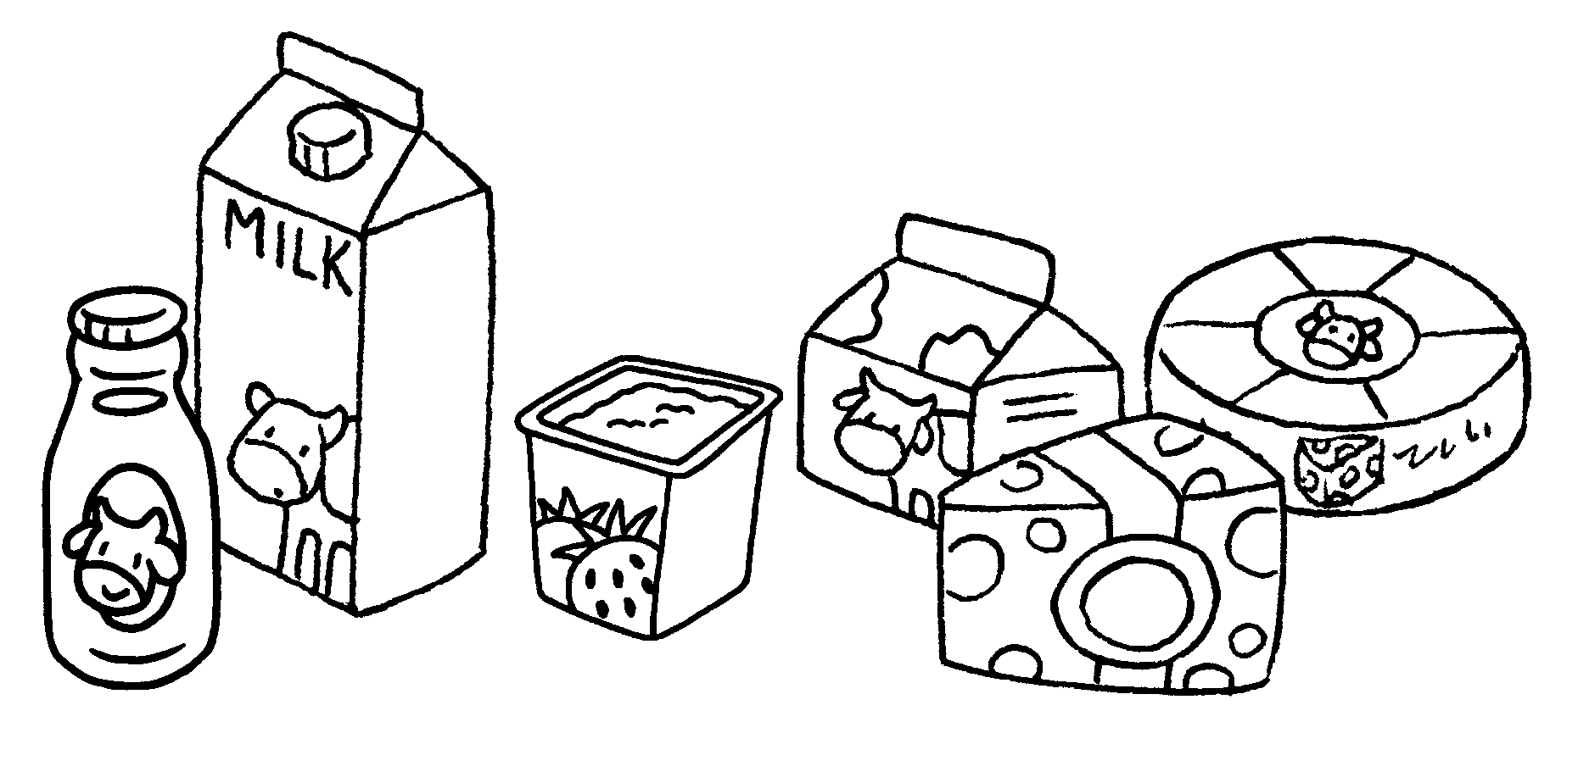 | 
6 | 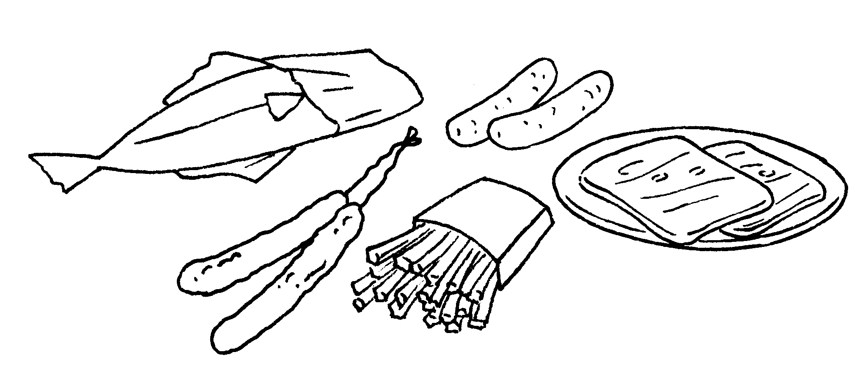 | 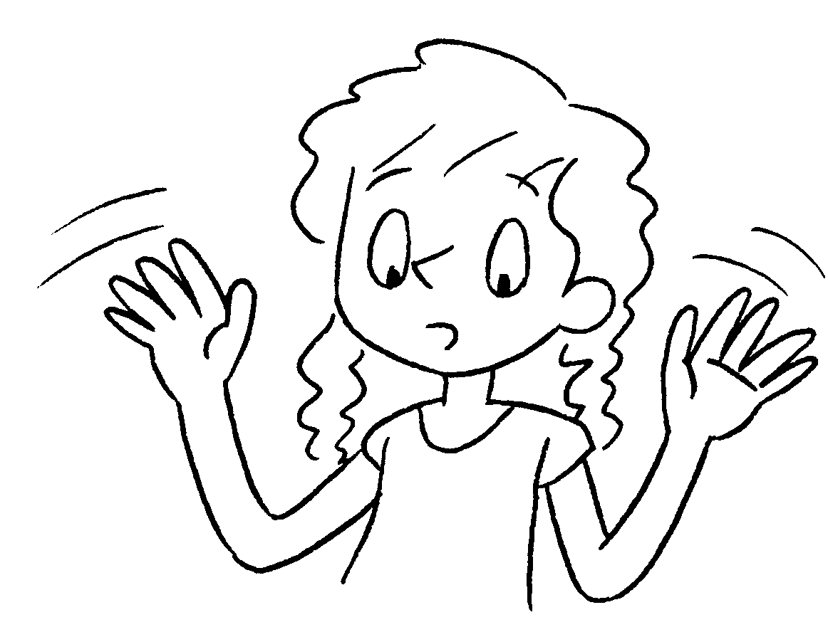


Book 4B Chapter 4 Graded Worksheets
Worksheet 2⬇⬇
- bad
- good for
- Grain products good for
- Sugary food bad for
- Dairy products are good for us.
- Salty food is bad for us.

