Finish what they say.
good
bad

1 | 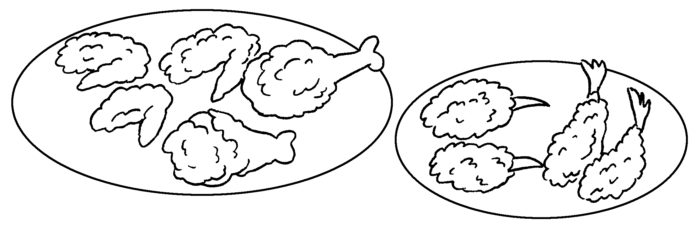 |  | Fried food is  for us.
2 | 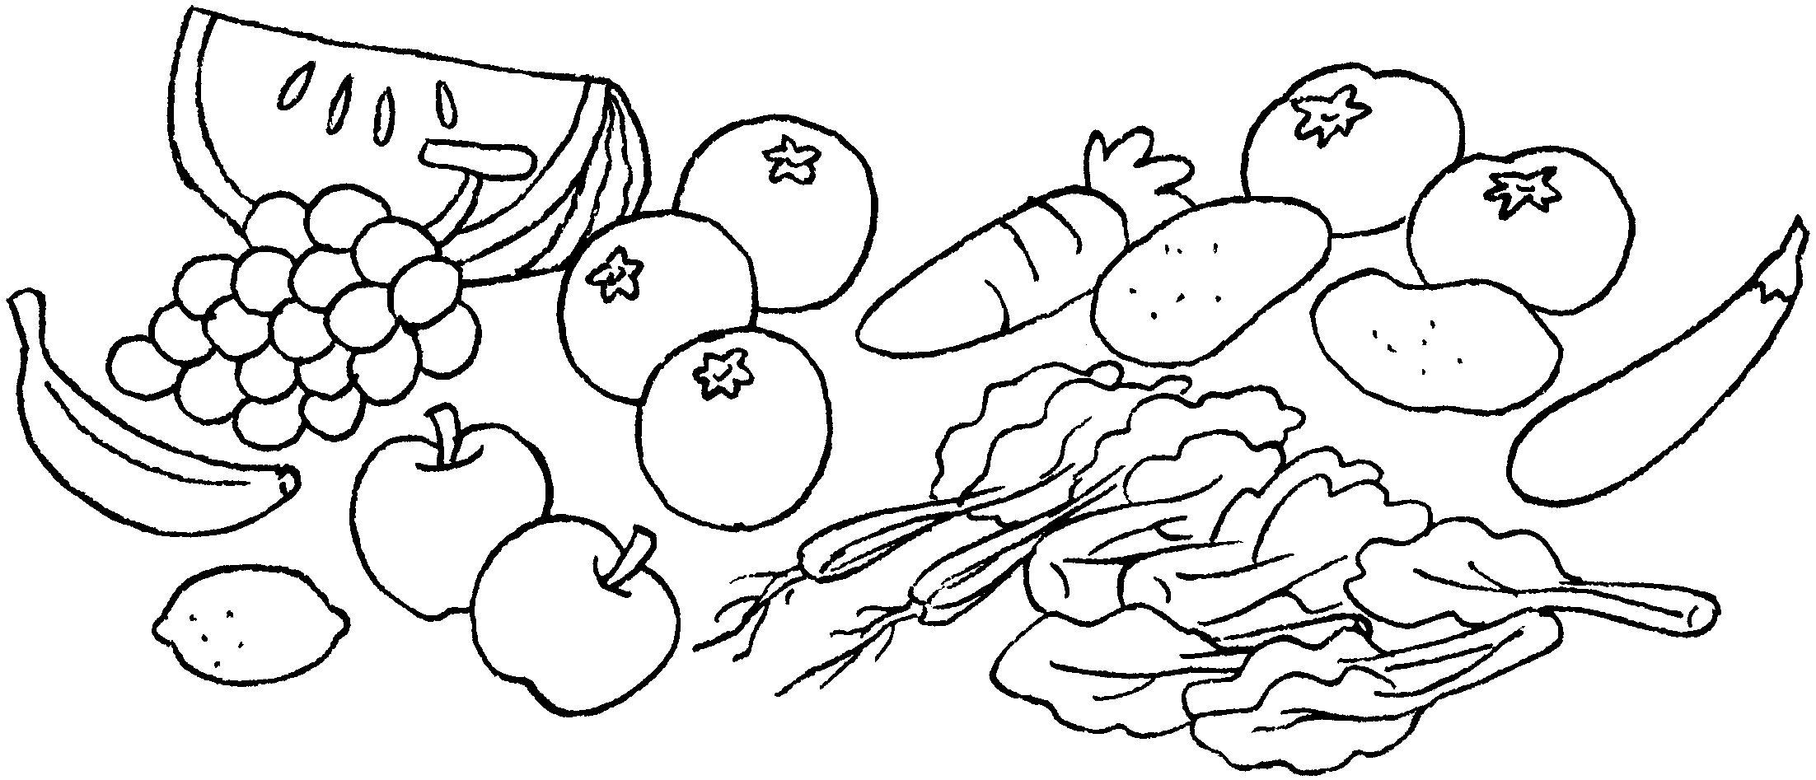 |  | Fruit and vegetables are  us.
3 | 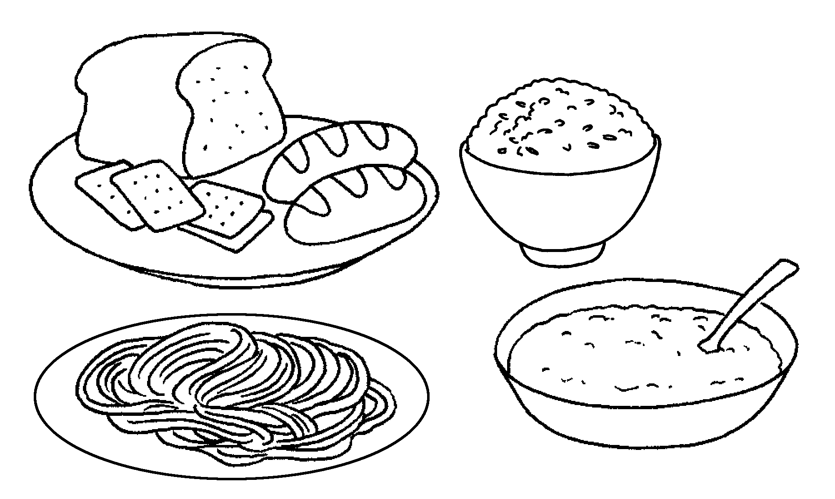 | 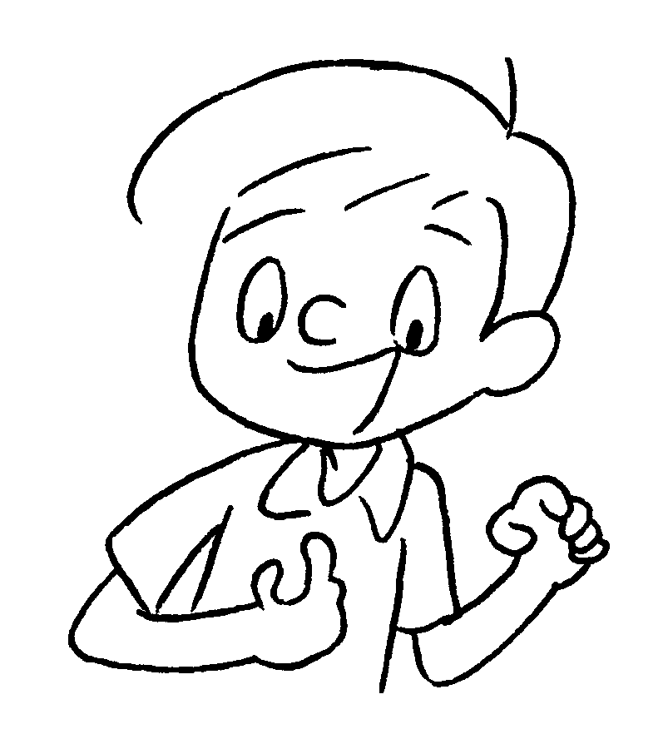 | are  us.
4 | 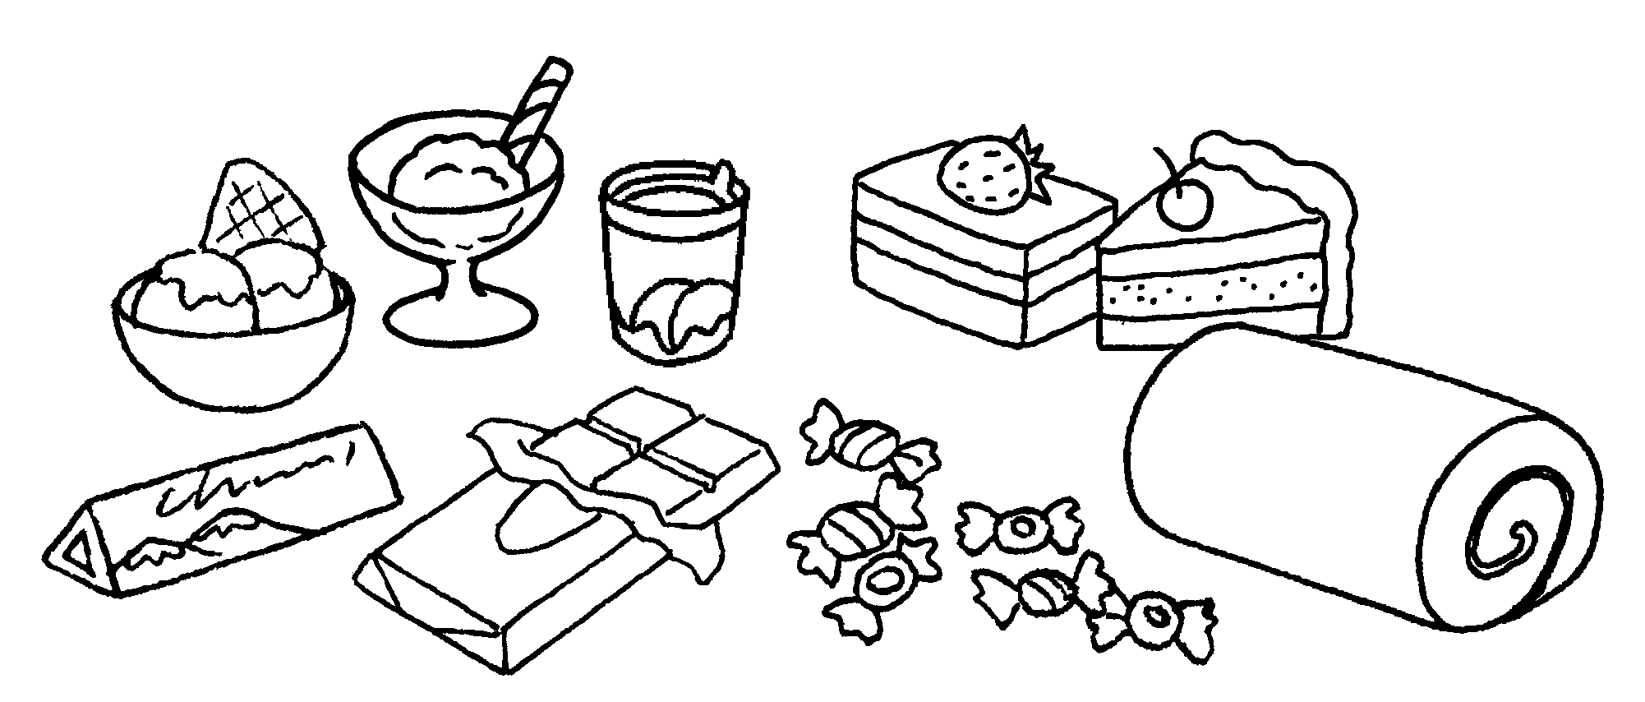 | 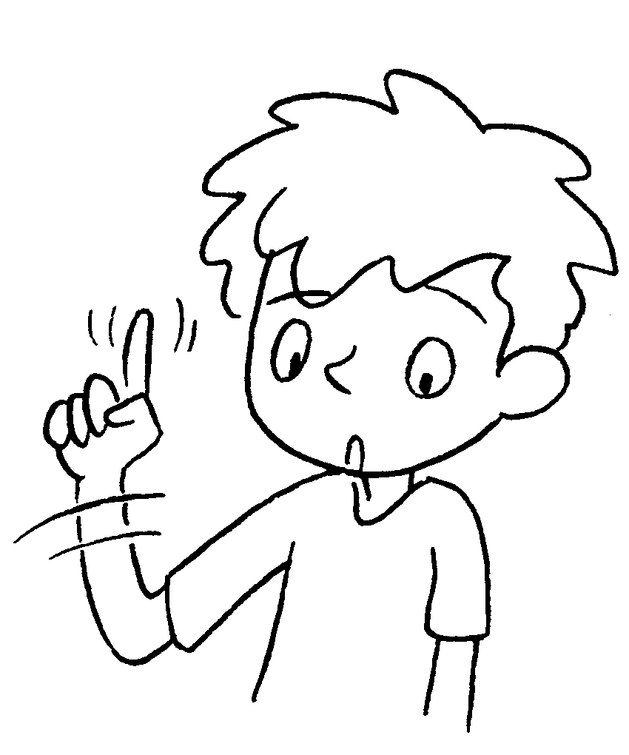 | is  us.
5 | 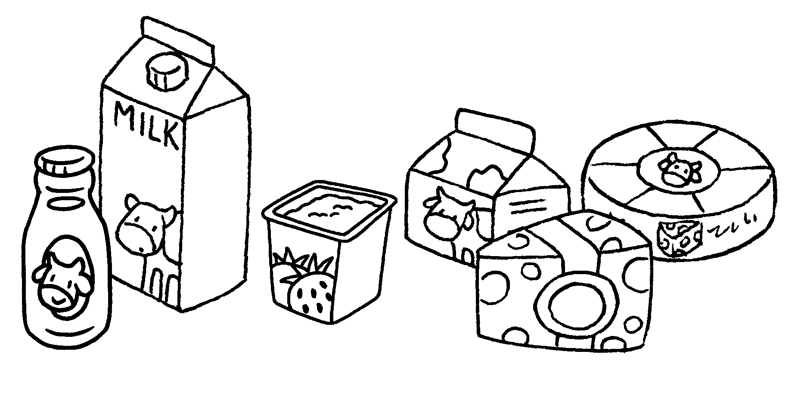 | 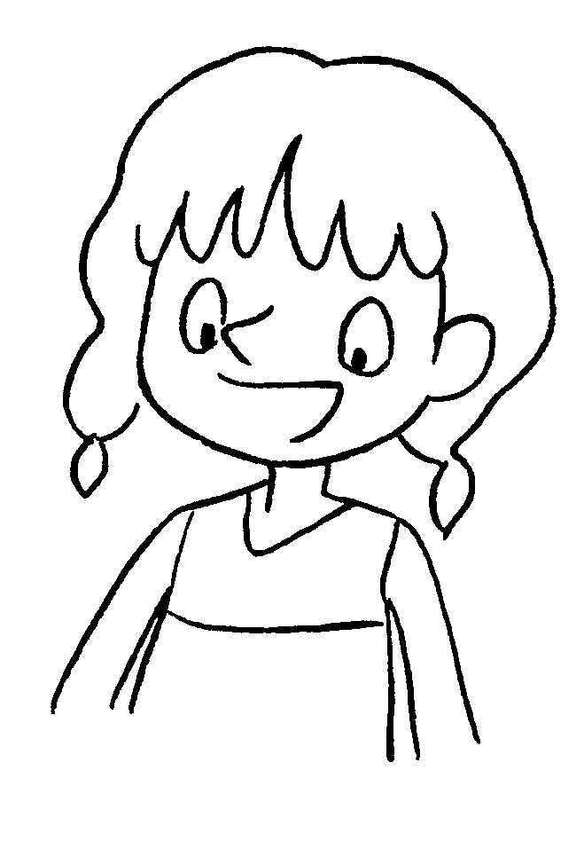
6 | 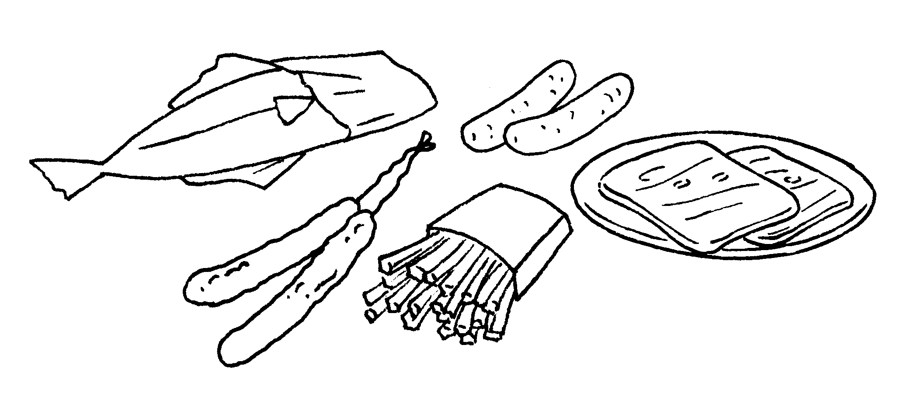 | 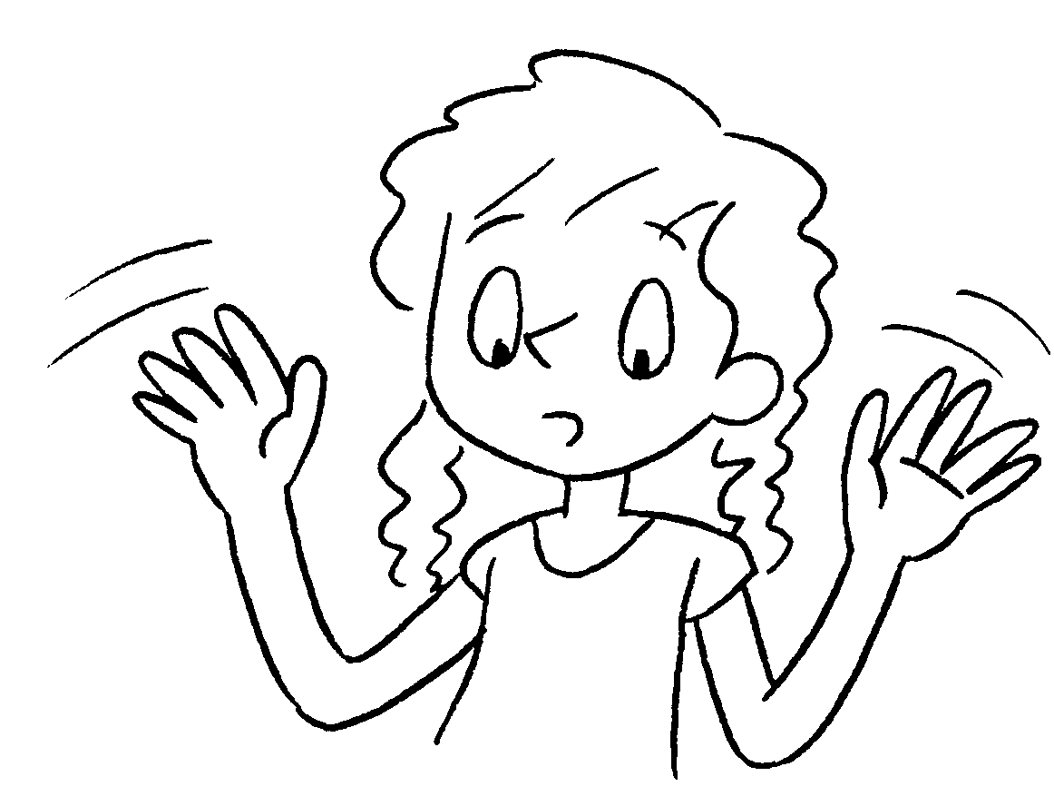


Book 4B Chapter 4 Graded Worksheets
Worksheet 2⬇⬇⬇
1 bad
2 good for
3 Grain products good for
4 Sugary food bad for
5 Dairy products are good for us.
6 Salty food is bad for us.

