A
B

Choose and write.
 | 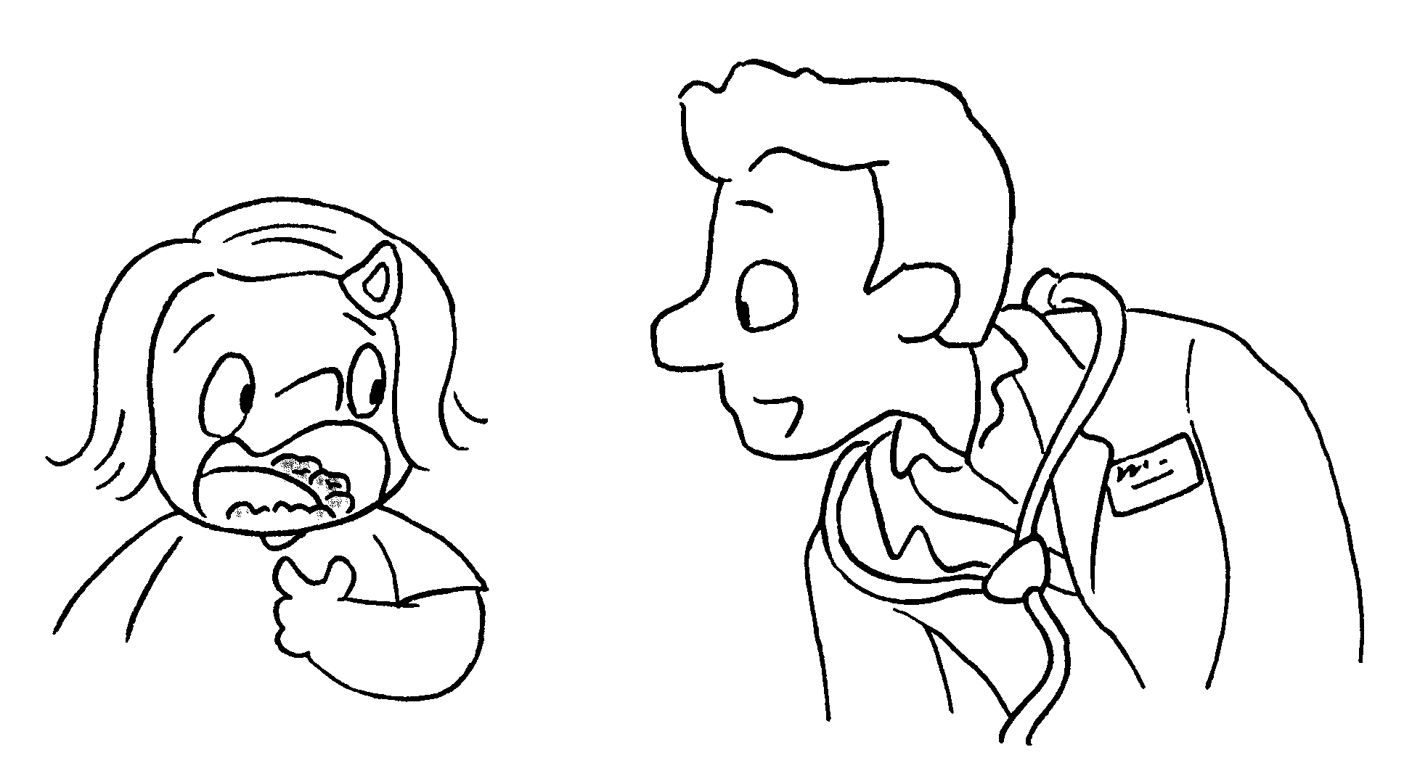 | too many  too much
1 | 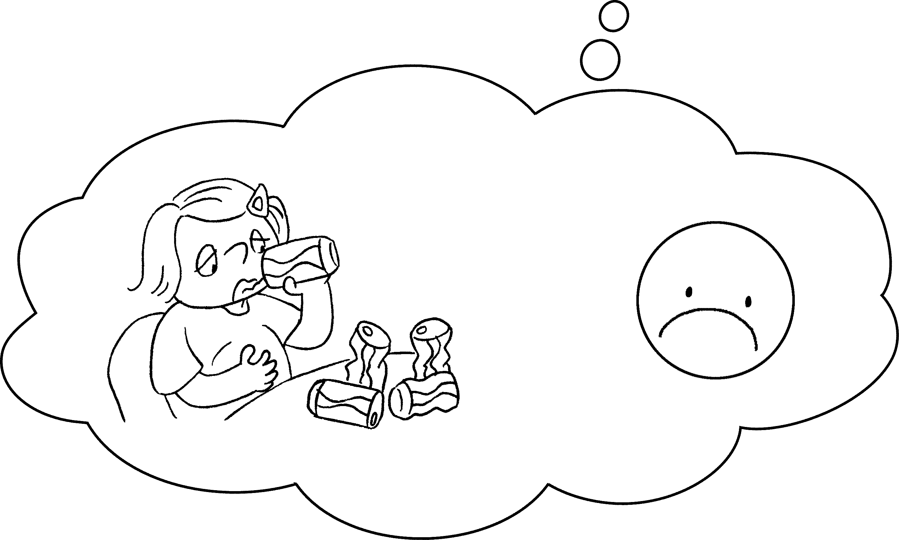 | A : I drank five cans of cola today.  B : You drank cola.
2 | 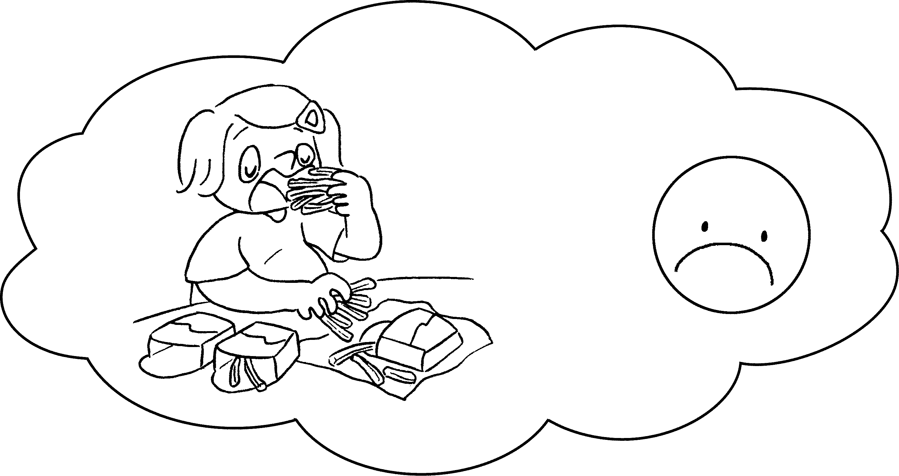 | A : I ate three packets of French fries  yesterday.  B : You ate French  fries.
3 | 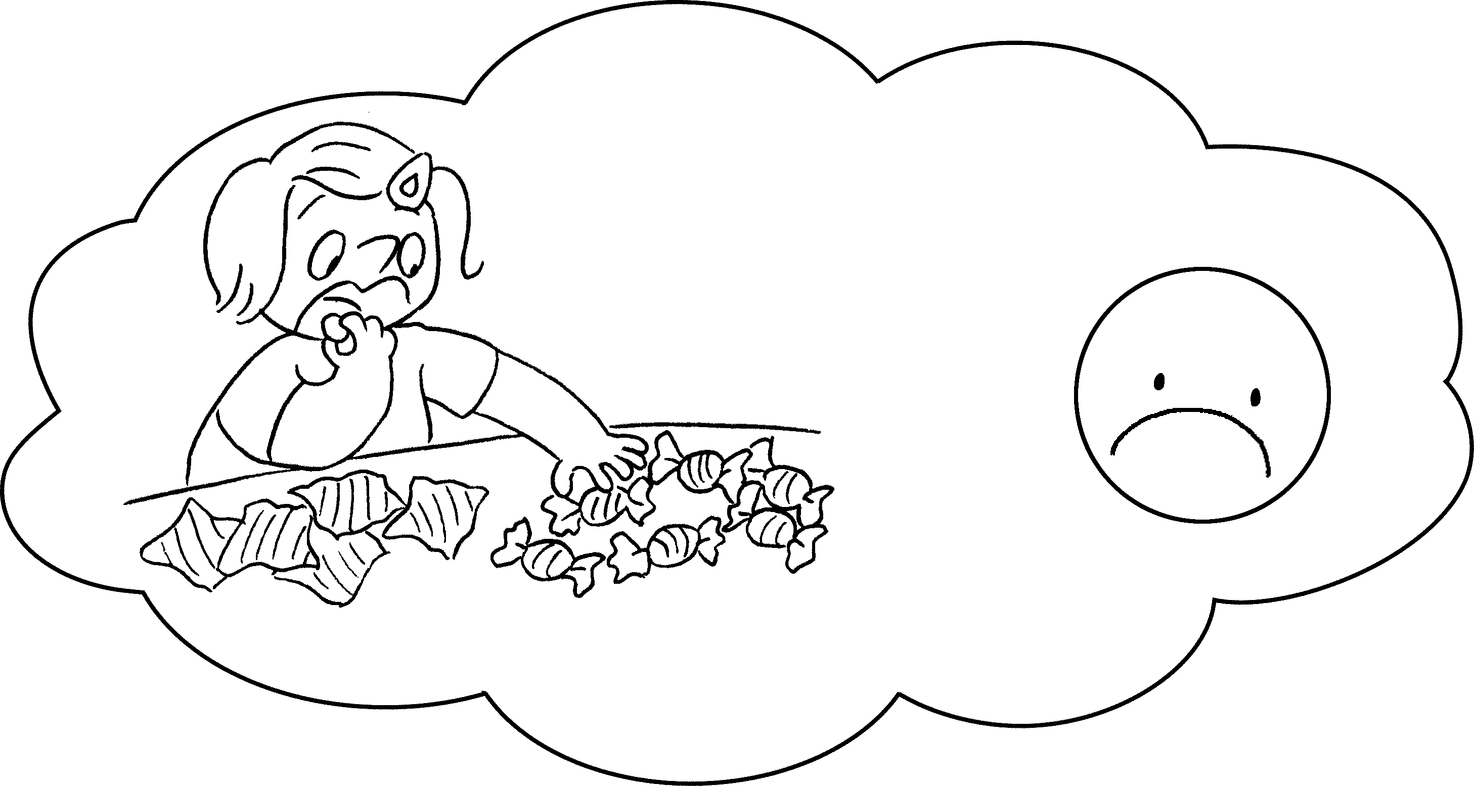 | A : I ate twelve sweets today.  B : You ate sweets.  sugary food is  bad for us.
4 | 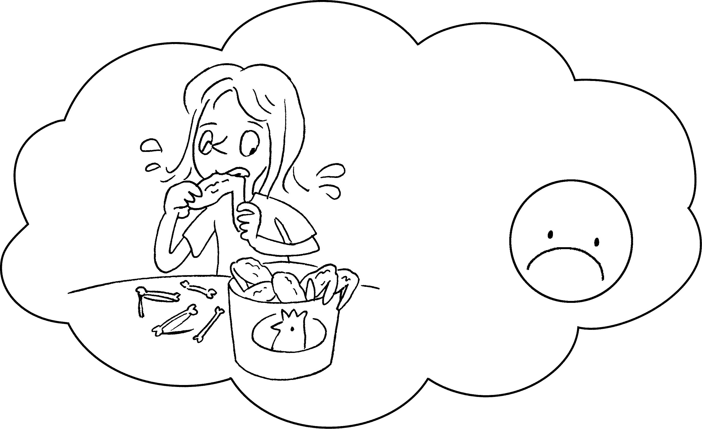 | A : My sister ate ten chicken wings today.  B : Your sister ate  chicken wings.  fried food is bad for us.
5 | 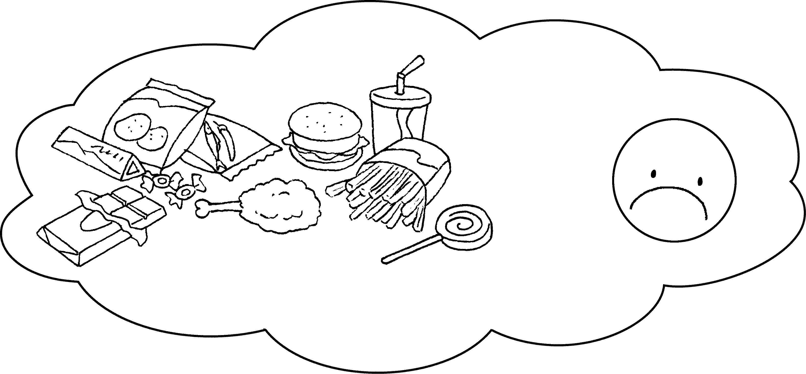 | B : junk food is bad  for us.

A
B

Book 4B Chapter 4 Graded Worksheets
Worksheet 3⬇
- too much
- too many
- too many
Too much
4 too many
Too much
5 Too much

