A
B

Finish what the doctor says.
too many
too much
 | 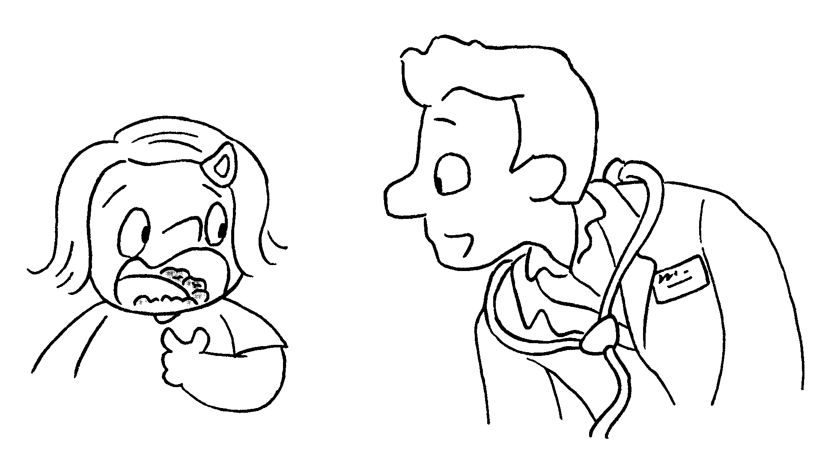 | fried  junk  sugary
1 | 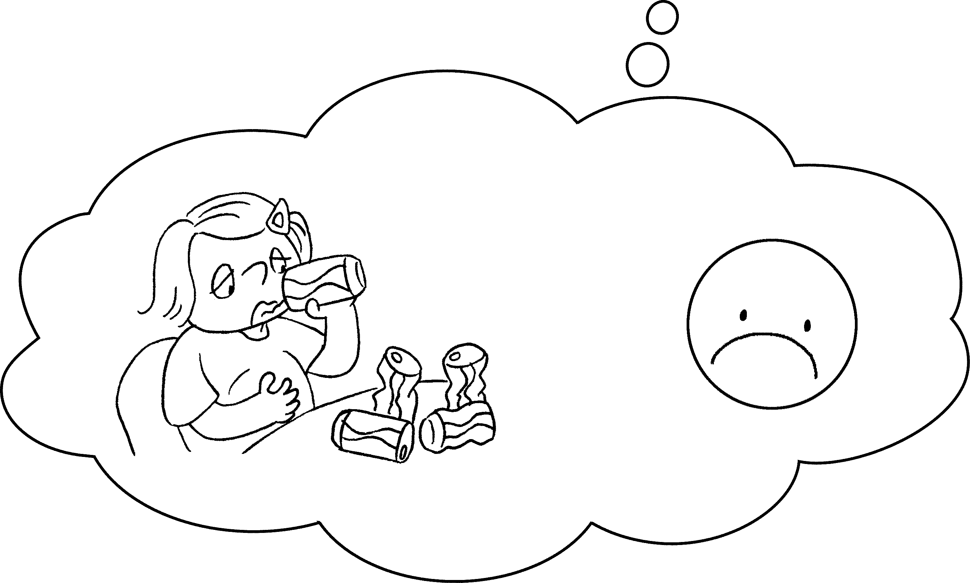 | A : I drank five cans of cola today.  B : You drank cola.
2 | 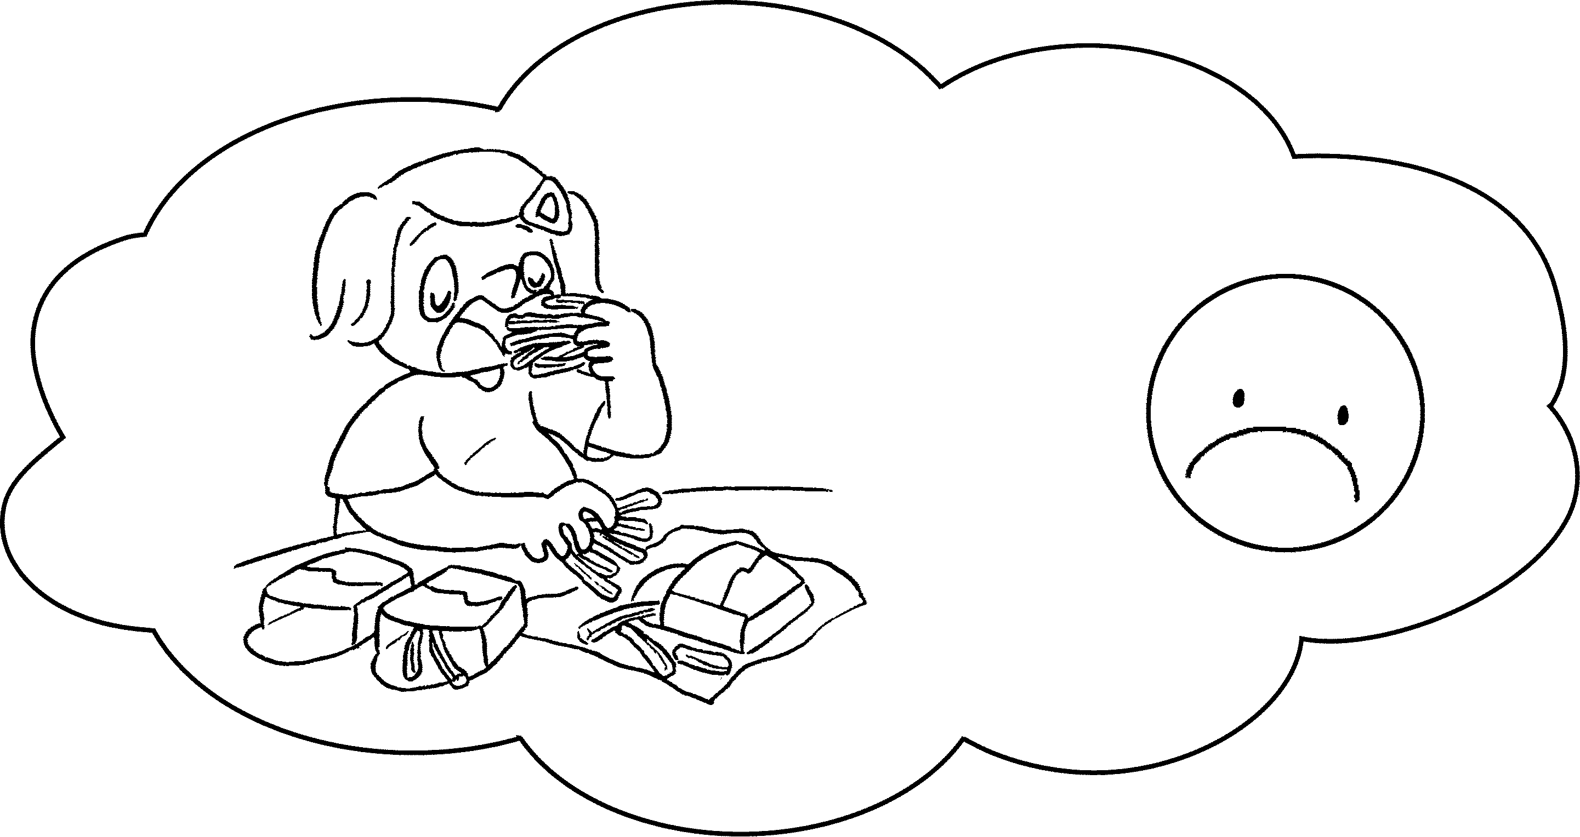 | A : I ate three packets of French fries  yesterday.  B : You ate French  fries.
3 | 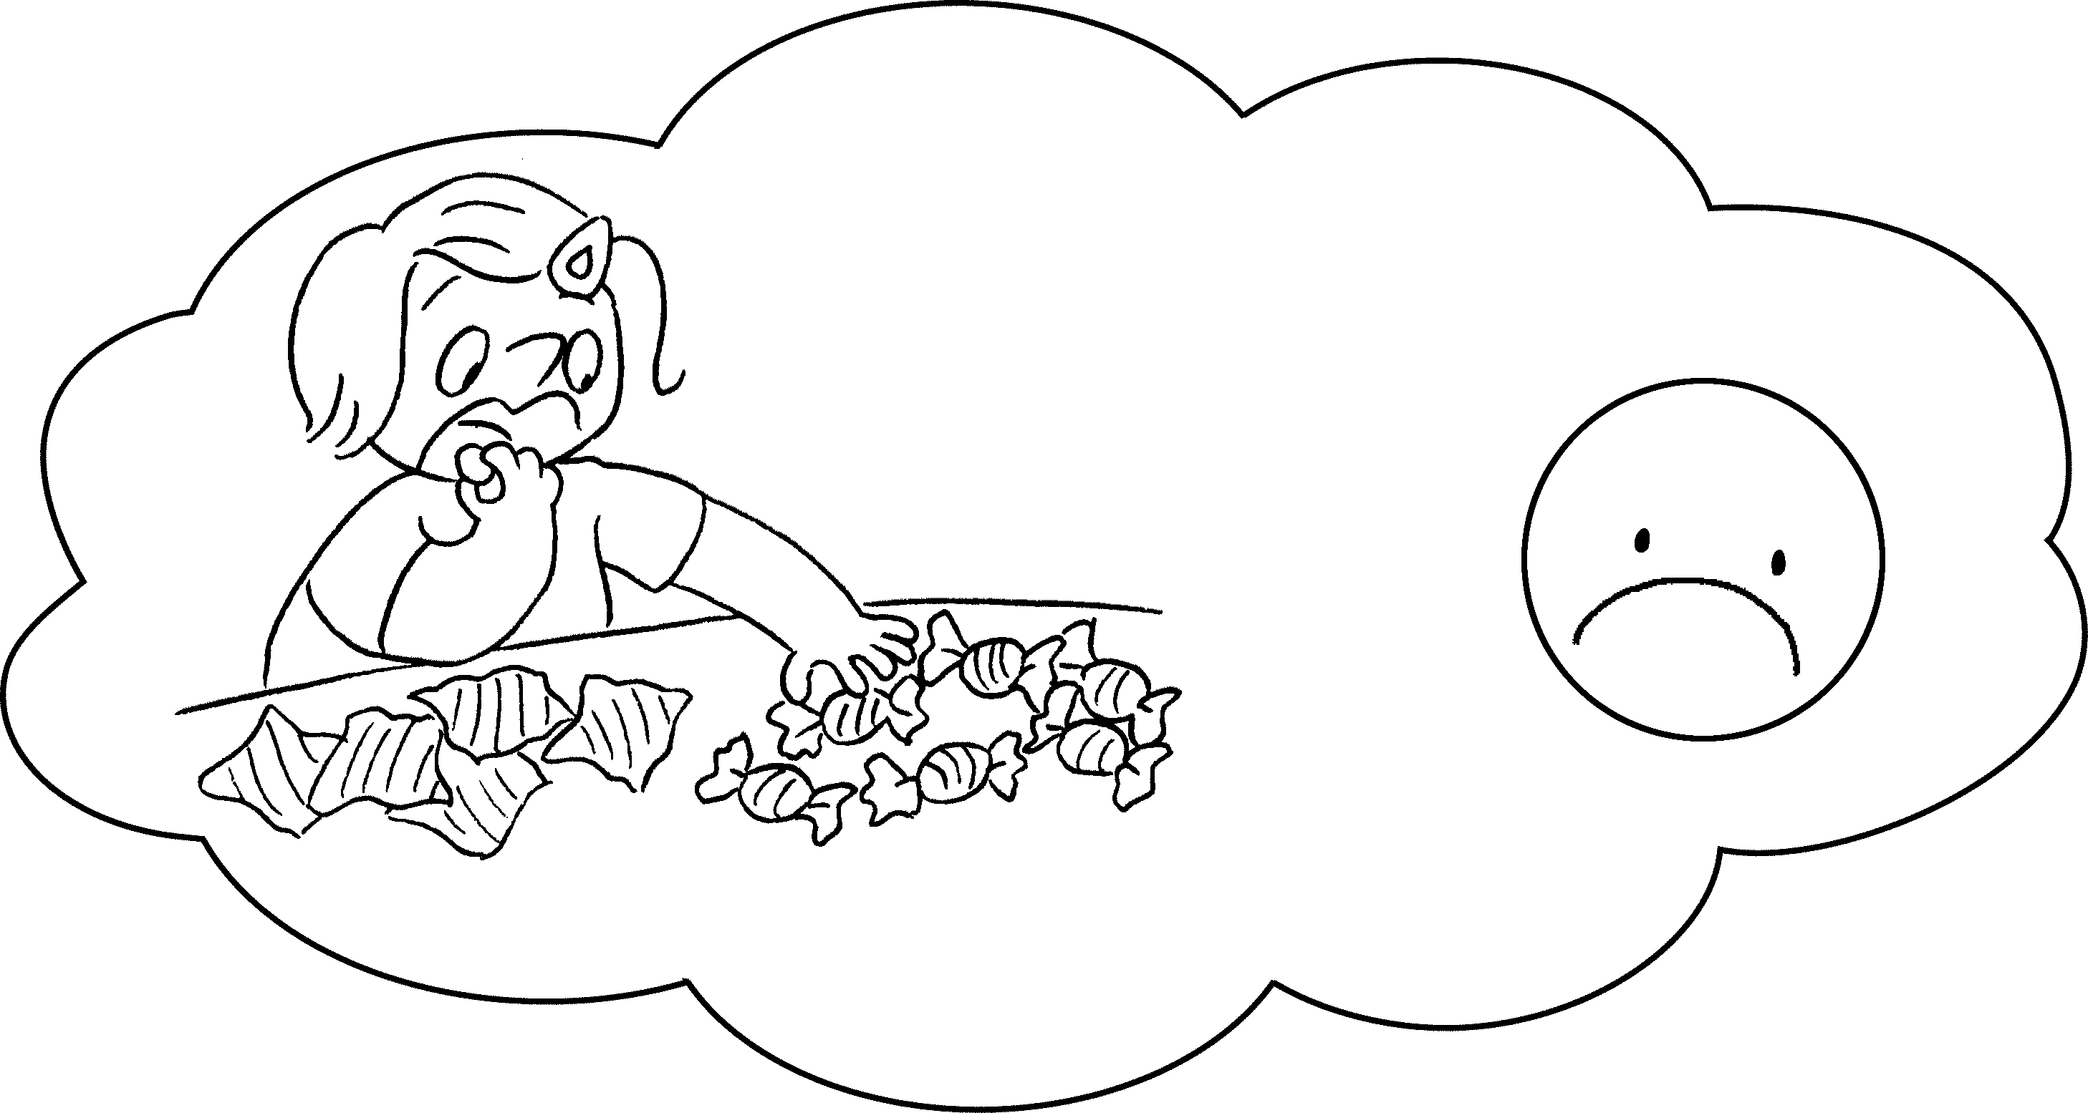 | A : I ate twelve sweets today.  B : You ate sweets.  Too much food is  bad for us.
4 | 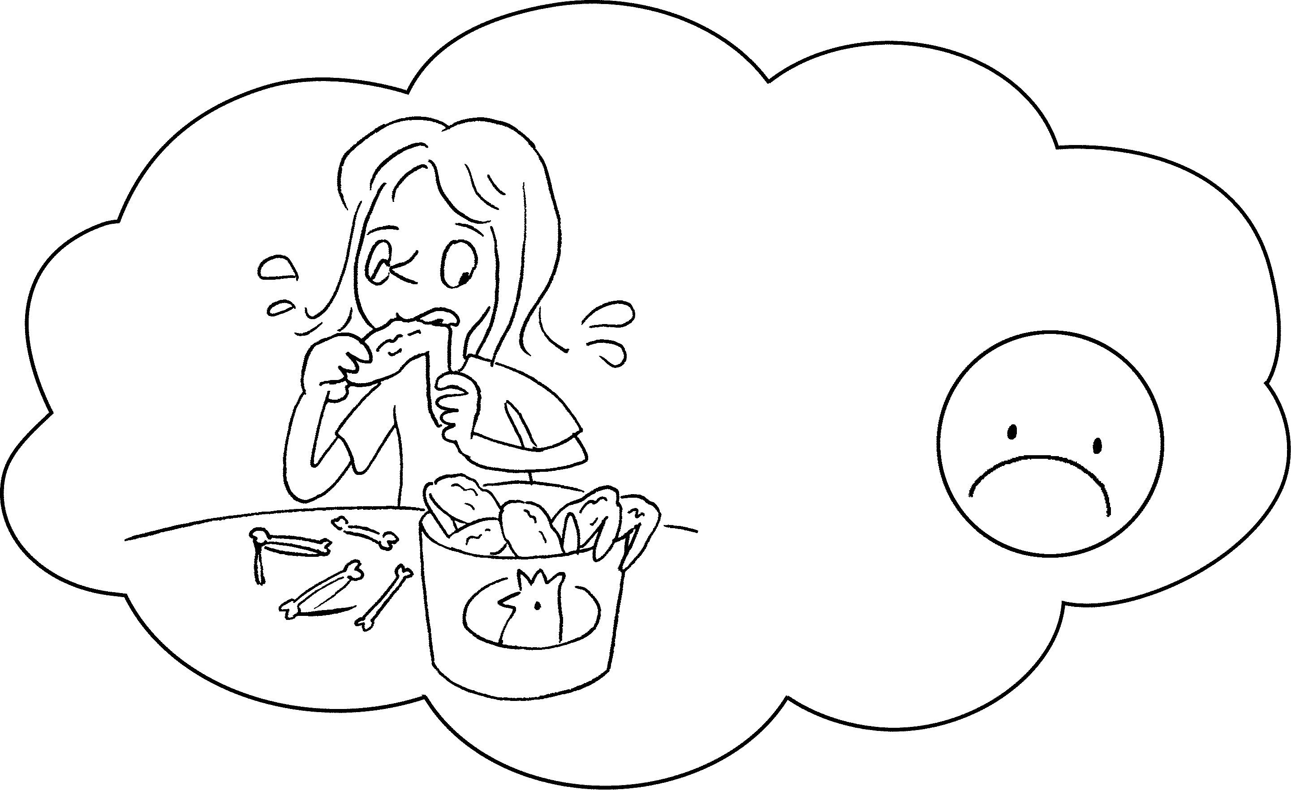 | A : My sister ate ten chicken wings today.  B : Your sister ate  chicken wings.  __________________ food is bad for us.
5 | 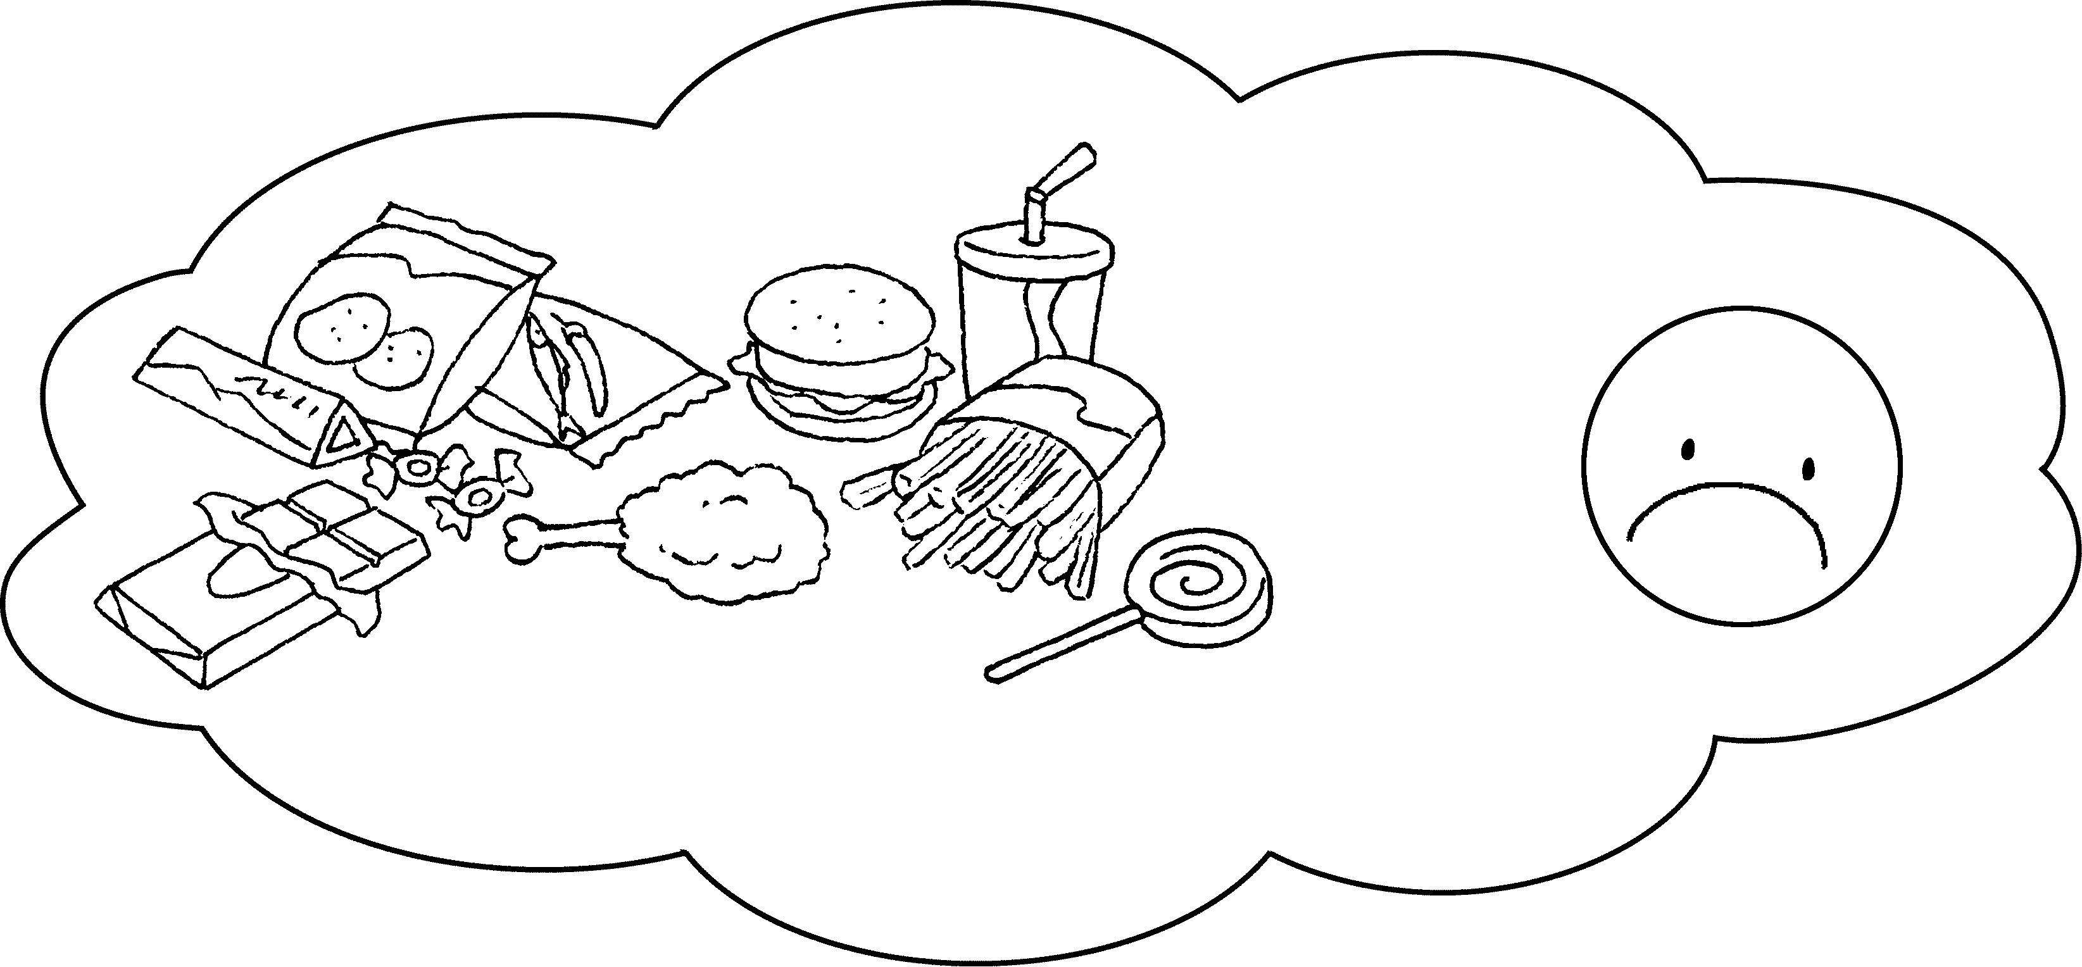 | B : food is bad  for us.


Book 4B Chapter 4 Graded Worksheets
Worksheet 3⬇⬇
- too much
- too many
- too many
sugary
- too many
Too much fried
- Too much junk

