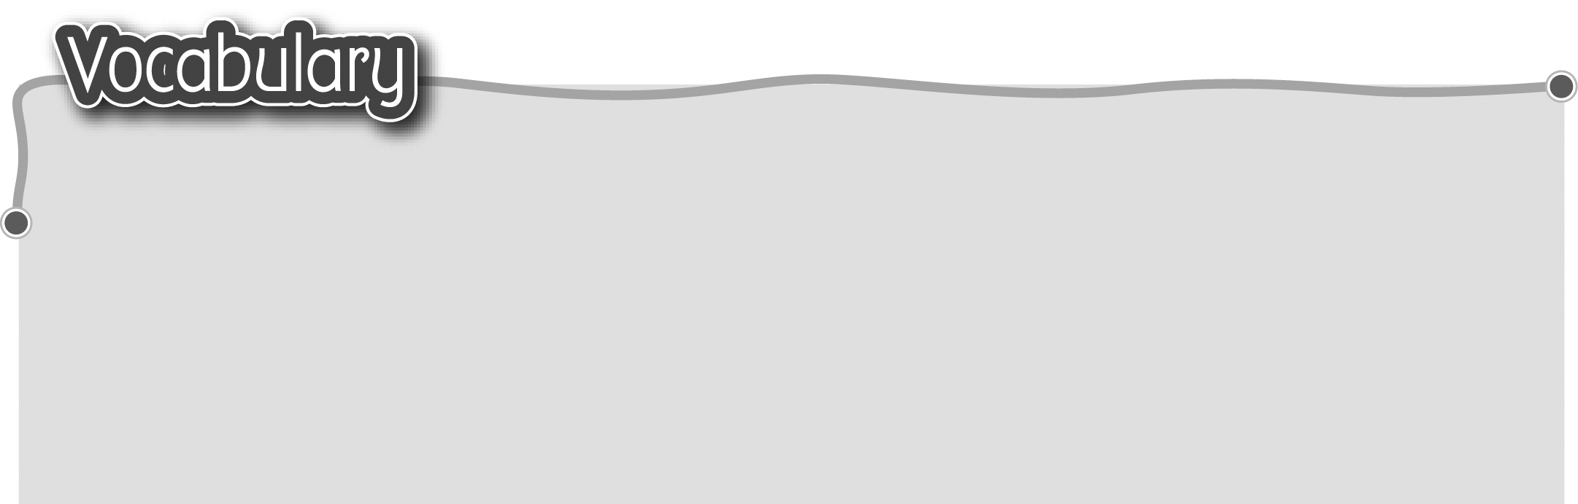
1 food group 食物類別 5 fried food 煎炸食物
2 junk food 垃圾食物 6 soft drinks 汽水
3 sugary food 含糖的食物 7 dairy products 奶類產品
4 salty food 含鹽的食物 8 grain products 穀類產品
The words marked with * have different meanings in other
contexts. You can look up those meanings in a dictionary.
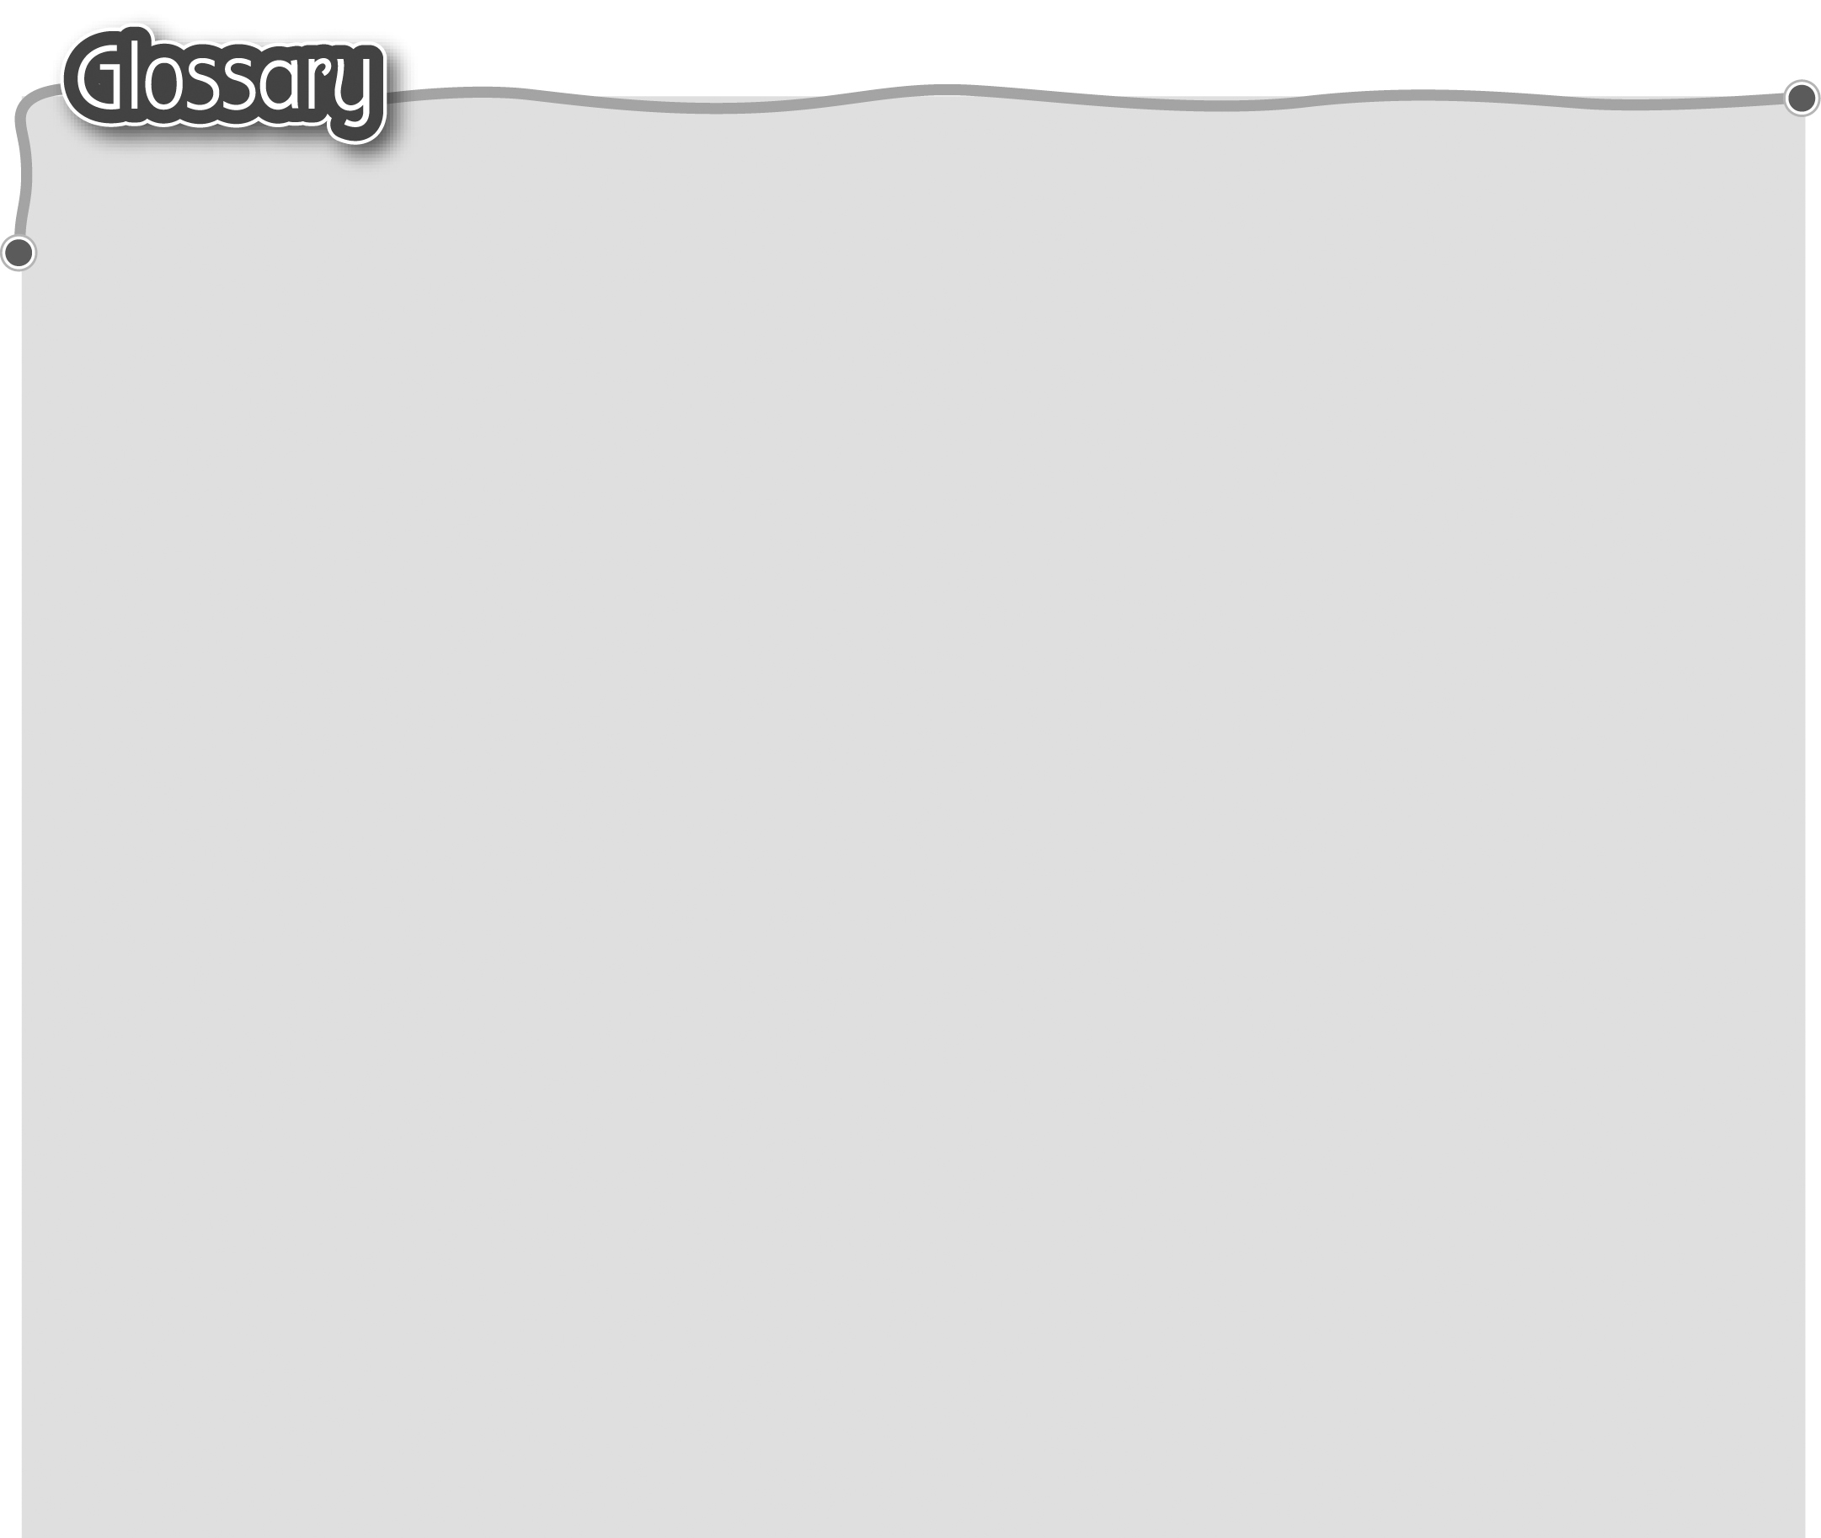
1 food pyramid (p.28) 食物金字塔 14 bone* (p.28) 骨骼
2 good / bad for (p.28) 15 low-fat (p.28) 低脂
對……有益/有害 16 serving* (p.28) 一份（名詞）
3 at the bottom / top (p.28) 17 a slice of (p.28) 一片
在……的底部/頂部 18 bowl (p.28) 碗
4 easy (p.28) 容易 19 lots of (p.29) 大量
5 fat (p.28) 脂肪（名詞）/ 20 vitamin (p.29) 維生素
肥胖（形容詞） 21 mineral (p.29) 礦物質
6 sugar* (p.28) 糖類 22 high in … (p.29) ……含量高
7 too much (p.28) 太多 23 cereal (p.29) 穀物
8 energy* (p.28) 能量 24 important (p.29) 重要
9 too many (p.28) 太多 25 forget (p.29) 忘記
10 sweet* (p.28) 糖果（名詞） 26 exercise* (p.29) 做運動（動詞）
11 teeth (tooth) (p.28) 牙齒 27 idea (p.32) 主意
12 yoghurt (p.28) 乳酪 28 advice* (p.34) 忠告
13 cheese (p.28) 芝士 29 steamed (p.34) 蒸

