RP no: Century Gothic 15pt
(所有圈號用15pt)
Choose and write.
do more sportsdo revisiongo to bed earlykeep a diarytidy my bookshelvesread more bookswatch less TVdo Chinese / Maths / English exercises

1 |  | 2 | 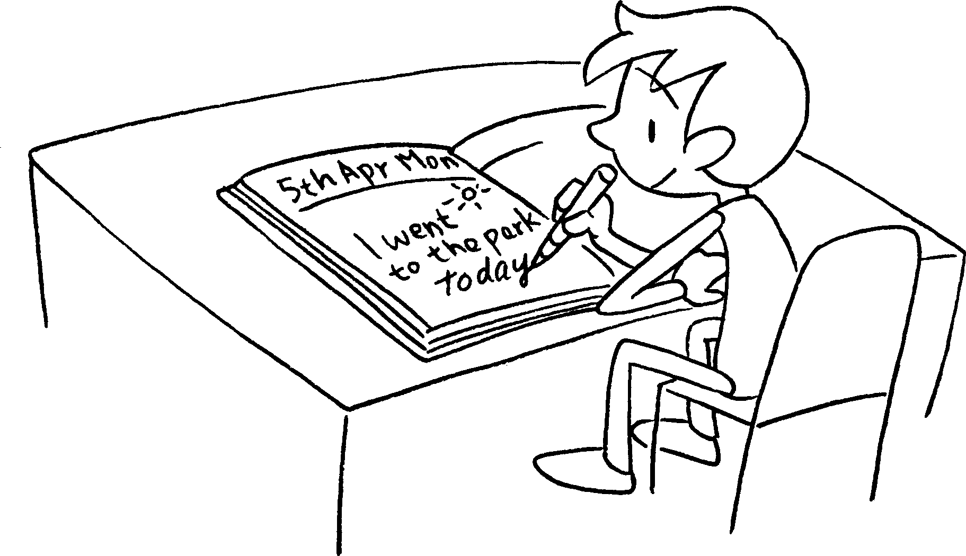
34  every day  every Sunday | 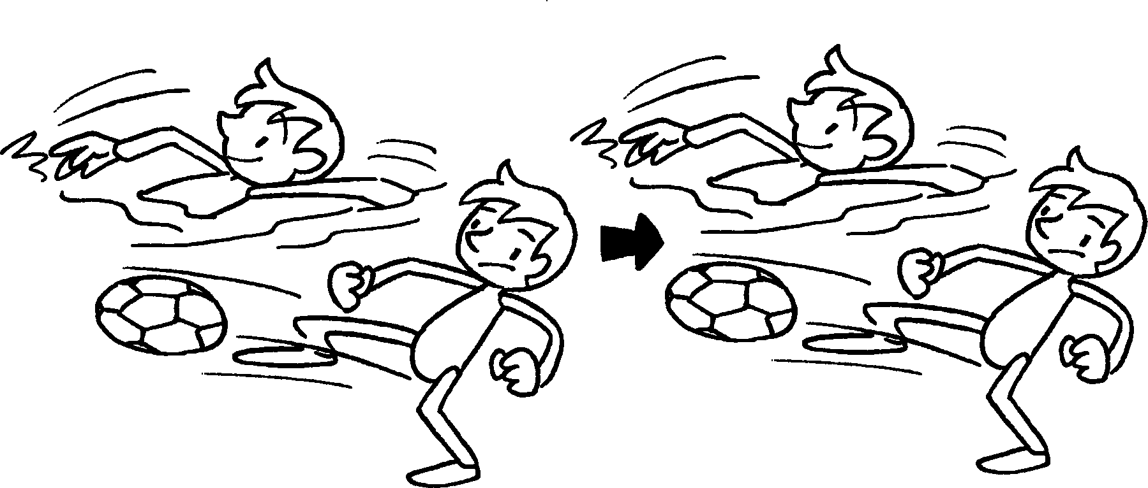 | 4 |   6 : 00 ~ 8 : 30  6 : 00 ~ 6 : 30
5 |  | 6 | 
7 |  | 8 | 

RP no: Century Gothic 15pt
(所有圈號用15pt)


Book 4B Chapter 5 Graded Worksheets
Worksheet 1⬇
- go to bed early 2 keep a diary
- do more sports 4 watch less TV
- read more books 6 do revision
- tidy my bookshelves 8 do Chinese / Maths / English exercises

