RP no: Century Gothic 15pt
(所有圈號用15pt)
Choose and write.

do keep read tidy watch

books bookshelves diary bed revision
Chinese / Maths / English exercises sports TV

1 | 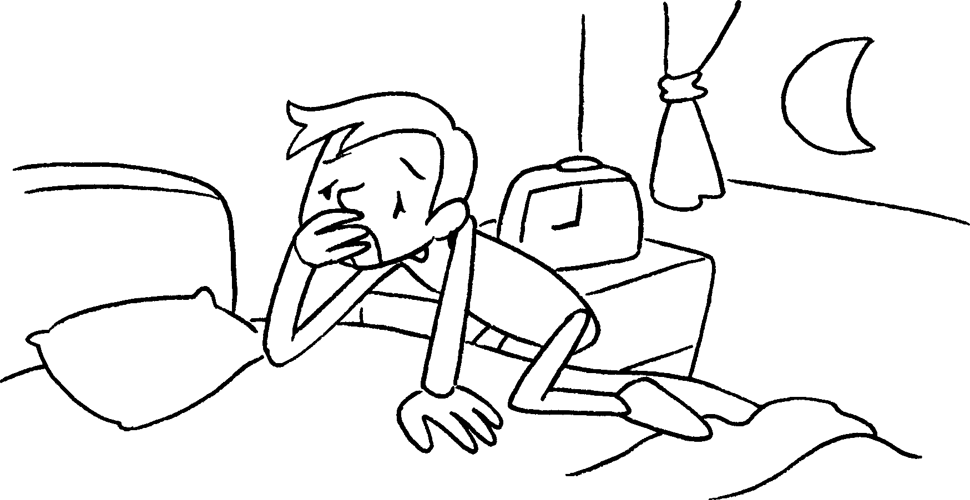  go to __________ early | 2 | 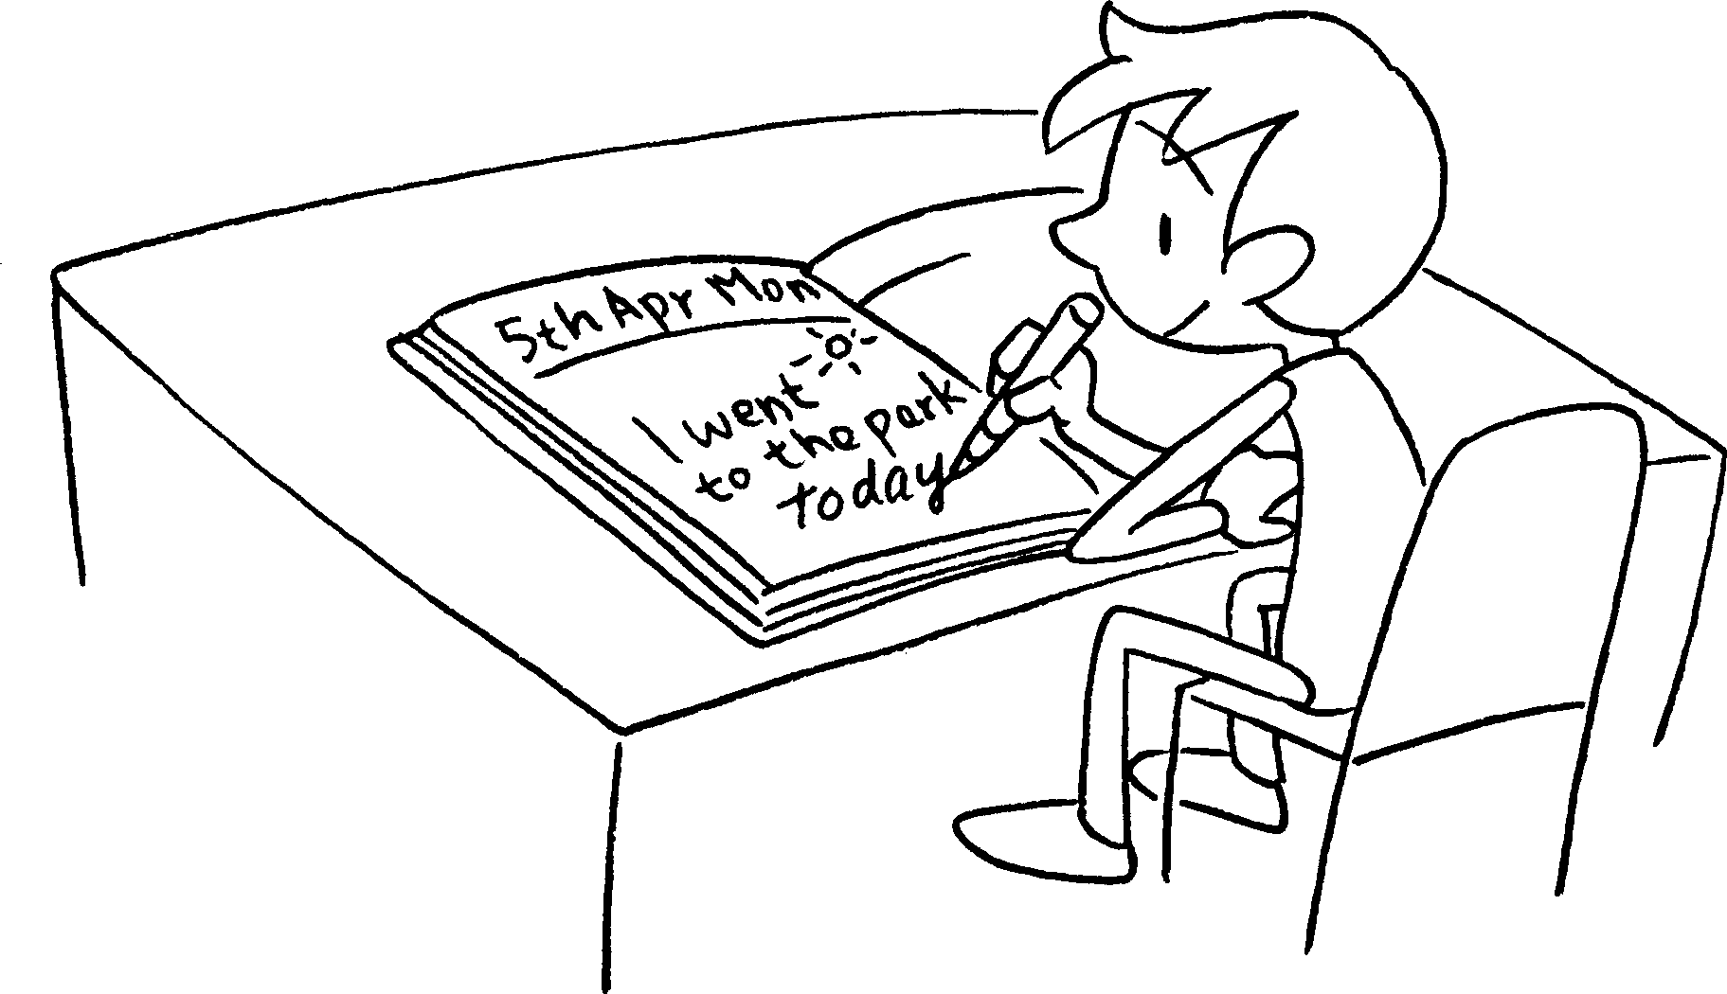  ___________ a ___________
34  every day  every Sunday | 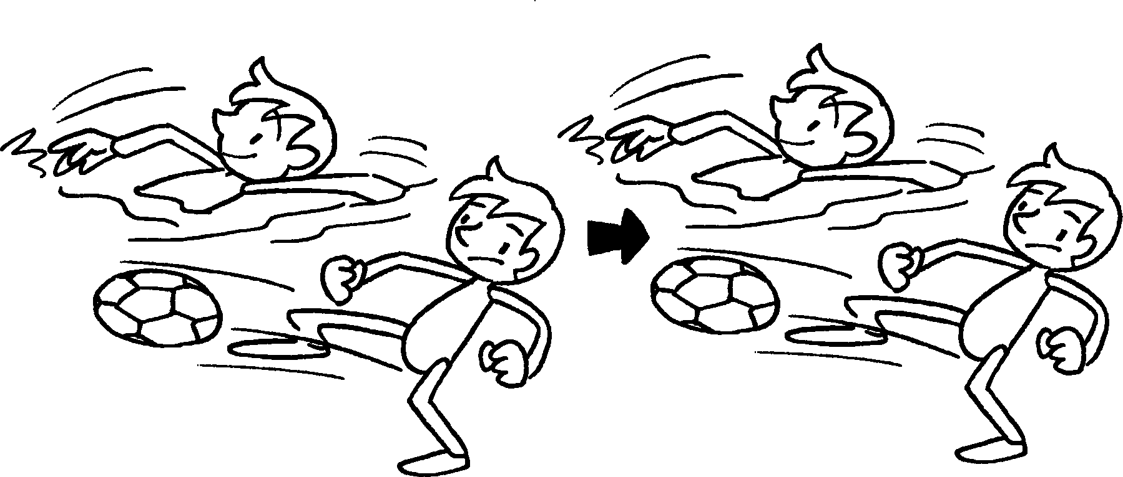  __________ _________ ________  more | 4 |   6 : 00 ~ 8 : 30  6 : 00 ~ 6 : 30  _________ _________ __________
5 |   __________ __________ _________ | 6 | 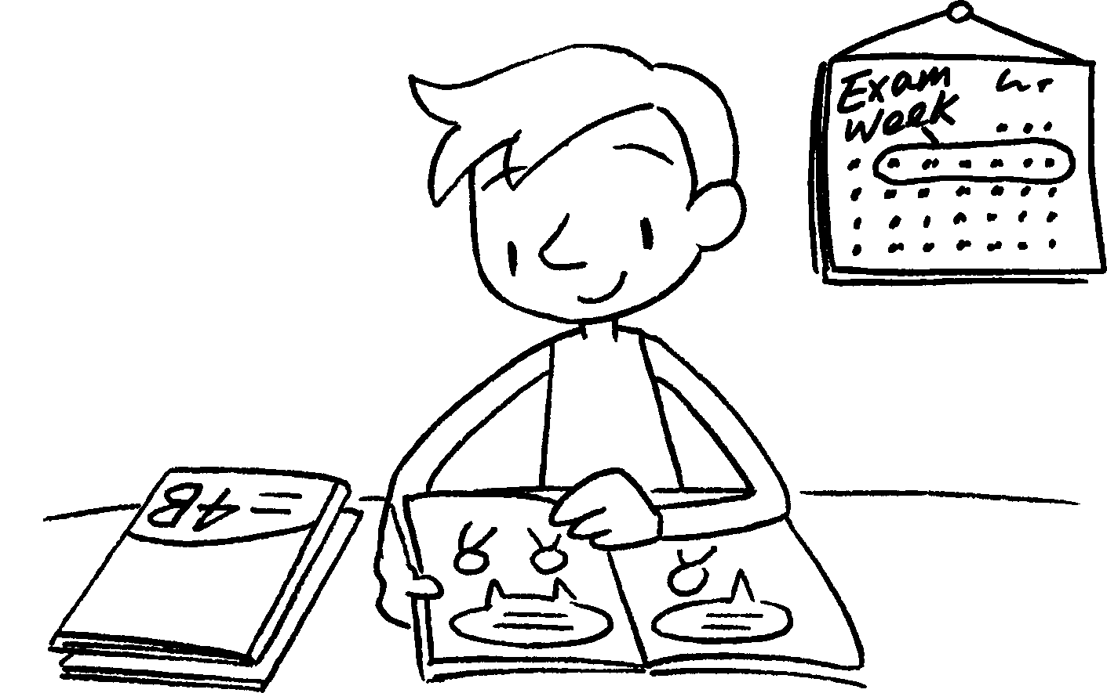  ______________ ______________
7 | 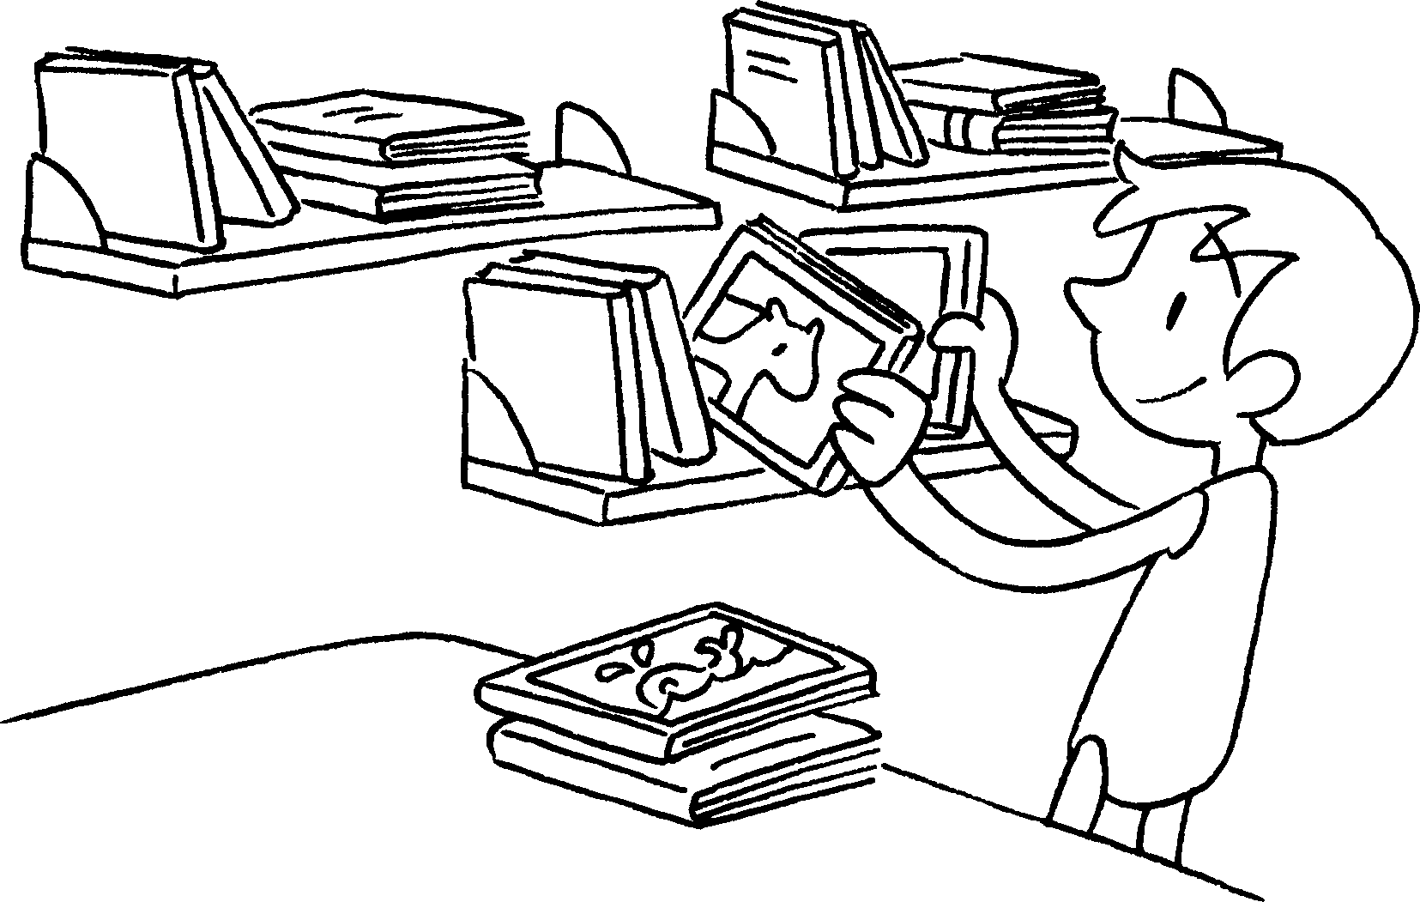  _____________________ ________  ______________________________ | 8 | 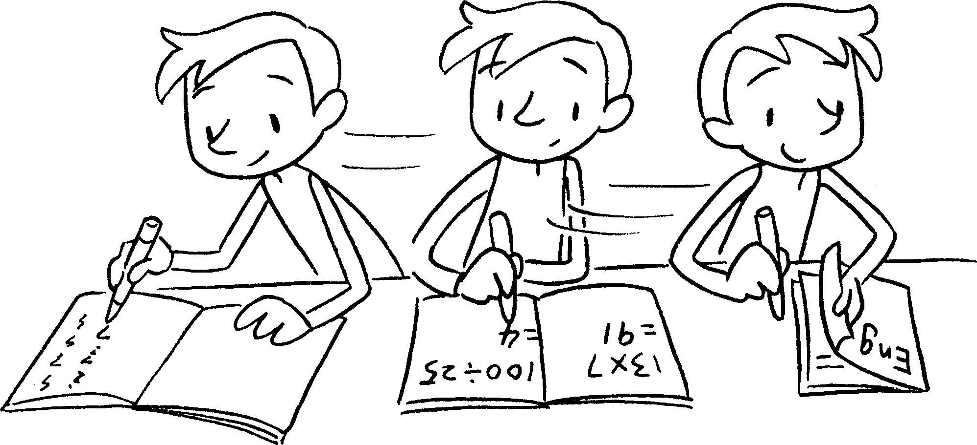  _________ ____________________  _____________________________


Book 4B Chapter 5 Graded Worksheets
Worksheet 1⬇⬇
- bed 2 keep diary
3 do sports 4 watch less TV
5 read more books 6 do revision
7 tidy my bookshelves 8 do Chinese / Maths / English exercises
(Accept any reasonable answers.)

